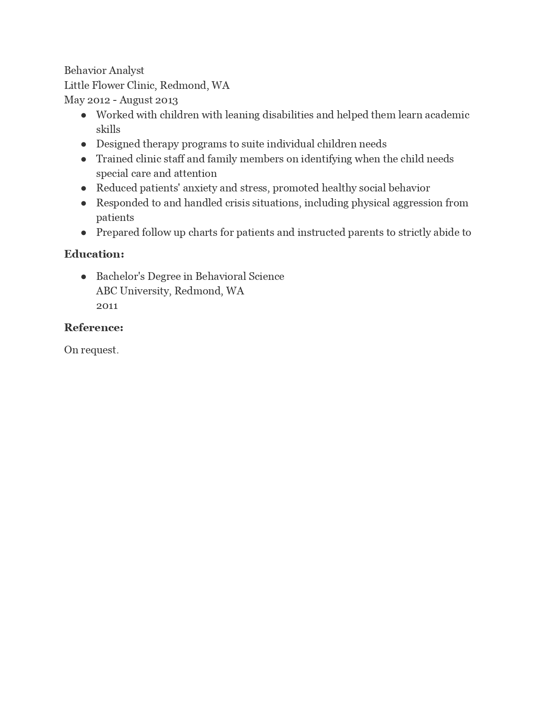
Behavior Analyst Little Flower Clinic, Redmond, WA May 2012 - August 2013 • Worked with children with leaning disabilities and helped them learn academic
skills • Designed therapy programs to suite individual children needs • Trained clinic staff and family members on identifying when the child needs
special care and attention • Reduced patients' anxiety and stress, promoted healthy social behavior • Responded to and handled crisis situations, including physical aggression from
patients • Prepared follow up charts for patients and instructed parents to strictly abide to
Education:
•
Bachelor's Degree in Behavioral Science ABC University, Redmond, WA 2011
Reference:
On request.

