HeartWorks Weekly Digest

We have a surprise!
Lorem ipsum dolor sit amet, consectetuer adipiscing.
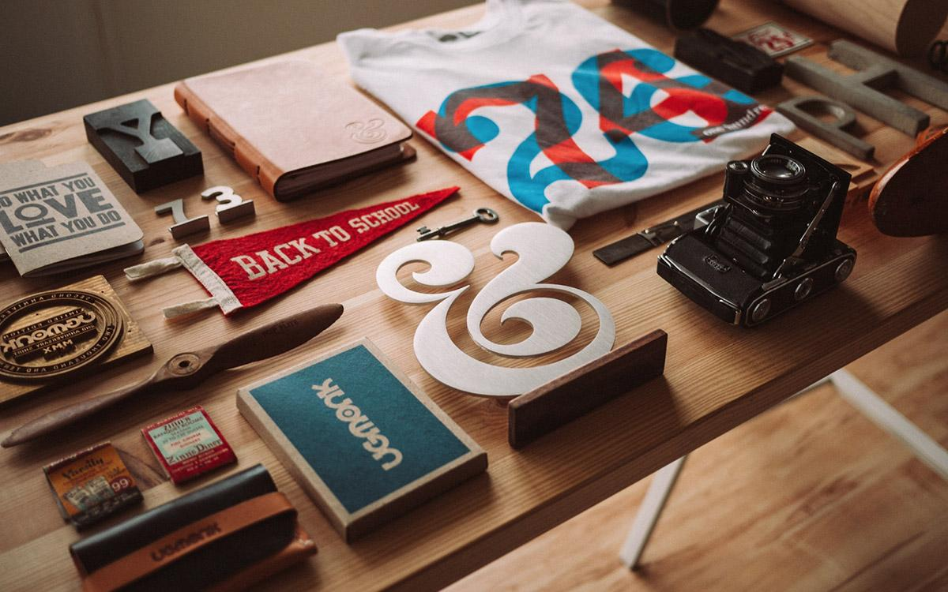
by Your Name on September 04
Lorem ipsum dolor sit amet, consectetuer adipiscing elit, sed diam nonummy nibh euismod tincidunt ut laoreet dolore magna aliquam erat volutpat. Ut wisi enim ad minim veniam, quis nostrud exerci tation ullamcorper suscipit lobortis nisl ut aliquip ex ea commodo consequat.
Duis autem vel eum iriure dolor in hendrerit in vulputate velit esse molestie consequat, vel illum dolore eu feugiat nulla facilisis at vero eros et accumsan.
THIS WEEK’S
TOP STORIES

Lorem ipsum dolor sit amet
by Your Name on September 04
Nam liber tempor cum soluta nobis eleifend option congue nihil imperdiet doming id quod mazim placerat facer possim assum.

Duis autem vel eum iriure dolor
by Your Name on September 04
Duis autem vel eum iriure dolor in hendrerit in vulputate velit esse molestie consequat, vel illum dolore eu feugiat nulla facilisis at vero eros et accumsan.

READ MORE ON OUR WEBSITE
HeartWorks Inc.
115, SomeCity, PA, 55344

