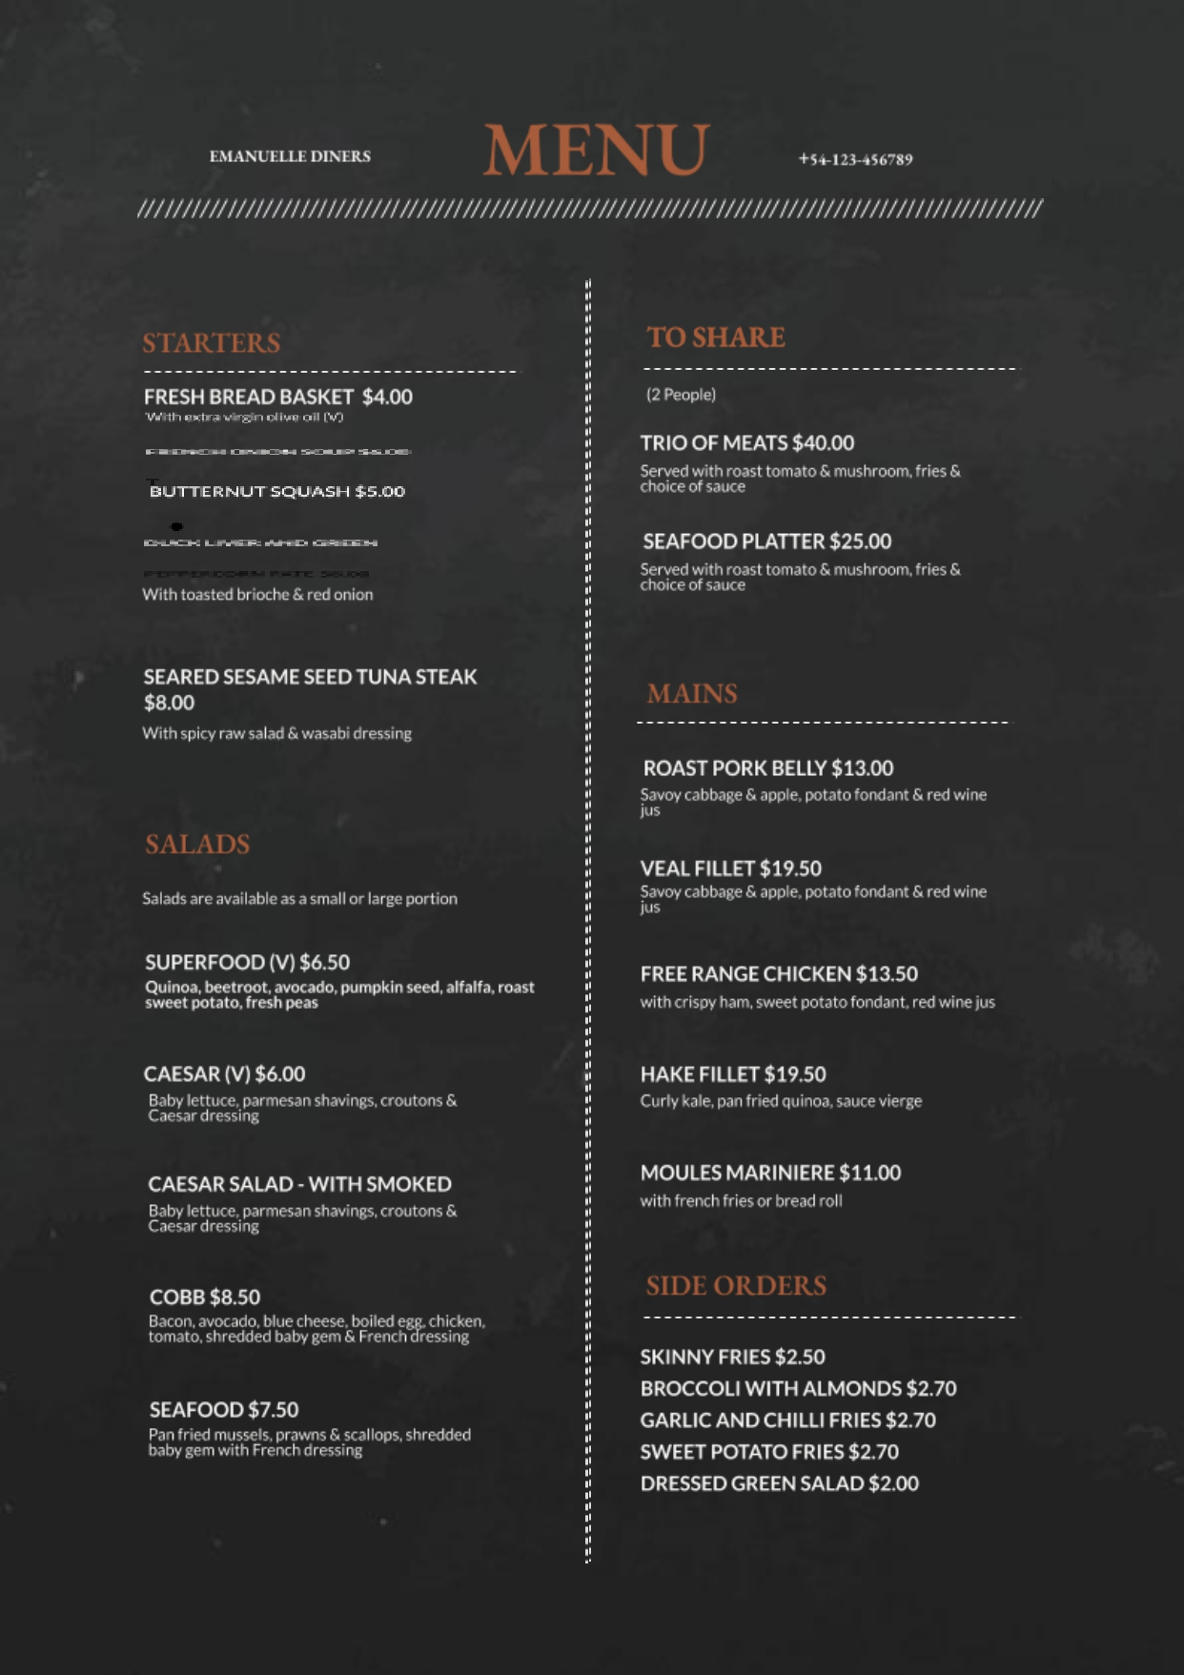
EMANUELLE DINERS
EMANUELLE DINERS
M ENU
+54-123-456789
STARTERS
TO SHARE
(2 People)
FRESH BREAD BASKET $4.00 With extra virgin olive oil (V)
TRIO OF MEATS $40.00 Served with roast tomato & mushroom, fries & choice of sauce
BUTTERNUT SQUASH $5.00
CHURCH LEDGRAM
SEAFOOD PLATTER $25.00 Served with roast tomato & mushroom, fries & choice of sauce
With toasted brioche & red onion
SEARED SESAME SEED TUNA STEAK $8.00 With spicy raw salad & wasabi dressing
MAINS
-
-
-
-
-
-
-
-
-
-
-
-
- -
- -
- -
-
-
-
-
-
-
-
-
-
=======================129999999999EEEEEEEEEEEE33333333333333333
ROAST PORK BELLY $13.00 Savoy cabbage & apple, potato fondant & red wine jus
SALADS
VEAL FILLET $19.50 Savoy cabbage & apple, potato fondant & red wine jus
Salads are available as a small or large portion
SUPERFOOD (V) $6.50
Quinoa, beetroot, avocado, pumpkin seed, alfalfa, roast sweet potato, fresh peas
FREE RANGE CHICKEN $13.50 with crispy ham, sweet potato fondant, red wine jus
CAESAR (V) $6.00 Baby lettuce, parmesan shavings, croutons & Caesar dressing
HAKE FILLET $19.50 Curly kale, pan fried quinoa, sauce vierge
CAESAR SALAD - WITH SMOKED Baby lettuce, parmesan shavings, croutons & Caesar dressing
MOULES MARINIERE $11.00 with french fries or bread roll
SIDE ORDERS
COBB $8.50 Bacon, avocado, blue cheese, boiled ege. chicken, tomato, shredded baby gem & French dressing
--
-
-
-
-
-
-
-
-
-
-
-
-
-
-
SEAFOOD $7.50 Pan fried mussels, prawns & scallops, shredded baby gem with French dressing
============
SKINNY FRIES $2.50 BROCCOLI WITH ALMONDS $2.70 GARLIC AND CHILLI FRIES $2.70 SWEET POTATO FRIES $2.70 DRESSED GREEN SALAD $2.00

