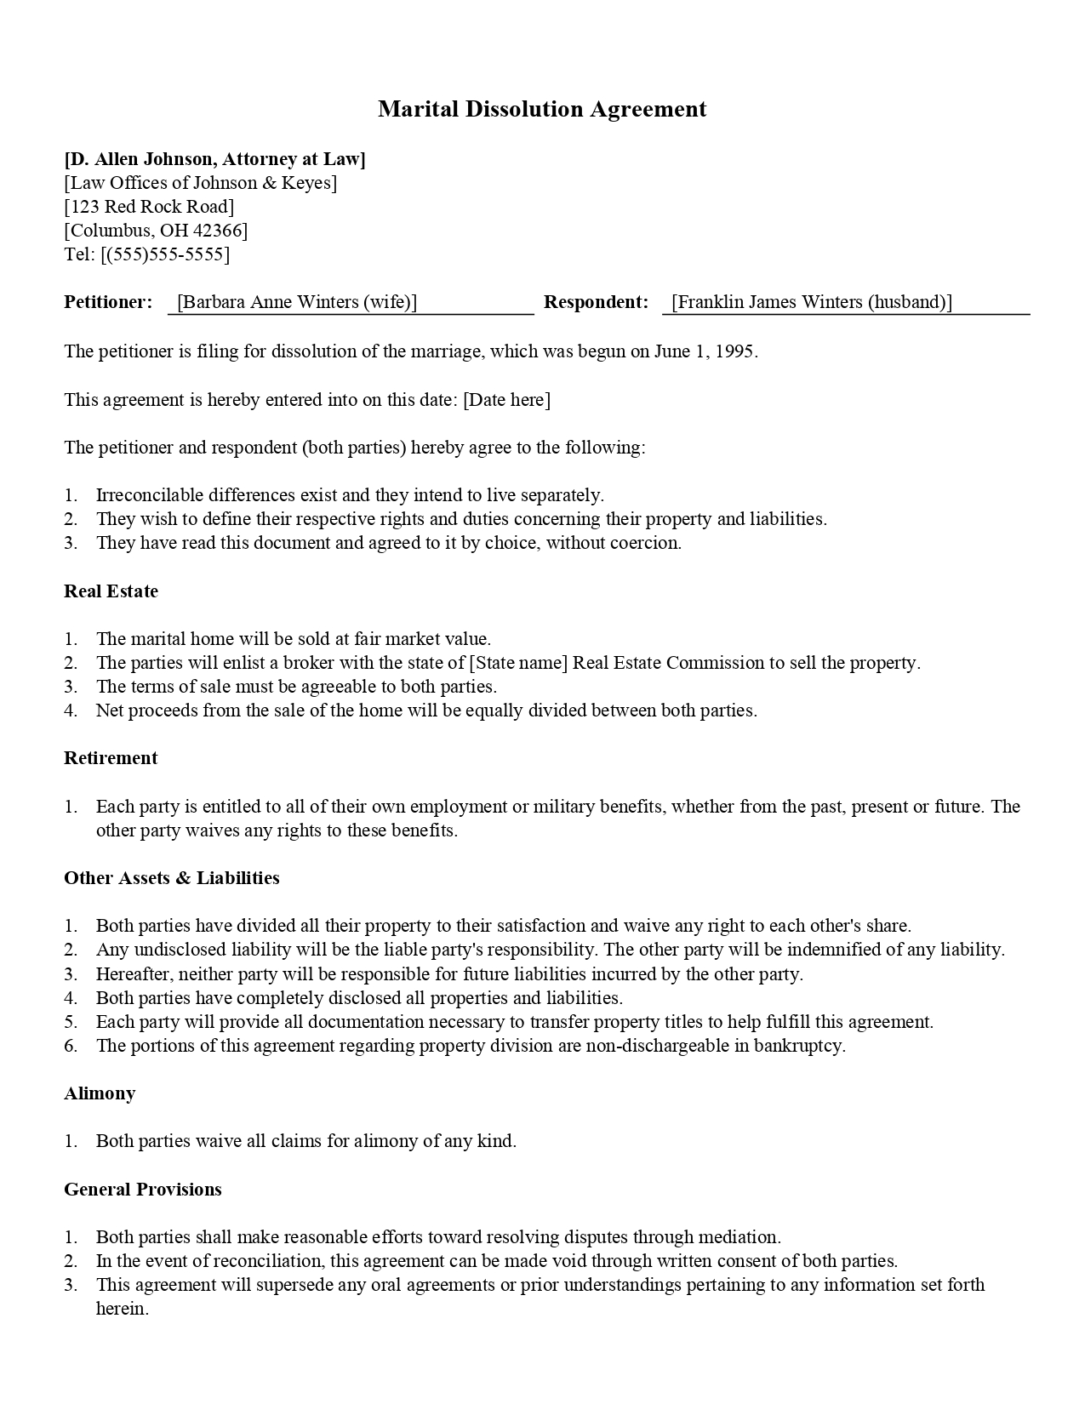
Marital Dissolution Agreement
[D. Allen Johnson, Attorney at Law] [Law Offices of Johnson & Keyes] [123 Red Rock Road] [Columbus, OH 42366] Tel: [(555)555-5555]
Petitioner:
Barbara Anne Winters (wife)
Respondent:
Franklin James Winters (husband)]
The petitioner is filing for dissolution of the marriage, which was begun on June 1, 1995.
This agreement is hereby entered into on this date: [Date here]
The petitioner and respondent (both parties) hereby agree to the following:
1. Irreconcilable differences exist and they intend to live separately. 2. They wish to define their respective rights and duties concerning their property and liabilities. 3. They have read this document and agreed to it by choice, without coercion.
Real Estate
1. The marital home will be sold at fair market value. 2. The parties will enlist a broker with the state of [State name) Real Estate Commission to sell the property. 3. The terms of sale must be agreeable to both parties. 4. Net proceeds from the sale of the home will be equally divided between both parties.
Retirement
1. Each party is entitled to all of their own employment or military benefits, whether from the past, present or future. The
other party waives any rights to these benefits.
Other Assets & Liabilities
1. Both parties have divided all their property to their satisfaction and waive any right to each other's share. 2. Any undisclosed liability will be the liable party's responsibility. The other party will be indemnified of any liability. 3. Hereafter, neither party will be responsible for future liabilities incurred by the other party. 4. Both parties have completely disclosed all properties and liabilities. 5. Each party will provide all documentation necessary to transfer property titles to help fulfill this agreement. 6. The portions of this agreement regarding property division are non-dischargeable in bankruptcy.
Alimony
1. Both parties waive all claims for alimony of any kind.
General Provisions
1. Both parties shall make reasonable efforts toward resolving disputes through mediation. 2. In the event of reconciliation, this agreement can be made void through written consent of both parties. 3. This agreement will supersede any oral agreements or prior understandings pertaining to any information set forth
herein.

