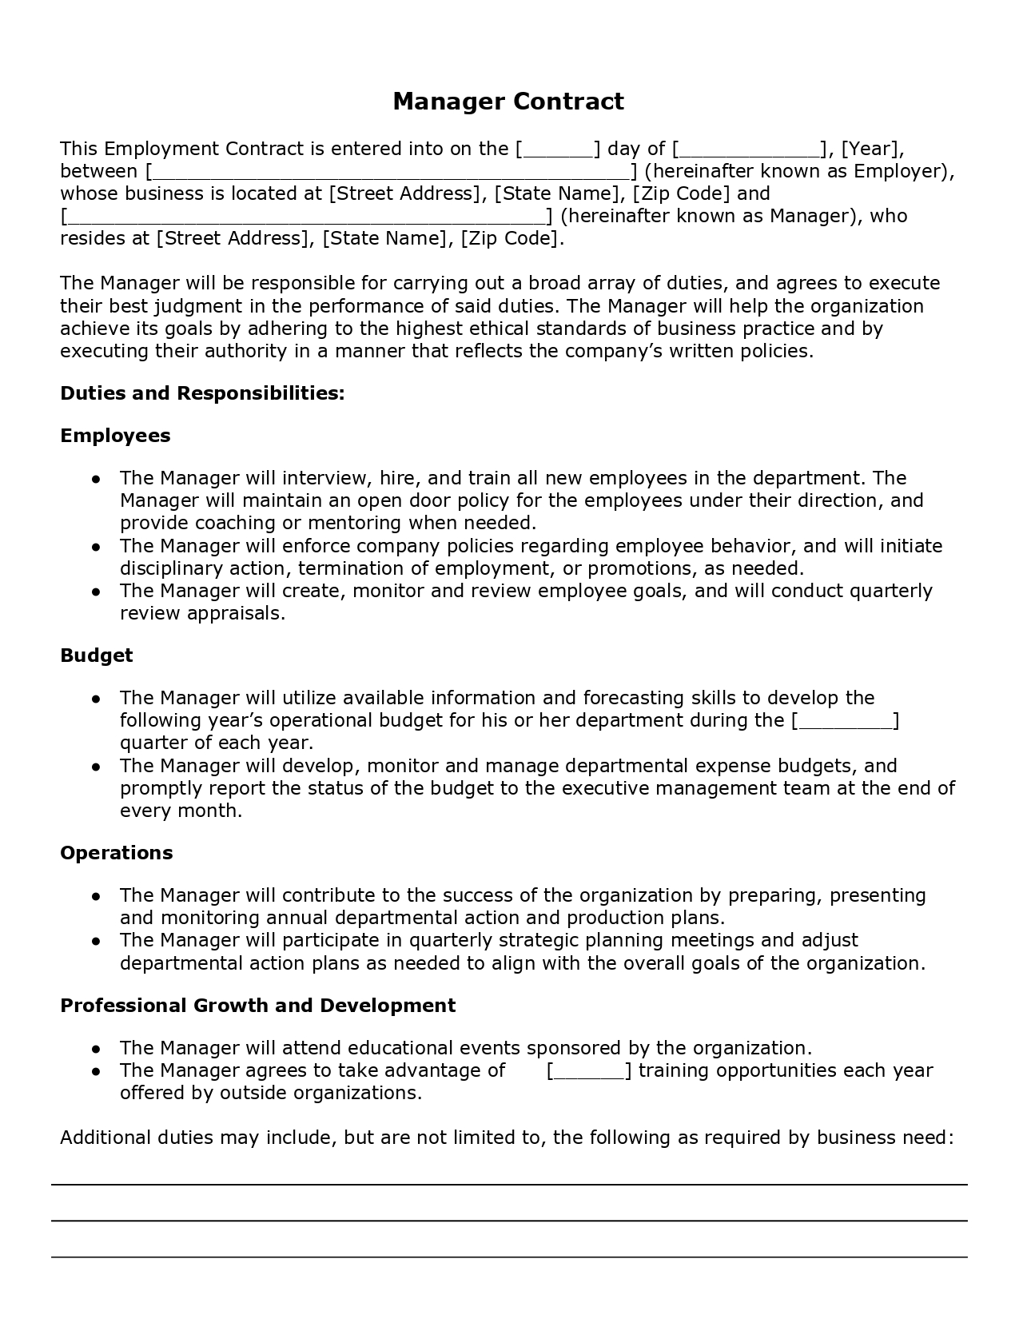
Manager Contract
This Employment Contract is entered into on the [ ] day of [
_], [Year], between [.
] (hereinafter known as Employer), whose business is located at [Street Address], [State Name], [Zip Code] and
] (hereinafter known as Manager), who resides at [Street Address], [State Name], [Zip Code).
The Manager will be responsible for carrying out a broad array of duties, and agrees to execute their best judgment in the performance of said duties. The Manager will help the organization achieve its goals by adhering to the highest ethical standards of business practice and by executing their authority in a manner that reflects the company's written policies.
Duties and Responsibilities:
Employees
• The Manager will interview, hire, and train all new employees in the department. The
Manager will maintain an open door policy for the employees under their direction, and provide coaching or mentoring when needed. The Manager will enforce company policies regarding employee behavior, and will initiate disciplinary action, termination of employment, or promotions, as needed. The Manager will create, monitor and review employee goals, and will conduct quarterly review appraisals.
Budget
•
The Manager will utilize available information and forecasting skills to develop the
ar's operational budget for his or her department during the [ quarter of each year. The Manager will develop, monitor and manage departmental expense budgets, and promptly report the status of the budget to the executive management team at the end of every month.
Operations
• The Manager will contribute to the success of the organization by preparing, presenting
and monitoring annual departmental action and production plans. • The Manager will participate in quarterly strategic planning meetings and adjust
departmental action plans as needed to align with the overall goals of the organization.
Professional Growth and Development
• The Manager will attend educational events sponsored by the organization. • The Manager agrees to take advantage of
] training opportunities each year offered by outside organizations.
Additional duties may include, but are not limited to, the following as required by business need:

