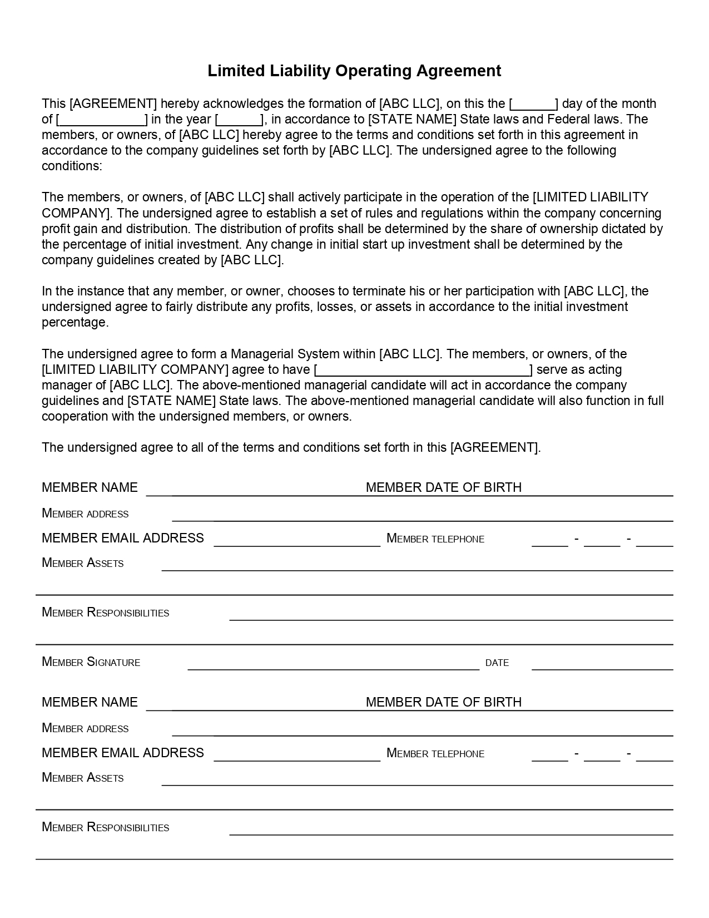
Limited Liability Operating Agreement
This (AGREEMENT) hereby acknowledges the formation of ABC LLC], on this the
day of the month of [.
J in the year ], in accordance to [STATE NAME] State laws and Federal laws. The members, or owners, of (ABC LLC] hereby agree to the terms and conditions set forth in this agreement in accordance to the company guidelines set forth by (ABC LLC]. The undersigned agree to the following conditions:
The members, or owners, of (ABC LLC] shall actively participate in the operation of the [LIMITED LIABILITY COMPANY). The undersigned agree to establish a set of rules and regulations within the company concerning profit gain and distribution. The distribution of profits shall be determined by the share of ownership dictated by the percentage of initial investment. Any change in initial start up investment shall be determined by the company guidelines created by [ABC LLC].
In the instance that any member, or owner, chooses to terminate his or her participation with (ABC LLC], the undersigned agree to fairly distribute any profits, losses, or assets in accordance to the initial investment percentage.
The undersigned agree to form a Managerial System within (ABC LLC]. The members, or owners, of the [LIMITED LIABILITY COMPANY] agree to have
serve as acting manager of [ABC LLC]. The above-mentioned managerial candidate will act in accordance the company guidelines and [STATE NAME] State laws. The above-mentioned managerial candidate will also function in full cooperation with the undersigned members, or owners.
The undersigned agree to all of the terms and conditions set forth in this (AGREEMENT).
MEMBER NAME
MEMBER DATE OF BIRTH
MEMBER ADDRESS
MEMBER EMAIL ADDRESS
MEMBER TELEPHONE
MEMBER TELEPHONE
-
:-
:
MEMBER ASSETS
MEMBER RESPONSIBILITIES
MEMBER SIGNATURE
DATE
MEMBER NAME
MEMBER DATE OF BIRTH
MEMBER ADDRESS MEMBER EMAIL ADDRESS
MEMBER TELEPHONE
—
—
MEMBER ASSETS
MEMBER RESPONSIBILITIES

