WEEKLY BUSINESS REPORT

Company Name
Company Address
Contact Number
Email Address
Prepared by: [SPECIFY NAMES]

TABLE OF CONTENTS

- INTRODUCTION Page No.

- CUSTOMER SERVICES Page No.

- PRODUCT DELIVERY Page No.

- MARKETING AND COMMUNICATION Page No.

- FINANCIAL REPORTS Page No.

- FINDINGS, CONCLUSIONS, AND RECOMMENDATIONS Page No.

INTRODUCTION
This weekly business report covers the week of [SPECIFY THE PERIOD].

The report covers weekly updates on the following:

I. Customer Services
II. Product Delivery
III. Marketing and Communication
IV. Financial Reports

The purpose of this weekly business report is to share updates with stakeholders.

[INSERT OTHER PURPOSE]

The scope and limitation of this report include: [SPECIFY THE SCOPE AND LIMITATION].

During the preparation of this report, the source documents that were used are [INSERT LIST OF DOCUMENTS AND SOURCES].

CUSTOMER SERVICES
Customers per Day per Service

[INDICATE THE SERVICE THAT THE COMPANY IS OFFERING]

Sunday

As provided below, there has been an (increase or decrease) of the number of customers as compared to [SPECIFY THE DATE].

SERVICE | [CURRENT DATA] | [OLD DATA] | DIFFERENCE
[SPECIFY SERVICE] | 00 Customers | 00 Customers | 00%

Monday

As provided below, there has been an (increase or decrease) of the number of customers as compared to [SPECIFY THE DATE]

SERVICE | [CURRENT DATA] | [OLD DATA] | DIFFERENCE
[SPECIFY SERVICE] | 00 Customers | 00 Customers | 00%

Tuesday

As provided below, there has been an (increase or decrease) of the number of customers as compared to [SPECIFY THE DATE]

SERVICE | [CURRENT DATA] | [OLD DATA] | DIFFERENCE
[SPECIFY SERVICE] | 00 Customers | 00 Customers | 00%

Wednesday

As provided below, there has been an (increase or decrease) of the number of customers as compared to [SPECIFY THE DATE]

SERVICE | [CURRENT DATA] | [OLD DATA] | DIFFERENCE
[SPECIFY SERVICE] | 00 Customers | 00 Customers | 00%

Thursday

As provided below, there has been an (increase or decrease) of the number of customers as compared to [SPECIFY THE DATE]

SERVICE | [CURRENT DATA] | [OLD DATA] | DIFFERENCE
[SPECIFY SERVICE] | 00 Customers | 00 Customers | 00%

Friday

As provided below, there has been an (increase or decrease) of the number of customers as compared to [SPECIFY THE DATE]
SERVICE | [CURRENT DATA] | [OLD DATA] | DIFFERENCE
[SPECIFY SERVICE] | 00 Customers | 00 Customers | 00%

Saturday

As provided below, there has been an (increase or decrease) of the number of customers as compared to [SPECIFY THE DATE]

SERVICE | [CURRENT DATA] | [OLD DATA] | DIFFERENCE
[SPECIFY SERVICE] | 00 Customers | 00 Customers | 00%

The difference in the number of customers vary for the following reasons:

[SPECIFY REASONS]

The day with the lowest number of customers was on [SPECIFY THE DAY]

The day with the highest number of customers was on [SPECIFY THE DAY].

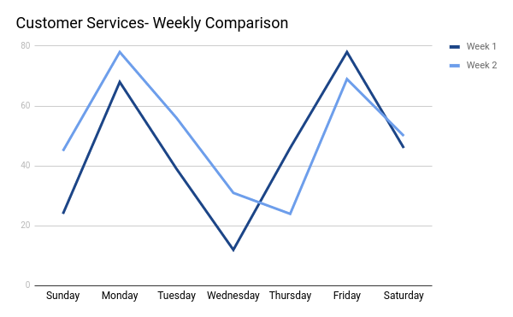
As seen above, this week’s number of customers is (higher/lower) than last week’s numbers.

Areas for improvement include the following:

[SPECIFY AREAS FOR IMPROVEMENT]

PRODUCT DELIVERY [INSERT WEEK COVERAGE]
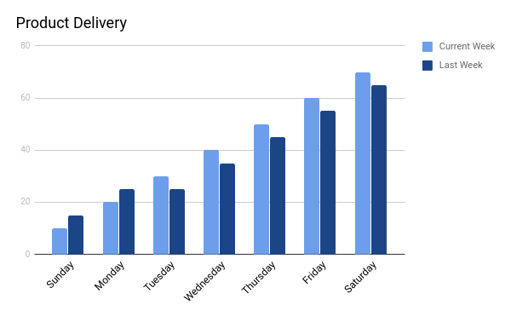

There is a difference of [ ] % in the total number of product deliveries compared to last week.

A difference in the demand is caused by: [SPECIFY THE CAUSE]

MARKETING AND COMMUNICATION
- Advertisements and Commercials

For this week, the marketing department spent $00.00 for advertisements and commercials. The breakdown for the amount is as follows:

ADVERTISEMENT | PLATFORM | DATE | TIME SLOT | COST
[SPECIFY ADVERTISEMENT] | Radio | [SPECIFY DATE] | [SPECIFY TIME SLOT] | $00.00
[SPECIFY ADVERTISEMENT] | Television | [SPECIFY DATE] | [SPECIFY TIME SLOT] | $00.00
[SPECIFY ADVERTISEMENT] | Newspaper | [SPECIFY DATE] | Not Applicable | $00.00
TOTAL |  |  |  | $00.00

- Free Sampling

There have been free sampling of the products in the following locations:

DATE | LOCATION | PRODUCT | COST
Sunday | [SPECIFY LOCATION] | [SPECIFY PRODUCT] | $00.00
Monday | [SPECIFY LOCATION] | [SPECIFY PRODUCT] | $00.00
Tuesday | [SPECIFY LOCATION] | [SPECIFY PRODUCT] | $00.00
Wednesday | [SPECIFY LOCATION] | [SPECIFY PRODUCT] | $00.00
Thursday | [SPECIFY LOCATION] | [SPECIFY PRODUCT] | $00.00
Friday | [SPECIFY LOCATION] | [SPECIFY PRODUCT] | $00.00
Saturday | [SPECIFY LOCATION] | [SPECIFY PRODUCT] | $00.00
TOTAL |  | $00.00

- Brochures

This covers the breakdown of brochure expenses:

EXPENSES | COST | QUANTITY | TOTAL AMOUNT
[SPECIFY EXPENSE] | $00.00 | 00 | $00.00
TOTAL |  | $00.00

- Social Media Interaction

The company opted to contract administrative assistants to post products and services on various social media websites and assist with customer concerns.

  - Facebook

During the week, there were varying numbers of product likes and shares.

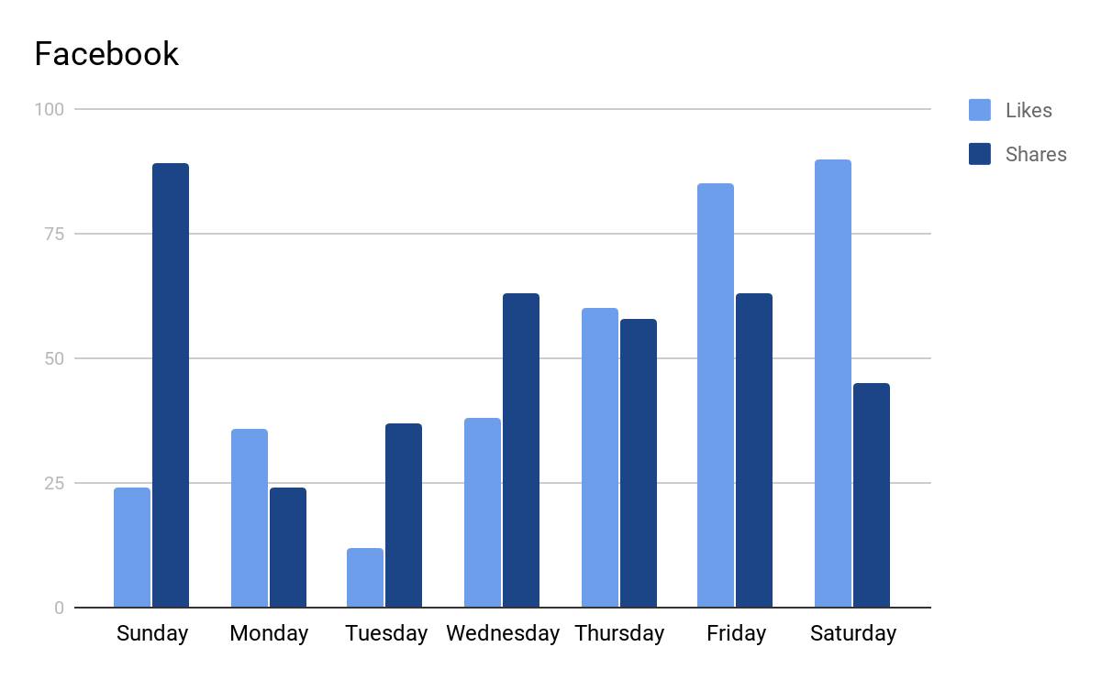

  - Instagram

There was an increase in the number of followers from the time the company Instagram account was created.

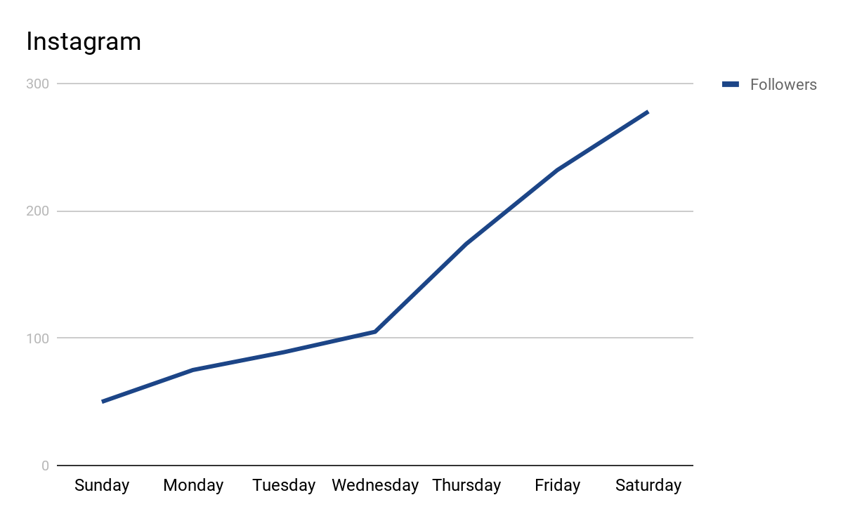

- Survey

A general survey on the use of company products and services was conducted.

DATE | SURVEY LOCATION | PRODUCT | NUMBER OF RESPONDENTS
 |  |  | TOTAL RESPONDENTS | USING THE PRODUCT | NOT USING THE PRODUCT | NO ANSWER INDICATED
Sunday | [SPECIFY SURVEY LOCATION] | [SPECIFY PRODUCT] | 00 | 00 | 00 | 00
Monday | [SPECIFY SURVEY LOCATION] | [SPECIFY PRODUCT] | 00 | 00 | 00 | 00
Tuesday | [SPECIFY SURVEY LOCATION] | [SPECIFY PRODUCT] | 00 | 00 | 00 | 00
Wednesday | [SPECIFY SURVEY LOCATION] | [SPECIFY PRODUCT] | 00 | 00 | 00 | 00
Thursday | [SPECIFY SURVEY LOCATION] | [SPECIFY PRODUCT] | 00 | 00 | 00 | 00
Friday | [SPECIFY SURVEY LOCATION] | [SPECIFY PRODUCT] | 00 | 00 | 00 | 00
Saturday | [SPECIFY SURVEY LOCATION] | [SPECIFY PRODUCT] | 00 | 00 | 00 | 00
TOTAL |  |  | 00 | 00 | 00 | 00

FINANCIAL REPORTS
The Weekly Financial Reports are as follows:

- Statement of Financial Performance

 | CURRENT WEEK | LAST WEEK |  | DIFFERENCE
Sales | $00.00 | $00.00 |  | 00%
Less: Sales Returns and Discounts | $00.00 | $00.00 |  | 00%
Net Sales | $00.00 | $00.00 |  | 00%
Less: Cost of Goods Sold | $00.00 | $00.00 |  | 00%
Gross Profit | $00.00 | $00.00 |  | 00%
Less:
General and Administrative Expenses | $00.00 |  | $00.00 |  | 00%
Selling Expenses | $00.00 |  | $00.00 |  | 00%
Income before Tax | $00.00 |  | $00.00 |  | 00%
Less: Income Tax | $00.00 |  | $00.00 |  | 00%
Net Income | $00.00 |  | $00.00 |  | 00%

- Statement of Cash Flows

 | CURRENT WEEK | LAST WEEK | DIFFERENCE
Cash Flow From Operations | $00.00 | $00.00 | 00%
Net Income | $00.00 | $00.00 | 00%
Depreciation Expense | $00.00 | $00.00 | 00%
Bad Debts Expense | $00.00 | $00.00 | 00%
Decrease (Increase)- Accounts Receivable | $00.00 | $00.00 | 00%
Decrease (Increase)- Finished Goods Inventory | $00.00 | $00.00 | 00%
Increase (Decrease)- Current Liabilities: | $00.00 | $00.00 | 00%
Accounts Payable | $00.00 | $00.00 | 00%
Accrued Utilities Expense | $00.00 | $00.00 | 00%
Accrued Salaries Expense | $00.00 | $00.00 | 00%
Accrued Rent Expense | $00.00 | $00.00 | 00%
Accrued Income Tax | $00.00 | $00.00 | 00%
Net Cash Provided by Operating Activities | $00.00 | $00.00 | 00%
Cash Flow From Investing Activities | $00.00 | $00.00 | 00%
Increase from acquisition of Property and Equipment | $00.00 | $00.00 | 00%
Net Cash Provided by Investing Activities | $00.00 | $00.00 | 00%
Cash Flow from Financing Activities | $00.00 | $00.00 | 00%
Equity, Beginning | $00.00 | $00.00 | 00%
Additional Investment | $00.00 | $00.00 | 00%
Withdrawals | $00.00 | $00.00 | 00%
Net Cash Provided by Financing Activities | $00.00 | $00.00 | 00%
Add: Cash Balance, Beginning | $00.00 | $00.00 | 00%
Cash Balance, Ending | $00.00 | $00.00 | 00%

FINDINGS, CONCLUSIONS, AND RECOMMENDATIONS

The findings of this weekly business report are as follows:

[SPECIFY THE FINDINGS]
The conclusions of this weekly business report are as follows:

[SPECIFY THE CONCLUSIONS]

The recommendations for this weekly business report are as follows:

[SPECIFY THE RECOMMENDATIONS]

