VENDING MACHINE BUSINESS PLAN

[INSERT NAME OF THE BUSINESS/COMPANY]
[INSERT THE COMPLETE BUSINESS/COMPANY ADDRESS]
[INSERT THE BUSINESS/COMPANY CONTACT NUMBERS]
[INSERT THE BUSINESS/COMPANY EMAIL ADDRESS]
[INSERT THE BUSINESS/COMPANY WEBSITE ADDRESS]

PREPARED BY:

[INSERT FULL NAME/S OF THE
PEOPLE WHO PREPARED THIS PLAN]

[INSERT DATE]

Index

Executive Summary [PAGE NUMBER]
Company Overview [PAGE NUMBER]
Products and Services [PAGE NUMBER]
Execution [PAGE NUMBER]
Operational Plan [PAGE NUMBER]
Financial Plan [PAGE NUMBER]

EXECUTIVE SUMMARY:

[Houser Vending Company] is a startup company based in [Atlanta, Georgia] that offers snack and beverage vending packages. The company considers universities and corporate offices as target customers. It will utilize [search engine optimization] (SEO) and social media platforms to market its services.

The company aims to attract more clients and increase its revenue in the next [three] years.

COMPANY OVERVIEW:

Mission Statement: [Houser Vending Company] satisfies customer needs by providing them with the best vending experience possible.

Philosophy: [Houser Vending Company] takes pride in everything it does. Its employees deliver excellent service with customer convenience as its topmost priority.

Vision: [Houser Vending Company] is the leading vending company in [Atlanta, Georgia].

Outlook: The vending machine operators industry has experienced a crisis in recent years but there is still a demand for [vending services] among schools and offices. The company takes advantage of such market demand and aims to increase the number of customers in the next [three] years.

Type of Industry: [Vending Machine Operators Industry]

Business Structure: Sole Proprietorship

Ownership: Sole Proprietorship, [Michael Houser]

Start-Up Summary: [Houser Vending Company’s] total startup cost of [265K] USD is to be shouldered by the [sole proprietor]. This fund covers payment for initial operating disbursements such as [rent, insurance, legal fees, and payroll].

Start-Up Funding
Start-Up Expenses | $157,125
Start-Up Assets | $107,875
Total Funding Required | $265,000
Assets
Non-Cash Assets from Start-Up | $80,000
Cash Requirements from Start-up | $9,000
Additional Cash Raised | $17,875
Cash Balance on Starting Date | $1,000
Total Assets | $107,875
Capital
Planned Investment
Owners | $265,000
Other | $0
Additional Investment Requirement | $0
Total Planned Investment | $265,000
Loss at Start-Up (Start-Up Expenses) | -$157,125
Total Capital | $107,875
Liabilities | $0
Total Capital and Liabilities | $107,875
Start-Up
Requirements
Start-Up Expenses
Rent - 6 Months | $59,625
Advertising | $2,500
Legal Fees | $3,500
Staff Training | $8,500
Insurance | $3,000
Other | $80,000
Total Start-Up Expenses | $157,125
Start-Up Assets
Cash Required | $10,000
Start-Up Inventory | $25,000
Other Current Assets | $17,875
Long-Term Assets | $55,000
Total Assets | $107,875
Total Requirements (Total Start-Up Expenses + Total Assets) | $265,000

MANAGEMENT TEAM:

Management Team | Role/Function | Skills
Michael Houser | General Manager | Communication, Leadership, Decision-Making, Problem-Solving
Paula Hodges | Finance Manager | Analytical, Attention to Detail, Communication, Team Management

SHORT- AND LONG-TERM GOALS AND MILESTONES:

Short-Term Goals | Milestones
Hire sufficient personnel to deliver the company’s services | The company recruited about [50%] of the needed personnel as of [December 5, 2018].
Partner with snack and beverage companies for inventory | The company recently closed a deal with a multi-national beverage company.
Long-Term Goals | Milestones
Attract more schools and offices to avail of the company’s services | The company presented its proposal to about 5 schools and 5 offices in Atlanta, Georgia.
Obtain a solid online market presence | The company created its own website for customers to browse through.

PRODUCTS AND SERVICES

Product/Service Description: [Houser Vending Company] provides snack and beverage [vending service] packages to schools and offices in [Atlanta, Georgia].

Value Proposition: [Houser Vending Company] makes it a point to deliver and enhance the convenience that vending machines give to consumers.

Pricing Strategy: [Houser Vending Company] uses both price bundling and competitive pricing methods. The company refers to its competitors’ rates when pricing its vending service packages.

EXECUTION

Marketing Plan: [Houser Vending Company] plans to make its website and its content land on the top search results in various search engines through [SEO]. The company also wants to make its business known on social media channels like [Facebook and Instagram].

Market Research: The [vending machine operators industry] has struggled with a decrease in revenue in the past [five] years. Even so, there is still a continuous demand for vending machines in establishments such as universities and corporate offices as shown in the chart below.

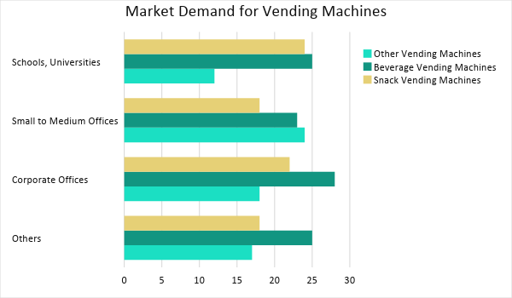

SWOT Analysis | Strengths | Weaknesses | Opportunities | Threats
Houser Vending Company | Provides premium quality vending service packages at affordable rates | Very limited market coverage | Growing demand for vending machines among schools and offices | Market influence of established vending machine operators
The Vending Corp. | Considered as a global vending machine operator | Highly expensive charge for its services | Upgrades in machines through advanced technology | Affordable pricing in vending services of emerging companies
Atlanta Vending Express | Offers quick and efficient vending machine services | Very limited choice of goods | Constant change in preference of consumers on vending machine goods | Preference of consumers in common snack/beverage choices

Marketing Strategy: [Houser Vending Company] will use its website to market its vending service packages. The company will also open accounts on [Facebook and Instagram] to post content about its services and to heighten its social media presence. The table below shows the activities recently started to accomplish these strategies.

Marketing Strategy | Activities | Timeline | Success Criteria
Optimize website through SEO | Hire an SEO company to handle website optimization | January 20, 2019 | Hired SEO company and completed the optimization during the first quarter of 2019
Heighten social media presence | Open Facebook and Instagram accounts | January 10, 2019 | Created accounts generate about 5,000 followers in the month of January 2019

ORGANIZATIONAL STRUCTURE:

[Houser Vending Company] follows a [divisional organizational structure] with [Michael Houser] as the President. The company’s divisions are assigned with different sales, marketing, and finance teams.

OPERATIONAL PLAN:

Location and Facilities

[Houser Vending Company] operates in a [4,500 square foot property] in [719 Miami Cir NE Lindbergh – Morosgo], [Atlanta, GA 30324, USA]. The company has a spacious area to store vending machines and inventory.

Tools and Equipment Checklist

Software | Quantity
Inventory Management System | 3
Customer Database System | 1
Hardware | Quantity
Computers | 5
Vending Machines | 10

IT INFRASTRUCTURE

The following table shows the IT infrastructure of [Houser Vending Company].

Infrastructure | Existing (Y/N) | Description
Website | Y | The company owns a website.
Latency | Y | The company encounters quick response and processing time from the network.
Zero Downtime | Y | The company experiences network interruptions.

FINANCIAL PLAN

Assumptions

[Houser Vending Company] used the following financial assumptions to create its projected financial statements:

- The company projects a [40%] increase in revenue in the second year of operations.
- The prevailing market interest is [4%] and the tax rate for compensation is [12%].
- There is an expected [5%] inflation in the next [two years].

Monthly Expense

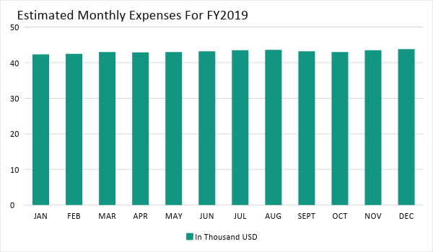

Monthly Revenue

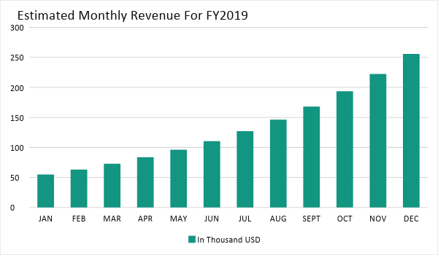

BUSINESS FINANCING

The [sole proprietor] generated the funds to initially operate the [Houser Vending Company] through a short-term loan amounting to [265K USD]. The said loan is payable within [18 months].

STATEMENTS

Profit and Loss Projection
 | FY2019 | FY2020 | FY2021
Sales | $495,000.00 | $693,000.00 | $970,200.00
Direct Cost of Sale | $222,750.00 | $311,850.00 | $436,590.00
Other Cost of Sale | $2,500.00 | $2,625.00 | $2,756.25
Total Cost of Goods Sold or COGS (Sales - Direct Cost of Sale - Other Cost of Sale) | $269,750.00 | $378,525.00 | $530,853.75
Gross Profit (Sales-Total Cost of Goods Sold) | $225,250.00 | $314,475.00 | $439,346.25
Gross Margin % (Gross Profit/Sales) | 45.51% | 45.38% | 45.28%
Operating Expenses
Rent | $119,250.00 | $119,250.00 | $119,250.00
Insurance | $7,500.00 | $7,500.00 | $7,500.00
Utilities | $8,000.00 | $8,160.00 | $8,323.20
Salary (Including Tax) | $65,000.00 | $65,000.00 | $65,000.00
Maintenance & Supplies | $7,000.00 | $7,175.00 | $7,354.38
Total Operating Expenses | $206,750.00 | $207,085.00 | $207,427.58
EBITDA (Total Cost of Sale-Total Operating Expenses) | $63,000.00 | $171,440.00 | $323,426.18
Depreciation | $1,000.00 | $1,000.00 | $1,000.00
Interest Expense | $10,600.00 | $10,600.00 | $10,600.00
Taxes Paid | $7,800.00 | $7,800.00 | $7,800.00
Net Profit (Gross Profit - Operating Expenses - Taxes - Interest) | $100.00 | $88,990.00 | $213,518.68

Balance Sheet Projection
 | FY2019 | FY2020 | FY2021
Cash | $15,250.00 | $102,990.00 | $305,883.68
Accounts Receivable | $75,000.00 | $105,000.00 | $147,000.00
Inventory | $25,000.00 | $31,250.00 | $39,062.50
Other Current Assets | $17,875.00 | $20,556.25 | $23,639.69
Total Current Assets | $133,125.00 | $259,796.25 | $515,585.86
Long-Term Assets | $55,000.00 | $63,250.00 | $72,737.50
Accumulated Depreciation | $1,000.00 | $2,000.00 | $3,000.00
Total Long-Term Assets (Long-Term Assets-Accumulated Depreciation) | $54,000.00 | $61,250.00 | $69,737.50
Total Assets (Total Current Assets + Total Long-Term Assets) | $187,125.00 | $321,046.25 | $585,323.36
Accounts Payable | $57,000.00 | $52,000.00 | $47,000.00
Notes Payable | $45,000.00 | $51,750.00 | $59,512.50
Other | $5,000.00 | $5,000.00 | $5,000.00
Total Liabilities | $107,000.00 | $108,750.00 | $111,512.50
Paid-in Capital | $80,000.00 | $80,000.00 | $80,000.00
Retained Earnings | $100.00 | $89,090.00 | $302,608.68
Total Owner's Equity (Total Assets - Total Liabilities) | $80,125.00 | $212,296.25 | $473,810.86
Total Liabilities & Equity (Total Liabilities/Total Owner's Equity) | 133.54% | 51.23% | 23.54%

Cash Flow Projection
 | FY2019 | FY2020 | FY2021
Operating Cash Beginning | $10,000.00 | $15,250.00 | $102,990.00
Sources of Cash | $8,500.00 | $10,625.00 | $13,281.25
Receivables | $75,000.00 | $105,000.00 | $147,000.00
Sales | $125,000.00 | $175,000.00 | $245,000.00
Others | $3,500.00 | $4,200.00 | $5,040.00
Total Cash | $222,000.00 | $310,075.00 | $513,311.25
Expenditures
Rent | $119,250.00 | $119,250.00 | $119,250.00
Insurance | $7,500.00 | $7,500.00 | $7,500.00
Utilities | $8,000.00 | $8,160.00 | $8,323.20
Salary (Including Tax) | $65,000.00 | $65,000.00 | $65,000.00
Maintenance & Supplies | $7,000.00 | $7,175.00 | $7,354.38
Total Expenditures | $206,750.00 | $207,085.00 | $207,427.58
Net Income/Loss (Total Cash - Total Expenditures) | $15,250.00 | $102,990.00 | $305,883.68

