Business Plan For Fiscal Year 2019

[January 15, 2019]

[William C. Myers]
[willmyers@gmail.com]
[239-464-0792]
[www.myershumanresources.com]
[Park Meadows Office Building, 1910 Park Meadows Dr,
Fort Myers, FL 33907, USA]

Human Resource
Consulting Business Plan

Index

Executive Summary [PAGE NUMBER]

Company Overview [PAGE NUMBER]

Products and Services [PAGE NUMBER]

Execution [PAGE NUMBER]

Operational Plan [PAGE NUMBER]

Financial Plan [PAGE NUMBER]

EXECUTIVE SUMMARY

[Myers Human Resources] will render cost-efficient and effective human resource consulting services to small and medium-sized businesses that are in need of improvements in terms of employee engagement as well as of a reliable payroll software technology to implement compensation and benefits programs for employees. The firm has a pool of experts in handling human resource issues and concerns that can help clients succeed in their business operations.

[Myers Human Resources] plans to position itself as a reliable and trusted human resource consulting firm. The firm will use its social media accounts and SEO to market or promote its services and credibility to a much wider audience.

COMPANY OVERVIEW

Mission Statement

[Myers Human Resources] helps small and medium-sized businesses to maximize the potential of their human capital investment by providing reliable and cost-efficient human resource consulting services.

Philosophy

[Myers Human Resources] treats and addresses the human resource problems and issues of their clients as if they are their own. The firm offers inexpensive yet high-quality consulting services that can improve employee performance and increase accuracy in payroll administration. By providing cost-efficient consulting services, they help businesses fulfill their goals.

Vision

[Myers Human Resources] aims to become the top provider of human resources consulting services to various business industries in [Fort Myers].

Outlook

The demand for human resource consulting services is continuously growing. For businesses to attain success in their field or industry, they need to invest in the efficacy and efficiency of their business operations to maintain a steady business flow. There may be more human resource consulting services in the coming years as the need and demand arise.

Type of Industry: Consulting Services Industry

Business Structure

[Myers Human Resources] will follow a partnership business structure with [William C. Myers] as the general partner.

Ownership: Partnership, [William C. Myers]

Start-Up Summary

The startup cost for [Myers Human Resources] amounts to [150K] USD to be provided by all the partners using the agreed [50-30-20] ratio. This amount will cover the firm’s startup expenses such as office rent, furniture and fixtures, office equipment, and starting compensation.

Start-Up Funding
Start-Up Expenses | $59,100
Start-Up Assets | $90,900
Total Funding Required | $150,000
Assets
Non-Cash Assets from Start-Up | $35,900
Cash Requirements from Start-up | $30,000
Additional Cash Raised | $20,000
Cash Balance on Starting Date | $5,000
Total Assets | $90,900
Capital
Planned Investment
Owner | $75,000
Partner 1 | $45,000
Partner 2 | $30,000
Additional Investment Requirement | $0
Total Planned Investment | $150,000
Loss at Start-Up (Start-Up Expenses) | -$59,100
Total Capital | $90,900
Liabilities | $0
Total Capital and Liabilities | $90,900
Start-Up
Requirements
Start-Up Expenses
Rent - 6 Months | $45,000
Advertising | $6,000
Legal Fees | $2,000
Website Launch | $600
Insurance | $2,500
Other | $3,000
Total Start-Up Expenses | $59,100
Start-Up Assets
Cash Required | $35,000
Start-Up Inventory | $15,900
Other Current Assets | $20,000
Long-Term Assets | $20,000
Total Assets | $90,900
Total Requirements (Total Start-Up Expenses + Total Assets) | $150,000

Management Team:

Management Team | Role/Function | Skills
[William C. Myers] | Chief Executive Officer | Communication, Decision-Making, Leadership, Strategic Thinking, Motivator
[Laura J. Garcia] | Chief Financial Officer | Communication, Accuracy in Financial Data Interpretation, Budgeting, and Forecasting
[Brandon A. Hensley] | Chief Operations | Strategic in implementing processes and policies, Communication, Leadership

Short- and Long-Term Goals and Milestones:

Short-Term Goals | Milestones
Recruit experienced and qualified junior and senior associates to deliver and execute the human resources consulting services to clients | Completion of the recruitment process will be done by the end of [February 2018].
Finalize the nature of human resources consulting services that will fit any business industry | Finalization for the employee engagement service procedure will be completed on [February 1, 2018].
Long-Term Goals | Milestones
A steady flow of clients to avail of the human resources consulting services we offer | A final list of prospective and existing clients is already prepared. Telemarketing will start on [March 8, 2018].
Establish a secure position in the market as a reliable human resources consulting firm | The first draft will be completed by the end of [January 2018].

PRODUCTS AND SERVICES

Product/Service Description

[Myers Human Resources] will offer the following human resources consulting services to its clients:

- Employee Engagement: The firm will render consulting services for the enhancement of employee engagement and retention to improve employee performance and productivity.

- Payroll Administration: The firm will help clients in designing their compensation and employee benefit programs based on the evaluation of employee position.

Value Proposition

[Myers Human Resources] seeks to provide affordable and reliable solutions to its clients’ human resource needs. Together with its advanced and technological approach, the firm has a pool of experts who can provide high-quality human resource consulting services to deserving clients.

Pricing Strategy

[Myers Human Resources] will use price bundling as its pricing strategy. The firm’s human resource consulting services will be bundled or grouped depending on the nature of human resource issues and problems that the client wants to address. The firm will also apply penetration pricing to compete with other consulting firms in the market.

EXECUTION

Marketing Plan

[Myers Human Resources] aims to establish its name and reputation as a credible and reliable human resource consulting firm. The firm wants to increase awareness of its target market on the firm’s services through utilization of the internet. The firm will focus on enhancing its social media exposure and will use SEO to increase its visibility online and make it accessible on the web for potential clients. The firm will also use telemarketing to reach out to customers within the proximity of the firm’s location.

Market Research

More businesses are now more inclined to outsourcing certain business tasks, particularly payroll, recruitment, and employee performance engagement. Because of outsourcing’s cost-efficient advantage, a higher percentage of small and medium-sized businesses resort to and avail of human resource consulting services in the last [two] years as provided in the chart.
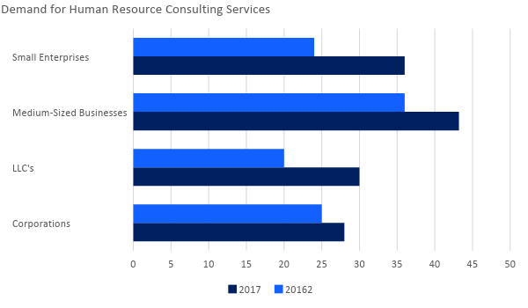

SWOT Analysis | Strengths | Weaknesses | Opportunities | Threats
[Myers Human Resources] | - A technologically-advanced approach to human resource consultation  - Affordability of consulting services  - Experienced human resource professionals | - The firm is a new player in the industry  - Unstable market position | - Commercial establishments prefer consulting firms who offer affordable and cost-efficient services | - There are established and newly opened consulting firms who offer similar services at a similar or lower price range
[HR Consult Camp] | - Affordability of consulting services  - Reliable human resource professionals | - Still new to the business industry  - Client reviews depict the firm’s poor customer service | - The increasing demand of businesses for consulting and outsourcing services | - Start-up consulting firms who offer better quality services with a similar price range
[Growth Tactic Consulting Ltd.] | - One of the established consulting firms in the United States  - Has over 50 offices in different states | - Highly-expensive consulting service offerings | - The loyalty and patronage of businesses to established consulting firms | - The increasing number of credible consulting firms who offer similar quality of service at an affordable price range

Marketing Strategy

[Myers Human Resources] will focus on improving its market position through extensive social media exposure and search engine optimization (SEO). The newly hired marketing director, [Denise F. Washington], has started the implementation:

Marketing Strategy | Activities | Timeline | Success Criteria
Website development | Hire the services of a reliable and trusted website developer to create the firm’s website | February 12, 2018 | A website developer has been hired. Discussion on the website details starts by [February 18, 2018].
Social media exposure | Create and update the firm’s account on selected social media platforms | ASAP | Final draft on the social media postings and advertisements will be completed by [February 10, 2018].
Search Engine Optimization | Contact an SEO company to aid the firm in optimizing online visibility of the created website. | February 28, 2018 | A meeting is scheduled by [March 10, 2018] to discuss the terms and conditions regarding SEO.

Organizational Structure:

[Myers Human Resources] follows an organizational structure wherein the three partners oversee different business tasks. The firm employs a marketing director, a human resource manager, and a few junior and senior experienced associates.

CEO (General Partner)
CFO (Limited Partner)
COO (Limited Partner)
Marketing Director
Human Resource Manager
CEO (General Partner)
CEO (General Partner)

Position | Roles/Responsibilities | Person/s Assigned | Recruitment Status
Marketing Director | Oversees the marketing and promotional activities of the firm | [Denise Washington] | ☐ Still Hiring  ☐ Already Hired
Human Resource Manager | Oversees the recruitment and processing of the employees’ compensation and benefits | [Aubrey Dye] | ☐ Still Hiring  ☐ Already Hired
Senior and Junior Associates | Delivers the human resource consulting services to clients as teams | [No final list  of names yet] | ☐ Still Hiring  ☐ Already Hired

OPERATIONAL PLAN

Location and Facilities

[Myers Human Resources] is located at [Park Meadows Office Building, 1910 Park Meadows Dr,
Fort Myers, FL 33907, USA]. The firm leases a [120 square feet] building with an open office designed for employees to mingle and work together harmoniously. There are offices designated for the management and a meeting room where all discussions with clients will be convened as shown on the sketch plan below.

Entrance/Exit
Guest Lounge
Conference Room for Meetings/Client Discussions
Office of the CEO
Office of the CFO
Office of the COO
Employee Workstations
Pantry/Break Area
Comfort Rooms

Tools and Equipment Checklist

Software | Quantity
Customer Database | 1
Payroll Preparation Software | 2
Word/Excel Processing Applications | 5
Hardware | Quantity
Laptop | 10
Printer | 4
Fax Machine | 2
Telephones | 6

IT Infrastructure

[Myers Human Resources] adopts basic IT systems to run the software to be used in the firm’s daily operations. As for the website creation and SEO, the firm plans to hire the services of a reliable website developer and SEO company. Social media accounts created for the firm will be managed and updated by both the Marketing Director and the Human Resource Manager.

FINANCIAL PLAN

Assumptions

[Myers Human Resources] prepared its projected financial statements with consideration to the following financial assumptions:

- Taxes on compensation equal to [20]% of the total salary expense.
- The prevailing market interest is [6]%.
- Cost of Sales for the first [two] years is an amount equal to [40]% of the total sales.
- Payment of each consulting service bundle is assumed to be paid using installment payments with an initial payment equal to [40]% of the total selling price. The Accounts Receivable amount is the total unpaid balances of clients.
- The business expects a total of [5]% increase in sales in the next [two] years, [2]% and [3]% respectively.
- Software maintenance increases by 1000 over the next [two] years.
- The markup on each service bundle is set to increase by [50]% by [2020].

Monthly Expense

The following chart shows the projected increases and decreases in monthly expenses for the year [2019].

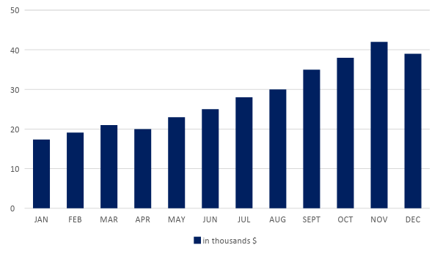

Monthly Revenue

The following chart shows the projected monthly revenue of the firm for the year [2019].

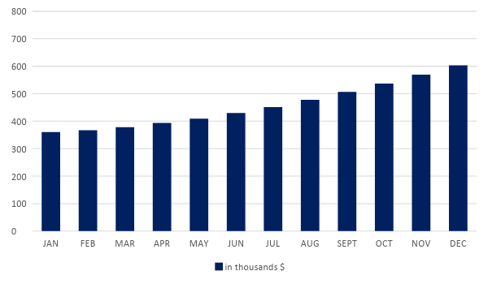

Business Financing

Since [Myers Human Resources] adopts a partnership business structure, the partners divide the total capital contribution of $[150,000] using the agreed upon 50-30-20 ratio. The table below shows the business loan and the cash contribution of each partner to complete the firm’s capital.

Partners | General or Limited? | Business Loan  (50-30-20) | Cash Contribution  (50-30-20)
[William C. Myers] | General | $ 50,000 | $ 25,000
[Laura J. Garcia] | Limited | $ 30,000 | $ 15,000
[Brandon A. Hensley] | Limited | $ 20,000 | $ 10,000
Total Amount |  | $ 100,000 | $50,000

The funds pooled by the partners will be used to cover expenses such as rent, maintenance, compensation, utilities, and advertising costs.

Statements

Profit and Loss Projection
 | FY2018 | FY2019 | FY2020
Sales | $600,000.00 | $612,000.00 | $642,600.00
Direct Cost of Sale | $240,000.00 | $244,800.00 | $289,170.00
Other Cost of Sale | $6,500.00 | $6,630.00 | $6,762.60
Total Cost of Goods Sold or COGS (Sales - Direct Cost of Sale - Other Cost of Sale) | $353,500.00 | $360,570.00 | $346,667.40
Gross Profit (Sales-Total Cost of Goods Sold) | $246,500.00 | $251,430.00 | $295,932.60
Gross Margin % (Gross Profit/Sales) | 41.08% | 41.08% | 46.05%
Operating Expenses
Rent | $90,000.00 | $90,000.00 | $90,000.00
Insurance | $5,000.00 | $5,000.00 | $5,000.00
Utilities | $20,000.00 | $20,000.00 | $20,000.00
Salary (Including Tax) | $60,000.00 | $60,000.00 | $60,000.00
Maintenance & Supplies | $10,000.00 | $11,000.00 | $12,000.00
Total Operating Expenses | $185,000.00 | $186,000.00 | $187,000.00
EBITDA (Total Cost of Sale-Total Operating Expenses) | $168,500.00 | $174,570.00 | $159,667.40
Depreciation | $8,000.00 | $8,000.00 | $8,000.00
Interest Expense | $6,000.00 | $6,000.00 | $6,000.00
Taxes Paid | $12,000.00 | $12,000.00 | $12,000.00
Net Profit (Gross Profit - Operating Expenses - Taxes - Interest) | $43,500.00 | $47,430.00 | $90,932.60

Balance Sheet Projection
 | FY2018 | FY2019 | FY2020
Cash | $278,500.00 | $433,500.00 | $573,500.00
Accounts Receivable | $150,000.00 | $147,058.82 | $144,175.32
Inventory | $70,000.00 | $70,000.00 | $70,000.00
Other Current Assets | $7,000.00 | $7,000.00 | $7,000.00
Total Current Assets | $505,500.00 | $657,558.82 | $794,675.32
Long-Term Assets | $30,000.00 | $30,000.00 | $30,000.00
Accumulated Depreciation | $8,000.00 | $8,000.00 | $8,000.00
Total Long-Term Assets (Long-Term Assets-Accumulated Depreciation) | $22,000.00 | $22,000.00 | $22,000.00
Total Assets (Total Current Assets + Total Long-Term Assets) | $527,500.00 | $679,558.82 | $816,675.32
Accounts Payable | $90,000.00 | $80,000.00 | $70,000.00
Notes Payable | $3,500.00 | $2,800.00 | $2,300.00
Other | $3,500.00 | $3,500.00 | $3,500.00
Total Liabilities | $97,000.00 | $86,300.00 | $75,800.00
Paid-in Capital | $150,000.00 | $150,000.00 | $150,000.00
Retained Earnings | $43,500.00 | $90,930.00 | $181,862.60
Total Owner's Equity (Total Assets - Total Liabilities) | $430,500.00 | $593,258.82 | $740,875.32
Total Liabilities & Equity (Total Liabilities/Total Owner's Equity) | 22.53% | 14.55% | 10.23%

Cash Flow Projection
 | FY2018 | FY2019 | FY2020
Operating Cash Beginning | $55,000.00 | $278,500.00 | $433,500.00
Sources of Cash | $30,000.00 | $20,000.00 | $15,000.00
Receivables | $81,000.00 | $50,000.00 | $45,000.00
Sales | $92,500.00 | $70,000.00 | $70,000.00
Others | $20,000.00 | $15,000.00 | $10,000.00
Total Cash | $278,500.00 | $433,500.00 | $573,500.00
Expenditures
Rent | $90,000.00 | $90,000.00 | $90,000.00
Insurance | $5,000.00 | $5,000.00 | $5,000.00
Utilities | $20,000.00 | $20,000.00 | $20,000.00
Salary (Including Tax) | $60,000.00 | $60,000.00 | $60,000.00
Maintenance & Supplies | $10,000.00 | $11,000.00 | $12,000.00
Total Expenditures | $185,000.00 | $186,000.00 | $187,000.00
Net Income/Loss (Total Cash - Total Expenditures) | $93,500.00 | $247,500.00 | $386,500.00

