[HOTEL LOGO]
[NAME OF COMPANY]

YEARLY SALES AND MARKETING PLAN

[INSERT YEAR]

Prepared By:
[NAME OF AUTHOR]
[DATE PREPARED]

TABLE OF CONTENTS

Hotel Overview xx

Market Overview xx

- Target Market xx

- Competitive Analysis xx

Strengths, Weaknesses, Opportunities, and Threats (SWOT) Analysis xx

Sale and Marketing Actions xx

Sales and Marketing Budget xx

[HOTEL NAME] Overview

The [HOTEL NAME] is a premier luxury hotel nestled right in [CITY], [STATE] offering the charms of retro and vintage interiors and elite four-star service rooms and suites. It is part of the elite hotel chain, [NAME OF HOTEL CHAIN], which consistently dominates the hotel industry since its establishment in [YEAR].

Currently, it is a five-floor high hotel housing three-hundred rooms divided into deluxe accommodations, suite rooms, and a presidential suite providing the comforts of an upscale service. It has a variety of facilities for all guests such as an informative concierge, bell desk, and valet parking. It also features an infinity pool, a fitness center, full-service spa, and a business center for access to wireless technology and other business needs.

Facilities Offered | Services Offered
- State-of-the-art business center  - Valet parking  - Infinity pools  - Banquet facilities  - Medical facilities  - Cafeteria and cocktail lounge | - 24-hours room service  - Thermostatically-controlled rooms and suites  - Free-handling of package deliveries  - Pets allowed  - Laundry services

Mission Statement

The hotel’s mission is to generate a profitable income by providing excellent hospitality service to guests and creating memorable experiences with them, as well as, contributing to the community where the hotel belongs.

MARKET OVERVIEW

Target Market

The hotel is situated in the capital city of [STATE], which abounds with cultural attractions and a tourism industry that generates an income of USD [INSERT FIGURES] every year, attracting a considerable amount of both domestic and international guests.

The city has, in fact, one of the highest records of visitors year after year as shown in the graph below:
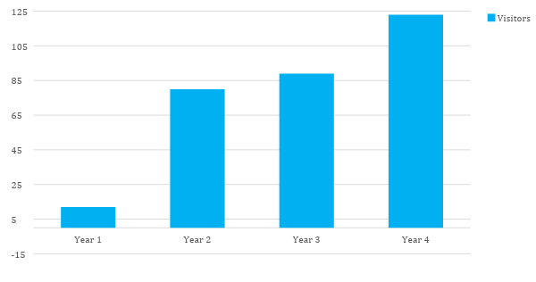

Figure 1

Statistics also show that with the number of visitors that the city attracts, it has acquired the highest revenue from tourists spending, and is supporting and generating [INSERT NUMERICAL FIGURE] jobs.

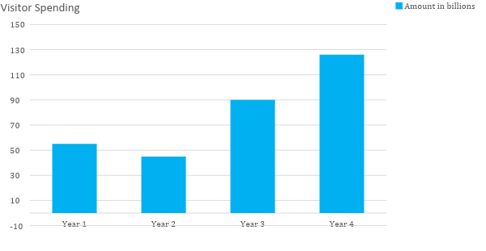

Figure 2

With the positive rise of the tourism industry in the city, hotel demands are also on the rise with higher levels of occupancy being sought. Moreover, competition between upscale and luxurious hotels has become more rigorous as the demands for hotel occupancy continues to increase.

With the provided statistics, the hotel aims to continue attracting guests, which are categorized below according to geography, demography, and behavior:

Geographic | Demographic | Behavioral
- Domestic Traveler  (includes guests who are residents within and outside the state)  - Foreign Traveler  (guests from other countries or nations) | - Age Groups: 35-45, 46-55, 56-70+  - An average income of not less than USD 0.00 | - Travel Occasion: Business and Leisure  - Travel Company: Individuals and Groups  - Travel Duration: Short and Long Stays

Competitive Analysis

An analysis is made below to measure the level of competitiveness of the hotel against other four-starred local hotel competitors in the city. Competitiveness is ranked according to the success criteria listed below.

Score: A - Excellent, B - Good, C - Fair, and D - Mediocre

Information | [HOTEL NAME] | Hotel Competitor (1) | Hotel Competitor (2) | Hotel Competitor (3)
Inception Year | 19xx | 19xx | 19xx | 19xx
Accessibility | A | B | B | C
Service Efficiency | B | A | C | D
Website | x | x | x | x
Customer Loyalty
Number of Rooms | 320 | x | x | x
Number of Suites | 2 | x | x | x
Parking Services | B | A | B | C
Guest Security | B | D | B | D
Responsiveness to Customer Demands | C | C | A | A

STRENGTHS, WEAKNESSES, OPPORTUNITIES, AND THREATS (SWOT) ANALYSIS

The SWOT Analysis is a tool that will help the hotel identify the different factors that affect and have an impact on its success. Through the SWOT Analysis, the hotel can increase its competitive advantage.

STRENGTHS | WEAKNESSES
- Strategic location in the city  - Established brand of hotel  - Good employee retention (Regularization of employees)  - High-profit margin  - Detailed and thorough service to its customers  - State-of-the-art facilities  - Positive brand image | - Focused on expansion  - High-season dependence
OPPORTUNITIES | THREATS
- Increasing globalization has resulted in fewer barriers for travel  - Inclinations to digitization  - Shutdown or closure of other hotel businesses in the city  - High demand for hotel occupancy in the city | - Rigid competition in the local hotel industry  - Political and economic instability in the country where the hotel is situated  - Possibility of terrorism  - The rise of alternative establishment accommodations such as motels, home rentals, and etc.

SALES AND MARKETING ACTIONS

Taking into consideration the competitive positioning of the hotel, as well as, the market trends in the industry, the Hotel shall adopt these strategies to further improve its performance for the next four quarters of operations in the current financial year:

QUARTER | PROPOSED ACTION | DETAILS
FIRST  (January-February-March) | - New Year’s Eve Package  - Valentine’s Day Package  - Brunch Package  - Overnight Package  - Direct Booking strategy | New Year’s Eve Package:  The package deal shall include:  - Breakfast for two  - Complimentary champagne Fireworks display viewing  - Valet parking  Valentine’s Day Package:  - The package deal shall include:  - Candlelit dinner for two  - 10% off of selected luxury accommodation  - Complimentary wine upon arrival  - Late checkout  - Valet parking  Brunch Package:  The package deal shall include:  - Brunch for two (additional parties shall incur additional rates)  - Valet parking  Overnight Package:  The package deal shall include:  - Luxury suite accommodation  - Food and beverage credit  - Valet Parking  Direct Booking Strategy:  - For every three bookings made, the customer shall get 10% off on selected room accommodations.
SECOND  (April-May-June) | - Summer Package Deals  - Direct Booking Strategy | Summer Package:  - The package deal shall include:  - Exclusive infinity pool access  - A three-night stay shall afford the customer a 15% discount from the original price.  Direct Booking Strategy:  - For every three bookings made, the customer shall get 10% off on selected room accommodations.
THIRD  (July-August-September) | - Theater Package  - Fourth of July Package  - Direct Booking Strategy | Theater Package:  - The package deal shall include:  - Exclusive use of the Theater Room for two  - Buffet deals  Fourth of July Package:  The package deal shall include:  - Fireworks display viewing  - Complimentary craft beer delivered in room  - 20% off on spa services  Direct Booking Strategy:  - For every three bookings made, the customer shall get 10% off on selected room accommodations.
FOURTH  (October-November-December) | - Thanksgiving Package  - Trick-or-Treat Package  - Holiday Brunch Package | Thanksgiving Package:  The package deal shall include:  - 15% off on spa services  - Complimentary turkey delivered to the room accommodation  - 4:00 PM late checkout  Trick-or-Treat Package:  The package deal shall include:  - 20% off on select luxury accommodations  - Free-viewing of selected horror film in the Theater Room  Holiday Brunch Package:  The package deal shall include:  - Brunch for two  - 4:00 PM late checkout  - Valet parking

SALES AND MARKETING EXPENSE BUDGET

The table below shows the proposed estimated sales and marketing budget of the Hotel for the [INSERT YEAR] financial year. The following figures provided below are subject to change in accordance with the budget allocated for the intended financial year.

EXPENSE ESTIMATE
 | FIRST QUARTER  (January-March) | SECOND QUARTER  (April-June) | THIRD QUARTER  (July-September) | FOURTH QUARTER  (October-December)
Advertising Strategies
Print | 0.00 (USD) | 0.00 (USD) | 0.00 (USD) | 0.00 (USD)
Online
Public Relations
Sales Strategies
Overnight Stay Packages
Special Occasion
Experience
Romance Package
Holiday Packages
Loyalty Rewards
Cross Promotion Deals
TOTAL EXPENSES | 0.00 (USD) | 0.00 (USD) | 0.00 (USD) | 0.00 (USD)

To Use This Documents
The text inside the brackets which is highlighted is meant to be edited with your text. This is the way you can edit the document as given below:

To Edit Text:
- Point the mouse where you want to edit and delete the sample text and then you can add your text.
- You can change the size, font & color of the text in the Main Tab: Home

To Edit Table:
- Point the mouse in the table where you want to edit and delete the sample text and then you can add your text.
- You can adjust the row & column size of the table in the Main Tab: Layout

To Edit Chart:
- Select the chart which is going to edit and then
- In Main tab: Design -> Edit Data
- It will open the excel sheet where you can edit the values of the chart

