MUSIC
SCHOOL BUSINESS PLAN
Business Plan For Fiscal Year 2020
[Cheryl Downing] [cherdowning@gmail.com]
[303-965-9491] [www.coinwashexpress.com]
[2076 S University Blvd University Park, Denver, CO 80210, USA]

January 24, 2019

CONTENTS
Executive Summary
Company Overview
Products and Services
Execution
Operational Plan
Financial Plan
[Page Number]
[Page Number]
[Page Number]
[Page Number]
[Page Number]
[Page Number]

EXECUTIVE SUMMARY

[Pittsburgh Professional] [Music Academy (PPMA)] is a school of music based in Pittsburgh, Pennsylvania. Three major programs comprise the academy's curriculum: instrument playing with basic recording, commercial songwriting, and professional music production. The academy aims to help local independent musicians and songwriters, as well as young people in and around Pittsburgh, build a career in music.

[PPMA] is confident that its programs and expertise can lure more people to enroll in, including those who are still hesitant to get formal music education.

COMPANY OVERVIEW

Mission Statement: The [Pittsburgh Professional] Music Academy helps young musicians and songwriters in Pittsburgh create a mark in the professional music industry.

Philosophy: [PPMA] values the cultivation of creativity and culture in a community where music is yet to be seen as a key component to a livable city. The school's curriculums are designed to educate students that music plays a vital role in the community, that it is a lucrative livelihood, and that it facilitates for the creative expression of one’s self.

Vision: The [PPMA] aspires to contribute to the growth of Pittsburgh's music community by providing access to anyone who has an ear for music.

Outlook: The City of Pittsburgh has received numerous requests for more community programs for independent musicians, most of which are coursed through the Pittsburgh Downtown Partnership. [PPMA] sees this as an opportunity to coordinate with the city to help resolve the concerns of these musicians, most especially those who are yet to undergo proper training. In its first two years of operation, the academy aims to have at least [20] single-course students, [10] full-time students, and working partnerships with local record labels and publishing companies where the students can also apply for internships or even be hired as salaried employees.

Type of Industry: Entertainment Industry / Education Industry

Business Structure and Ownership: [PPMA] will be formed as a limited liability partnership (LLP) in the state of Pennsylvania. The partnership will consist of four members, who will contribute both in the financial and operational aspects of the business.

Start-Up Summary: The start-up costs for the [PPMA] are set at $235,000.00.

Start-Up Funding
Start-Up Expenses | $105,000.00
Start-Up Assets | $130,000.00
Total Funding Required | $235,000.00
Assets
Non-Cash Assets from Start-Up | $50,000.00
Cash Requirements from Start-up | $50,000.00
Additional Cash Raised | $10,000.00
Cash Balance on Starting Date | $20,000.00
Total Assets | $130,000.00
Capital
Planned Investment
Owners | $200,000.00
Additional Investment Requirement | $35,000.00
Total Planned Investment | $235,000.00
Loss at Start-Up (Start-Up Expenses) | -$105,000.00
Total Capital | $130,000.00
Total Capital and Liabilities | $130,000.00
Start-Up
Requirements
Start-Up Expenses
Rent and Utilities | $40,000.00
Tools, Equipment and Maintenance | $20,000.00
Insurance, Licenses and Permits | $5,000.00
Payroll | $30,000.00
Marketing and Promotion | $10,000.00
Total Start-Up Expenses | $105,000.00
Start-Up Assets
Cash Required | $80,000.00
Other Current Assets | $20,000.00
Long-Term Assets | $30,000.00
Total Assets | $130,000.00
Total Requirements (Total Start-Up Expenses + Total Assets) | $235,000.00

Management Team:

Management Team | Role/Function | Skills
Taylor Klein | Chief Operations Officer | Leadership, decision making, resource management
Nicholas Adams | HR and Admin Manager | Employee relations, customer service, office organization
Jason McPherson | Marketing and Sales Director | Strategic planning, commercial awareness, sales planning
Sara Perez | Finance Manager | Numeracy and technical skills, problem-solving, data analysis

Short- and Long-Term Goals and Milestones:

Short-Term Goals | Milestones
Register with the state of Pennsylvania as an LLP | - Obtained all required forms to be filled on November 13, 2018.  - Completed all forms and submitted together with other requirements on December 7, 2018.
Secure leasehold on commercial property to be used for business | - Met with property manager and discussed requirements for the leasehold on November 7, 2018.  - Signed commercial lease contract on January 8, 2019.
Long-Term Goals | - Milestones
Increase clients by 10% to 20% starting Q3 of FY2 | - Drafted marketing plan (from 3rd week of November to 2nd week of December).  - Incorporated marketing plan into 3-year sales plan (from 3rd week of December to present).
Collaborate with the Pittsburgh Downtown Partnership on a special scholarship program for exceptional local musicians and songwriters | - Met with representatives from the Pittsburgh Downtown Partnership to discuss prospects on the program on December 20, 2018.  - Created a scholarship program outline providing rough details on course offerings (from January 3, 2019 to present).

PRODUCTS AND SERVICES

Service Description: The [PPMA] will offer both part-time and full-time courses for instrument playing, basic audio recording, commercial songwriting, and professional music production (including advanced recording, mixing, and mastering audio). Once the academy is authorized by the state government to provide formal education, four-year music and audio production degrees will be offered.

Pricing Strategy: The company will use penetration pricing in its first year of operation for local musicians and songwriters who are mostly from low- to middle-income households. Price bundling will also be incorporated into the strategy.

Course | Tuition Fees
 | Per session | Per month | Per quarter
Individual Courses
Instruments + Basic Audio Recording | $25.00  (minimum of 3 sessions) | $150.00 | $270.00
Commercial Songwriting | $20.00  (minimum of 2 sessions) | $150.00 | $250.00
Professional Music Production | $30.00  (minimum of 5 sessions) | $320.00 | $450.00
Course Packages (All payable in installments)
Instruments, Recording, Songwriting | NA | $300.00 | $750.00
Songwriting and Music Prod | NA | $500.00 | $800.00

Value Proposition: "Play like a pro. Produce like a pro." The [PPMA] has a unique approach to professional music education, but it guarantees that it can compete with high-end music schools inside and outside of Pittsburgh. Its instructors--who are either musicians or music producers, or both--have had more than 5 years of experience in teaching music.

EXECUTION

Marketing Plan: Marketing strategies for [PPMA] will be focused on immersing in the local music community by participating in or sponsoring in gigs and shows. It also plans to strengthen its online presence via different social media platforms.

Market Research: The Pittsburgh Music Ecosystem Study indicates that [56%] of creatives in Pittsburgh hold at least a bachelor's degree, and most of them desire for Pittsburgh to have as many music academies, like [PPMA], to choose from. There is a steady demand for quality local music in the city. To meet that demand, PPMA is more than ready to assist and guide amateur and professional musicians and songwriters in the community.

[PPMA] will tap the following market segments:

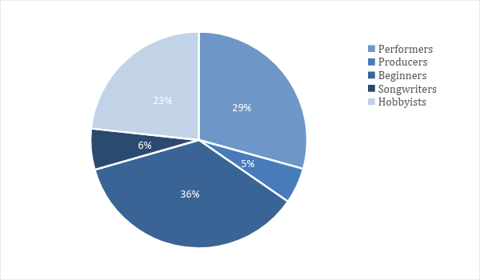

SWOT Analysis:

Company | Strengths | Weaknesses | Opportunities | Threats
Pittsburgh Professional Music Academy | Team comprises of experienced professionals in the music industry  Curriculum is based on current music industry standards | New establishment; needs rigorous networking | Government accreditation as a formal music academy may attract more students | Target market is initially dubious on paying for music education  Online tutorials and courses are easier to avail than going to an actual school
City Music Center (CMC) of Duquesne University | Well-structured and time-tested music school programs  Offers comprehensive lesson packages | Music technology program is not updated to meet current industry standards  Highly theoretical approach, less practical teaching, and more focused on classical and jazz music | Increase of classical and jazz music schools within Pennsylvania will need more certified professionals which the CMC can easily provide  Several local foundations are willing to partner with CMC for musicianship programs | Decrease of interest in classical and jazz music among CMC's target market
Sunburst School of Music | Huge client base | Focused on kids and teenagers  DJ and music production courses are for beginners only | Adult hobbyists with no plans to pursue a career in music will prefer schooling that is not too rigorous and serious | Low population growth in Pittsburgh may affect business in the long run

Marketing Strategy: Considering that [PPMA]s target clients are mostly musicians and songwriters from ages 13 to 35, its marketing strategies revolve around online marketing and word-of-mouth advertising.

Marketing Strategy | Activities | Timeline | Success Criteria
Online marketing | Build and develop website | Last week of October to January 2019 | Website runs smoothly upon beta test 2 weeks before launch date
 | Set up social media pages | January 10 to 17, 2019 | 1000 likes within first 2 months of activation, with 30 to 40% interaction rate
Word-of-mouth ad | Attend local gigs, shows, festivals | Every month from November until business operations commence | On-site inquiries by at least 15 people from any target market segment
 | Invite interested folks to a tour around the academy | 2-3 weeks before the academy opens for business in April 2019 | At least a total of 100 people turn up for the tour (in separate batches)

Organizational Structure:

CHIEF OPERATIONS OFFICER
HR & ADMIN MANAGER
FINANCE MANAGER
MARKETING & SALES DIRECTOR
ASSISTANT STAFF 1
ASSISTANT STAFF 2

OPERATIONAL PLAN

Location and Facilities: The academy will be built around the existing recording studio under the leasehold of Taylor Klein. The studio complex is located at Jacobs Street, just a few blocks from downtown Pittsburgh. The recording studio will be used as the practical teaching area for the audio engineering and post production courses. The first floor will have the reception area and classrooms for music theory lessons. The second floor will have soundproof rooms for the instrument playing and songwriting classes.

Tools and Equipment:

Software | Quantity
Avid Pro Tools music software | 1
Office 360 | 5
Hardware | Quantity
Dell Inspiron 15 7000 desktop PC | 2
Presonus Eris E4.5 2-Way monitor speakers | 4

IT Infrastructure: [PPMA] will hire a professional IT support and maintenance service provider to manage all of the IT-related aspects of the business, including systems monitoring, data and information storage and backup, network security, hardware and software support, web development, and mobile device management.

Infrastructure | Existing (Y/N) | Description
Wireless networking | Y | - Covers all areas in the studio complex  - Roaming-enabled
Data Storage | N | - Limited data storage capacities  - Must be expanded once operations commence, esp. for music production courses that require memory storage for large-sized audio project files
Website | N | - Still under development  - Interface needs to be more user-friendly
FINANCIAL PLAN

Assumptions: The financial plan for [PPMA] is based on the following assumptions:

1. No significant increase in monthly expenses until Q3 of FY1.

2. Average number of enrollees for Q1 to Q2 of FY1:

Course | Total Number of Enrollees
 | Per session | Per month | Per quarter
Individual Courses
Instruments + Basic Audio Recording | 3 | 3 | 5
Commercial Songwriting | 2 | 2 | 3
Professional Music Production | 2 | 2 | 3
Course Packages (All payable in installments.)
Instruments, Recording, Songwriting | NA | 5 | 3
Songwriting and Music Prod | NA | 5 | 3

3. 20% increase of total enrollees per quarter beginning of Q3 of FY1 indicating at least 10% monthly sales growth rate.

Monthly Expenses

Monthly expenses in the first quarter will be higher compared to the second quarter. An increase in expenses is expected by the third quarter as the number of total enrollees is also expected to increase by then.

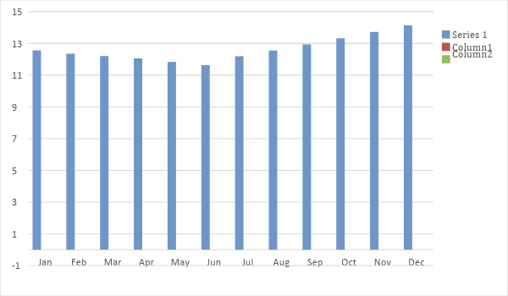

Monthly Revenue

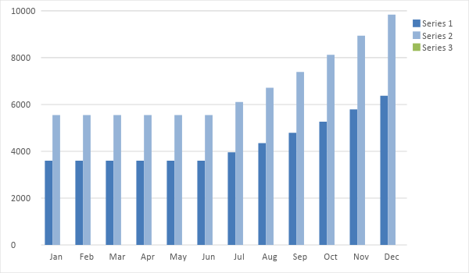

Business Financing: Each of the four partners will contribute [$50,000.00] for the initial capital. To cover for remaining start-up and operational expenses, the LLP will acquire a [$50,000.00] business loan which will be payable in [5 years] with an interest rate of [1.2%] per annum.

Financial Statements:

Profit and Loss Projection
 | FY2019 | FY2020 | FY2021
Sales | $132,489.00 | $162,045.00 | $178,546.35
Direct Cost of Sale | $22,745.00 | $30,745.00 | $37,745.00
Other Cost of Sale | $0.00 | $0.00 | $0.00
Total Cost of Goods Sold or COGS (Sales - Direct Cost of Sale - Other Cost of Sale) | $22,745.00 | $30,745.00 | $37,745.00
Gross Profit (Sales-Total Cost of Goods Sold) | $109,744.00 | $131,300.00 | $140,801.35
Gross Margin % (Gross Profit/Sales) | 82.83% | 81.03% | 78.86%
Operating Expenses
Rent and Utilities | $40,000.00 | $40,000.00 | $40,000.00
Tools, Equipment and Maintenance | $20,000.00 | $20,000.00 | $20,000.00
Insurance, Licenses and Permits | $5,000.00 | $5,000.00 | $5,000.00
Payroll | $30,000.00 | $30,000.00 | $30,000.00
Marketing and Promotion | $10,000.00 | $10,000.00 | $10,000.00
Total Operating Expenses | $105,000.00 | $105,000.00 | $105,000.00
EBITDA (Total Cost of Sale-Total Operating Expenses) | -$82,255.00 | -$74,255.00 | -$67,255.00
Depreciation | $1,000.00 | $1,000.00 | $1,000.00
Interest Expense | $0.00 | $0.00 | $0.00
Taxes Paid | $0.00 | $0.00 | $0.00
Net Profit (Gross Profit - Operating Expenses - Taxes - Interest) | $4,744.00 | $26,300.00 | $35,801.35

Balance Sheet Projection
 | FY2019 | FY2020 | FY2021
Cash | $80,000.00 | $100,000.00 | $125,000.00
Accounts Receivable | $0.00 | $7,500.00 | $9,000.00
Inventory | $0.00 | $0.00 | $0.00
Other Current Assets | $20,000.00 | $7,500.00 | $11,000.00
Total Current Assets | $100,000.00 | $115,000.00 | $145,000.00
Long-Term Assets | $30,000.00 | $10,000.00 | $15,000.00
Accumulated Depreciation | $0.00 | $1,000.00 | $1,000.00
Total Long-Term Assets (Long-Term Assets-Accumulated Depreciation) | $30,000.00 | $9,000.00 | $14,000.00
Total Assets (Total Current Assets + Total Long-Term Assets) | $130,000.00 | $124,000.00 | $159,000.00
Accounts Payable | $10,000.00 | $10,000.00 | $10,000.00
Notes Payable | $0.00 | $0.00 | $0.00
Other | $120.00 | $120.00 | $120.00
Total Liabilities | $10,120.00 | $10,120.00 | $10,120.00
Paid-in Capital | $200,000.00 | $120,000.00 | $160,000.00
Retained Earnings | $40,000.00 | $60,000.00 | $70,000.00
Total Owner's Equity (Total Assets - Total Liabilities) | $119,880.00 | $113,880.00 | $148,880.00
Total Liabilities & Equity (Total Liabilities/Total Owner's Equity) | 8.44% | 8.89% | 6.80%

Cash Flow Projection
 | FY2019 | FY2020 | FY2022
Operating Cash Beginning | $80,000.00 | $100,000.00 | $125,000.00
Sources of Cash
Receivables | $10,000.00 | $25,000.00 | $15,000.00
Sales | $109,744.00 | $131,300.00 | $140,800.00
Others | $4,500.00 | $6,000.00 | $5,000.00
Total Cash | $204,244.00 | $262,300.00 | $285,800.00
Expenditures
Rent and Utilities | $40,000.00 | $40,000.00 | $40,000.00
Tools, Equipment and Maintenance | $20,000.00 | $20,000.00 | $20,000.00
Insurance, Licenses and Permits | $5,000.00 | $5,000.00 | $5,000.00
Payroll | $30,000.00 | $30,000.00 | $30,000.00
Marketing and Promotion | $10,000.00 | $10,000.00 | $10,000.00
Total Expenditures | $105,000.00 | $105,000.00 | $105,000.00
Net Income/Loss (Total Cash - Total Expenditures) | $99,244.00 | $157,300.00 | $180,800.00

