MASSAGE CENTER BUSINESS PLAN
Business Plan For Fiscal Year 2020

February 14, 2019
[Angelica R. Fitzgerald] [arfitzgerald@aol.com]
[608-633-9473 | 920-201-3382] [www.zencure.com]
[Riverside Complex, 3300 Primrose Lane La Crosse, WI 54601, USA]

INDEX
Executive Summary
Company Overview
Products and Services
Execution
Operational Plan
Financial Plan
[Page Number]
[Page Number]
[Page Number]
[Page Number]
[Page Number]
[Page Number]

Executive Summary:

[Zen Cure Massage Center] will provide a wide range of massage therapy services in La Crosse, Wisconsin. The business aims to create a demand for massage services among low and middle income earners in La Crosse by offering the services at relatively lower prices. In order to achieve its sales goals, Zen Cure Massage Center will concentrate on building relationships with potential customers through social media and free service test trials.

Company Overview:

Mission Statement: The mission of [Zen Cure Massage Center] is to help people relax and heal through excellent massage therapy services.

Philosophy: [Zen Cure Massage Center] values professionalism and customer respect in performing a body-sensitive service.

Vision: [Zen Cure Massage Center] a personalized experience for each customer that will transform their view of massage therapy from recreation to necessity.

Outlook: Massage therapy remains to be one of the most in-demand services among the working population in La Crosse, Wisconsin. Due to the self-care movement, more millennials are investing in services that will help them achieve a relaxing body rest free from any physical stress. There has also been a significant increase in demand for budget-friendly massage services in the city.

Type of Industry: Health and Wellness Industry

Business Structure: Sole Proprietorship

Ownership: Angelica R. Fitzgerald is the sole proprietor and operator of the business.

Start-Up Summary: Start-up costs total to [$130,000.00,] and cover mostly rent, utilities, insurance, payroll, and other operational expenses.

Start-Up Funding
Start-Up Expenses | $65,000.00
Start-Up Assets | $65,000.00
Total Funding Required | $130,000.00
Assets
Non-Cash Assets from Start-Up | $10,000.00
Cash Requirements from Start-up | $30,000.00
Additional Cash Raised | $10,000.00
Cash Balance on Starting Date | $15,000.00
Total Assets | $65,000.00
Capital
Planned Investment
Owners | $100,000.00
Additional Investment Requirement | $30,000.00
Total Planned Investment | $130,000.00
Loss at Start-Up (Start-Up Expenses) | -$65,000.00
Total Capital | $65,000.00
Total Capital and Liabilities | $65,000.00
Start-Up
Requirements
Start-Up Expenses
Rent and Utilities | $20,000.00
Operations | $10,000.00
Insurance, Permits and Licenses | $5,000.00
Payroll | $20,000.00
Others | $10,000.00
Total Start-Up Expenses | $65,000.00
Start-Up Assets
Cash Required | $55,000.00
Other Current Assets | $5,000.00
Long-Term Assets | $5,000.00
Total Assets | $65,000.00
Total Requirements (Total Start-Up Expenses + Total Assets) | $130,000.00

Management Team:

Management Team | Role/Function | Skills
Angelica Fitzgerald | General Manager | Budgeting, delegation, marketing
Faye Watkins | HR Manager | Communication, organization, conflict management

Short- and Long-Term Goals and Milestones:

Short-Term Goals | Milestones
Hire employees | Hired two massage therapists on January 27, 2019
Conduct employee training | Training completed on February 2, 2019
Long-Term Goals | Milestones
Build online/social media presence | Opened Facebook and Instagram accounts for the business on February 2, 2019
Gain at least $30,000.00 revenue on FY 2019 | Created sales plan on November 3, 2018

Products and Services

Product/Service Description: [Zen Cure Massage Center] offers a wide range of massage services including Swedish, Shiatsu, deep-tissue, hot stone, sports, and prenatal massage.

Value Proposition: Affordability is key in the business of [Zen Cure Massage Center]. The company recognizes its target customers' need to find quality yet inexpensive massage services.

Pricing Strategy: All services are priced relatively lower than the average rate among massage services in La Crosse. This is to capture the potentially huge market of low income earners. Price bundling will also be utilized for promos such as couple and group massages.

Execution

Marketing Plan: [Zen Cure Massage Center] will position itself as the massage place for low to middle income earners within the [23-35] age range. Marketing the business will focus on online strategies that will make the business more accessible to its customers and traditional word-of-mouth marketing through referrals and recommendations.

Market Research: A recent study indicates that more than [51%] of the working population in La Crosse, Wisconsin, engages in relaxation and recreational activities. Massage services remain to be the top preferred means of relieving stress from work. The market for massage therapy also includes injured persons, senior citizens, and pregnant women.

SWOT Analysis | Strengths | Weaknesses | Opportunities | Threats
Zen Cure Massage Center | Affordable services | New establishment, weak customer base | Increase in demand for budget-friendly massage establishments | Adoption of penetration pricing strategies by competitors
HealMe Day Spa Services | Good customer service | Limited operating hours | Store policy changes to adjust operating hours | Segregation of customer base upon opening of budget-friendly establishments
18 Points Therapeutic Massage | Open 24/7 | Poor human resource management | Seminars for proper business management | Possibility of crimes endangering business operations at night

Marketing Strategy: [Zen Cure Massage Center] marketing strategies will be aggressive in terms of social media and interpersonal marketing.

Marketing Strategy | Activities | Timeline | Success Criteria
Online marketing | Develop website and mobile application; open social media pages | November 10, 2018 to present | Minor bug fixes on website and mobile app; the company will have Facebook and Instagram as early as February 10, 2019.
Promotional services | Offer free massage services in malls, offices. | January to February 2019 | At least 40 customers indicate that they will be going to the establishment within 3 months.
Word-of-mouth marketing | Encourage customers to post reviews of the services on their social media accounts | Upon commencement of operations | Increase in the use of hashtags for the company's online marketing.

Organizational Structure:

GENERAL MANAGER
HR MANAGER
SALES & MARKETING CONSULTANT
MASSAGE THERAPISTS
STORE STAFF

Operational Plan:

Location and Facilities: The massage center will be located at the Riverside Complex, a commercial building in downtown La Crosse. With a total floor space of [1,207] sq. ft., the interior of the massage center will have a reception area and waiting lounge, [10] massage rooms, [2] comfort rooms, and a back office space with a pantry and a separate comfort room for the managers and administrative staff.

Tools and Equipment Checklist:

Software | Quantity
Square POS | 1
Office 360 | 1
Hardware | Quantity
Massage beds | 10
PC units | 3

IT Infrastructure:

Infrastructure | Existing (Y/N) | Description
Social Media | N | Facebook and Instagram accounts must be active at least a month before commencement of operations.
Data Storage | Y | Square POS has cloud data storage capacity.

Financial Plan

Assumptions: The financial plan for [Zen Cure Massage Center] is based on the following assumptions:

1. Monthly operational expenses will not exceed [$5,000.00]

2. Sales revenue will increase by [1.57%] beginning Q2 of FY[ 2019].

3. Increase of working population will bring in more potential customers.

Monthly Expense
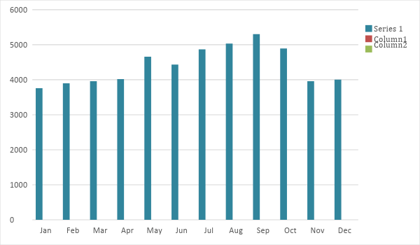

Monthly Revenue
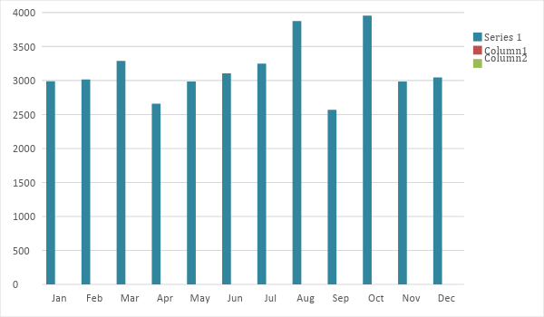

Business Financing: The owner will provide the [$100,000.00] initial capital. If sales revenue are not able to meet expense requirement by Q3 of FY [2020], the owner will acquire a business loan worth at least [$30,000.00]

Statements

Profit and Loss Projection
 | FY2019 | FY2020
Sales | $37,717.00 | $81,937.00
Direct Cost of Sale | $14,675.00 | $15,675.00
Other Cost of Sale | $1,000.00 | $1,000.00
Total Cost of Goods Sold or COGS (Sales - Direct Cost of Sale - Other Cost of Sale) | $15,675.00 | $16,675.00
Gross Profit (Sales-Total Cost of Goods Sold) | $22,042.00 | $65,262.00
Gross Margin % (Gross Profit/Sales) | 58.44% | 79.65%
Operating Expenses
Rent and Utilities | $20,000.00 | $20,000.00
Operations | $10,000.00 | $10,000.00
Insurance, Permits and Licenses | $5,000.00 | $3,000.00
Payroll | $20,000.00 | $20,000.00
Others | $10,000.00 | $5,000.00
Total Operating Expenses | $65,000.00 | $58,000.00
EBITDA (Total Cost of Sale-Total Operating Expenses) | -$49,325.00 | -$41,325.00
Depreciation | $0.00 | $10,000.00
Interest Expense | $0.00 | $0.00
Taxes Paid | $0.00 | $0.00
Net Profit (Gross Profit - Operating Expenses - Taxes - Interest) | -$42,958.00 | $7,262.00

Balance Sheet Projection
 | FY2019 | FY2020
Cash | $55,000.00 | $65,000.00
Accounts Receivable | $0.00 | $2,000.00
Inventory | $3,000.00 | $6,000.00
Other Current Assets | $2,000.00 | $6,000.00
Total Current Assets | $60,000.00 | $79,000.00
Long-Term Assets | $5,000.00 | $10,000.00
Accumulated Depreciation | $0.00 | $2,000.00
Total Long-Term Assets (Long-Term Assets-Accumulated Depreciation) | $5,000.00 | $8,000.00
Total Assets (Total Current Assets + Total Long-Term Assets) | $65,000.00 | $87,000.00
Accounts Payable | $10,000.00 | $20,000.00
Notes Payable | $0.00 | $1,000.00
Other | $0.00 | $500.00
Total Liabilities | $10,000.00 | $21,500.00
Paid-in Capital | $100,000.00 | $100,000.00
Retained Earnings | $37,750.00 | $67,850.00
Total Owner's Equity (Total Assets - Total Liabilities) | $55,000.00 | $65,500.00
Total Liabilities & Equity (Total Liabilities/Total Owner's Equity) | 18.18% | 32.82%

Cash Flow Projection
 | FY2019 | FY2020
Operating Cash Beginning | $55,000.00 | $65,000.00
Sources of Cash
Receivables | $0.00 | $2,000.00
Sales | $37,717.00 | $81,937.00
Others | $0.00 | $30,000.00
Total Cash | $92,717.00 | $178,937.00
Expenditures
Rent and Utilities | $20,000.00 | $20,000.00
Operations | $10,000.00 | $10,000.00
Insurance, Permits and Licenses | $5,000.00 | $3,000.00
Payroll | $20,000.00 | $20,000.00
Others | $10,000.00 | $5,000.00
Total Expenditures | $65,000.00 | $58,000.00
Net Income/Loss (Total Cash - Total Expenditures) | $27,717.00 | $120,937.00

