LOGISTICS BUSINESS PLAN

[INSERT NAME OF THE BUSINESS/COMPANY]
[INSERT THE COMPLETE BUSINESS/COMPANY ADDRESS]
[INSERT THE BUSINESS/COMPANY CONTACT NUMBERS]
[INSERT THE BUSINESS/COMPANY EMAIL ADDRESS]
[INSERT THE BUSINESS/COMPANY WEBSITE ADDRESS]

PREPARED BY:

[INSERT FULL NAME/S OF THE
PEOPLE WHO PREPARED THIS PLAN]

[INSERT DATE]

Index

Executive Summary [PAGE NUMBER]
Company Overview [PAGE NUMBER]
Products and Services [PAGE NUMBER]
Execution [PAGE NUMBER]
Operational Plan [PAGE NUMBER]
Financial Plan [PAGE NUMBER]

EXECUTIVE SUMMARY:

[Fly Box Enterprise] is a domestic air [freight logistics service]. Currently, the company caters only to the state of Alabama but is looking at expanding its reach to other nearby states. Fly Box Enterprise uses strategies such as influencer marketing, promotional videos, and online ads to grow its brand name. Looking at the steady growth in online shopping, the company sees a [35%] profit margin quarterly.

COMPANY OVERVIEW:

Mission Statement: [Fly Box Enterprise] aims to be the trusted brand in logistics.

Philosophy: [Fly Box Enterprise] values knowing the customer’s expectations and prides itself in meeting them.

Vision: [Fly Box Enterprise] aspires to be able to locally serve other states in the [USA].

Outlook: The online shopping craze has dramatically increased public interest in sending and receiving packages. In [Alabama] alone, studies show that more than [50%] of the populace already prefer shopping online rather than physically going to the store. This implies an increasing need for a stable and reliable logistics service.

Type of Industry: [Logistics Industry]

Business Structure: Sole Proprietorship

Ownership: Sole Proprietorship, [Howard R. Pike]

Start-Up Summary: The start-up cost is [two million USD] to be provided by the company’s board of directors and to be used mainly for insurance, fuel and transportation, supplies, and legal fees.

Start-Up Funding
Start-Up Expenses | $1,500,000
Start-Up Assets | $500,000
Total Funding Required | $2,000,000
Assets
Non-Cash Assets from Start-Up | $100,000
Cash Requirements from Start-up | $400,000
Additional Cash Raised | $0
Cash Balance on Starting Date | $0
Total Assets | $500,000
Capital
Planned Investment
Owner | $2,000,000
Other | $0
Additional Investment Requirement | $0
Total Planned Investment | $2,000,000
Loss at Start-Up (Start-Up Expenses) | -$1,500,000
Total Capital | $500,000
Liabilities | $0
Total Capital and Liabilities | $500,000
Start-Up
Requirements
Start-Up Expenses
Rent | $0
Advertising | $0
Legal Fees | $400,000
Staff Training | $500,000
Insurance | $600,000
Other | $0
Total Start-Up Expenses | $1,500,000
Start-Up Assets
Cash Required | $100,000
Start-Up Inventory | $0
Other Current Assets | $400,000
Long-Term Assets | $0
Total Assets | $500,000
Total Requirements (Total Start-Up Expenses + Total Assets) | $2,000,000

MANAGEMENT TEAM:

Management Team | Role/Function | Skills
Alvin Torada | Executive Manager | People Management, Teamwork, and Resilience
Apple Sakada | HR Manager | Communication, Onboarding, and People Skills

SHORT- AND LONG-TERM GOALS AND MILESTONES:

Short-Term Goals | Milestones
- Renovate inventory space | - Hire a freelance architect to draft the blueprint
- Create a promotional video content | - A few video production groups have been interviewed for the contractual job
Long-Term Goals | Milestones
- Open another branch in Tennessee by the 2nd quarter of 2022. | - The company has started to secure properties for its inventory warehouse and base of operations

PRODUCTS AND SERVICES

Product/Service Description: [Fly Box Enterprise] offers storing and sending parcels to all the towns of Alabama, as well as door-to-door delivery. The company has a real-time tracking service on its website and offers various insurance packages for different types of parcels.

[Fly Box Enterprise] also has a main branch where customers may opt to temporarily store their packages before personally picking them up.

Value Proposition: [Fly Box Enterprise] operates seven days a week to ensure the speedy transfer of all parcels, making same-day deliveries possible. Beyond that, the company also offers package tracking via the company website, email, and even SMS.

Pricing Strategy: [Fly Box Enterprise] utilizes standard pricing. A definite price is set for a fixed distance.

Formula:
Profit Margin = 1- (Expenses/Net Sales)

Fly Box Enterprise
Profit Margin = 1 - ($200,000/$357,000)
= 1-0.56
= 0.44 or 44%

EXECUTION

Marketing Plan: [Fly Box Enterprise] aims to expand its reach to other states in the US. To attain this goal, the company plans to leverage promotional videos and influencer marketing since these two are very prominent strategies in today’s economic climate.

Market Research: The current trend in the [US] is all about same-day deliveries. This study highlights the importance of no-delay operations. A study in [2018] also reveals that the demographic that uses this type of service most often are as young as [18-years-old] and as old [80] years of age.

SWOT Analysis | Strengths | Weaknesses | Opportunities | Threats
Fly Box Enterprise | - Low fees relative to competitors | - Does not take into account customer preferences | - Logistics services for businesses and households will increase together with an industrializing city | - Customer satisfaction is an unidentifiable variable
Air Jets | - Worldwide delivery  - Flexible to changes | - Parcel security is an issue |  | - Due to the growing popularity of digital retailers, the competitive landscape is always in a state of flux
Flight Freight United | - Fast delivery | - Has yet to expand globally | - Growing interest in the industry means more rapid demand | - Other companies are offering faster services with better customer support

Marketing Strategy: To penetrate the market successfully, [Fly Box Enterprise] builds on online content such as ads and promotional videos. A very concise tutorial video will also be uploaded on the company website to teach users how to use the service efficiently. This same video will also be used by the company’s list of curated influencers.

[Fly Box Enterprise] has also hired a new executive manager to oversee the marketing changes and spearhead the strategies mentioned above.

The company has kicked-off some activities.

Marketing Strategy | Activities | Timeline | Success Criteria
Influencer Marketing | - The designated team has refined the list of interested influencers to be able to choose the suitable ones. | January 1, 2019 | The selected influencers will have their videos sponsored by the company provided that they spread the company’s brand name with a positive tone to their audiences.
Video tutorials | - The managers are currently evaluating a video production team. | January 3, 2019 | The video will be uploaded on the company website and distributed to various influencers.

Organizational Structure:

[Fly Box Enterprise] is headed by the [CEO], [Howard R. Pike], who manages the company together with eight board of directors. The company also has eight supervisors, a dedicated HR personnel and a marketing specialist, two front desk clerks, and [25] couriers.

OPERATIONAL PLAN:

Location and Facilities

Provide a sketch or blueprint of the facility.

Provide photos or images of the location/facility.

Tools and Equipment Checklist

Software | Quantity
QR Code - Tracking | 1
RFID Tags with CMMS (Computerized maintenance management systems) | 1
Hardware | Quantity
Vehicles | 30

IT Infrastructure

The following table reflects [Fly Box Enterprise]’s IT infrastructure.

Infrastructure | Existing (Y/N) | Description
Small server | Y | The company has a server to coordinate all inventory stats and trackers.
Professional-Grade Cabling | Y | Fly Box Enterprise has outfitted all its network and computer cabling with professional-grade cables and sleeves to ensure that no technical malfunction and service disruption will occur.

FINANCIAL PLAN

Assumptions

The financial forecast is based on the trends in the logistics industry and its available funds. The company will focus much of its services on e-commerce. Most of its expenses will be on payroll, transportation and maintenance, legal fees, and insurance.

Monthly Expense

The chart shows the projected monthly expense for [2019].

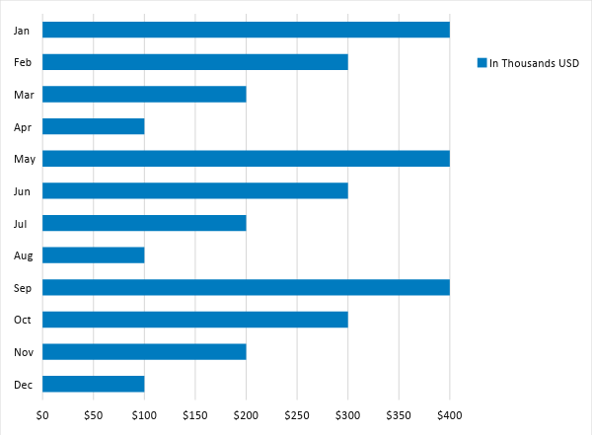

Monthly Revenue

The chart shows the projected monthly revenue for [2019].

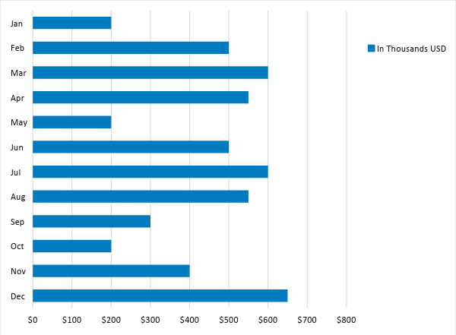

BUSINESS FINANCING

The total start-up cost, [2M USD], will be provided by [Howard R. Pike] and the board of directors. The most significant expenses will be on facilities, transportation and maintenance, salaries, and legal fees.

STATEMENTS

Profit and Loss Projection
 | FY2019 | FY2020 | FY2021
Sales | $400,000.00 | $400,000.00 | $450,000.00
Direct Cost of Sale | $158,000.00 | $300,000.00 | $190,500.00
Other Cost of Sale | $0.00 | $0.00 | $0.00
Total Cost of Goods Sold or COGS (Sales - Direct Cost of Sale - Other Cost of Sale) | $242,000.00 | $100,000.00 | $259,500.00
Gross Profit (Sales-Total Cost of Goods Sold) | $158,000.00 | $300,000.00 | $190,500.00
Gross Margin % (Gross Profit/Sales) | 39.50% | 75.00% | 42.33%
Operating Expenses
Rent | $0.00 | $0.00 | $0.00
Insurance | $5,000.00 | $5,000.00 | $5,000.00
Utilities | $100,000.00 | $100,000.00 | $100,000.00
Salary (Including Tax) | $30,000.00 | $40,000.00 | $50,000.00
Maintenance & Supplies | $9,000.00 | $99,000.00 | $9,000.00
Total Operating Expenses | $144,000.00 | $244,000.00 | $164,000.00
EBITDA (Total Cost of Sale-Total Operating Expenses) | $98,000.00 | -$144,000.00 | $95,500.00
Depreciation | $4,000.00 | $4,000.00 | $4,000.00
Interest Expense | $0.00 | $0.00 | $0.00
Taxes Paid | $4,000.00 | $5,000.00 | $6,000.00
Net Profit (Gross Profit - Operating Expenses - Taxes - Interest) | $10,000.00 | $51,000.00 | $20,500.00

Balance Sheet Projection
 | FY2019 | FY2020 | FY2021
Cash | $300,000.00 | $165,000.00 | $40,000.00
Accounts Receivable | $310,000.00 | $200,000.00 | $300,000.00
Inventory | $0.00 | $0.00 | $0.00
Other Current Assets | $0.00 | $0.00 | $0.00
Total Current Assets | $610,000.00 | $365,000.00 | $340,000.00
Long-Term Assets | $3,000.00 | $4,000.00 | $9,000.00
Accumulated Depreciation | $0.00 | $0.00 | $0.00
Total Long-Term Assets (Long-Term Assets-Accumulated Depreciation) | $3,000.00 | $4,000.00 | $9,000.00
Total Assets (Total Current Assets + Total Long-Term Assets) | $613,000.00 | $369,000.00 | $349,000.00
Accounts Payable | $40,000.00 | $30,000.00 | $15,000.00
Notes Payable | $5,000.00 | $0.00 | $9,000.00
Other | $9,000.00 | $3,000.00 | $69,000.00
Total Liabilities | $54,000.00 | $33,000.00 | $93,000.00
Paid-in Capital | $0.00 | $0.00 | $0.00
Retained Earnings | $300,000.00 | $120,000.00 | $100,000.00
Total Owner's Equity (Total Assets - Total Liabilities) | $559,000.00 | $336,000.00 | $256,000.00
Total Liabilities & Equity (Total Liabilities/Total Owner's Equity) | 9.66% | 9.82% | 36.33%

Cash Flow Projection
 | FY2019 | FY2020 | FY2021
Operating Cash Beginning | $100,000.00 | $150,000.00 | $160,000.00
Sources of Cash | $15,000.00 | $18,000.00 | $15,000.00
Receivables | $10,000.00 | $12,000.00 | $30,000.00
Sales | $30,000.00 | $25,000.00 | $35,000.00
Others | $5,000.00 | $7,000.00 | $8,000.00
Total Cash | $160,000.00 | $212,000.00 | $248,000.00
Expenditures
Rent | $0.00 | $0.00 | $0.00
Insurance | $3,000.00 | $4,000.00 | $9,000.00
Utilities | $20,000.00 | $10,000.00 | $26,000.00
Salary (Including Tax) | $49,000.00 | $80,000.00 | $30,000.00
Maintenance & Supplies | $3,000.00 | $60,000.00 | $6,700.00
Total Expenditures | $75,000.00 | $154,000.00 | $71,700.00
Net Income/Loss (Total Cash - Total Expenditures) | $85,000.00 | $58,000.00 | $176,300.00

