KINDERGARTEN BUSINESS PLAN

[INSERT NAME OF THE BUSINESS/COMPANY]
[INSERT THE COMPLETE BUSINESS/COMPANY ADDRESS]
[INSERT THE BUSINESS/COMPANY CONTACT NUMBERS]
[INSERT THE BUSINESS/COMPANY EMAIL ADDRESS]
[INSERT THE BUSINESS/COMPANY WEBSITE ADDRESS]

[INSERT DATE]

PREPARED BY:

[INSERT FULL NAME/S OF THE
PEOPLE WHO PREPARED THIS PLAN]

Index

Executive Summary [PAGE NUMBER]
Company Overview [PAGE NUMBER]
Products and Services [PAGE NUMBER]
Execution [PAGE NUMBER]
Operational Plan [PAGE NUMBER]
Financial Plan [PAGE NUMBER]

EXECUTIVE SUMMARY

[Dreamer Kindergarten School] is a private school operated by licensed teachers [Davide Henry and Tonia Fowler]. The school offers full-day kindergarten programs based on the curriculum set by the education board of the city of [Baldwin Park]. The school will house 60 kindergarten students, divided into two classes, and will offer curriculums that introduce the basic appreciations for [science, mathematics, geography, history and other social sciences].

[Dreamer Kindergarten School] will focus on 3 marketing strategies: [local media coverage, print advertising, and community awareness initiatives].

COMPANY OVERVIEW

Mission Statement: [Dreamer Kindergarten School] provides a safe and nurturing environment for kids where learning is fun and engaging.

Philosophy: [Dreamer Kindergarten School] has a comprehensive approach to educating and enriching the children. The school is focused on building skills that set children up for success in kindergarten and beyond.

Vision: [Dreamer Kindergarten School] envisions to be recognized as a leader in the community for building a strong foundation that kids can use for future academic success.

Outlook: Statistics in the [US] show that in [2015], [four million] children were enrolled in kindergarten. Many parents in [California] who work long hours or struggle between two jobs prefer full-day kindergarten programs. There is a growing number of parents opting to enroll their children in full-day kindergarten programs, which will also increase the need for teachers.

Type of Industry: [Education Industry]

Business Structure: Partnership

Ownership: Partnership, [David Henry and Tonia Fowler]

Start-Up Summary: The start-up cost worth [500K USD] is to be provided by the owner and to be used mainly for the [rent, insurance, supplies, and payroll].

Start-Up Funding
Start-Up Expenses | $300,000
Start-Up Assets | $200,000
Total Funding Required | $500,000
Assets
Non-Cash Assets from Start-Up | $50,000
Cash Requirements from Start-up | $75,000
Additional Cash Raised | $30,000
Cash Balance on Starting Date | $45,000
Total Assets | $200,000
Capital
Planned Investment
Owner | $500,000
Other | $0
Additional Investment Requirement | $0
Total Planned Investment | $500,000
Loss at Start-Up (Start-Up Expenses) | -$300,000
Total Capital | $200,000
Liabilities | $0
Total Capital and Liabilities | $200,000
Start-Up
Requirements
Start-Up Expenses | $50,000
Rent - 1 year | $120,000
Advertising | $10,000
Legal Fees | $20,000
Staff Training | $20,000
Insurance | $50,000
Other | $30,000
Total Start-Up Expenses | $300,000
Start-Up Assets
Cash Required | $75,000
Start-Up Inventory | $50,000
Other Current Assets | $30,000
Long-Term Assets | $45,000
Total Assets | $200,000
Total Requirements (Total Start-Up Expenses + Total Assets) | $500,000

MANAGEMENT TEAM:

Management Team | Role/Function | Skills
David Henry | Admin Officer | Problem-solving, management, communication, leadership
Tonia Fowler | Head of Faculty | Leadership, interpersonal, analytical, creative, management

SHORT- AND LONG-TERM GOALS AND MILESTONES:

Short-Term Goals | Milestones
Hire two teachers and other school staff | The headteacher already interviewed five applicants and the admin official has scheduled the applicants for a final interview.
Start the registration for full-day kindergarten | The school has already posted advertisements in the local community and updated the website to include information about the registration.
Long-Term Goals | Milestones
Expand the school to include 3 more kindergarten classes. | The partners already prepared a financial plan and 50% of the retained earnings for the academic year 2019, 2020, and 2021 will be restricted for the expansion.

PRODUCTS AND SERVICES

Product/Service Description:

[Dreamer Kindergarten School] offers a variety of educational services and materials, including the following:

- Basic literacy and numeracy programs
- Educational books and materials
- Basic introductions to science, mathematics, geography, history and other social sciences
- Extracurricular activities

Value Proposition: Excellent leaders are made, not born. Dreamer Kindergarten School provides educational services that help children excel as leaders in the future.

Pricing Strategy: [Dreamer Kindergarten School] utilizes competitive pricing. The average tuition fee of private schools in [California] is at [$13,773] per year. The kindergarten school’s tuition fee is [$13,000] per student.

EXECUTION

Marketing Plan: [Dreamer Kindergarten School] aims to expand the school to accommodate at least [150] kindergarten students in the next [2 years]. It wants to leverage on local media coverage, print advertising, and community awareness initiatives.

Market Research: The current trend in the private school industry implies that more parents are enrolling their children in private schools to properly monitor their progress.

SWOT Analysis | Strengths | Weaknesses | Opportunities | Threats
Dreamer Kindergarten School | The school has a team that has the passion and drive for taking care of children | As a new private kindergarten school, it would take some time to break into the market and gain acceptance in the private school industry | Active community involvement in the school’s extracurricular activities | Unfavorable government policies that might affect private schools
Starter Kindergarten School | The school has employed high-skilled teachers with a vast teaching experience | Some teachers are not available to meet parents often enough | Increasing school transfer rate from public to private | The arrival of a competitor near the school
Confidence Kindergarten School | The school has a strong ethos of openness, sharing, and commitment to their job | The curriculum is too stretched for any additional activity | Business networking with other child care institutions | Non commitment of the government to help fund the school’s extracurricular activities

MARKETING STRATEGY:

[Dreamer Kindergarten School] will be using the following marketing strategies: local media coverage, print advertising, and community awareness initiatives.

The team has kicked-off various activities to move the marketing strategies forward. Here are some of the updates:

Marketing Strategy | Activities | Timeline | Success Criteria
Local media coverage | Make a draft for the newspaper advertising | July 15, 2019 | The school advertisement is printed in the local newspaper on August 1, 2019
Print advertising | Make a draft for the brochure of the school | June 30, 2019 | The brochure is printed by July 15, 2019

ORGANIZATIONAL STRUCTURE:

School Administrator
Head Teacher
Assistant Principal
Teachers
Accounting Officer

OPERATIONAL PLAN

Location and Facilities

[Dreamer Kindergarten School] is located at [1029 Middleville Road], [Baldwin Park, California]. The school has two classrooms, each housing 30 students. It also has a principal office, faculty room, and [3 restrooms]. The school also has an open space outside the rooms for any outdoor activities.

Tools and Equipment Checklist

Software | Quantity
iSAMS | 1
feKara | 1
Hardware | Quantity
Table | 50
Chair | 80

IT Infrastructure

The following table reflects the [Dreamer Kindergarten School’s] IT infrastructure.

Infrastructure | Existing (Y/N) | Description
Website | Y | The school’s website is updated.
Internet | Y | The school’s computers and educational gadgets are connected to a strong and reliable internet connection.
Educational Software | Y | The school has different educational software ready for use by the teachers.

FINANCIAL PLAN

Assumptions

The financial forecast is based mainly on the current trends in the education industry. Most of the school’s expenses will be on the [payroll, maintenance and supplies, business insurance, and rent].

Monthly Expense

The chart shows the projected monthly expenses for [2019].

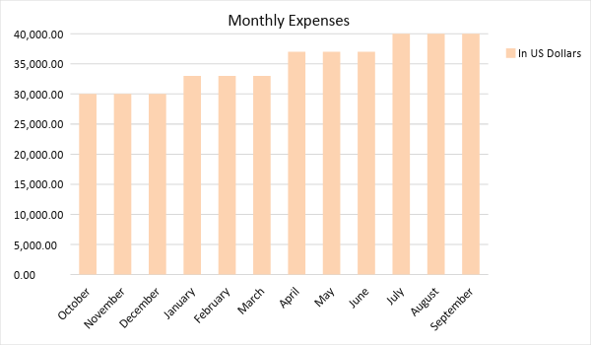

Monthly Revenue

The chart depicts the projected monthly revenues for [2019].

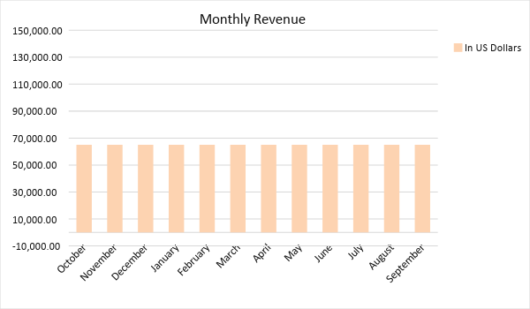

BUSINESS FINANCING

The funding for the business mainly comes from a business loan worth [$500,0000.00]. The major expenses will go to business [insurance, rent, salaries, supplies, and maintenance].

STATEMENTS

Profit and Loss Projection
 | FY 2019 | FY 2020 | FY 2021
Sales | $780,000.00 | $910,000.00 | $1,080,000.00
Direct Cost of Sale | $75,000.00 | $80,000.00 | $100,000.00
Other Cost of Sale | $5,000.00 | $5,000.00 | $7,000.00
Total Cost of Goods Sold or COGS (Sales - Direct Cost of Sale - Other Cost of Sale) | $80,000.00 | $85,000.00 | $107,000.00
Gross Profit (Sales-Total Cost of Goods Sold) | $700,000.00 | $825,000.00 | $973,000.00
Gross Margin % (Gross Profit/Sales) | 89.74% | 90.66% | 90.09%
Operating Expenses
Rent | $120,000.00 | $120,000.00 | $120,000.00
Insurance | $50,000.00 | $50,000.00 | $50,000.00
Utilities | $50,000.00 | $45,000.00 | $48,000.00
Salary (Including Tax) | $150,000.00 | $170,000.00 | $180,000.00
Maintenance & Supplies | $50,000.00 | $60,000.00 | $75,000.00
Total Operating Expenses | $420,000.00 | $445,000.00 | $473,000.00
EBITDA (Total Cost of Sale-Total Operating Expenses) | $280,000.00 | $380,000.00 | $500,000.00
Depreciation | $3,000.00 | $3,000.00 | $3,000.00
Interest Expense | $4,000.00 | $4,000.00 | $4,000.00
Taxes Paid | $28,000.00 | $38,000.00 | $50,000.00
Net Profit (Gross Profit - Operating Expenses - Taxes - Interest) | $248,000.00 | $338,000.00 | $446,000.00

Balance Sheet Projection
 | FY 2019 | FY 2020 | FY 2021
Cash | $296,600.00 | $338,300.00 | $418,800.00
Accounts Receivable | $39,000.00 | $45,500.00 | $54,000.00
Inventory | $1,000.00 | $2,000.00 | $3,000.00
Other Current Assets | $3,000.00 | $5,000.00 | $8,000.00
Total Current Assets | $339,600.00 | $390,800.00 | $483,800.00
Long-Term Assets | $400,000.00 | $400,000.00 | $400,000.00
Accumulated Depreciation | $5,000.00 | $10,000.00 | $15,000.00
Total Long-Term Assets (Long-Term Assets-Accumulated Depreciation) | $395,000.00 | $390,000.00 | $385,000.00
Total Assets (Total Current Assets + Total Long-Term Assets) | $734,600.00 | $780,800.00 | $868,800.00
Accounts Payable | $70,000.00 | $100,600.00 | $150,800.00
Notes Payable | $25,600.00 | $30,200.00 | $37,500.00
Other | $5,000.00 | $6,000.00 | $15,000.00
Total Liabilities | $100,600.00 | $136,800.00 | $203,300.00
Paid-in Capital | $50,000.00 | $59,000.00 | $80,500.00
Retained Earnings | $585,000.00 | $585,000.00 | $585,000.00
Total Owner's Equity (Total Assets - Total Liabilities) | $634,000.00 | $644,000.00 | $665,500.00
Total Liabilities & Equity (Total Liabilities/Total Owner's Equity) | 15.87% | 21.24% | 30.55%

Cash Flow Projection
 | FY 2019 | FY 2020 | FY 2021
Operating Cash Beginning | $150,000.00 | $150,000.00 | $150,000.00
Sources of Cash
Receivables | $39,000.00 | $45,500.00 | $54,000.00
Sales | $780,000.00 | $910,000.00 | $1,080,000.00
Others | $7,800.00 | $9,100.00 | $10,800.00
Total Cash | $976,800.00 | $1,114,600.00 | $1,294,800.00
Expenditures
Rent | $120,000.00 | $120,000.00 | $120,000.00
Insurance | $50,000.00 | $50,000.00 | $50,000.00
Utilities | $50,000.00 | $45,000.00 | $48,000.00
Salary (Including Tax) | $150,000.00 | $170,000.00 | $180,000.00
Maintenance & Supplies | $50,000.00 | $60,000.00 | $75,000.00
Total Expenditures | $420,000.00 | $445,000.00 | $473,000.00
Net Income/Loss (Total Cash - Total Expenditures) | $556,800.00 | $669,600.00 | $821,800.00

