IMMIGRATION BUSINESS PLAN

[INSERT NAME OF THE BUSINESS/COMPANY]
[INSERT THE COMPLETE BUSINESS/COMPANY ADDRESS]
[INSERT THE BUSINESS/COMPANY CONTACT NUMBERS]
[INSERT THE BUSINESS/COMPANY EMAIL ADDRESS]
[INSERT THE BUSINESS/COMPANY WEBSITE ADDRESS]

PREPARED BY:

[INSERT FULL NAME/S OF THE
PEOPLE WHO PREPARED THIS PLAN]

[INSERT DATE]

Index

Executive Summary [PAGE NUMBER]
Company Overview [PAGE NUMBER]
Products and Services [PAGE NUMBER]
Execution [PAGE NUMBER]
Operational Plan [PAGE NUMBER]
Financial Plan [PAGE NUMBER]

EXECUTIVE SUMMARY:

[Louis Immigration Services] is an immigration service provider based in [San Diego, California]. The company serves as an intermediary between immigrants and the state government through its provision of affordable services. The company expects increases in the number of immigrants in the coming years.

[Louis Immigration Services] plans to become one of the trusted and forerunning immigration service providers in [San Diego, California]. In this regard, the company utilizes search engine optimization and social media marketing to reach a wider target market.

COMPANY OVERVIEW:

Mission Statement: [Louis Immigration Services] contributes to the security and prosperity of [San Diego, California], by providing efficient and effective law-compliant immigration services.

Philosophy: [Louis Immigration Services] exercises integrity, courtesy, and alertness when providing [immigration services] to clients.

Vision: [Louis Immigration Services] becomes the forerunner of immigration services in [San Diego, California].

Outlook: [The company] anticipates a continuous increase in the number of immigrants as the US economy continues to grow in the coming years.

Type of Industry: [Service Industry]

Business Structure: Sole Proprietorship

Ownership: Sole Proprietorship, [Jacob Louis]

Start-Up Summary: [Louis Immigration Services] operates with a total start-up cost of [120K] USD. The fund covers the payment for [rent, insurance, advertising, and legal fees].

Start-Up Funding
Start-Up Expenses | $57,915
Start-Up Assets | $62,085
Total Funding Required | $120,000
Assets
Non-Cash Assets from Start-Up | $44,500
Cash Requirements from Start-up | $5,000
Additional Cash Raised | $11,085
Cash Balance on Starting Date | $1,500
Total Assets | $62,085
Capital
Planned Investment
Owners | $120,000
Other | $0
Additional Investment Requirement | $0
Total Planned Investment | $120,000
Loss at Start-Up (Start-Up Expenses) | -$57,915
Total Capital | $62,085
Liabilities | $0
Total Capital and Liabilities | $62,085
Start-Up
Requirements
Start-Up Expenses
Rent - 6 Months | $8,415
Advertising | $1,500
Legal Fees | $3,000
Staff Training | $3,500
Insurance | $1,500
Other | $40,000
Total Start-Up Expenses | $57,915
Start-Up Assets
Cash Required | $6,500
Start-Up Inventory | $9,500
Other Current Assets | $11,085
Long-Term Assets | $35,000
Total Assets | $62,085
Total Requirements (Total Start-Up Expenses + Total Assets) | $120,000

MANAGEMENT TEAM:

Management Team | Role/Function | Skills
Jacob Louis | Managing Executive | Leadership, Delegation, Forward-Planning, Communication
Jorge Fortner | Marketing Executive | Planning and Organization, Communication

SHORT- AND LONG-TERM GOALS AND MILESTONES:

Short-Term Goals | Milestones
Hire office clerks to assist executives | Recruited 2 qualified applicants last November 28, 2018
Secure necessary permits and licenses | Completed submission of necessary requirements
Long-Term Goals | Milestones
Establish a good brand and reputation | Created a user-friendly website for clients to easily browse through
Cooperate with the government | Collaborated with the government to organize an immigration symposium

PRODUCTS AND SERVICES

Product/Service Description: [Louis Immigration Services] serves as an intermediary between the immigrants and the state government of [California]. The company assists immigrants in their application for a visa in [San Diego, California].

Value Proposition: [Louis Immigration Services] strives to deliver the needs of clients while observing immigration rules and regulations.

Pricing Strategy: [Louis Immigration Services] uses penetration pricing method. The company charges clients with inexpensive fees in exchange for premium quality service.

EXECUTION

Marketing Plan: [Louis Immigration Services] wants to establish a good reputation as an immigration office. The company plans to optimize its website and do aggressive social media advertising to reach out to a wider market.

Market Research: Immigrants make up a large percentage in the total [US] population. In [2017], the [US government] recorded a total of [1,127,167] individuals from different countries. The chart below shows the percentage of immigrants per continent.

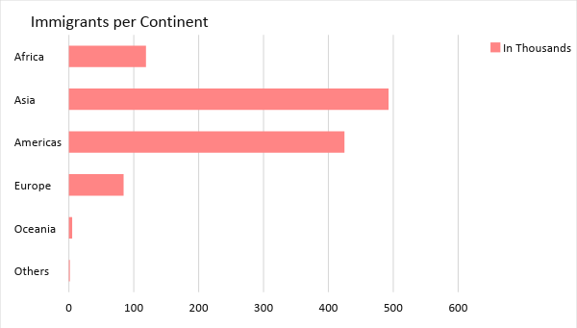

SWOT Analysis | Strengths | Weaknesses | Opportunities | Threats
Louis Immigration Services | Cost-efficient immigration services | Limited market coverage | Growing number of immigrants in the US | Market influence of already established immigration offices
San Diego Immigration Consultants | Most trusted immigration consultancy office | Highly expensive charges on services | The approval of favorable immigration laws | Emerging immigration offices that offer affordable fees
CA Immigration Inc | Exceptional customer service | Weak management | Unchanged consumer preference on offices with the best customer service | Tight market competition among small and medium-sized immigration offices

Marketing Strategy: [Louis Immigration Services] will improve the [SEO] aspect of its website so it will land in the top search results. The company will also advertise its services on various social media platforms. The table below presents the tasks to be performed by the company to achieve these marketing strategies.

Marketing Strategy | Activities | Timeline | Success Criteria
SEO | Hire an SEO company to conduct website optimization | ASAP | The website ranks as one of the top search results across popular search engines by February 2019.
Social Media Advertising | Post articles about immigration on Facebook | January 20, 2019 | The company gains new followers on Facebook.
-- | -- | -- | --

ORGANIZATIONAL STRUCTURE:

[Louis Immigration Services] follows a simple organizational structure. The executives handle major decisions and tasks of the company while the office clerks assist the executives. The office clerks take responsibility in receiving inquiries from clients regarding immigration.

OPERATIONAL PLAN:

Location and Facilities

[Louis Immigration Services] occupies an [850 square foot office space] in [2801] [Camino Del Rio S Mission Valley East, San Diego, CA 92108], USA. The office has a meeting area, customer lounge, and offices for the executives.

Tools and Equipment Checklist

Software | Quantity
Immigration Software | 2
Accounting Software | 1
Hardware | Quantity
Computers | 5
Printers | 2

IT Infrastructure

The following table reflects the IT infrastructure of [Louis Immigration Services].

Infrastructure | Existing (Y/N) | Description
Social Media | N | The company is yet to open a Facebook page.
Website | Y | The company owns a user-friendly website.
Zero Downtime | Y | The company did not encounter any network disruptions.

FINANCIAL PLAN

Assumptions

[Louis Immigration Services] referred to these financial assumptions during the preparation of its financial assumptions:

- The company expects a continuous increase in the number of immigrants in the next three years. A yield of [25%] is expected.
- The prevailing market interest is [4%] and the tax rate is [13%].
- Immigration laws increase certain expenses relevant to the processing of an [immigrant’s documents].

Monthly Expense

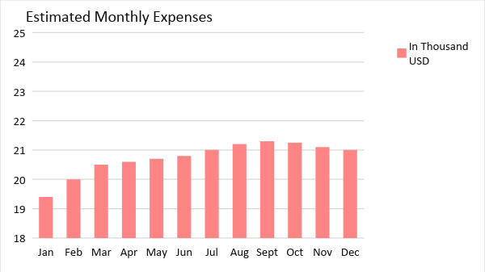

Monthly Revenue

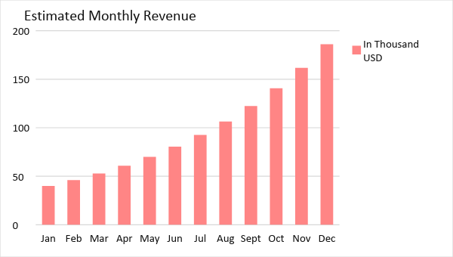

BUSINESS FINANCING

[Louis Immigration Services] gained its initial operating fund of [120K USD] through the owner’s acquisition of a loan payable within [18 months].

STATEMENTS

Profit and Loss Projection
 | FY2019 | FY2020 | FY2021
Sales | $250,000.00 | $312,500.00 | $390,625.00
Direct Cost of Sale | $75,000.00 | $93,750.00 | $118,945.31
Other Cost of Sale | $2,000.00 | $2,000.00 | $2,030.00
Total Cost of Goods Sold or COGS (Sales - Direct Cost of Sale - Other Cost of Sale) | $173,000.00 | $216,750.00 | $269,649.69
Gross Profit (Sales-Total Cost of Goods Sold) | $77,000.00 | $95,750.00 | $120,975.31
Gross Margin % (Gross Profit/Sales) | 30.80% | 30.64% | 30.97%
Operating Expenses
Rent | $16,830.00 | $16,830.00 | $16,830.00
Insurance | $6,000.00 | $6,000.00 | $6,000.00
Utilities | $5,000.00 | $5,000.00 | $5,000.00
Salary (Including Tax) | $30,000.00 | $30,000.00 | $30,000.00
Maintenance & Supplies | $5,000.00 | $5,000.00 | $5,000.00
Total Operating Expenses | $62,830.00 | $62,830.00 | $62,830.00
EBITDA (Total Cost of Sale-Total Operating Expenses) | $110,170.00 | $153,920.00 | $206,819.69
Depreciation | $150.00 | $150.00 | $150.00
Interest Expense | $4,800.00 | $4,800.00 | $4,800.00
Taxes Paid | $3,900.00 | $3,900.00 | $3,900.00
Net Profit (Gross Profit - Operating Expenses - Taxes - Interest) | $5,470.00 | $24,220.00 | $49,445.31

Balance Sheet Projection
 | FY2019 | FY2020 | FY2021
Cash | $24,170.00 | $61,540.00 | $123,465.00
Accounts Receivable | $35,000.00 | $43,750.00 | $54,687.50
Inventory | $10,000.00 | $10,150.00 | $10,302.25
Other Current Assets | $15,000.00 | $42,000.00 | $42,000.00
Total Current Assets | $84,170.00 | $157,440.00 | $230,454.75
Long-Term Assets | $45,000.00 | $45,000.00 | $45,000.00
Accumulated Depreciation | $150.00 | $300.00 | $450.00
Total Long-Term Assets (Long-Term Assets-Accumulated Depreciation) | $44,850.00 | $44,700.00 | $44,550.00
Total Assets (Total Current Assets + Total Long-Term Assets) | $129,020.00 | $202,140.00 | $275,004.75
Accounts Payable | $35,000.00 | $20,000.00 | $15,500.00
Notes Payable | $2,500.00 | $2,625.00 | $2,756.25
Other | $1,500.00 | $1,500.00 | $1,500.00
Total Liabilities | $39,000.00 | $24,125.00 | $19,756.25
Paid-in Capital | $85,000.00 | $120,000.00 | $120,000.00
Retained Earnings | $5,470.00 | $29,690.00 | $79,135.31
Total Owner's Equity (Total Assets - Total Liabilities) | $90,020.00 | $178,015.00 | $255,248.50
Total Liabilities & Equity (Total Liabilities/Total Owner's Equity) | 43.32% | 13.55% | 7.74%

Cash Flow Projection
 | FY2019 | FY2020 | FY2021
Operating Cash Beginning | $6,500.00 | $24,170.00 | $61,540.00
Sources of Cash | $2,500.00 | $3,000.00 | $3,600.00
Receivables | $35,000.00 | $43,750.00 | $54,687.50
Sales | $40,000.00 | $50,000.00 | $62,500.00
Others | $3,000.00 | $3,450.00 | $3,967.50
Total Cash | $87,000.00 | $124,370.00 | $186,295.00
Expenditures
Rent | $16,830.00 | $16,830.00 | $16,830.00
Insurance | $6,000.00 | $6,000.00 | $6,000.00
Utilities | $5,000.00 | $5,000.00 | $5,000.00
Salary (Including Tax) | $30,000.00 | $30,000.00 | $30,000.00
Maintenance & Supplies | $5,000.00 | $5,000.00 | $5,000.00
Total Expenditures | $62,830.00 | $62,830.00 | $62,830.00
Net Income/Loss (Total Cash - Total Expenditures) | $24,170.00 | $61,540.00 | $123,465.00

