HEALTH CARE BUSINESS PLAN

[INSERT NAME OF THE BUSINESS/COMPANY]
[INSERT THE COMPLETE BUSINESS/COMPANY ADDRESS]
[INSERT THE BUSINESS/COMPANY CONTACT NUMBERS]
[INSERT THE BUSINESS/COMPANY EMAIL ADDRESS]
[INSERT THE BUSINESS/COMPANY WEBSITE ADDRESS]

PREPARED BY:

[INSERT FULL NAME/S OF THE
PEOPLE WHO PREPARED THIS PLAN]

[INSERT DATE]

Index

Executive Summary [PAGE NUMBER]
Company Overview [PAGE NUMBER]
Products and Services [PAGE NUMBER]
Execution [PAGE NUMBER]
Operational Plan [PAGE NUMBER]
Financial Plan [PAGE NUMBER]

EXECUTIVE SUMMARY:

[Vitto Health Care Clinic] (VHCC) provides medical assistance to the rural areas of [Richmond, Indiana]. It also introduces advanced diagnostic procedures and treatments to remote areas in the city. The owner aims to improve access to healthcare treatments to cater to the growing needs for better health facilities in the neighborhood. In order to spread brand awareness, the clinic will reach out to local community [groups, schools, and small businesses and introduce its products and services].

COMPANY OVERVIEW:

Mission Statement: [Vitto Health Care Clinic’s] mission is to provide easy access to quality health care to the rural areas of [Richmond].

Philosophy: The clinic will always prioritize the needs of the clients and will make sure to give the necessary treatment to their illnesses.

Vision: [Vitto Health Care Clinic] aims to create a place where no person is devoid of quality medical attention.

Outlook: Since the clinic offers inexpensive fees for its services, it aims to cut its cost and improve its packages to maximize the value it gives and the profit it gets. [Vitto Health Care Clinic] plans to penetrate distant neighborhoods in the future and open additional branches. The company also looks forward to collaborating with other health care providers to improve brand awareness and gain a competitive advantage.

Type of Industry: [Health Care Industry]

Business Structure: Sole Proprietorship

Ownership: Sole Proprietorship, [Noah Phillips, MD]

Start-Up Summary: The cost of the start-up is [$100,000] which is provided by the owner and will be used for the [rent, supplies, salary, permits, and business insurance policies].

Start-Up Funding
Start-Up Expenses | $25,000
Start-Up Assets | $75,000
Total Funding Required | $100,000
Assets
Non-Cash Assets from Start-Up | $30,000
Cash Requirements from Start-up | $12,500
Additional Cash Raised | $20,000
Cash Balance on Starting Date | $12,500
Total Assets | $75,000
Capital
Planned Investment
Owner | $100,000
Other | $0
Additional Investment Requirement | $0
Total Planned Investment | $100,000
Loss at Start-Up (Start-Up Expenses) | -$25,000
Total Capital | $75,000
Liabilities | $0
Total Capital and Liabilities | $75,000
Start-Up
Requirements
Start-Up Expenses
Rent - 5 Months | $11,000
Advertising | $2,500
Legal Fees | $2,500
Staff Training | $5,000
Insurance | $3,500
Other | $500
Total Start-Up Expenses | $25,000
Start-Up Assets
Cash Required | $12,500
Start-Up Inventory | $30,000
Other Current Assets | $20,000
Long-Term Assets | $12,500
Total Assets | $75,000
Total Requirements (Total Start-Up Expenses + Total Assets) | $100,000

MANAGEMENT TEAM:

Management Team | Role/Function | Skills
Hermelinda S. Tapp | Medical Office Manager | Scheduling, Quality Improvement, Leadership, and Public Speaking
Christa J. Aguiar | Head Nurse | Management, Administration, Communication, and Client Handling

SHORT- AND LONG-TERM GOALS AND MILESTONES:

Short-Term Goals | Milestones
- Hire one medical receptionist | - Done hiring last January 7, 2019
- Partner with five small businesses by the end of the year | - Already made contact with ten prospective clients as of February 8, 2019
Long-Term Goals | Milestones
- Maintain a profit margin of 20% for the first three years of operation | - All the sales target for the previous months are met.
- Decrease operational cost by 10% by the end of the first year | - Management will implement cost-cutting strategies

PRODUCTS AND SERVICES

Product/Service Description: [VHCC] offers affordable health services that include laboratory [examinations, radiology, dental, internal medicine, and gynecologic consultations, and immunizations].

Value Proposition: [VHCC] provides modern health diagnostics and treatments that are accessible to the rural areas of [Richmond].

Pricing Strategy: Competitive pricing and price bundling strategies are used to attract prospective clients and gain competitive advantage.

Formula:
Profit Margin = 1- (Expenses/Net Sales)

Vitto Health Care Clinic
Profit Margin = 1 - ($157,000/$170,000)
= 1-0.923
= 0.077 or 7.7%

EXECUTION

Marketing Plan: [VHCC] plans to partner with [small businesses, schools, and community groups in Richmond to attract clients and promote its services].

Market Research: Health expenditures in the United States are expected to continue to rise. In [2017], the global revenue for the health care industry reached [$7.7 trillion] and is expected to grow to [$10 trillion] by [2022]. Aging and growing population, the prevalence of [chronic diseases, and advances in digital technology] have contributed to the demands of health care services. The industry isn’t likely to go down in a few years, but there is still a struggle to build a more sustainable foundation for [affordable, accessible, and high-quality care].

SWOT Analysis | Strengths | Weaknesses | Opportunities | Threats
Vitto Health Care Clinic | - Convenient  - Affordable | - Clinic processes still need standardization | - Lack of dominant competition | - Changes in insurance plans that increase the cost of business operations
Mayberry Health Clinic | - Uses advanced technology | - Has a narrow scope of care | - Increasing demand for health care services | - Adverse government policies and changes in taxation
Richmond Health Care | - Has established a good reputation | - Currently has marketing deficiencies | - Demographic changes that favor the demand for health care services | - New competition in the area

Marketing Strategy: [Vitto Health Care Clinic’S] strategy is to come up with attractive package deals and promo offers and sell them to relevant establishments in the neighborhood. The team will reach out to different [schools, small businesses, and community groups] to negotiate these deals.

The team has started executing several activities to drive the marketing strategy forward. Here is their progress so far:

Marketing Strategy | Activities | Timeline | Success Criteria
Bundle offers | - The bundle pricing strategy is already awaiting approval | April 5, 2019 | Sales increases because of the bundling scheme.
B2B tie-ups | - Has called 20 small businesses last month | April 30, 2019 | Will close 10 deals by the end of the second quarter

ORGANIZATIONAL STRUCTURE:

CEO
HEAD NURSE
MEDICAL MANAGER
NURSE 1
NURSE 2
RECEPTIONIST
NURSE ASSISTANT
MEDICAL ASSISTANT

OPERATIONAL PLAN:

Location and Facilities

Provide a sketch or blueprint of the facility.

Provide photos or images of the location/facility.

Tools and Equipment Checklist

Software | Quantity
PrimeSuite | 2
Zoho | 2
Hardware | Quantity
Stethoscope | 5
Weighing scale | 2
Centrifuge | 3
IT Infrastructure

The following table reflects [Vitto Health Care Clinic’s] IT infrastructure.

Infrastructure | Existing (Y/N) | Description
CCTV | Y | Enhances the clinic’s security measures
Server | Y | Storage of patient records

FINANCIAL PLAN

Assumptions

This forecast is based on the current performance of the [healthcare industry]. The company expects a substantial increase in its sales within the third and fourth year of operation.
Majority of the expenses will be on [payroll, rent, supplies, maintenance, permits, and insurance policies].

Monthly Expense

The chart details the projected monthly expense for [2019].

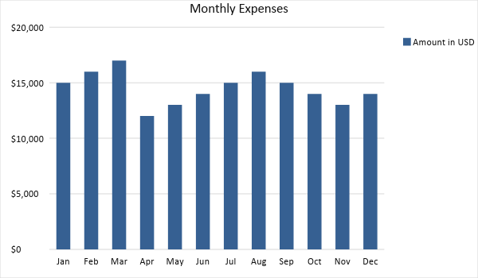

Monthly Revenue

The chart shows the projected monthly revenue for 2019.

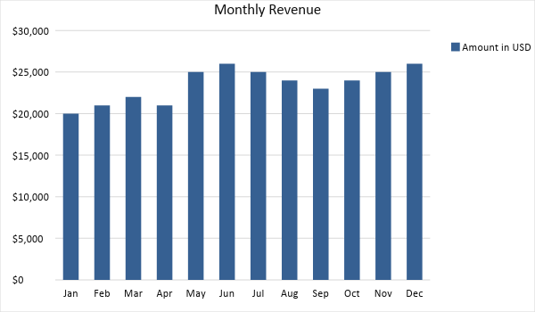

BUSINESS FINANCING

The funds for the business comes from the owner worth [$100,000]. Most of the expenses will be on [rent, insurance, permits, supplies, and payroll].

STATEMENTS

Profit and Loss Projection
 | FY2019 | FY2020 | FY2021
Sales | $250,000.00 | $300,000.00 | $400,000.00
Direct Cost of Sale | $120,000.00 | $125,000.00 | $160,000.00
Other Cost of Sale | $50,000.00 | $60,000.00 | $80,000.00
Total Cost of Goods Sold or COGS (Sales - Direct Cost of Sale - Other Cost of Sale) | $80,000.00 | $115,000.00 | $160,000.00
Gross Profit (Sales-Total Cost of Goods Sold) | $170,000.00 | $185,000.00 | $240,000.00
Gross Margin % (Gross Profit/Sales) | 68.00% | 61.67% | 60.00%
Operating Expenses
Rent | $40,000.00 | $40,000.00 | $40,000.00
Insurance | $12,000.00 | $13,000.00 | $14,000.00
Utilities | $10,000.00 | $14,000.00 | $15,000.00
Salary (Including Tax) | $80,000.00 | $90,000.00 | $100,000.00
Maintenance & Supplies | $15,000.00 | $16,000.00 | $20,000.00
Total Operating Expenses | $157,000.00 | $173,000.00 | $189,000.00
EBITDA (Total Cost of Sale-Total Operating Expenses) | -$77,000.00 | -$58,000.00 | -$29,000.00
Depreciation | $5,000.00 | $6,000.00 | $7,000.00
Interest Expense | $0.00 | $0.00 | $0.00
Taxes Paid | $4,000.00 | $5,000.00 | $6,000.00
Net Profit (Gross Profit - Operating Expenses - Taxes - Interest) | $9,000.00 | $7,000.00 | $45,000.00

Balance Sheet Projection
 | FY2019 | FY2020 | FY2021
Cash | $120,000.00 | $150,000.00 | $200,000.00
Accounts Receivable | $50,000.00 | $60,000.00 | $80,000.00
Inventory | $50,000.00 | $60,000.00 | $75,000.00
Other Current Assets | $15,000.00 | $16,000.00 | $18,000.00
Total Current Assets | $235,000.00 | $286,000.00 | $373,000.00
Long-Term Assets | $100,000.00 | $120,000.00 | $160,000.00
Accumulated Depreciation | $10,000.00 | $12,000.00 | $13,000.00
Total Long-Term Assets (Long-Term Assets-Accumulated Depreciation) | $90,000.00 | $108,000.00 | $147,000.00
Total Assets (Total Current Assets + Total Long-Term Assets) | $325,000.00 | $394,000.00 | $520,000.00
Accounts Payable | $100,000.00 | $120,000.00 | $150,000.00
Notes Payable | $60,000.00 | $70,000.00 | $90,000.00
Other | $20,000.00 | $30,000.00 | $40,000.00
Total Liabilities | $180,000.00 | $220,000.00 | $280,000.00
Paid-in Capital | $60,000.00 | $70,000.00 | $100,000.00
Retained Earnings | $250,000.00 | $300,000.00 | $360,000.00
Total Owner's Equity (Total Assets - Total Liabilities) | $145,000.00 | $174,000.00 | $240,000.00
Total Liabilities & Equity (Total Liabilities/Total Owner's Equity) | 124.14% | 126.44% | 116.67%

Cash Flow Projection
 | FY2019 | FY2020 | FY2021
Operating Cash Beginning | $90,000.00 | $120,000.00 | $150,000.00
Sources of Cash | $20,000.00 | $30,000.00 | $50,000.00
Receivables | $30,000.00 | $40,000.00 | $50,000.00
Sales | $100,000.00 | $110,000.00 | $140,000.00
Others | $15,000.00 | $20,000.00 | $25,000.00
Total Cash | $255,000.00 | $320,000.00 | $415,000.00
Expenditures
Rent | $40,000.00 | $40,000.00 | $40,000.00
Insurance | $12,000.00 | $13,000.00 | $14,000.00
Utilities | $10,000.00 | $14,000.00 | $15,000.00
Salary (Including Tax) | $80,000.00 | $90,000.00 | $100,000.00
Maintenance & Supplies | $15,000.00 | $16,000.00 | $20,000.00
Total Expenditures | $157,000.00 | $173,000.00 | $189,000.00
Net Income/Loss (Total Cash - Total Expenditures) | $98,000.00 | $147,000.00 | $226,000.00

