GAS STATION BUSINESS PLAN
Business Plan For Fiscal Year 2020
July 1, 2020
[Cheryl Downing] [cherdowning@gmail.com]
[303-965-9491] [www.coinwashexpress.com]
[2076 S University Blvd University Park, Denver, CO 80210, USA]

INDEX
Executive Summary
Company Overview
Products and Services
Execution
Operational Plan
Financial Plan
[Page Number]
[Page Number]
[Page Number]
[Page Number]
[Page Number]
[Page Number]

Executive Summary

[Regas Station] is one of the subsidiary companies of Star Coms Inc., which specializes in the exploration and production of oil and gas and petroleum refining.

[Regas Station] will leverage on the use of a loyalty program, the company website, and email marketing to create a solid customer base.

Company Overview

Mission Statement: [Regas Station] provides residents and visitors of Englewood, Colorado, with gasoline at competitive prices.

Philosophy: [Regas Station] firmly believes that quality products combined with superior customer service would lead you to attain maximum profitability.

Vision:
The vision of [Regas Station] is to make a difference by forming a team of dedicated professionals and initiating sustainable development programs.

Outlook: Oil and gas trends show that the industry is recovering from the last few years of weak prices, enforced capital discipline, portfolio realignments, and productivity efficiencies. In the US alone, there is a continued increase in the demand for fuel.

Type of Industry: Retail Industry

Business Structure: Corporation

Ownership: Corporation, Shareholders: Antonio Morales, Susan Brown, Denise Fox, Leona Lewis, and Thomas Robertson

Start-Up Summary: The start-up cost of [500K] USD is to be provided by the shareholders and to be used mainly for the purchase of machinery and equipment, supplies, insurance, legal fees, and payroll.

Start-Up Funding
Start-Up Expenses | $200,000
Start-Up Assets | $300,000
Total Funding Required | $500,000
Assets
Non-Cash Assets from Start-Up | $200,000
Cash Requirements from Start-up | $50,000
Additional Cash Raised | $30,000
Cash Balance on Starting Date | $20,000
Total Assets | $300,000
Capital
Planned Investment
Owner | $500,000
Other | $0
Additional Investment Requirement | $0
Total Planned Investment | $500,000
Loss at Start-Up (Start-Up Expenses) | -$200,000
Total Capital | $300,000
Liabilities | $0
Total Capital and Liabilities | $300,000
Start-Up
Requirements
Start-Up Expenses | $5,000
Supplies | $150,000
Advertising | $1,000
Legal Fees | $2,000
Staff Training | $5,000
Insurance | $30,000
Other | $7,000
Total Start-Up Expenses | $200,000
Start-Up Assets
Cash Required | $50,000
Start-Up Inventory | $200,000
Other Current Assets | $30,000
Long-Term Assets | $20,000
Total Assets | $300,000
Total Requirements (Total Start-Up Expenses + Total Assets) | $500,000

Management Team:

Management Team | Role/Function | Skills
Antonio Morales | Administrative Manager | Technology, communication, organizational, time management, office coordination, and problem-solving
Susan Brown | Operations Manager | Leadership, conflict management, business negotiation, and decision-making

Short- and Long-Term Goals and Milestones:

Short-Term Goals | Milestones
Hire a gasoline station manager | The company has already hired a gasoline station manager last June 20, 2019
Open the gasoline station in July 2020 | The company has already started the construction last January 1, 2019
Long-Term Goals | Milestones
Open a second gasoline station by 2020 | The shareholders have decided to restrict 50% of its retained earnings for the year 2020 for the opening of the second gasoline station
Open a convenience store alongside the gasoline station | The shareholders have decided to restrict 30% of its retained earnings for the year 2021 for the opening of the convenience store

Products and Services

Product/Service Description: [Regas Station] provides its customers with high-quality fuels, lubricants, bitumen, and fuel additives.

[Regas Station] also offers quick oil change service with free preventive maintenance checks. It also provides basic vehicle service, including brake system maintenance, minor mechanical repairs, transmission works, and tune-ups.
Value Proposition: One-stop shop for all the vehicle’s needs. [Regas Station] provides its customers with the best and high-quality products coupled with the best services by well-trained and experienced employees.

Pricing Strategy: [Regas Station] utilizes competitive pricing and the prices are in conformance with the prices set by the Organization of the Petroleum Exporting Countries.

Execution

Marketing Plan: [Regas Station] aims to increase its number of customers by introducing a loyalty program while using the company website as well as email marketing to promote the business.

Market Research: The current trend in the oil and gas industry shows that it is recovering from the continued weak prices from the past [5] years. The United States is the leading national market for gasoline due to high car ownership and lower efficiency standards as compared to markets in Asia and some parts of Europe.

SWOT Analysis | Strengths | Weaknesses | Opportunities | Threats
Regas Station | Limited start-up risk | Competitors can offer the same products quickly | Continued expansion | Changes in regulations could have a negative impact on the business
Gas Unlimited | Highly experienced owner-operator | The prices are higher | Ability to develop additional stores | Products are already sold by major competitors
Total Inc. | Limited competition in the Englewood area | The services offered are limited | Affiliate relations with other vendors | The need for gasoline is expected to decline over the next 10 years

Marketing Strategy: The company has kicked-off various activities to move the following marketing strategies forward. Here are some of the updates:

Marketing Strategy | Activities | Timeline | Success Criteria
Loyalty program | The company has made a draft for the design of the loyalty card | March 1, 2019 | The final draft for the loyalty card design is submitted to the shareholders for approval on April 1, 2019
Creation of company website | The company has hired an IT specialist for the creation of the website | April 1, 2019 | The company website is fully developed by May 1, 2019
Email marketing | The marketing manager has prepared a list of prospective customers | May 1, 2019 | The marketing manager has finalized the list of prospective customers by June 1, 2019

Organizational Structure:

BOARD OF DIRECTORS
Administrative Manager
Operations Manager
Store Manager
Accounting Manager
Marketing Manager
Gas Station Attendant
Technician
Cashier

Operational Plan
Location and Facilities
[Regas Station] is located in [3376] Sampson Street, Englewood, Colorado and is highly accessible to the public.

Tools and Equipment Checklist

Software | Quantity
POS management software | 2
Storage tank ATG systems | 6
Hardware | Quantity
Service Station Equipment | 6

IT Infrastructure
[Regas Station] is outsourcing its IT operations and infrastructure.

Financial Plan

Assumptions
The financial forecast is based mainly on the current trends in the oil and gas industry. The company will focus much of its efforts on its marketing strategies as well as on the creation of a convenience store and expansion in [2020] and [2021].

Monthly Expense
The chart shows the projected monthly expenses for [2019].

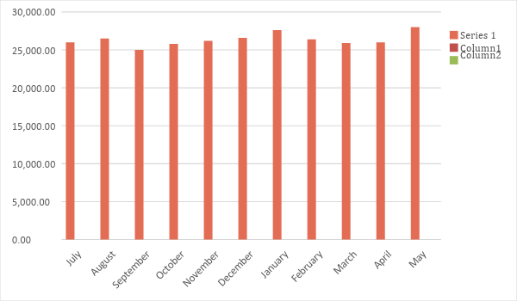

Monthly Revenue
The chart depicts the projected monthly revenues for [2019].

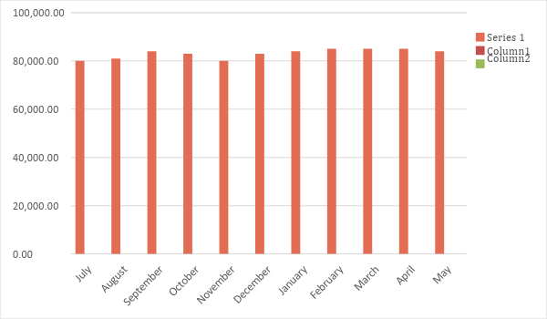
Business Financing
The funding for the business mainly comes from the investment of the shareholders, each contributing [$500,000]. The major expenses will go to the purchase of machinery and equipment, supplies, insurance, legal fees, and payroll.

Statements

Profit and Loss Projection
 | FY 2019 | FY 2020 | FY 2021
Sales | $1,000,000.00 | $1,500,000.00 | $3,000,000.00
Direct Cost of Sale | $300,000.00 | $500,000.00 | $800,000.00
Other Cost of Sale | $50,000.00 | $70,000.00 | $90,000.00
Total Cost of Goods Sold or COGS (Sales - Direct Cost of Sale - Other Cost of Sale) | $350,000.00 | $570,000.00 | $890,000.00
Gross Profit (Sales-Total Cost of Goods Sold) | $650,000.00 | $930,000.00 | $2,110,000.00
Gross Margin % (Gross Profit/Sales) | 65.00% | 62.00% | 70.33%
Operating Expenses
Supplies | $150,000.00 | $180,000.00 | $12,000.00
Insurance | $30,000.00 | $30,000.00 | $1,200.00
Utilities | $10,000.00 | $15,000.00 | $25,000.00
Salary (Including Tax) | $80,000.00 | $100,000.00 | $150,000.00
Maintenance & Supplies | $50,000.00 | $80,000.00 | $120,000.00
Total Operating Expenses | $320,000.00 | $405,000.00 | $308,200.00
EBITDA (Total Cost of Sale-Total Operating Expenses) | $330,000.00 | $525,000.00 | $1,801,800.00
Depreciation | $5,000.00 | $5,000.00 | $5,000.00
Interest Expense | $8,000.00 | $15,000.00 | $20,000.00
Taxes Paid | $33,000.00 | $52,500.00 | $180,180.00
Net Profit (Gross Profit - Operating Expenses - Taxes - Interest) | $289,000.00 | $457,500.00 | $1,601,620.00

Balance Sheet Projection
 | FY 2019 | FY 2020 | FY 2021
Cash | $700,000.00 | $1,000,000.00 | $1,500,000.00
Accounts Receivable | $30,000.00 | $80,000.00 | $317,000.00
Inventory | $80,000.00 | $100,000.00 | $300,000.00
Other Current Assets | $10,000.00 | $16,000.00 | $85,000.00
Total Current Assets | $820,000.00 | $1,196,000.00 | $2,202,000.00
Long-Term Assets | $50,000.00 | $80,000.00 | $220,000.00
Accumulated Depreciation | $5,000.00 | $10,000.00 | $15,000.00
Total Long-Term Assets (Long-Term Assets-Accumulated Depreciation) | $45,000.00 | $70,000.00 | $205,000.00
Total Assets (Total Current Assets + Total Long-Term Assets) | $865,000.00 | $1,266,000.00 | $2,407,000.00
Accounts Payable | $30,000.00 | $40,000.00 | $50,000.00
Notes Payable | $10,000.00 | $15,000.00 | $20,000.00
Other | $5,000.00 | $6,000.00 | $7,000.00
Total Liabilities | $45,000.00 | $61,000.00 | $77,000.00
Paid-in Capital | $70,000.00 | $80,000.00 | $80,000.00
Retained Earnings | $750,000.00 | $1,125,000.00 | $2,250,000.00
Total Owner's Equity (Total Assets - Total Liabilities) | $820,000.00 | $1,205,000.00 | $2,330,000.00
Total Liabilities & Equity (Total Liabilities/Total Owner's Equity) | 5.49% | 5.06% | 3.30%

Cash Flow Projection
 | FY 2019 | FY 2020 | FY 2021
Operating Cash Beginning | $70,000.00 | $70,000.00 | $70,000.00
Sources of Cash
Receivables | $30,000.00 | $50,000.00 | $70,000.00
Sales | $1,000,000.00 | $1,500,000.00 | $3,000,000.00
Others | $5,000.00 | $7,000.00 | $9,000.00
Total Cash | $1,105,000.00 | $1,627,000.00 | $3,149,000.00
Expenditures
Supplies | $150,000.00 | $180,000.00 | $12,000.00
Insurance | $30,000.00 | $30,000.00 | $1,200.00
Utilities | $10,000.00 | $15,000.00 | $25,000.00
Salary (Including Tax) | $80,000.00 | $100,000.00 | $150,000.00
Maintenance & Supplies | $50,000.00 | $80,000.00 | $120,000.00
Total Expenditures | $320,000.00 | $405,000.00 | $308,200.00
Net Income/Loss (Total Cash - Total Expenditures) | $785,000.00 | $1,222,000.00 | $2,840,800.00

