FLORIST SALES PLAN

[Bud Blossoms Flower Shop]
Sales Plan [2018 – 2019]

Index

Executive Summary [PAGE NUMBER]
Company Overview [PAGE NUMBER]
Products and Services [PAGE NUMBER]
Marketing Analysis [PAGE NUMBER]
Strategy and Implementation [PAGE NUMBER]
Management and Personnel [PAGE NUMBER]

Sales Action Plan [PAGE NUMBER]

EXECUTIVE SUMMARY

[Bud Blossoms Flower Shop] is a small flower shop based in [Aurora, Colorado]. It also offers floral arrangements and decorations for any event such as weddings, debuts, and funeral services. The floral shop currently targets customers from the middle and upper classes who discretionary funds to purchase the services of a florist and the flowers for their loved ones.

[Bud Blossoms Flower Shop] plans to provide service bundles and a flower delivery service. The flower shop will advertise these services through social media for a wider target market coverage. It anticipates an increase in customers during peak seasons and when there are special occasions.

COMPANY OVERVIEW

Mission Statement:

[Bud Blossoms Flower Shop] provides only the best floral products to better accentuate and enliven a formal event decoration.

Philosophy:

[Bud Blossoms Flower Shop] aims to build trust and a strong relationship with clients by providing them excellent services.

Vision:

To become one of the leading flower shops and floral decorators in [Aurora, Colorado].

Outlook:

Purchases on flowers depend on the available discretionary funds of customers. The flower shop takes advantage of this fact and plans to provide services suitable for each client’s economic status. The flower shop anticipates sales increases during peak seasons and when the city, state, or country celebrates a special occasion.

Type of Industry: Flower/Floral Industry

Business Structure: Sole Proprietorship

Ownership: Sole Proprietorship, Elsie Kersey

Start-Up Summary:

The sole proprietor provided the initial startup capital of [70K] USD to initially operate the business in [2017]. The fund covered payment for operating expenses such as rent, insurance, legal fees, and
advertising costs.

Start-Up Funding
Start-Up Expenses | $39,500
Start-Up Assets | $30,500
Total Funding Required | $70,000
Assets
Non-Cash Assets from Start-Up | $20,000
Cash Requirements from Start-up | $2,900
Additional Cash Raised | $7,500
Cash Balance on Starting Date | $100
Total Assets | $30,500
Capital
Planned Investment
Owner | $70,000
Other | $0
Additional Investment Requirement | $0
Total Planned Investment | $70,000
Loss at Start-Up (Start-Up Expenses) | -$39,500
Total Capital | $30,500
Liabilities | $0
Total Capital and Liabilities | $30,500
Start-Up
Requirements
Start-Up Expenses
Rent - 5 Months | $2,500
Advertising | $4,000
Legal Fees | $3,750
Staff Training | $2,000
Insurance | $2,250
Other | $25,000
Total Start-Up Expenses | $39,500
Start-Up Assets
Cash Required | $3,000
Start-Up Inventory | $8,500
Other Current Assets | $7,500
Long-Term Assets | $11,500
Total Assets | $30,500
Total Requirements (Total Start-Up Expenses + Total Assets) | $70,000

PRODUCTS AND SERVICES

Product/Service Description:

[Bud Blossoms Flower Shop] provides floral arrangements and event accessories/decorations for any event like weddings, debuts, and funerals.

Value Proposition:

[Bud Blossoms Flower Shop] focuses on the personal taste and preferences of its clients when decorating or arranging flowers for them.

Pricing Strategy:

[Bud Blossoms Flower Shop] utilizes the price bundling scheme as flower arrangement and decorating materials differ per event.

MARKETING ANALYSIS

[The flower/floral industry] remains to be a steadily progressing industry with less competition. The industry is going strong amidst fluctuations in costs of flowers in the market. The demand for flowers depends on the spending confidence of customers and the effectiveness of the shops’ promotional activities.

Market Segmentation

[Bud Blossoms Flower Shop] targets people from the middle and upper classes because they have discretionary funds to spend for floral arrangements and decorations during special events and occasions. A recent market survey shows that individuals with discretionary funds are highly likely to spend for flowers even on ordinary days.

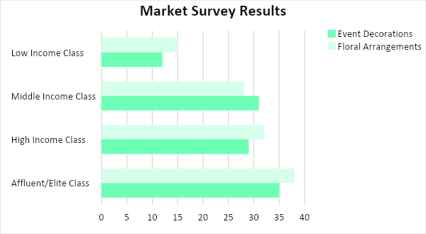

Target Market Segmentation Strategy

Customers belonging to the middle and high-income classes

- Create product/service bundles suitable for each income class/level
- Promote services through various social media platforms

Customers belonging to the affluent/elite class

- Collaborate with popular event coordinators, wedding planners, funeral homes, and gift shops who work with affluent individuals
- Offer door-to-door flower delivery services

STRATEGY AND IMPLEMENTATION

Target Market Strategy

[Bud Blossoms Flower Shop] aims to increase its monthly sales by [10%]. The flower shop will heighten its social media presence, partner with relevant entities and will offer personalized flower delivery service for affluent customers.

Competitive Edge

SWOT Analysis | Strengths | Weaknesses | Opportunities | Threats
Bud Blossoms  Flower Shop | Offers affordable floral arrangements and event decorations | Weak market presence | Increase spending confidence of people from the middle and upper-income classes | Market influence of established flower shops in Aurora, Colorado
FlowerLuxe Garden | Offers unique flowers in its selection | Overly dependent on suppliers for daily operations | Consistent demand for shops that offer a variety of flowers | Economic conditions that can affect the business
Bloomerly Haven | Offers flowers with the longest life span | Highly expensive flowers and services | Availability of e-commerce for customers outside Aurora, Colorado | Increased usage of plastic flowers over fresh ones

Sales Strategy and Forecast

With strengthened social media presence, business partnerships, and personalized delivery service, the flower shop expects the following monthly sales in USD for the fiscal year [2018].

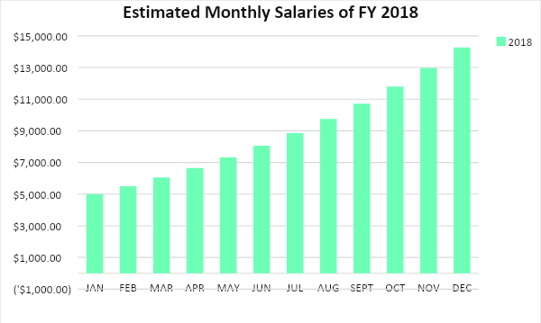

Bud Blossoms Flower Shop anticipates the following percentages in customer growth among flower purchasers per income level as a result of its improved social media presence and added services.

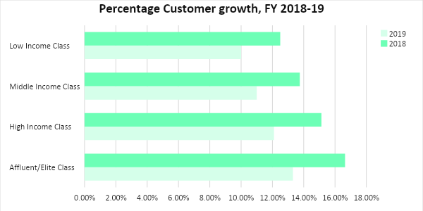
The flower shop will utilize the following strategies to achieve its expected monthly increases in sales.

Sales Strategy | Activities | Timeline | Success Criteria
Promotion of Service Bundles | The florist groups together flowers and necessary arrangement/decoration materials suitable for common weddings, debuts, and funeral services. | ASAP | With the use of bundles, quoting prices to inquiring customers is made easier.
Personalized Flower Delivery Service | The florist allows the customer to add a personal touch before the arranged flowers are delivered to the receiver. | January 28, 2018 | The flower shop receives multiple orders on February 14, 2018.

Marketing Strategy

[Bud Blossoms Flower Shop] will use social media to promote its service bundles and personalized delivery services. The flower shop utilizes features on social media that enables customers to message the shop for inquiries and orders.

Milestones

Marketing Strategy | Activities | Timeline | Success Criteria
Advertise services through social media | Post content regarding the availability of event bundles and personalized delivery services | ASAP | The flower shop gains popularity and a large following in all of its social media accounts.
Use messaging features of social media apps to receive inquiries and order | Chat with customers through Facebook or Instagram for their inquiries and orders | January 31, 2018 | The flower shop receives lots of messages, especially during important occasions.

MANAGEMENT AND PERSONNEL

The sole proprietor, Elsie Kersey, personally manages [Bud Blossoms Flower Shop]. The flower shop employs two flower arrangers and three delivery men.

SALES ACTION PLAN

The table below shows the sales goals of [Bud Blossoms Flower Shop] and the corresponding activities to achieve such goals. Additional information pertains to target dates, resources, person-in-charge, and key performance indicators (KPIs).

Sales Goals | Action Items | Start Date | End Date | KPIs | Owner
Reach a total of 250 deliveries during peak seasons | Post attractive and engaging contents on social media 1-2 weeks before special days | Jan 1, 2018 | No end date; It should be done annually and consistently | Delivered 250 arranged flowers or more during peak seasons | Sole Proprietor, Floral Arrangement and Delivery Team
 | Allow customers to add their personal touch on the flowers to be delivered | Jan 1, 2018
Handle 500 event decorations annually | Partner with event coordinators, planners, funeral homes, and gift shops | Jan 1, 2018 | Until partnership ends | Confirmed partnerships with 10 famous coordinators and planners, 3 funeral homes, and 5 gift shops | Sole Proprietor, Floral Arrangement and Delivery Team
 | Obtain 15 bookings for each formal event during the first quarter | Jan 1, 2018 | Mar 31, 2018 | Confirmed 45 bookings for the month of January

