FINANCIAL ADVISOR BUSINESS PLAN
Business Plan For Fiscal Year 2019

[February 1, 2019]
[Dean Furlong]
[deanfurlong@gmail.com]
[614-563-6301]
[www.deanfurlong.com]
[4576 Farnum Road New York City, New York 10016, USA]

INDEX
Executive Summary
Company Overview
Services
Execution
Operational Plan
Financial Plan
[Page Number]
[Page Number]
[Page Number]
[Page Number]
[Page Number]
[Page Number]

Executive Summary

[Furlong Financial Advisor] will offer financial advisory services in the city of New York. The financial advisory industry is continuously growing as more people and businesses become more conscious of their finances.

[Furlong Financial Advisor] aims to establish its brand presence through the use of social media and also plans on attending training on financial advisory to increase its connections with other professionals in the field.

Company Overview

Mission Statement: [Furlong Financial Advisor] provides objective financial advice to its clients.

Philosophy: [Furlong Financial Advisor] empathizes and always on focus in dealing with and giving clients their needs.

Vision: [Furlong Financial Advisor] envisions to have a long-term financial advisory relationship with clients that is based on trust and confidence.

Outlook: Despite the presence of robo-advisors, the financial advisory industry is continuously thriving as more people and businesses become more conscious of their finances. In the US, financial advisory firms have opted to focus on specialties rather than offer a wide variety of services for different industries.

Type of Industry: Financial Advisory Industry

Business Structure: Sole Proprietorship

Ownership: Sole Proprietorship, Dean Furlong

Start-Up Summary: The start-up cost is [308K USD], which is to be provided by the owner and to be used mainly for the rent, insurance, supplies, and payroll.

Start-Up Funding
Start-Up Expenses | $10,000
Start-Up Assets | $15,000
Total Funding Required | $25,000
Assets
Non-Cash Assets from Start-Up | $5,000
Cash Requirements from Start-up | $10,000
Additional Cash Raised | $0
Cash Balance on Starting Date | $10,000
Total Assets | $15,000
Capital
Planned Investment
Owner | $25,000
Other | $0
Additional Investment Requirement | $0
Total Planned Investment | $25,000
Loss at Start-Up (Start-Up Expenses) | -$10,000
Total Capital | $15,000
Liabilities | $0
Total Capital and Liabilities | $15,000
Start-Up
Requirements
Start-Up Expenses | $2,000
Rent - 1 year | $3,600
Advertising | $200
Legal Fees | $1,000
Staff Training | $0
Insurance | $500
Other | $2,700
Total Start-Up Expenses | $10,000
Start-Up Assets
Cash Required | $10,000
Start-Up Inventory | $0
Other Current Assets | $0
Long-Term Assets | $5,000
Total Assets | $15,000
Total Requirements (Total Start-Up Expenses + Total Assets) | $25,000

Management Team:

Management Team | Role/Function | Skills
Dean Furlong | Financial Advisor | - Excellent communication and interpersonal skills  - Can explain complex information simply and clearly  - Can easily establish relationships with clients  - Has analytical skills

Short- and Long-Term Goals and Milestones:

Short-Term Goals | Milestones
Find an office space in New York City | The owner already found an office space available on March 1, 2019
Attend a training on financial advisory | The owner has already registered for a 5-day training on February 23 to 28, 2019
Long-Term Goals | Milestones
Obtain a Series 6 license | The owner already took the Series 6 examination last February 15, 2019
Expand the firm and hire other employees | The owner is already preparing a financial plan for the expansion.

Services

Product/Service Description:
[Furlong Financial Advisor] offers financial advice and financial planning on the following:
- Income tax review
- Investments
- Education funding
- Estate planning review

Value Proposition: Delivering financial freedom. [Furlong Financial Advisor] serves its clients with the utmost trust and confidence and creates a fiduciary relationship with them through financial prioritization.

Pricing Strategy: [Furlong Financial Advisor] utilizes price bundling and competitive pricing. Customers prefer the price bundling scheme.

Execution

Marketing Plan: [Furlong Financial Advisor] aims to establish its brand presence through the use of social media since it can easily be accessed by everyone. It also plans on attending training on financial advisory to increase its connections with other professionals in the field.

Market Research:
The outlook for financial advisors is bright. Current estimates suggest that financial advisors will have a [30%] job growth through [2024]. Experienced financial advisors can expect an income of [$100,000] a year, with the top [25%] making more than [$160,000] per year.

SWOT Analysis | Strengths | Weaknesses | Opportunities | Threats
[Furlong Financial Advisor] | Has vast experience and knowledge in financial planning | Has no employees yet and has a small market share | Has an opportunity for expansion | Huge competition in the market
Alpha Financial Advisors, LLC | Known to have a strong client investment portfolio | Has limited flexibility in pricing | Has an opportunity to establish affiliate relations with other financial advisors | Stricter compliance requirement from the government
Beta Financial Advisors | Worked directly with the clients and has scheduled weekly meetings | Has not yet established a website and market presence is poor | Has a large pool of people to recruit for its practice team | Increase in the mandated continuing education for financial advisors

Marketing Strategy:
[Furlong Financial Advisor] plans to focus on giving specialized services. The firm does not have a social media presence and is planning on using such in order to market its services to a much wider audience. The owner will also be attending a series of training on financial advisory to increase its connections with other professionals in the field.

The owner has kicked-off various activities to move the marketing strategies forward. Here are some of the updates:

Marketing Strategy | Activities | Timeline | Success Criteria
Use of social media | Already created a LinkedIn and Facebook account | February 15, 2019 | Social media accounts have 500 to 1000 followers by the end of 2020
Training on financial advisory | The owner already registered for a 5-day training on February 23 to 28, 2019 | February 15, 2019 | Owner obtains a list of contact information of at least 20 financial advisors from different firms

Organizational Structure:
[Furlong Financial Advisor] is solely owned and managed by Dean Furlong. Furlong aims to expand the firm and hire employees one or two years after the start of the operations.

Operational Plan

Location and Facilities
The office space of [Furlong Financial Advisor] is located at[ 4576] Farnum Road, New York City, New York.

Tools and Equipment Checklist

Software | Quantity
eMoney Advisor | 1
Finance Logix | 1
Hardware | Quantity
Personal Computer | 1

IT Infrastructure

The following table reflects the [Furlong Financial Advisor’s] IT infrastructure.

Infrastructure | Existing (Y/N) | Description
Social Media | Y | The company has Facebook and Instagram accounts.

Financial Plan

Assumptions
The financial forecast is based mainly on the current trends in the financial advisory industry. Its expenses will be on rent, insurance, supplies, and other operational expenses.

Monthly Expense
The chart shows the projected monthly expense for [2019].
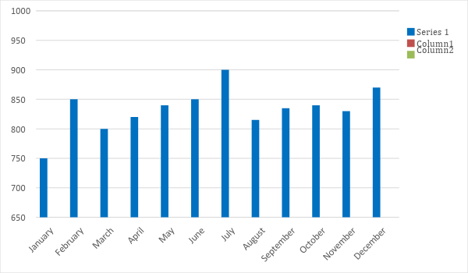

Monthly Revenue
The chart depicts the projected monthly revenues for [2019].

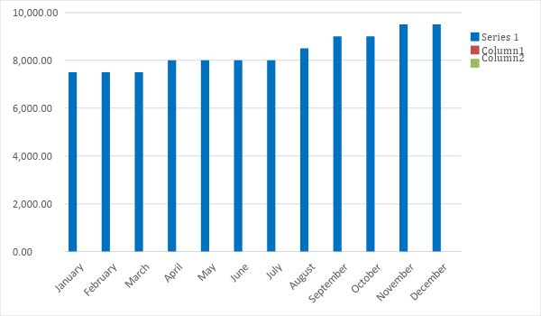

Business Financing
The funding for the business mainly comes from the personal investment of the owner worth [$25,000].

Statements

PROFIT AND LOSS PROJECTION
 | FY 2019 | FY 2020 | FY 2021
Sales | $100,000.00 | $130,000.00 | $150,000.00
Direct Cost of Sale | $5,000.00 | $6,500.00 | $9,000.00
Other Cost of Sale | $1,000.00 | $2,000.00 | $3,500.00
Total Cost of Goods Sold or COGS (Sales - Direct Cost of Sale - Other Cost of Sale) | $6,000.00 | $8,500.00 | $12,500.00
Gross Profit (Sales-Total Cost of Goods Sold) | $94,000.00 | $121,500.00 | $137,500.00
Gross Margin % (Gross Profit/Sales) | 94.00% | 93.46% | 91.67%
Operating Expenses
Rent | $3,600.00 | $3,600.00 | $3,600.00
Insurance | $500.00 | $500.00 | $500.00
Utilities | $5,000.00 | $7,000.00 | $7,500.00
Advertising | $200.00 | $500.00 | $1,000.00
Maintenance & Supplies | $700.00 | $1,000.00 | $3,000.00
Total Operating Expenses | $10,000.00 | $12,600.00 | $15,600.00
EBITDA (Total Cost of Sale-Total Operating Expenses) | $84,000.00 | $108,900.00 | $121,900.00
Depreciation | $2,000.00 | $2,000.00 | $2,000.00
Interest Expense | $1,000.00 | $1,000.00 | $1,000.00
Taxes Paid | $8,400.00 | $10,890.00 | $12,190.00
Net Profit (Gross Profit - Operating Expenses - Taxes - Interest) | $74,600.00 | $97,010.00 | $108,710.00

BALANCE SHEET PROJECTION
 | FY 2019 | FY 2020 | FY 2021
Cash | $120,500.00 | $149,600.00 | $167,900.00
Accounts Receivable | $5,000.00 | $6,500.00 | $7,500.00
Inventory | $200.00 | $500.00 | $750.00
Other Current Assets | $1,000.00 | $3,000.00 | $5,000.00
Total Current Assets | $126,700.00 | $159,600.00 | $181,150.00
Long-Term Assets | $5,000.00 | $5,000.00 | $5,000.00
Accumulated Depreciation | $500.00 | $1,000.00 | $1,500.00
Total Long-Term Assets (Long-Term Assets-Accumulated Depreciation) | $4,500.00 | $4,000.00 | $3,500.00
Total Assets (Total Current Assets + Total Long-Term Assets) | $131,200.00 | $163,600.00 | $184,650.00
Accounts Payable | $25,000.00 | $32,000.00 | $37,000.00
Notes Payable | $5,900.00 | $8,600.00 | $10,000.00
Other | $300.00 | $900.00 | $1,040.00
Total Liabilities | $31,200.00 | $41,500.00 | $48,040.00
Paid-in Capital | $25,000.00 | $24,600.00 | $24,110.00
Retained Earnings | $75,000.00 | $97,500.00 | $112,500.00
Total Owner's Equity (Total Assets - Total Liabilities) | $100,000.00 | $122,100.00 | $136,610.00
Total Liabilities & Equity (Total Liabilities/Total Owner's Equity) | 31.20% | 33.99% | 35.17%

CASH FLOW PROJECTION
 | FY 2019 | FY 2020 | FY 2021
Operating Cash Beginning | $25,000.00 | $25,000.00 | $25,000.00
Sources of Cash
Receivables | $5,000.00 | $6,500.00 | $7,500.00
Sales | $100,000.00 | $130,000.00 | $150,000.00
Others | $500.00 | $700.00 | $1,000.00
Total Cash | $130,500.00 | $162,200.00 | $183,500.00
Expenditures
Rent | $3,600.00 | $3,600.00 | $3,600.00
Insurance | $500.00 | $500.00 | $500.00
Utilities | $5,000.00 | $7,000.00 | $7,500.00
Advertising | $200.00 | $500.00 | $1,000.00
Maintenance & Supplies | $700.00 | $1,000.00 | $3,000.00
Total Expenditures | $10,000.00 | $12,600.00 | $15,600.00
Net Income/Loss (Total Cash - Total Expenditures) | $120,500.00 | $149,600.00 | $167,900.00

