[INSERT DATE]

DISTILLERY BUSINESS PLAN

PREPARED BY:

[INSERT FULL NAME/S OF THE
PEOPLE WHO PREPARED THIS PLAN]

[INSERT NAME OF THE BUSINESS/COMPANY]
[INSERT THE COMPLETE BUSINESS/COMPANY ADDRESS]
[INSERT THE BUSINESS/COMPANY CONTACT NUMBERS]
[INSERT THE BUSINESS/COMPANY EMAIL ADDRESS]
[INSERT THE BUSINESS/COMPANY WEBSITE ADDRESS]

Index

Executive Summary [PAGE NUMBER]
Company Overview [PAGE NUMBER]
Products and Services [PAGE NUMBER]
Execution [PAGE NUMBER]
Operational Plan [PAGE NUMBER]
Financial Plan [PAGE NUMBER]

EXECUTIVE SUMMARY

[Micro Craft Distillery] is a liquor and spirits distillery based in Connecticut. With world-class facilities, the company aims to become a staple name in today’s culture. [Micro Craft Distillery] manufactures its own brand of liquor and spirits and markets them via influencer marketing, word of mouth, and promotional events. With how liquor and spirits have been culturally relevant throughout the years, the company is looking at a [35%] increase in profit quarterly.

Company Overview

Mission Statement: [Micro Craft Distillery] inspires people to experience the taste of world-class liqueur and unleash a side of them they never knew existed.

Philosophy: [Micro Craft Distillery] understands that the distillation process is an age-old tradition. The process needs love and respect to produce superior products.

Vision: [Micro Craft Distillery] aims to build a powerful connection between the company and its consumers while maintaining tradition.

Outlook: In [2017], annual global alcohol consumption reached a whopping [7.15] liters per person over [15] years old. This is especially prominent in Connecticut. With this in mind, the company is looking at a steady [20%] profit margin month after month.

Type of Industry: [Distillery]

Business Structure: Sole Proprietorship

Ownership: Sole Proprietorship, [Amanda W. Sain]

Start-Up Summary: The cost to start the business is [800K USD]. This amount is provided by the owner and CEO, [Amanda W. Sain]. The significant costs will be used for its facilities, warehouses, inventory, payroll, logistics, and equipment.

Start-Up Funding
Start-Up Expenses | $300,000
Start-Up Assets | $500,000
Total Funding Required | $800,000
Assets
Non-Cash Assets from Start-Up | $100,000
Cash Requirements from Start-up | $200,000
Additional Cash Raised | $200,000
Cash Balance on Starting Date | $0
Total Assets | $500,000
Capital
Planned Investment
Owner | $800,000
Other | $0
Additional Investment Requirement | $0
Total Planned Investment | $800,000
Loss at Start-Up (Start-Up Expenses) | -$300,000
Total Capital | $500,000
Liabilities | $0
Total Capital and Liabilities | $500,000
Start-Up
Requirements
Start-Up Expenses
Rent | $0
Advertising | $200,000
Legal Fees | $50,000
Staff Training | $0
Insurance | $50,000
Other | $0
Total Start-Up Expenses | $300,000
Start-Up Assets
Cash Required | $300,000
Start-Up Inventory | $100,000
Other Current Assets | $100,000
Long-Term Assets | $0
Total Assets | $500,000
Total Requirements (Total Start-Up Expenses + Total Assets) | $800,000

MANAGEMENT TEAM:

Management Team | Role/Function | Skills
Sira Henley | Executive Manager | Teamwork and QA
Adamson Michaels | HR Manager | Customer Relationship and Communication
Cody Adams | Marketing | Strategy and Implementation

SHORT- AND LONG-TERM GOALS AND MILESTONES:

Short-Term Goals | Milestones
- Hire a dedicated writer | - Ten prominent applicants are for review
- Build a strong marketing pitch | - A videographer has been outsourced to shoot the project
Long-Term Goals | Milestones
- Premier liquor distributor in the US | - The product is already starting to penetrate Alabama. The next target is Cleveland, Ohio.
- Create new products for all types of drinkers (beer, rum, gin, vodka) | - Ongoing business research on beer and gin

PRODUCTS AND SERVICES

Product/Service Description: [Micro Craft Distillery] manufactures distilled spirits and liquor that cater to all audiences. The company distributes its products in Connecticut.

Value Proposition: [Micro Craft Distillery] understands the market’s taste and the current trend in alcoholic beverages. As the company’s market study suggests, [80%] of drinkers are below [35] years old and love sweet, fruity alcoholic drinks. Thus, the company wants to capitalize on this by brewing different fruity flavors of each product.

Pricing Strategy: [Micro Craft Distillery] matches the current worldwide market pricing level standard.

Formula:
Profit Margin = 1- (Expenses/Net Sales)

Micro Craft Distillery
Profit Margin = 1 - ($300,000/$600,000)
= 1-0.5
= 0.5 or 50%

EXECUTION

Marketing Plan: [Micro Craft Distillery] focuses on building brand awareness through influencer marketing, referrals, and word of mouth. Since cultural-relevance is the company’s aim, market studies and research are going to be done in order to determine what is the current trend in alcoholic beverages and what are the people’s preferences.

Market Research: A [2018] study with a sample size of [20,000] individuals shows that drinkers can be as young as [15] years old to as old as [85]. Also, the largest demographic of those [20,000] people belong to the millennial generation.

SWOT Analysis | Strengths | Weaknesses | Opportunities | Threats
Micro Craft Distillery | - Experienced executives who already have a clear vision of how to make the company better | - New to the industry | - The target market is increasing in size annually | - The industry is saturated with mega distilleries
Happy Brewery Corporation | - Wide varieties of spirits and liquor | - Chaotic KPI system  - Low production rate | - New technology available to corporations | - Unfavorable government policies and an economic downturn can be crippling
Strong Elixir Incorporated | - Fast production cycle  - Quality customer service | - The company has difficulties with timely deliveries | - Lack of dominant competition | - Rapid changes in customer preferences impact profitability

Marketing Strategy: [Micro Craft Distillery] will utilize cost-free word of mouth marketing and influencer marketing. With the projected savings on advertisements, Micro Craft Distillery will also be able to sponsor other influencers and content creators.

Management has approved various activities that align with the company’s marketing strategies. Here are the updates:

Marketing Strategy | Activities | Timeline | Success Criteria
Promotional Events | - Micro Craft Distillery has sponsored events to market the company’s brand | March 1, 2019 | - Brand awareness is built up enormously in these particular events.
Influencer Marketing | - A raffle of discount coupons for the company’s products will be conducted live on the selected influencer’s website or social media account. | January 15, 2019 | - Achieve at least 80% clicks, likes, and shares

Organizational Structure:

The owner, [Amanda W. Sain], is also the [CEO]. [Micro Craft Distillery] has one executive manager, five managers overseeing the day-to-day operations, and three quality assurance specialists. The company also has a dedicated HR representative and currently [35] employees in the production area.

OPERATIONAL PLAN:

Tools and Equipment Checklist

Software | Quantity
OrchestratedSpirits | 1
Hardware | Quantity
Manufacturing equipment (grain mill, fermenter, filter, and a serving tank) | 10

IT Infrastructure

The following table reflects [Micro Craft Distillery] IT infrastructure.

Infrastructure | Existing (Y/N) | Description
Social media | Y | The company has Facebook, Twitter, and Instagram.
Routers | Y | Routers have been put in place for employees to connect to the Internet via their mobile phones.

FINANCIAL PLAN

Assumptions

The financial plan is based on the growing trend from [2017-2018] in liquor drinking. Due to the market demand in Connecticut, a steady increase in annual revenue is expected. The key expenses will be on logistics and day-to-day operating costs.

In terms of growth, the company hopes to scale up production to serve more states in the [US].

Monthly Expense

The chart shows the projected monthly expense for [2019].

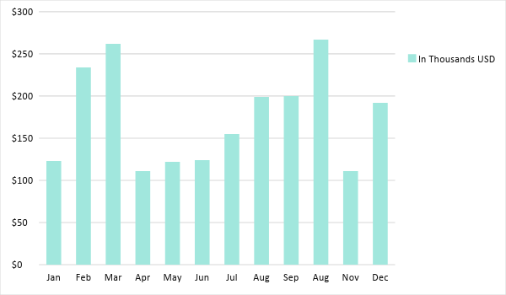

Monthly Revenue

The chart depicts the projected monthly revenue for [2019].

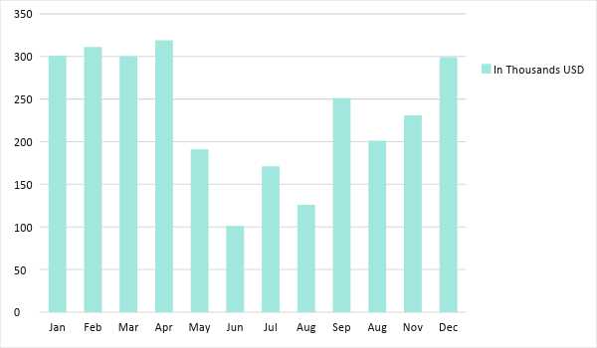

BUSINESS FINANCING

[Micro Craft Distillery’s] funds and assets come directly from the pockets of its owner, [Amanda W. Sain].

STATEMENTS

Profit and Loss Projection
 | FY2019 | FY2020 | FY2021
Sales | $900,000.00 | $530,000.00 | $690,000.00
Direct Cost of Sale | $450,000.00 | $230,000.00 | $340,000.00
Other Cost of Sale | $2,000.00 | $8,000.00 | $9,000.00
Total Cost of Goods Sold or COGS (Sales - Direct Cost of Sale - Other Cost of Sale) | $448,000.00 | $292,000.00 | $341,000.00
Gross Profit (Sales-Total Cost of Goods Sold) | $452,000.00 | $238,000.00 | $349,000.00
Gross Margin % (Gross Profit/Sales) | 50.22% | 44.91% | 50.58%
Operating Expenses
Rent | $0.00 | $0.00 | $0.00
Insurance | $200.00 | $2,000.00 | $2,000.00
Utilities | $30,000.00 | $30,000.00 | $40,000.00
Salary (Including Tax) | $90,000.00 | $90,000.00 | $90,000.00
Maintenance & Supplies | $3,000.00 | $4,000.00 | $4,500.00
Total Operating Expenses | $123,200.00 | $126,000.00 | $136,500.00
EBITDA (Total Cost of Sale-Total Operating Expenses) | $324,800.00 | $166,000.00 | $204,500.00
Depreciation | $0.00 | $0.00 | $0.00
Interest Expense | $0.00 | $0.00 | $0.00
Taxes Paid | $4,000.00 | $5,000.00 | $6,000.00
Net Profit (Gross Profit - Operating Expenses - Taxes - Interest) | $324,800.00 | $107,000.00 | $206,500.00

Balance Sheet Projection
 | FY2019 | FY2020 | FY2021
Cash | $300,000.00 | $400,000.00 | $300,000.00
Accounts Receivable | $0.00 | $0.00 | $0.00
Inventory | $0.00 | $0.00 | $0.00
Other Current Assets | $1,000.00 | $1,000.00 | $1,000.00
Total Current Assets | $301,000.00 | $401,000.00 | $301,000.00
Long-Term Assets | $9,000.00 | $3,000.00 | $4,000.00
Accumulated Depreciation | $5,000.00 | $6,000.00 | $9,000.00
Total Long-Term Assets (Long-Term Assets-Accumulated Depreciation) | $4,000.00 | -$3,000.00 | -$5,000.00
Total Assets (Total Current Assets + Total Long-Term Assets) | $305,000.00 | $398,000.00 | $296,000.00
Accounts Payable | $0.00 | $0.00 | $0.00
Notes Payable | $25,000.00 | $3,000.00 | $45,000.00
Other | $0.00 | $99,000.00 | $99,000.00
Total Liabilities | $25,000.00 | $102,000.00 | $144,000.00
Paid-in Capital | $5,000.00 | $5,000.00 | $5,000.00
Retained Earnings | $115,000.00 | $120,000.00 | $130,000.00
Total Owner's Equity (Total Assets - Total Liabilities) | $280,000.00 | $296,000.00 | $152,000.00
Total Liabilities & Equity (Total Liabilities/Total Owner's Equity) | 8.93% | 34.46% | 94.74%

Cash Flow Projection
 | FY2019 | FY2020 | FY2021
Operating Cash Beginning | $300,000.00 | $450,000.00 | $300,000.00
Sources of Cash | $90,000.00 | $90,000.00 | $90,000.00
Receivables | $0.00 | $0.00 | $0.00
Sales | $45,000.00 | $45,000.00 | $45,000.00
Others | $6,000.00 | $6,000.00 | $6,000.00
Total Cash | $441,000.00 | $591,000.00 | $441,000.00
Expenditures
Rent | $0.00 | $0.00 | $0.00
Insurance | $25,000.00 | $25,000.00 | $25,000.00
Utilities | $0.00 | $0.00 | $0.00
Salary (Including Tax) | $99,000.00 | $99,000.00 | $99,000.00
Maintenance & Supplies | $10,000.00 | $10,000.00 | $10,000.00
Total Expenditures | $134,000.00 | $134,000.00 | $134,000.00
Net Income/Loss (Total Cash - Total Expenditures) | $307,000.00 | $457,000.00 | $307,000.00

