BINGO BUSINESS PLAN

[INSERT NAME OF THE BUSINESS/COMPANY]
[INSERT THE COMPLETE BUSINESS/COMPANY ADDRESS]
[INSERT THE BUSINESS/COMPANY CONTACT NUMBERS]
[INSERT THE BUSINESS/COMPANY EMAIL ADDRESS]
[INSERT THE BUSINESS/COMPANY WEBSITE ADDRESS]

[INSERT DATE]

PREPARED BY:

[INSERT FULL NAME/S OF THE
PEOPLE WHO PREPARED THIS PLAN]

Index

Executive Summary [PAGE NUMBER]

Company Overview [PAGE NUMBER]

Products and Services [PAGE NUMBER]

Execution [PAGE NUMBER]

Operational Plan [PAGE NUMBER]

Financial Plan [PAGE NUMBER]

Executive Summary:

Fun Time [Bingo Bonanza] is an affordable but fun and entertaining bingo center based in [Nashville], [Tennessee]. The center gathers both the old and young generations who find joy playing this thrilling game of chance. The center will also be a good place for charitable organizations to hold their fundraising events at a discounted price.

Fun Time [Bingo Bonanza] plans to establish a solid customer base and will market the place via different social media platforms to encourage more youth to play games.

Company Overview:

Mission Statement: Fun Time [Bingo Bonanza] delivers premium quality entertainment and services to customers while it helps and partners with other organizations to realize any community-driven projects.

Philosophy: Fun Time [Bingo Bonanza] prioritizes excellence, integrity, and innovation in providing fun and entertainment to customers.

Vision: Fun Time Bingo Bonanza will become one of the leading fun and entertaining centers in Tennessee.

Outlook: Bingo game bridges generations. Both young and old show interest in playing bingo. The company takes advantage of this trend and aims to increase the number of playing customers from the younger generations.

Type of Industry: Gambling Industry

Business Structure: Sole Proprietorship

Ownership: Sole Proprietorship, [Theresa Rivera]

Start-Up Summary: Fun Time [Bingo Bonanza] has a start-up cost of [250K] USD. The [bingo center's] initial funds will be shouldered by the owner and will be used to pay for bingo supplies, rent, payroll, legal fees, and other necessary initial operating expenses.

Start-Up Funding
Start-Up Expenses | $138,900
Start-Up Assets | $111,100
Total Funding Required | $250,000
Assets
Non-Cash Assets from Start-Up | $71,100
Cash Requirements from Start-up | $8,000
Additional Cash Raised | $25,000
Cash Balance on Starting Date | $7,000
Total Assets | $111,100
Capital
Planned Investment
Owners | $250,000
Other | $0
Additional Investment Requirement | $0
Total Planned Investment | $250,000
Loss at Start-Up (Start-Up Expenses) | -$138,900
Total Capital | $111,100
Liabilities | $0
Total Capital and Liabilities | $111,100
Start-Up
Requirements
Start-Up Expenses
Rent - 6 Months | $48,000
Advertising | $4,500
Legal Fees | $2,000
Staff Training | $7,500
Insurance | $1,900
Other | $75,000
Total Start-Up Expenses | $138,900
Start-Up Assets
Cash Required | $15,000
Start-Up Inventory | $20,000
Other Current Assets | $25,000
Long-Term Assets | $51,100
Total Assets | $111,100
Total Requirements (Total Start-Up Expenses + Total Assets) | $250,000

Management Team:

Management Team | Role/Function | Skills
Cynthia Kring | Operations Manager | Communication, Leadership, Conflict Management
Harvey Hines | Marketing Manager | Market Awareness, Attention to Detail, Organization and Planning skills

Short- and Long-Term Goals and Milestones:

Short-Term Goals | Milestones
Recruit qualified applicants for the operations and marketing managerial positions | Shortlisted 5 qualified candidates last February 5, 2020
Hire sufficient staff to aid the management in the day-to-day operations | A total of 5 out of 8 personnel needed have been hired last February 10, 2020
Long-Term Goals | Milestones
Secure a solid customer base in Tennessee | About 25% of the citizens in Nashville have already bought coupons for the first bingo bonanza game on March 15, 2020
Partner with organizations for fundraising events | Finalized a list of charitable organizations to partner and collaborate with

Products and Services

Product/Service Description: Fun Time [Bingo Bonanza] offers a different kind of bingo for its customers. The [bingo hall’s] primary game is the bingo bonanza, which is participated by the majority of customers. The bingo center allows organizations to rent the hall for their fundraising events at affordable rates.

Value Proposition: Fun Time Bingo Bonanza enables customers to enjoy and have fun with family and friends at a very affordable rate.

Pricing Strategy: Fun Time Bingo Bonanza uses the penetration pricing approach as its pricing strategy. The bingo center will offer buy-in games as low as $2 equivalent to 1 or 2 regular bingo games.

Execution

Marketing Plan: Fun Time Bingo Bonanza plans to establish a solid market base in Tennessee through the active participation of both the older and the younger generations living in the community. To gather more patrons from this customer base, the bingo center plans to strengthen its social media exposure and provide special prizes in some games. It will also make sure that its services suit the tastes and preferences of the youngsters.

Market Research: Bingo has always been considered as an opportunity for a social gathering among friends. This opportunity is not limited to the older generations though as the youth of today also has shown interest to play this thrilling game of chance. The bingo center’s survey results show that youth from ages 15-24 show interest in having a bingo hall in Nashville, Tennessee.

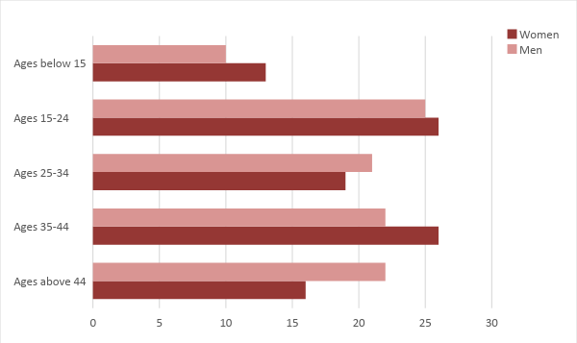

SWOT Analysis | Strengths | Weaknesses | Opportunities | Threats
Fun Time Bingo Bonanza | - Affordable price for its bingo games | - Has a small area as compared to its competitors | - The increasing interest of both old and younger generations on affordable bingo centers | - The influence of existing bingo centers in Tennessee
Tennessee Bingo Center | - Has a bingo center and snack bar | - Location is distant from the city of Nashville | - A demand to open a branch in the main city | - Affordable bingo centers in Nashville
All-Time Bingo | - High-end bingo hall in Tennessee | - Expensive charge for each bingo game | - Most middle-income people play in high-end bingo halls | - Affordable bingo halls that offer quality bingo games and awesome prizes

Marketing Strategy: Fun Time Bingo Bonanza aims to strengthen its social media exposure and gain a sufficient number of bingo customers from the younger generations, particularly those ages 15-24.

The recently employed marketing manager has accomplished the following tasks and activities to effectively implement the bingo center’s marketing strategies.

Marketing Strategy | Activities | Timeline | Success Criteria
Strengthen social media exposure | Post information about the bingo center’s games | ASAP | Generate 1,000 followers on the Facebook page by the end of March 2020
Attract customers from the younger generation | Prepare prizes suitable to the youth | March 10, 2020 | Finalize a list of items/coupons that the youth want as prizes on March 5, 2020

Organizational Structure:

Fun Time Bingo Bonanza follows a simple organizational structure. The bingo center is owned by Theresa Rivera and is assisted by the operations and marketing managers who handle the day-to-day operations. The bingo center will employ additional personnel as needed.

Operational Plan:

Location and Facilities

Fun Time [Bingo Bonanza] occupies a [6,000 sq. ft.] space in [858 Dickerson Pike Cleveland Park], [Nashville, TN 37201, USA]. It has available restrooms and parking spaces for customers to use. The location is spacious enough to host different bingo games for about 100 people.

Tools and Equipment Checklist

Software | Quantity
Bingo Game | 1
POS | 1
Hardware | Quantity
Computers, Smart TV | 5, 3
Sound System | 2

IT Infrastructure

The following table shows the IT infrastructure of Fun Time Bingo Bonanza.

Infrastructure | Existing (Y/N) | Description
Social Media | Y | The bingo center owns a Facebook account.
Latency Proof | N | There are certain delays in network connections.
Downtime | N | No encountered interruptions on the network.

Financial Plan

Assumptions

The projected financial statements of Fun Time Bingo Bonanza is created with reference to the financial assumptions generated from current market trends. The financial assumptions referred to are as follows:
- The bingo center expects to gain an increase of 40% in sales during the second year of its operations.
- The prevailing market interest rate is 4.3% and the tax on compensation equals to 20% of the total compensation amount.
- There will be no drastic changes in costs during the year but inflation is expected to rise to about 5% during the third year.

Monthly Expense

The chart below presents the estimated monthly expenses of Fun Time Bingo Bonanza for the year 2020.
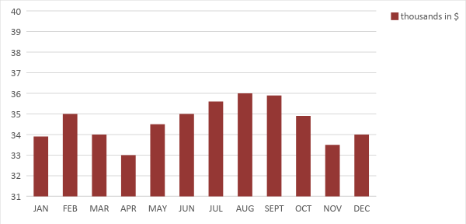

Monthly Revenue

The chart below presents the estimated monthly revenues of Fun Time Bingo Bonanza for the year 2020.

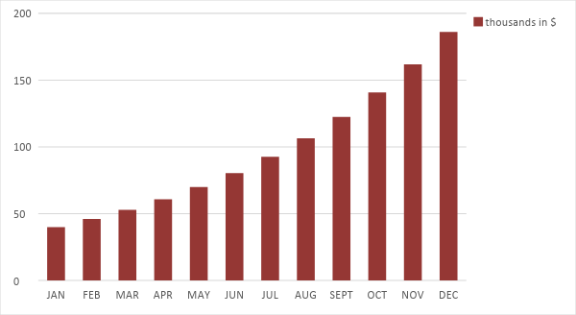

Business Financing

The owner of Fun Time Bingo Bonanza, Theresa Rivera, obtained a business loan amounting to $250,000 to fund the initial operations of the bingo center. The business loan is payable within 5 years.

Statements

Profit and Loss Projection
 | FY2020 | FY2021 | FY2022
Sales | $429,000.00 | $600,600.00 | $840,840.00
Direct Cost of Sale | $193,050.00 | $270,270.00 | $378,378.00
Other Cost of Sale | $5,100.00 | $5,202.00 | $5,306.04
Total Cost of Goods Sold or COGS (Sales - Direct Cost of Sale - Other Cost of Sale) | $230,850.00 | $325,128.00 | $457,155.96
Gross Profit (Sales-Total Cost of Goods Sold) | $198,150.00 | $275,472.00 | $383,684.04
Gross Margin % (Gross Profit/Sales) | 46.19% | 45.87% | 45.63%
Operating Expenses
Rent | $96,000.00 | $96,000.00 | $96,000.00
Insurance | $3,800.00 | $3,800.00 | $3,800.00
Utilities | $7,000.00 | $7,245.00 | $7,498.58
Salary (Including Tax) | $60,000.00 | $60,000.00 | $60,000.00
Maintenance & Supplies | $8,000.00 | $8,280.00 | $8,569.80
Total Operating Expenses | $174,800.00 | $175,325.00 | $175,868.38
EBITDA (Total Cost of Sale-Total Operating Expenses) | $56,050.00 | $149,803.00 | $281,287.59
Depreciation | $2,100.00 | $2,100.00 | $2,100.00
Interest Expense | $10,750.00 | $10,750.00 | $10,750.00
Taxes Paid | $12,000.00 | $12,000.00 | $12,000.00
Net Profit (Gross Profit - Operating Expenses - Taxes - Interest) | $600.00 | $77,397.00 | $185,065.67

Balance Sheet Projection
 | FY2020 | FY2021 | FY2022
Cash | $20,600.00 | $76,255.00 | $204,337.63
Accounts Receivable | $60,000.00 | $65,000.00 | $74,750.00
Inventory | $20,000.00 | $24,800.00 | $30,752.00
Other Current Assets | $25,000.00 | $25,000.00 | $25,000.00
Total Current Assets | $125,600.00 | $191,055.00 | $334,839.63
Long-Term Assets | $51,100.00 | $51,100.00 | $51,100.00
Accumulated Depreciation | $2,100.00 | $4,200.00 | $6,300.00
Total Long-Term Assets (Long-Term Assets-Accumulated Depreciation) | $49,000.00 | $46,900.00 | $44,800.00
Total Assets (Total Current Assets + Total Long-Term Assets) | $174,600.00 | $237,955.00 | $379,639.63
Accounts Payable | $95,000.00 | $90,000.00 | $85,000.00
Notes Payable | $2,000.00 | $2,400.00 | $2,880.00
Other | $1,500.00 | $2,000.00 | $2,500.00
Total Liabilities | $98,500.00 | $94,400.00 | $90,380.00
Paid-in Capital | $250,000.00 | $250,000.00 | $250,000.00
Retained Earnings | $600.00 | $77,997.00 | $263,062.87
Total Owner's Equity (Total Assets - Total Liabilities) | $76,100.00 | $143,555.00 | $289,259.63
Total Liabilities & Equity (Total Liabilities/Total Owner's Equity) | 129.43% | 65.76% | 31.25%

Cash Flow Projection
 | FY2020 | FY2021 | FY2022
Operating Cash Beginning | $15,000.00 | $20,600.00 | $76,255.00
Sources of Cash | $10,000.00 | $12,500.00 | $15,625.00
Receivables | $60,000.00 | $65,000.00 | $74,750.00
Sales | $105,000.00 | $147,000.00 | $205,800.00
Others | $5,400.00 | $6,480.00 | $7,776.00
Total Cash | $195,400.00 | $251,580.00 | $380,206.00
Expenditures
Rent | $96,000.00 | $96,000.00 | $96,000.00
Insurance | $3,800.00 | $3,800.00 | $3,800.00
Utilities | $7,000.00 | $7,245.00 | $7,498.58
Salary (Including Tax) | $60,000.00 | $60,000.00 | $60,000.00
Maintenance & Supplies | $8,000.00 | $8,280.00 | $8,569.80
Total Expenditures | $174,800.00 | $175,325.00 | $175,868.38
Net Income/Loss (Total Cash - Total Expenditures) | $20,600.00 | $76,255.00 | $204,337.63

