ART GALLERY SALES PLAN
[Canvas Sales Plan]

[2019 – 2020]

Index

Executive Summary [PAGE NUMBER]
Company Overview [PAGE NUMBER]
Products and Services [PAGE NUMBER]
Marketing Analysis [PAGE NUMBER]
Strategy and Implementation [PAGE NUMBER]
Management and Personnel [PAGE NUMBER]
Sales Action Plan [PAGE NUMBER]

EXECUTIVE SUMMARY

[Canvas] is an art gallery strategically located in downtown [Key West, Florida]. The art gallery is owned by locally and internationally recognized painters Lino Reyes and Frida Osmond.

[Canvas] positions itself as the art hub of the city. It will host art exhibits, art auctions, and will display for sale the artwork of local artists. While it partners with leading artists in the country and around the world for the art shows, it will also host special and corporate events.

To keep up with the competitors around the city, the company management will aggressively conduct marketing and sales drives to boost the gallery's presence in the area.

COMPANY OVERVIEW

Mission Statement:

[Canvas] dedicates itself to preserving and promoting the artworks of local Key West artists and some guests from around the world. The gallery wants to educate and engage the public about local, state, and national issues through visual arts.

Philosophy:

[Canvas] identifies with the following values:

- Responsibility towards the artists and the community
- Creativity in curating relevant and entertaining art shows
- Excellence in doing its duties towards its staff, artists, guests, patrons, and the community.

Vision:

[Canvas] is very much accessible to everyone in Florida and the rest of the world. It is a vibrant space to enjoy arts and foster social engagement, creativity, and critical thinking.

Outlook:

The industry of art galleries and museum is an extremely fragmented one. Most galleries only employ about four to five staff. Considered as one of the thriving industries in the country, the art galleries and museums industry generated around [$9 billion] annually. Experts suggest that the growth of the industry will not slow down any time soon.

Type of Industry: Art Gallery and Museum Industry

Business Structure: Partnership

Ownership: Partners, Frida Osmond, and Lino Reyes

Start-Up Summary:

The owners set aside an amount of [30K] USD for the rent, insurance, supplies, and payroll.

Start-Up Funding
Start-Up Expenses | $20,000
Start-Up Assets | $10,000
Total Funding Required | $30,000
Assets
Non-Cash Assets from Start-Up | $5,000
Cash Requirements from Start-up | $3,000
Additional Cash Raised | $1,000
Cash Balance on Starting Date | $1,000
Total Assets | $10,000
Capital
Planned Investment
Owner | $30,000
Other | $0
Additional Investment Requirement | $0
Total Planned Investment | $30,000
Loss at Start-Up (Start-Up Expenses) | -$20,000
Total Capital | $10,000
Liabilities | $0
Total Capital and Liabilities | $10,000
Start-Up
Requirements
Start-Up Expenses
Rent - 5 Months | $8,000
Advertising | $1,000
Legal Fees | $1,000
Staff Training | $2,000
Insurance | $5,000
Other | $3,000
Total Start-Up Expenses | $20,000
Start-Up Assets
Cash Required | $3,000
Start-Up Inventory | $3,000
Other Current Assets | $1,500
Long-Term Assets | $2,500
Total Assets | $10,000
Total Requirements (Total Start-Up Expenses + Total Assets) | $30,000

PRODUCTS AND SERVICES

Product/Service Description:

[Canvas] offers the perfect venue for artists to exhibit their artworks to the public. The gallery's relationship with art collectors in Florida and the rest of the world will boost the chance of sales of their works.

Value Proposition:

A hub spot for arts. [Canvas] inspires creativity and critical thinking. It is a place known for world-class quality works of art and a meeting place for creative minds.
Pricing Strategy:

The gallery prices artwork depending on the artist's past sales record. Usually, artworks are priced using a cost-plus strategy. The management uses a competitive pricing strategy for the leasing of the venue for art events and other shows.

MARKETING ANALYSIS

Similar to the rest of the country, the art scene in [Key West, Florida] is thriving. New generation of artists and established ones are creating more artworks to respond to the increasing demands from private art collectors and other institutions. As a result, the need for more art galleries in the locale has increased and, at the same time, galleries are holding more shows this year.

Another shift in the industry is the use of online platforms. Artists, galleries, and museums are now using social media and websites to market artworks globally.

Market Segmentation

[Canvas] identifies its core market in four categories. These are artists, private art collectors, business institutions, and tourists. The gallery will focus its marketing strategy in turning the venue as a premier art hub..

The graph below shows the current distribution of the gallery’s market.

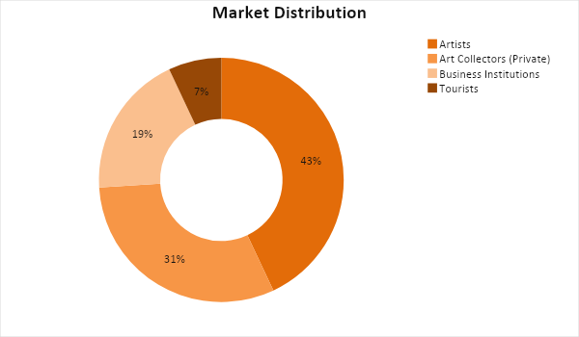

Target Market Segmentation Strategy

Artists

- They are the main market of the gallery.
- Canvas will work with them to showcase and sell their works for a commission.

Art Collectors (Private)

- These individuals are known to frequent art galleries to purchase works to add to their collection.
- Canvas will invite them during art shows and will send them the gallery’s current artwork portfolio.

Business Institutions

- The gallery will offer space to businesses to hold events.
- Canvas is a great venue for business meetings and fundraising.

Tourists

- Key West is a tourist destination city.
- Canvas will tie up with tour companies to include the gallery as one of the tour stops.

STRATEGY AND IMPLEMENTATION

Target Market Strategy

The art gallery industry has become competitive in Florida. [Canvas] aims to attract its target market by offering a customer-centric service and an art conducive venue. The gallery targets an increase of [5%] in the number of shows held, paintings sold, and venue leases this year.

SWOT Analysis | Strengths | Weaknesses | Opportunities | Threats
Canvass | - Employs a customer-centric business approach  - Situated in a strategic location | - Art collection needs to increase  - Need to diversify art shows | - Demand for artworks is rising, which means an increase in sales | - Established competitors have more contacts with art collectors
Floridian Museum | - Established museum  - A large collection of artworks | - Expensive venue  - Prices artworks high to maximize profit | - Customer buying power is on the rise; the gallery can stay competitive without changing its pricing practices | - Artists who would rather go straight to art collectors to sell their artwork
Gillian Gallery | - Offers very low priced artworks | - Quality of artworks is not consistent | - Number of artists is growing; this presents a chance to develop a more consistent quality | - Other galleries are faster to establish quality

Sales Strategy and Forecast

To improve its sales, [Canvas] will do both the traditional and modern ways of promoting its shows, collections, and venue.

The gallery targets the following monthly sales:

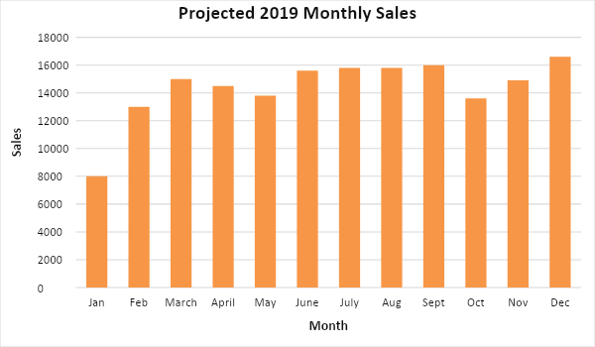

The next graph shows the forecasted sales distribution:

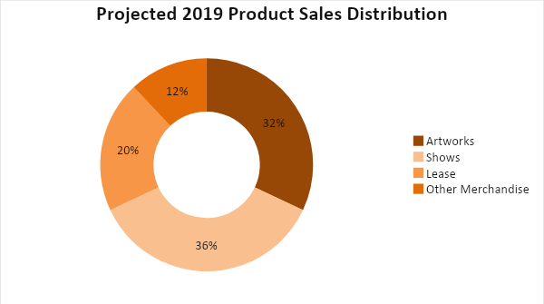

To stand out from the competition, the gallery will focus on effective customer service by making sure it provides a worthwhile experience to visitors and art collectors. Through an aggressive promotional campaign, the gallery hopes that it becomes the main art hub of Key West.

Sales Strategy | Activities | Timeline | Success Criteria
Gallery promotions | - Print ads promoting the gallery as the art hub the city is published in magazines and local papers.  - Publish online ads in social media platforms especially Pinterest and Instagram. | Online and print promotions will run throughout the year | - Digital marketing increases the online traffic of the gallery’s website  - Increase in number of art shows and artwork sales
Customer-centric approach | - Canvas personnel will be trained on how to provide excellent customer care | ASAP | - Canvas receives positive feedback about how its personnel treated guests

Marketing Strategy

The management plans to focus more on introducing the art gallery to the general public. Print advertisements will be published in local newspapers and art and lifestyle magazines. The marketing team will also leverage social media to promote the business and its products. Weekly events will also be held to encourage potential customers to visit the gallery. At the same time, introductory and promotional letters are sent to art collectors and businesses. In addition, [Canvas] will encourage loyal customers to promote the place through word of mouth.

Here are some updates of the gallery's marketing drive:

Milestones

Marketing Strategy | Activities | Timeline | Success Criteria
Print ads | - The marketing team designed banners and flyers  - Create promotional articles that will be published in local newspapers and magazines | January 15, 2019 | - Flyers and banners are distributed to key locations as identified by the marketing team.  - Two articles were published on Florida Times and Key West Lifestyle magazine.
Weekly shows | - The marketing and sales teams will develop a weekly show calendar for the whole year | February 2, 2019 | - The calendar is approved by the CEO
Introductory and quarterly portfolio | - The marketing and sales teams are tasked to make letters and portfolio for both local and regional art collectors | ASAP | - Letters and portfolio are sent before the end of February

MANAGEMENT AND PERSONNEL

The owners of [Canvas] are both established artists in the international art scene. Lino Reyes serves as the CEO and General Manager of the company due to his experience as a senior manager for an advertising company. Frida Osmond will serve as Marketing Manager and Clients' Relations Officer.

Below is the organizational structure of the company:

General Manager
CEO
Marketing Team
Sales Team
HR Team
Promotions
Customer Acquisition
Training
Events
Customer Care
Payroll
Inventory

SALES ACTION PLAN

The sales goals and their corresponding activities are listed in the table below. Key performance indicators (KPIs) and other details are also included to measure how successful the activities in achieving the goals.

Sales Goals | Action Items | Start Date | End Date | KPIs | Owner
1. Hold at least one art exhibit every month | - Create a lineup of artists to do an art show every month. - Invite potential art buyers to the shows. | - January 14, 2019  - January 20, 2019 | - January 25, 2019  - January 25, 2019 | - The final proposal approved before January 25, 2019  - Finalized list of invited guests | Sales Team,  Marketing Team
2. Increase in venue leasing | - Sales team to promote the gallery as the best venue to hold corporate and private events | - January 10, 2019 | - February 25, 2019 | - Confirmed bookings for the first quarter | Sales team

