[INSERT COMPANY NAME]
BUSINESS PLAN FOR FISCAL YEAR [INSERT YEAR]
[INSERT DATE]

[LEROY E. HEARD]
[LEROY@MIDDLEFORKADVS.COM]
[WWW.MIDDLEFORKADVS.COM]
[208-940-3852 | 208-303-8219]
[4646 MAPLE AVENUE]
[SALMON, ID 83467 USA]
WATER SPORTS BUSINESS PLAN

INDEX

EXECUTIVE SUMMARY  COMPANY OVERVIEW  PRODUCTS AND SERVICES  EXECUTION  OPERATIONAL PLAN  FINANCIAL PLAN | [INSERT PAGE NO.]  [INSERT PAGE NO.]  [INSERT PAGE NO.]  [INSERT PAGE NO.]  [INSERT PAGE NO.]  [INSERT PAGE NO.]

EXECUTIVE SUMMARY

[Middle Fork Adventures] facilitates water sports at the [Middle Fork section of the Salmon River] for young adventurous tourists. The company specializes in [whitewater rafting] and [kayaking], offering the best safety equipment and employing professionally trained guides to ensure the best experience possible for customers. Growing interest in extreme outdoor activities among working millennial will help make businesses such as [Middle Fork Adventures profitable].

COMPANY OVERVIEW

Mission Statement: [Middle Fork Adventures] is committed to facilitating safe and entertaining water sports activities for the free-spirited and adventurous individuals.

Philosophy: Professionalism and customer focus are central [Middle Fork Adventures] business operations. The company makes sure that the safety and well-being of its guests are the top priority.

Vision: [Middle Fork Adventures] aims to contribute to responsible tourism in Idaho by providing excellent customer service and observing safety measures that will ensure a pleasant and enjoyable experience for its customers.

Outlook: The water sports has seen tremendous growth over the past [5 years] as more young adults in America are engaging in outdoor recreation involving physical activity. Despite seasonal demands, companies providing such services foresee considerable growth as the need for extreme recreation becomes imperative for this particular market.

Type of Industry: Tourism Industry / Water Sports Industry

Business Structure: Limited Partnership

Ownership: [Middle Fork Adventures] is owned by partners [Leroy Heard] and [Jesse Larson], and limited partners [Damian Clinton] and [Vanessa Timid]. Each owns [25%] of the company's shares of profits and losses. Only [Leroy Heard] and [Leroy Heard] have managerial responsibilities.

Start-Up Summary: The [$100,000.00] start-up cost covers payments for the campsite land, supplies, equipment, utilities, and other operational expenses.

Start-Up Funding
Start-Up Expenses | $20,000.00
Start-Up Assets | $30,000.00
Total Funding Required | $50,000.00
Assets
Non-Cash Assets from Start-Up | $10,000.00
Cash Requirements from Start-up | $10,000.00
Additional Cash Raised | $0.00
Cash Balance on Starting Date | $10,000.00
Total Assets | $30,000.00
Capital
Planned Investment
Owners | $40,000.00
Additional Investment Requirement | $10,000.00
Total Planned Investment | $50,000.00
Loss at Start-Up (Start-Up Expenses) | -$20,000.00
Total Capital | $30,000.00
Total Capital and Liabilities | $30,000.00
Start-Up
Requirements
Start-Up Expenses
Lease | $5,000.00
Equipment and Supplies | $5,000.00
Utilities and Maintenance | $5,000.00
Marketing and Promotion | $2,000.00
Others | $3,000.00
Total Start-Up Expenses | $20,000.00
Start-Up Assets
Cash Required | $20,000.00
Other Current Assets | $5,000.00
Long-Term Assets | $5,000.00
Total Assets | $30,000.00
Total Requirements (Total Start-Up Expenses + Total Assets) | $50,000.00

Management Team:

Management Team | Role/Function | Skills
Leroy Heard | Operations Manager | Resource management, interpersonal communication
Jesse Larson | HR & Admin Manager | Conflict management, human resource management
Amelia Sands | Finance Manager | Accounting, budget management

Short- and Long-Term Goals and Milestones:

Short-Term Goals | Milestones
Acquire business permit | - Completed and submitted requirements to state wildlife services (October 13, 2018)  - Received business permit to operate (December 1, 2018)
Hire and train guides | - Hired 5 guides (3rd week of November 2018)  - Provided basic training (1st week of December)
Long-Term Goals | Milestones
Improve customer experience | - Attended training camp for outdoor recreation safety (November 7, 2018)  - Drafted company policies and regulations on safety (December 7, 2018)
Secure repeat business | -Created sales and marketing plan (December 10, 2018)

PRODUCTS AND SERVICES

Product/Service Description: [Middle Fork Adventures] facilitates single- and multi-day rafting trips and kayak games along the [Middle Fork section of Idaho's Salmon River]. The company provides all the equipment and tools needed for a trip or game. Each guest participant will be given full protective gear and oriented by a [Middle Fork Adventures] tour guide.

Value Proposition: All employees of [Middle Fork Adventures] are professionally trained and certified to assist and facilitate in extreme outdoor recreational activities such as whitewater rafting and kayaking. The company has also secured appropriate insurance policies. This ensures a safe and enjoyable experience for [Middle Fork Adventures] clients.

Pricing Strategy: The business utilizes premium pricing, considering its investments on the customers' safety and security.

EXECUTION

Marketing Plan: [Middle Fork Adventures] targets employed millennial aged [22 to 35]. Attracting this market requires aggressive online marketing, including social media campaigns and customer experience optimization in the company's official website.

Market Research: As of [2018], more than [50%] of America's adult population has made huge investments in recreation involving physical activity. Extreme outdoor activities are gaining popularity among millennial due to a shift in the perception of recreation. Water sports has become one of the most preferred modes of recreation alongside camping and trekking.

SWOT Analysis | Strengths | Weaknesses | Opportunities | Threats
Middle Fork Adventures | Safe and secure trips facilitated by professionally trained guides | Premium priced services | Offer unique tour and game packages to add value to premium prices | Reluctance of market to pay for premium services
River Drifters | Affordable package tours | Poor amenities and customer service | Brand franchising | Other businesses providing better services and amenities
Salmon River Experience | Offers a wide range of outdoor recreational services | Inaccessible location | Offer additional transportation services | Potential customers losing interest in the business due to location

Marketing Strategy: In order to reach [Middle Fork Adventures] millennial target market, online marketing will be central to the company's marketing strategies. Forming a network within the neighboring cities requires aggressive word-of-mouth marketing and community involvement.

Marketing Strategy | Activities | Timeline | Success Criteria
Social media | - Facebook, Twitter, and Instagram pages  - Photo and video promotion | October 2018 to present | Regular page visits and likes
Website and SEO | - Website with chat support and booking capacity  - Online directory listings | November 2018 to present | - Increase in the number of inquiries/searches/web visits
Community networking | - Word-of-mouth recommendations from friends and colleagues  - Participation in local events | September 2018 to present | - Increase in the number of inquiries through phone or personal communication

Organizational Structure:

OPERATIONS MANAGER
HR & ADMIN MANAGER
FINANCE MANAGER
SALES & MARKETING ASSOCIATE
EMPLOYEES

OPERATIONAL PLAN

Location and Facilities: The main office of [Middle Fork Adventures] is located at a small building in Maple Avenue and is easily accessible through the [I5 US-93 Highway]. All activities are done at the [Middle Fork section of the Salmon River], where a cabin at the owners' riverside property serves as a guest lounge.

Tools and Equipment Checklist:

Software | Quantity
Square POS | 1
Set more scheduling software | 1
Hardware | Quantity
Rafts | 10
Kayaks | 10

IT Infrastructure

Infrastructure | Existing (Y/N) | Description
POS system | N | For installment
Website | N | Under development
Social media | Y | Facebook, Instagram, Twitter

FINANCIAL PLAN

Assumptions:

The financial plan for Middle Fork Adventures is based on the following assumptions:

- Monthly total expenses will increase by [1.2%] beginning Q3 of [2019].
- Monthly revenue will increase by [2.8%] beginning Q3 of [2019].
- An increase in customers is expected from June to September.

Monthly Expense

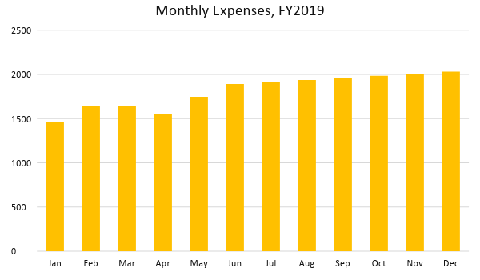

Monthly Revenue

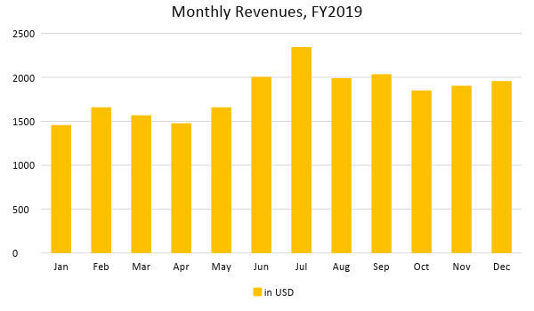

Business Financing: The owners will release [$40,000.00 of the $50,000.00] total planned investment from their personal accounts. The remaining [$10,000.00] will be acquired through an unsecured line of credit from the Idaho Central Credit Union.

Statements

Profit and Loss Projection
 | FY2019 | FY2020
Sales | $21,903.51 | $30,007.81
Direct Cost of Sale | $5,475.88 | $7,501.95
Other Cost of Sale | $1,098.00 | $1,546.11
Total Cost of Goods Sold or COGS (Sales - Direct Cost of Sale - Other Cost of Sale) | $6,573.88 | $9,048.06
Gross Profit (Sales-Total Cost of Goods Sold) | $15,329.63 | $20,959.75
Gross Margin % (Gross Profit/Sales) | 69.99% | 69.85%
Operating Expenses
Lease | $5,000.00 | $5,000.00
Equipment and Supplies | $5,000.00 | $2,500.00
Utilities and Maintenance | $5,000.00 | $3,500.00
Marketing and Promotion | $2,000.00 | $2,000.00
Others | $3,000.00 | $2,000.00
Total Operating Expenses | $20,000.00 | $15,000.00
EBITDA (Total Cost of Sale-Total Operating Expenses) | -$13,426.12 | -$5,951.94
Depreciation | $0.00 | $500.00
Interest Expense | $0.00 | $0.00
Taxes Paid | $100.00 | $150.00
Net Profit (Gross Profit - Operating Expenses - Taxes - Interest) | -$4,770.37 | $5,809.75

Balance Sheet Projection
 | FY2019 | FY2020
Cash | $20,000.00 | $20,000.00
Accounts Receivable | $0.00 | $1,000.00
Inventory | $0.00 | $1,000.00
Other Current Assets | $5,000.00 | $5,000.00
Total Current Assets | $25,000.00 | $27,000.00
Long-Term Assets | $5,000.00 | $5,000.00
Accumulated Depreciation | $0.00 | $500.00
Total Long-Term Assets (Long-Term Assets-Accumulated Depreciation) | $5,000.00 | $4,500.00
Total Assets (Total Current Assets + Total Long-Term Assets) | $30,000.00 | $31,500.00
Accounts Payable | $500.00 | $1,200.00
Notes Payable | $700.00 | $500.00
Other | $1,500.00 | $2,000.00
Total Liabilities | $2,700.00 | $3,700.00
Paid-in Capital | $40,000.00 | $50,000.00
Retained Earnings | $27,659.43 | $31,032.00
Total Owner's Equity (Total Assets - Total Liabilities) | $27,300.00 | $27,800.00
Total Liabilities & Equity (Total Liabilities/Total Owner's Equity) | 9.89% | 13.31%

Cash Flow Projection
 | FY2019 | FY2020
Operating Cash Beginning | $20,000.00 | $20,000.00
Sources of Cash
Receivables | $0.00 | $1,000.00
Sales | $21,903.51 | $30,007.81
Others | $5,000.00 | $5,000.00
Total Cash | $46,903.51 | $56,007.81
Expenditures
Lease | $5,000.00 | $5,000.00
Equipment and Supplies | $5,000.00 | $2,500.00
Utilities and Maintenance | $5,000.00 | $3,500.00
Marketing and Promotion | $2,000.00 | $2,000.00
Others | $3,000.00 | $2,000.00
Total Expenditures | $20,000.00 | $15,000.00
Net Income/Loss (Total Cash - Total Expenditures) | $26,903.51 | $41,007.81

