T-SHIRT COMPANY BUSINESS PLAN
Business Plan For Fiscal Year 2020
March 30, 2018
[Cheryl Downing] [cherdowning@gmail.com]
[303-965-9491] [www.coinwashexpress.com]
[2076 S University Blvd University Park, Denver, CO 80210, USA]

INDEX
[Page Number]
[Page Number]
[Page Number]
[Page Number]
[Page Number]
[Page Number]

Executive Summary
Company Overview
Products and Services
Execution
Operational Plan
Financial Plan

Executive Summary:

[Twisted Images] is a t-shirt manufacturing business that allows individuals to custom design their shirts. With the help of cutting-edge technology, the company can manufacture custom shirt printing at minimal costs, thus making the business attractive to its target market of individuals between the age of [13-45], social groups, and others who are interested in custom-made shirts.

By marketing the products through social media networking and influencer marketing, the business will grow by [12%] per year in the next five years.

Company Overview:

Mission Statement: [Twisted Images] offers the finest custom shirts at great prices as a way for customers to express themselves.

Philosophy: [Twisted Images] leverages on cutting-edge technology and high-quality products at reasonable prices, with quick turn-around times to ensure customer satisfaction.

Vision: [Twisted Images] strives to be a leading provider of custom shirts for individuals or groups in Illinois and, eventually, all states in the United States.

Outlook: The economy is showing stability, with rising income for consumers and businesses alike. The global market for custom t-shirt printing is seen to grow with rising household income. The custom t-shirt printing industry also shows a positive impact on the fashion industry, exhibiting higher acceptance for business. The global market is expected to cross [$10] billion in revenue by [2025].

Type of Industry: Clothing and Graphic Design

Business Structure: Sole Proprietorship

Ownership: Sole Proprietorship, Terrence Holt

Start-Up Summary: The startup cost of [$135,000.00] will be provided by the owner. This amount will be used primarily for rent, insurance, supplies, and payroll.

Start-Up Funding
Start-Up Expenses | $85,000
Start-Up Assets | $50,000
Total Funding Required | $135,000
Assets
Non-Cash Assets from Start-Up | $15,000
Cash Requirements from Start-up | $10,000
Additional Cash Raised | $10,000
Cash Balance on Starting Date | $15,000
Total Assets | $50,000
Capital
Planned Investment
Owner | $135,000
Other | $0
Additional Investment Requirement | $0
Total Planned Investment | $135,000
Loss at Start-Up (Start-Up Expenses) | -$85,000
Total Capital | $50,000
Liabilities | $0
Total Capital and Liabilities | $50,000
Start-Up
Requirements
Start-Up Expenses
Rent - 5 Months | $15,000
Advertising | $10,000
Legal Fees | $10,000
Staff Training | $30,000
Insurance | $20,000
Other | $0
Total Start-Up Expenses | $85,000
Start-Up Assets
Cash Required | $35,000
Start-Up Inventory | $5,000
Other Current Assets | $5,000
Long-Term Assets | $5,000
Total Assets | $50,000
Total Requirements (Total Start-Up Expenses + Total Assets) | $135,000

Management Team:

Management Team | Role/Function | Skills
Amy Beck | Store Manager | Communication, People Management, Teamwork, and Resilience
Jenny Taylor | HR Manager | Communication, Onboarding, People Skills, and Performance Management
Cristal Flores | Marketing Manager | Communication, Sales and Marketing, and Event Planning

Short- and Long-Term Goals and Milestones:

Short-Term Goals | Milestones
- Find retailers and distributors | Shortlist of distributors available. Final decisions to be made by the end of the month.
- Continue hiring staff | List of 5 applicants for interview
Long-Term Goals | Milestones
- Identify customer trends | Studies underway
- Create a dynamic, long-term marketing strategy | Hired a marketing manager to spearhead the campaign

Products and Services

Product/Service Description: [Twisted Images] offers a variety of options for custom designed shirts in a variety of fabrics and colors, using the printer sublimation technology that allows for high-quality, high-resolution prints.

Value Proposition: [Twisted Images] offers high-quality prints thanks to sublimation technology, allowing freedom of expression whether for fashion or social awareness.

Pricing Strategy: [Twisted Images] remain competitive with other custom shirt designing companies. Prices vary depending on the fabric, size, and print for each custom shirt.

Execution

Marketing Plan: [Twisted Images] will focus on online marketing especially on the use of social media such as Facebook, Instagram, and Twitter. This will include social media influencer campaigns to help promote the company.

Market Research: [Twisted Images] segments its market into three distinct groups based on the products it offers. Customers who frequently use graphic shirts tend to be teenagers or individuals in their mid-[20s], while those who prefer artwork tend to be older, between the late [20s] and mid-[40s]. Finally, there is a separate group that orders in bulk mostly coming from schools, companies, and others.

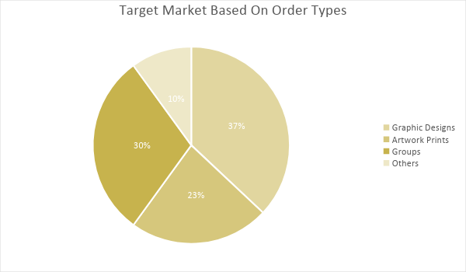

SWOT Analysis | Strengths | Weaknesses | Opportunities | Threats
Twisted Images | Great downtown location | Does not have the capacity to compete with larger companies yet | Cost-effectiveness of marketing strategies | A growing industry paves the way to more competition
Ink My Design Custom Shirts | Known brand with a large customer base | Problems with handling and shipping |  | An economic downturn can severely affect purchasing power
Unique Designs | Experienced in the industry | Niche market (millennials) | Creating a physical store can help widen customer base | The emergence of new custom t-shirt businesses

Marketing Strategy: [Twisted Images] will leverage on fun and pleasing ordering experience, with an easy-to-use website interface for those who wish to order online. It will also partner with different local groups to maximize exposure of the business, as well as use social media to advertise products, projects, and company updates.

Marketing Strategy | Activities | Timeline | Success Criteria
Launch an online store and create social media accounts | Offer exclusive promos for the first 250 online purchases and 200 in-store customers. | April 1, 2019 | $35,000 worth of online sales in the first month $10,000 in sales at the physical location
Partner with local businesses and groups | Meet with decision-makers to discuss marketing and discounts | ASAP | Positive responses from at least 10 companies or organizations

Organizational Structure:
The following shows the organizational structure of [Twisted Images].

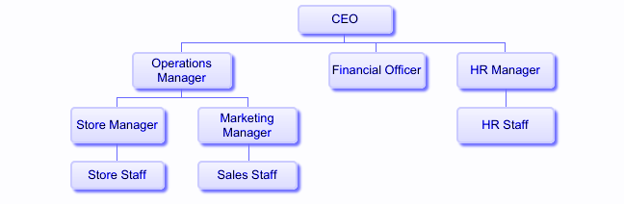
Operational Plan:
Location and Facilities
The boutique is located at [697] Walkers Ridge Way, Bartlett, Illinois. The physical store will have a display area of custom shirts and a service area for customers to place their orders and customize their designs. It will also have a work area with [3] sewers and [2] printers for shirt manufacturing, and a storage area for the items that are ready for release or shipping.

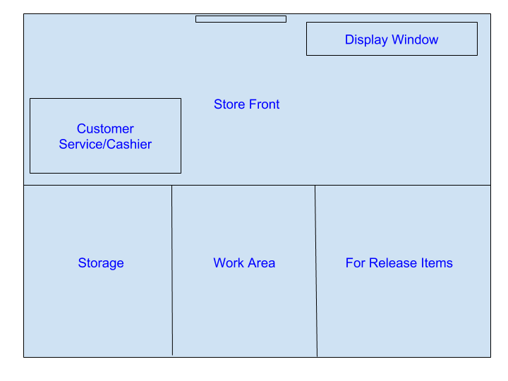

Financial Plan
Assumptions
[Twisted Images] has a reasonably conservative sales forecast based on customer behavior. Being a start-up company, it will take time to build a strong foundation for the business to stand on. While individuals purchase shirts year-round for different purposes and reasons, the following assumptions also take into account the seasons, where it’s likely for individuals to purchase shirts in the summer than in the winter months.

Monthly Expense
The chart shows the projected monthly expenses for [2019]. The largest expenses will be during the summer, where t-shirts prove to be most comfortable. With more orders come more expenses.

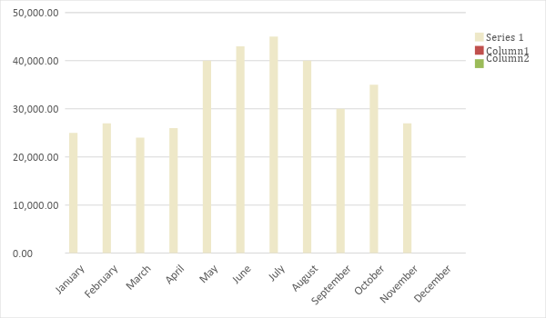
Monthly Revenue
The chart depicts the projected monthly revenues for [2019], showing that the late spring and early summer months will have the most number of orders.
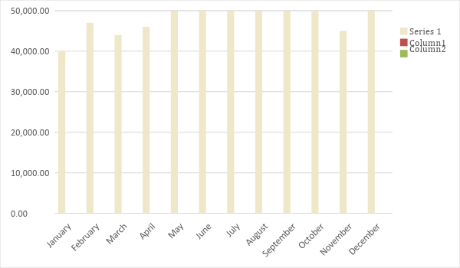

Business Financing
The amount of [$135,000] used to fund the business comes from the personal finances of the owner. This amount will cover the rent, salaries, supplies, and maintenance.

Statements

Profit and Loss Projection
 | FY2019 | FY2020 | FY2021
Sales | $750,000.00 | $875,000.00 | $1,200,000.00
Direct Cost of Sale | $400,000.00 | $500,000.00 | $620,000.00
Other Cost of Sale | $20,000.00 | $25,000.00 | $33,000.00
Total Cost of Goods Sold or COGS (Sales - Direct Cost of Sale - Other Cost of Sale) | $330,000.00 | $350,000.00 | $547,000.00
Gross Profit (Sales-Total Cost of Goods Sold) | $420,000.00 | $525,000.00 | $653,000.00
Gross Margin % (Gross Profit/Sales) | 56.00% | 60.00% | 54.42%
Operating Expenses
Rent | $36,000 | $36,000 | $36,000
Insurance | $10,000 | $10,000 | $10,000
Utilities | $10,000 | $12,000 | $15,000
Salary (Including Tax) | $200,000 | $200,000 | $270,000
Maintenance & Supplies | $20,000 | $23,000 | $25,000
Total Operating Expenses | $276,000.00 | $281,000.00 | $356,000.00
EBITDA (Total Cost of Sale-Total Operating Expenses) | $54,000.00 | $69,000.00 | $191,000.00
Depreciation | $3,000.00 | $4,000.00 | $4,000.00
Interest Expense | $0.00 | $0.00 | $0.00
Taxes Paid | $4,000.00 | $5,000.00 | $6,000.00
Net Profit (Gross Profit - Operating Expenses - Taxes - Interest) | $140,000.00 | $239,000.00 | $291,000.00

Balance Sheet Projection
 | FY2019 | FY2020 | FY2021
Cash | $1,500,000.00 | $2,000,000.00 | $2,500,000.00
Accounts Receivable | $10,000.00 | $15,000.00 | $11,000.00
Inventory | $10,000.00 | $12,000.00 | $15,000.00
Other Current Assets | $5,000.00 | $6,000.00 | $8,000.00
Total Current Assets | $1,525,000.00 | $2,033,000.00 | $2,534,000.00
Long-Term Assets | $80,000.00 | $70,000.00 | $60,000.00
Accumulated Depreciation | $3,000.00 | $2,500.00 | $2,000.00
Total Long-Term Assets (Long-Term Assets-Accumulated Depreciation) | $77,000.00 | $67,500.00 | $58,000.00
Total Assets (Total Current Assets + Total Long-Term Assets) | $1,602,000.00 | $2,100,500.00 | $2,592,000.00
Accounts Payable | $15,000.00 | $17,000.00 | $20,000.00
Notes Payable | $5,000.00 | $6,000.00 | $8,000.00
Other | $3,500.00 | $7,000.00 | $5,000.00
Total Liabilities | $23,500.00 | $30,000.00 | $33,000.00
Paid-in Capital | $5,000.00 | $5,000.00 | $5,000.00
Retained Earnings | $1,150,000.00 | $1,200,000.00 | $1,300,000.00
Total Owner's Equity (Total Assets - Total Liabilities) | $1,578,500.00 | $2,070,500.00 | $2,559,000.00
Total Liabilities & Equity (Total Liabilities/Total Owner's Equity) | 1.49% | 1.45% | 1.29%

Cash Flow Projection
 | FY2019 | FY2020 | FY2021
Operating Cash Beginning | $50,000.00 | $699,000.00 | $1,496,000.00
Sources of Cash | $20,000.00 | $26,000.00 | $40,000.00
Receivables | $150,000.00 | $170,000.00 | $200,000.00
Sales | $750,000.00 | $875,000.00 | $1,200,000.00
Others | $5,000.00 | $7,000.00 | $8,000.00
Total Cash | $975,000.00 | $1,777,000.00 | $2,944,000.00
Expenditures
Rent | $36,000 | $36,000 | $36,000
Insurance | $10,000 | $10,000 | $10,000
Utilities | $10,000 | $12,000 | $15,000
Salary (Including Tax) | $200,000 | $200,000 | $270,000
Maintenance & Supplies | $20,000 | $23,000 | $25,000
Total Expenditures | $276,000.00 | $281,000.00 | $356,000.00
Net Income/Loss (Total Cash - Total Expenditures) | $699,000.00 | $1,496,000.00 | $2,588,000.00

