SKIN CARE DERMA BUSINESS PLAN

[INSERT COMPANY NAME]
BUSINESS PLAN FOR FISCAL YEAR [INSERT YEAR]
[INSERT DATE]

[DR. JULIA MOORE]
[JULIAMOORE@GMAIL.COM]
[775-684-9061
[WWW.HEALTHYSKINHUBINC.COM]
[5210 US-50 CARSON CITY, NV 89701, USA]
INDEX

EXECUTIVE SUMMARY  COMPANY OVERVIEW  PRODUCTS AND SERVICES  EXECUTION  OPERATIONAL PLAN  FINANCIAL PLAN | [INSERT PAGE NO.]  [INSERT PAGE NO.]  [INSERT PAGE NO.]  [INSERT PAGE NO.]  [INSERT PAGE NO.]  [INSERT PAGE NO.]

EXECUTIVE SUMMARY

[Healthy Skin Hub Inc] is a skincare/derma clinic based in [Carson City, Nevada]. The company offers basic facial and diamond peel treatment to both men and women. The company plans to reach a wider target market through word-of-mouth advertising, printed media distribution, and social media. The company hopes to establish a secure market position within the skincare/dermatology industry in [Carson City, Nevada].

Company Overview:

Mission Statement: [Healthy Skin Hub Inc] provides the best quality of skin care services to clients using premium skin care or derma products.

Philosophy: [Healthy Skin Hub Inc] values professionalism, safety, and excellence in every skin care service rendered to clients.

Vision: [Healthy Skin Hub Inc] is one of the most influential skin care clinics in [Nevada].

Outlook: The skincare/dermatology industry is steadily growing with the increasing interest of both men and women in skin health and cosmetology. The company foresees increments in the number of clients every year beginning the second half of the first year of its operations.

Type of Industry: Skin Care/Dermatology Industry

Business Structure: Partnership

Ownership: Partnership, [Dr. Julia Moore and Dr. Dona Joyce]

Start-Up Summary: [Healthy Skin Hub Inc] has a startup cost of [200K USD] which will be generated by the partners equally. The aforementioned fund covers payment for rent, insurance, legal fees, and payroll.

Start-Up Funding
Start-Up Expenses | $90,544
Start-Up Assets | $109,456
Total Funding Required | $200,000
Assets
Non-Cash Assets from Start-Up | $84,456
Cash Requirements from Start-up | $8,000
Additional Cash Raised | $15,000
Cash Balance on Starting Date | $2,000
Total Assets | $109,456
Capital
Planned Investment
Owners | $200,000
Other | $0
Additional Investment Requirement | $0
Total Planned Investment | $200,000
Loss at Start-Up (Start-Up Expenses) | -$90,544
Total Capital | $109,456
Liabilities | $0
Total Capital and Liabilities | $109,456
Start-Up
Requirements
Start-Up Expenses
Rent - 6 Months | $8,244
Advertising | $1,800
Legal Fees | $2,500
Staff Training | $6,000
Insurance | $2,000
Other | $70,000
Total Start-Up Expenses | $90,544
Start-Up Assets
Cash Required | $10,000
Start-Up Inventory | $20,000
Other Current Assets | $15,000
Long-Term Assets | $64,456
Total Assets | $109,456
Total Requirements (Total Start-Up Expenses + Total Assets) | $200,000

Management Team:

Management Team | Role/Function | Skills
Dr. Julia Moore | General Manager | Leadership, Decision-Making, Conflict Management, Communication
Dr. Dona Joyce | Head Dermatologist | Wide Skin Care Knowledge, Client-focused, Problem-Solving, People Management

Short- and Long-Term Goals and Milestones:

Short-Term Goals | Milestones
Recruit clinic assistants and qualified dermatologists | Hired 3 clinic assistants and 1 dermatologist last December 20, 2018
Secure required licenses to operate the skincare/derma clinic | Completed the acquisition of necessary licenses to operate as mandated
Long-Term Goals | Milestones
Purchase new skin care technology | Canvassed cosmetology equipment
Establish a solid client base in Carson City, Nevada | Initiated word-of-mouth advertising and encouraged client referrals

PRODUCTS AND SERVICES

Product/Service Description: [Healthy Skin Hub Inc] provides basic facial treatment and diamond peel service to both men and women.

Value Proposition: [Healthy Skin Hub Inc] values skin health like any other vital parts of the human body. It focuses on rejuvenating the essential vitality of the client’s skin.

Pricing Strategy: [Healthy Skin Hub Inc] uses competitive pricing. The company wants to position itself between highly expensive and cheap skin care/derma clinics in terms of pricing.

EXECUTION

Marketing Plan: [Healthy Skin Hub Inc] plans to use both conventional and online media advertising. The company will utilize social media to have a wider reach of the market.

Market Research: The skin care/dermatology industry showed increasing growth in the past five years. More women and men take their time and pay for skincare/derma services. The chart below shows the results of the feasibility study that the company conducted in [Carson City, Nevada].

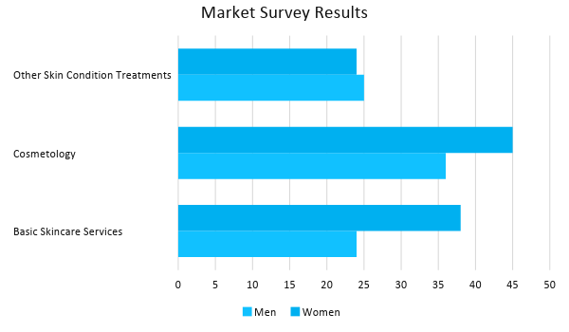

SWOT Analysis | Strengths | Weaknesses | Opportunities | Threats
Healthy  Skin Hub Inc | Offers premium quality basic facial treatment and diamond peel services at affordable rates | Limited skincare/derma technology | Increasing demand for skincare/derma services gives the company opportunities to add related skincare services | The market influence of established clinics in Carson City diminishing the marketability of emerging clinics
Nevada Derma and Spa | Uses advanced technology in providing skincare/derma services | Highly expensive charge for each service | Growing demand for cosmetology pushes the company to expand | The availability of skincare/derma clinics offering high-quality services at affordable rates
Skincare Zone Inc | Recognized as one of the top skincare/derma clinics worldwide | Exclusivity of its services as it caters only the elite class | Increase in the purchasing power of customers make the company consider expansion | The increasing number of expanding skincare/derma clinics that leads to a tighter market competition

Marketing Strategy: [Healthy Skin Hub Inc] will use both traditional and online marketing strategies. The company will leverage on word-of-mouth advertising and will distribute print ads. The company will also take advantage of the influence of various social media platforms to reach a wider target market.

The company accomplished the following activities to kick-off the implementation of the aforementioned strategies.

Marketing Strategy | Activities | Timeline | Success Criteria
Word of Mouth | Encourage clients to refer the clinic to their friends and colleagues | ASAP | Receive a total of 100 appointments by the end of January 2019 from client referrals
Print Ads | Distribute print ads outside the establishment | January 5, 2019 | Generated 100 new customers by January 20, 2019
Social Media | Open social media accounts for the clinic | January 2, 2019 | Generated 2,000 followers on Facebook and Instagram accounts during the first month of operations

Organizational Structure:

The partners of [Healthy Skin Hub Inc], [Dr. Julia Moore] and [Dr. Dona Joyce], will oversee the day-to-day operations of the clinic. The two will assume the positions of general manager and head dermatologist, respectively. All the clinic assistants and qualified dermatologists will report directly to either of the two.

OPERATIONAL PLAN

Location and Facilities

[Healthy Skin Hub Inc] operates in a [2,290 square foot] office space located at [5210 US-50 Carson City, NV 89701, USA]. The clinic has a spacious waiting area and has different rooms for dermatologists to render the skincare treatment for its clients.

Tools and Equipment Checklist

Software | Quantity
Customer Database System | 1
Inventory Management System | 1
Hardware | Quantity
Computers | 2
Skincare Equipment | 3

IT Infrastructure

The following table shows the IT infrastructure of [Healthy Skin Hub Inc].

Infrastructure | Existing (Y/N) | Description
Social Media | N | The company does not own any social media accounts yet.
Latency | Y | There are no encountered delays in network connections.
Downtime | Y | The company encounters system inactivity due to the network.

FINANCIAL PLAN

Assumptions

The financial assumptions used by [Healthy Skin Hub Inc] came from market trends. These assumptions are as follows:

- The company expects a [40%] increase in sales by the second year of operations.
- The prevailing market interest is [4.3%]. The tax rate on compensation is [15%].
- The company expects inflation of [3%] by the end of the second year.

Monthly Expense
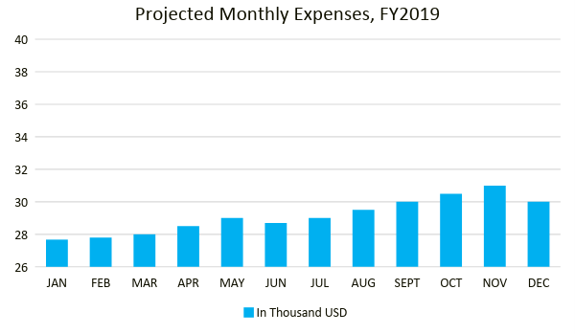
Monthly Revenue

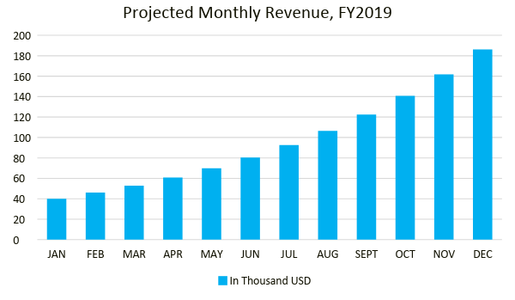
Business Financing

The partners of [Healthy Skin Hub Inc] generated the total operating fund of [200K USD] through equal capital contribution. The initial operating fund covered the purchase of equipment and relevant disbursements.

Statements

Profit and Loss Projection
 | FY2019 | FY2020 | FY2021
Sales | $220,000.00 | $308,000.00 | $431,200.00
Direct Cost of Sale | $99,000.00 | $138,600.00 | $194,040.00
Other Cost of Sale | $2,000.00 | $2,100.00 | $2,205.00
Total Cost of Goods Sold or COGS (Sales - Direct Cost of Sale - Other Cost of Sale) | $119,000.00 | $167,300.00 | $234,955.00
Gross Profit (Sales-Total Cost of Goods Sold) | $101,000.00 | $140,700.00 | $196,245.00
Gross Margin % (Gross Profit/Sales) | 45.91% | 45.68% | 45.51%
Operating Expenses
Rent | $16,488.00 | $16,488.00 | $16,488.00
Insurance | $6,000.00 | $6,000.00 | $6,000.00
Utilities | $7,500.00 | $7,650.00 | $7,803.00
Salary (Including Tax) | $55,000.00 | $55,000.00 | $55,000.00
Maintenance & Supplies | $7,500.00 | $7,687.50 | $7,879.69
Total Operating Expenses | $92,488.00 | $92,825.50 | $93,170.69
EBITDA (Total Cost of Sale-Total Operating Expenses) | $26,512.00 | $74,474.50 | $141,784.31
Depreciation | $1,500.00 | $1,500.00 | $1,500.00
Interest Expense | $0.00 | $0.00 | $0.00
Taxes Paid | $8,250.00 | $8,250.00 | $8,250.00
Net Profit (Gross Profit - Operating Expenses - Taxes - Interest) | $262.00 | $39,624.50 | $94,824.31

Balance Sheet Projection
 | FY2019 | FY2020 | FY2021
Cash | $17,512.00 | $62,936.50 | $161,178.31
Accounts Receivable | $25,000.00 | $35,000.00 | $49,000.00
Inventory | $60,000.00 | $55,000.00 | $60,000.00
Other Current Assets | $42,000.00 | $42,000.00 | $42,000.00
Total Current Assets | $144,512.00 | $194,936.50 | $312,178.31
Long-Term Assets | $95,000.00 | $95,000.00 | $95,000.00
Accumulated Depreciation | $1,500.00 | $3,000.00 | $4,500.00
Total Long-Term Assets (Long-Term Assets-Accumulated Depreciation) | $93,500.00 | $92,000.00 | $90,500.00
Total Assets (Total Current Assets + Total Long-Term Assets) | $238,012.00 | $286,936.50 | $402,678.31
Accounts Payable | $20,000.00 | $15,000.00 | $10,000.00
Notes Payable | $15,000.00 | $17,250.00 | $19,837.50
Other | $2,500.00 | $5,000.00 | $5,000.00
Total Liabilities | $37,500.00 | $37,250.00 | $34,837.50
Paid-in Capital | $200,000.00 | $200,000.00 | $200,000.00
Retained Earnings | $262.00 | $39,886.50 | $134,710.81
Total Owner's Equity (Total Assets - Total Liabilities) | $200,512.00 | $249,686.50 | $367,840.81
Total Liabilities & Equity (Total Liabilities/Total Owner's Equity) | 18.70% | 14.92% | 9.47%

Cash Flow Projection
 | FY2019 | FY2020 | FY2021
Operating Cash Beginning | $10,000.00 | $17,512.00 | $62,936.50
Sources of Cash | $5,000.00 | $6,250.00 | $7,812.50
Receivables | $25,000.00 | $35,000.00 | $49,000.00
Sales | $65,000.00 | $91,000.00 | $127,400.00
Others | $5,000.00 | $6,000.00 | $7,200.00
Total Cash | $110,000.00 | $155,762.00 | $254,349.00
Expenditures
Rent | $16,488.00 | $16,488.00 | $16,488.00
Insurance | $6,000.00 | $6,000.00 | $6,000.00
Utilities | $7,500.00 | $7,650.00 | $7,803.00
Salary (Including Tax) | $55,000.00 | $55,000.00 | $55,000.00
Maintenance & Supplies | $7,500.00 | $7,687.50 | $7,879.69
Total Expenditures | $92,488.00 | $92,825.50 | $93,170.69
Net Income/Loss (Total Cash - Total Expenditures) | $17,512.00 | $62,936.50 | $161,178.31

