SCHOOL BUSINESS PLAN
Business Plan For Fiscal Year 2020
[Lillian Patman] [lpatman@wakefieldmemorial.com] [619-479-4405] [http://wakefieldmemorial.com]
[2805 Poplar Avenue San Diego, CA 92139]
[March 30, 2018]

INDEX

Executive Summary
Company Overview
Products and Services
Execution
Operational Plan
Financial Plan
[Page Number]
[Page Number]
[Page Number]
[Page Number]
[Page Number]
[Page Number]

Executive Summary:
Wakefield Memorial School is a private school situated in San Jose, California. It is a standard private school that offers primary (kindergarten through sixth grade) and secondary (seventh through twelfth grade) education, funded through tuition fees and levies from students and other private sources. The school offers high-quality education in a conducive learning environment.

To reach the minimum number of enrollees in the first few years of operations, the school shall make use of social media marketing. It will also put advertising literature such as fliers and brochures in public areas such as the local library, bookstores, and the country club. Private schooling remains to be an important feature of the US education system, as it generates possibilities for parents to opt out of state-provided education, which is why financial projections remain positive for Wakefield Memorial School.

Company Overview:

Mission Statement: Wakefield Memorial School wants to provide a professional and conducive learning environment for students at different levels of learning.

Philosophy: Wakefield Memorial School shall ensure that staff and students alike reflect its values of integrity, service, and excellence in everything that they do.

Vision: Wakefield Memorial School has the vision to build a highly competitive private school that will be the first choice for both parents and students in San Diego, California.

Outlook: The revenue for private schools is expected to increase as the American economy continues to recover. An industry worth over $52 billion, it has an estimated growth rate of 1.2% in the coming years. Despite being a saturated industry, profit from educational institutions remain feasible as a growing population puts more importance on knowledge and education.

Type of Industry: Education

Business Structure: Partnership

Ownership: Partnership, Lillian Patman and Blair Rhodes

Start-Up Summary: It will cost an average of $2 million to start a small, but a standard private school in the United States. This amount will partly be financed by the owners, with a loan of $1 million to cover the rest of the finances.

Start-Up Funding
Start-Up Expenses | $1,000,000
Start-Up Assets | $1,000,000
Total Funding Required | $2,000,000
Assets
Non-Cash Assets from Start-Up | $750,000
Cash Requirements from Start-up | $200,000
Additional Cash Raised | $35,000
Cash Balance on Starting Date | $15,000
Total Assets | $1,000,000
Capital
Planned Investment
Owner | $2,000,000
Other | $0
Additional Investment Requirement | $0
Total Planned Investment | $2,000,000
Loss at Start-Up (Start-Up Expenses) | -$1,000,000
Total Capital | $1,000,000
Liabilities | $0
Total Capital and Liabilities | $1,000,000
Start-Up
Requirements
Start-Up Expenses
Construction and Renovations | $750,000
Advertising | $5,000
Legal Fees | $3,000
Staff Training | $200,000
Insurance | $20,000
Other | $22,000
Total Start-Up Expenses | $1,000,000
Start-Up Assets
Cash Required | $200,000
Start-Up Inventory | $175,000
Other Current Assets | $55,000
Long-Term Assets | $570,000
Total Assets | $1,000,000
Total Requirements (Total Start-Up Expenses + Total Assets) | $2,000,000

Management Team:

Management Team | Role/Function | Skills
Lillian Patman | Chairman,  Board of Directors | Business Judgment, Problem Solving and Innovation
Elizabeth Robertson | School Administrator | Communication, Organization Skills, Leadership
Ken Sutton | Maintenance and Security | Technical Skills, Detail-Oriented

Short- and Long-Term Goals and Milestones:

Short-Term Goals | Milestones
Develop strategies to address the educational needs of the students | Created lesson plans to maximize learning
Coach the administration and staff to develop better communication | Developed customized classes to better address student needs
Long-Term Goals | Milestones
Improve current educational practices by implementing a culture of excellence
Develop robust programs to maximize student potential

Products and Services

Product/Service Description: Wakefield Memorial School offer different educational services within the scope of the education board in the United States. Its service offerings include the following:
- Establish foundations in basic literacy and numeracy, science, mathematics, geography, history, and social sciences
- Provide access to extracurricular activities
- Retail of educational books and materials

Value Proposition: Wakefield Memorial School may be new to the industry, but its management and staff are highly qualified and experienced in the field. It also offers competitive academic education, extracurricular activities, and sports to maximize student experience.

Pricing Strategy: Similar to other schools in the United States, Wakefield Memorial School shall charge students per term. Wakefield Memorial School keeps competitive pricing strategies to be within the average costs of education in the area.

Execution

Marketing Plan: Wakefield Memorial School shall make use of different marketing and sales strategies to attract enrollees. These strategies include information dissemination via print media such as fliers and brochures. The school will also engage in online marketing and social media networking by putting up a website and maintaining Facebook, Twitter, Instagram, and LinkedIn accounts. It will also join relevant professional organizations.

Market Research: According to a 2017 report, private schools in the US is a small market with only 40% of them having more than 500 students. Wakefield Memorial School wants to take advantage of this and target students in the mid- to upper-class sectors. The following chart shows the average percentage of enrollees in private schools in the area:

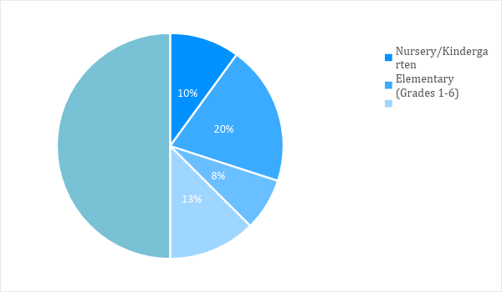
SWOT Analysis | Strengths | Weaknesses | Opportunities | Threats
Wakefield Memorial School | Has a strong workforce with excellent qualifications | Needs positive recognition to gain more students | The competitive industry allows for future expansion | Changes in government sanctions for private schools
San Jose Preparatory | Location is attractive to middle- and upper-class families | High tuition costs limit the number of enrollees every year | Adjustments in tuition fees encourage more enrollees | An economic downturn can affect the number of enrollees
Snicket Preparatory | Collaborative working environment | Focus on academics, but fewer extra-curricular activities | The location allows for bilingual studies | The emergence of competitor schools can threaten revenues

Marketing Strategy: Private schools attract students and their parents through educational performance and the passing rates of students in national exams. Private schools continue to thrive due to the fact that public schools cannot always accommodate the educational needs of the children.

Marketing Strategy | Activities | Timeline | Success Criteria
Community involvement and networking | Reach out to school districts | ASAP | At least 50 enrollees in the new school year
Traditional media advertising | Print fliers and brochures for distribution | March 30  SY 2019 | Inquiries from and meetings with parents and students
Online and social media reach | Create a website  Create social media pages | ASAP | 10,000 website views/week  Reach 25,000 likes by the end of the quarter

Organizational Structure:
The following shows the organizational structure of Wakefield Memorial School.

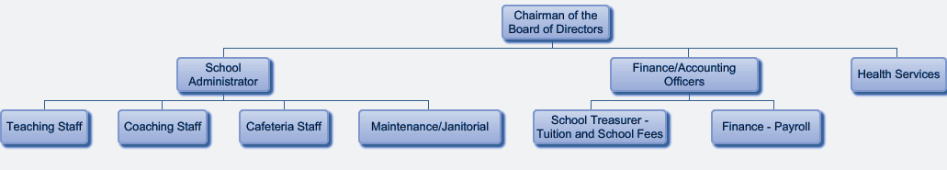

Operational Plan:
Location and Facilities
The following shows the school layout per floor. Wakefield Memorial School wants to encourage better student performance by ensuring that the classrooms are large enough to make learning comfortable for the students despite their increasing number over time.

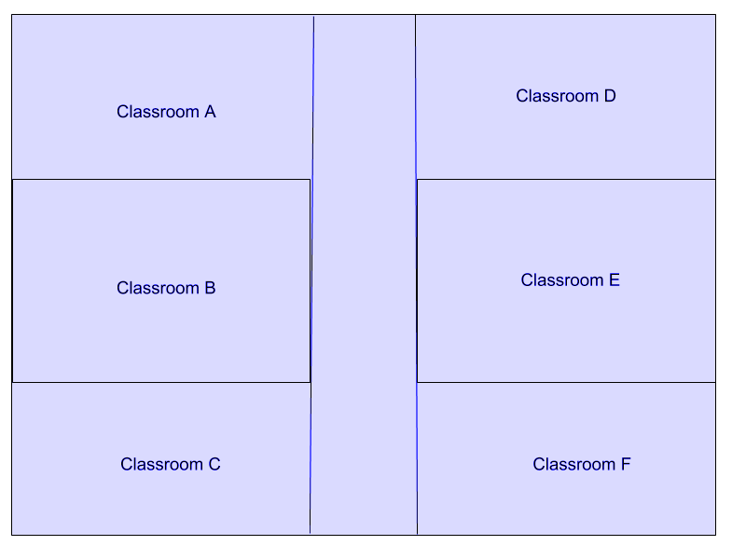

Financial Plan

Assumptions
Private school education remains relevant due to its ability to help students reach their educational goals. Looking into the current economy, the private school industry remains optimistic regarding its own income-generating goals. The following projections are based on what seems obtainable in the industry, with the assumption that there won’t be any sudden economic downturns or natural disasters in the period stated.

Monthly Expense
The following chart shows the projected monthly expenses for the upcoming year. The expenses are high in June and July due to the summer break. There is no income, but expenses shall be made for maintenance and renovation, construction, and purchase of school supplies for the next school year, as necessary.
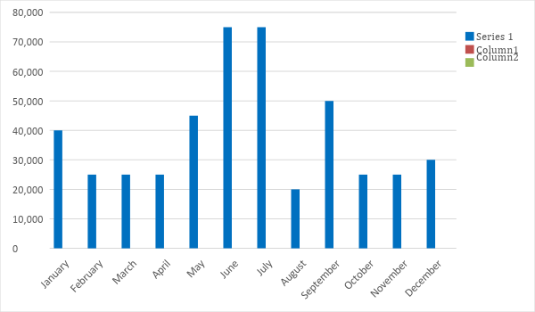
Monthly Revenue:
The following chart shows the projected monthly revenue for the following year. August will see the highest increase in revenue due to the tuition fees for the school year.
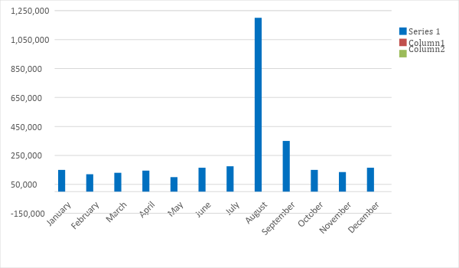

Business Financing
The business is funded partly through the amount raised by the partners, as well as loans worth $1 million. This amount shall be used for supplies, office and school furniture, construction and design, and payroll.

Statements

Profit and Loss Projection
 | FY2019 | FY2020 | FY2021
Sales | $3,000,000.00 | $3,500,000.00 | $4,000,000.00
Direct Cost of Sale | $2,500,000.00 | $2,700,000.00 | $3,300,000.00
Other Cost of Sale | $100,000.00 | $120,000.00 | $135,000.00
Total Cost of Goods Sold or COGS (Sales - Direct Cost of Sale - Other Cost of Sale) | $400,000.00 | $680,000.00 | $565,000.00
Gross Profit (Sales-Total Cost of Goods Sold) | $2,600,000.00 | $2,820,000.00 | $3,435,000.00
Gross Margin % (Gross Profit/Sales) | 86.67% | 80.57% | 85.88%
Operating Expenses
Construction and Renovations | $800,000.00 | $150,000.00 | $100,000.00
Insurance | $20,000.00 | $20,000.00 | $20,000.00
Utilities | $45,000.00 | $47,000.00 | $50,000.00
Salary (Including Tax) | $750,000.00 | $800,000.00 | $900,000.00
Maintenance & Supplies | $250,000.00 | $250,000.00 | $250,000.00
Total Operating Expenses | $1,865,000.00 | $1,267,000.00 | $1,320,000.00
EBITDA (Total Cost of Sale-Total Operating Expenses) | $669,000.00 | $965,800.00 | $1,329,300
Depreciation (Asset Cost - Residual Value/Useful Life of the Asset) | $10,000.00 | $10,000.00 | $10,000.00
Interest Expense | $0.00 | $0.00 | $0.00
Taxes Paid | $15,000.00 | $18,000.00 | $20,000.00
Net Profit (Gross Profit - Operating Expenses - Taxes - Interest) | $720,000.00 | $1,535,000.00 | $2,095,000.00

Balance Sheet Projection
 | FY2019 | FY2020 | FY2021
Cash | $250,000.00 | $1,250,000.00 | $1,450,000.00
Accounts Receivable | $100,000.00 | $150,000.00 | $110,000.00
Inventory | $7,000.00 | $8,000.00 | $10,000.00
Other Current Assets | $20,000.00 | $25,000.00 | $35,000.00
Total Current Assets | $377,000.00 | $1,433,000.00 | $1,605,000.00
Long-Term Assets | $45,000.00 | $43,000.00 | $47,000.00
Accumulated Depreciation | $3,000.00 | $2,500.00 | $2,000.00
Total Long-Term Assets (Long-Term Assets-Accumulated Depreciation) | $42,000.00 | $40,500.00 | $45,000.00
Total Assets (Total Current Assets + Total Long-Term Assets) | $419,000.00 | $1,473,500.00 | $1,650,000.00
Accounts Payable | $150,000.00 | $170,000.00 | $155,000.00
Notes Payable | $7,000.00 | $7,500.00 | $5,000.00
Other | $3,500.00 | $7,000.00 | $5,000.00
Total Liabilities | $160,500.00 | $184,500.00 | $165,000.00
Paid-in Capital | $10,000.00 | $5,000.00 | $5,000.00
Retained Earnings | $90,000.00 | $120,000.00 | $130,000.00
Total Owner's Equity (Total Assets - Total Liabilities) | $258,500.00 | $1,289,000.00 | $1,485,000.00
Total Liabilities & Equity (Total Liabilities/Total Owner's Equity) | 62.09% | 14.31% | 11.11%

Cash Flow Projection
 | FY2019 | FY2020 | FY2021
Operating Cash Beginning | $250,000.00 | $1,640,000.00 | $4,558,000.00
Sources of Cash | $150,000.00 | $180,000.00 | $150,000.00
Receivables | $100,000.00 | $100,000.00 | $120,000.00
Sales | $3,000,000.00 | $3,500,000.00 | $4,000,000.00
Others | $5,000.00 | $7,000.00 | $8,000.00
Total Cash | $3,505,000.00 | $5,427,000.00 | $8,836,000.00
Expenditures
Construction and Renovations | $800,000.00 | $150,000.00 | $100,000.00
Insurance | $20,000.00 | $20,000.00 | $20,000.00
Utilities | $45,000.00 | $47,000.00 | $50,000.00
Salary (Including Tax) | $750,000.00 | $800,000.00 | $900,000.00
Maintenance & Supplies | $250,000.00 | $250,000.00 | $250,000.00
Total Expenditures | $1,865,000.00 | $1,267,000.00 | $1,320,000.00
Net Income/Loss (Total Cash - Total Expenditures) | $1,640,000.00 | $4,160,000.00 | $7,516,000.00

