Commercial
Photography Business Plan

Business Plan For Fiscal Year 2019

[February 5, 2019]

[Mark M. Turner]
[mmturner@bing.com]
[216-591-0295]
[www.clickmarkturner.com]
[256 Parker Drive]
[Beachwood, OH 44122, USA]

Index

Executive Summary

Company Overview

Products and Services

Execution
Operational Plan

Financial Plan

EXECUTIVE SUMMARY

[Click Photography] offers top-class commercial photography services to small and medium-sized businesses to help increase the appeal of their products and boost their amount of sales. The photography industry has benefited a lot from the country’s improving economic conditions. The increasing demand for its service led to a $[10 billion] revenue in [2018] with an annual growth rate of [1.6]% over the course of [five] years. The industry is expected to grow in the coming years as the breakthroughs in photography technology continue.

COMPANY OVERVIEW

Mission Statement

[Click Photography] aims to be part of the success of small and medium-sized businesses by giving them high-quality commercial photography services.

Philosophy

[Click Photography] serves its clients with excellence and quality in mind. The company is committed to delivering quality services that exceed customer expectations.

Vision

[Click Photography] seeks to become one of the top three providers of commercial photography services in the state of [Ohio] in [five] years.

Outlook

The digital photography market is expected to reach a value of $[110.79 billion] by [2021] at a CAGR of [6.1]%. Due to the advancement of social networking and photo sharing sites, the demand for digital photography is surging. The growing disposable income of the population has also helped in the industry’s growth. After the economic downturn, the commercial photography industry is seeing a rising market.

Type of Industry: Photography Industry

Business Structure: Sole Proprietorship

Ownership: Sole Proprietorship, [Mark M. Turner]

Start-Up Summary

The cost for the start-up is $[60,000] which will be provided by the owner and will be used for supplies, rent, payroll, and business insurance.

Start-Up Funding
Start-Up Expenses | $20,000
Start-Up Assets | $40,000
Total Funding Required | $60,000
Assets
Non-Cash Assets from Start-Up | $10,000
Cash Requirements from Start-up | $15,000
Additional Cash Raised | $10,000
Cash Balance on Starting Date | $5,000
Total Assets | $40,000
Capital
Planned Investment
Owner | $60,000
Other | $0
Additional Investment Requirement | $0
Total Planned Investment | $60,000
Loss at Start-Up (Start-Up Expenses) | -$20,000
Total Capital | $40,000
Liabilities | $0
Total Capital and Liabilities | $40,000
Start-Up
Requirements
Start-Up Expenses
Rent - 5 Months | $7,500
Advertising | $3,000
Legal Fees | $3,000
Staff Training | $5,000
Insurance | $1,500
Other | $0
Total Start-Up Expenses | $20,000
Start-Up Assets
Cash Required | $15,000
Start-Up Inventory | $10,000
Other Current Assets | $5,000
Long-Term Assets | $10,000
Total Assets | $40,000
Total Requirements (Total Start-Up Expenses + Total Assets) | $60,000

Management Team:

Management Team | Role/Function | Skills
[Christopher C. Labat] | Business Manager | Photography, Marketing, Business Management, and Communication
Short- and Long-Term Goals and Milestones:

Short-Term Goals | Milestones
Obtain the necessary tools and equipment | Bought essential tools such as lenses, backdrops, tripod, camera bag, and lighting
Hire a business manager | Hiring completed last [December 1, 2018]
Long-Term Goals | Milestones
Acquire [35]% of market share within [5] years | Built a solid marketing plan, hired and trained a highly-skilled employee, and built a strong portfolio
Obtain more than [5,000] followers on Instagram and on the brand website within 18 months | Will set up a website and social media accounts and will start uploading valuable content as soon as possible.

PRODUCTS AND SERVICES

Product/Service Description

[Click Photography] offers small and medium-sized companies commercial photography services such as product photography. Services rendered include photo direction, use of mobile studio, and image processing and preparation.

Value Proposition

Clients will work with experts with more than [10] years of experience in commercial photography. They will be given expert guidance and high-quality customer service.

Pricing Strategy

The company utilizes a pricing scheme that varies on the length and difficulty of each project. It will price its clients based on the resources used, the number of photographs to be distributed, and the intellectual property value of each photograph.

Formula:
Profit Margin = 1- (Expenses/Net Sales)

[Click Photography]
Profit Margin = 1 - ($168,000/$750,000)
= 1-0.224
= 0.78 or 78%

EXECUTION

Marketing Plan

[Click Photography] marketing plan revolves around creating a significant exposure online and establishing a strong presence in the platform. Social media platforms and the company website will be used to attract and retain valuable clients.

Market Research

Since the growth of disposable income per capita and increase in advertising expenditure, there has been an increasing demand for both portrait and commercial photography services around the globe.

The company will target small businesses that have ongoing and regular needs for photography. These businesses prefer to work with smaller studios that prioritize them and understand their way of working.

[Click Photography] also sets its eyes to medium-sized businesses. This segment, which once hired larger commercial studios, is now looking for smaller ones because of the changes in rates. These businesses usually have a higher volume of photography needs which are outsourced from medium to smaller studios.

SWOT Analysis | Strengths | Weaknesses | Opportunities | Threats
[Click Photography] | - Superior customer services  - High-quality output  - Experienced photographers | - Has a small team  - Is able to handle only a few clients | - More demands for quality photos and contents due to the current digital marketing trends  - Market segments that prefer smaller photography studios | - Established small and medium-sized photography studios  - Studios with more capability to handle large amounts of clients
[Global Studios] | - Established photography studio  - Wide network of clients | - Expensive  - Does not prioritize small scale businesses | - An improving economy and trends in the digital marketing industry | - Photographers who offer less for their services  - An increasing cost of running the business
[Brenna Photos] | - Experienced photographers  - Less expensive for the quality they produce | - Small team  - Limited cash for execution | - More and more small scale businesses are looking for less expensive photo studios | - Bigger and more established competitors

Marketing Strategy

Establishing a strong online reputation and presence is an essential factor for the success in commercial photography. Therefore, [Click Photography] will focus its marketing efforts on creating a strong image on the internet.

The company will hire managers for both website and social media and create valuable content that will be uploaded on a regular basis. Contents such as blogs and articles will also be used and optimized to strengthen the website’s visibility and to attract and retain valuable customers.

Several activities have already been started by the team to drive the marketing strategy forward. Below are their progress:

Marketing Strategy | Activities | Timeline | Success Criteria
Website setup | A web developer/designer has already been hired to set up the website | January 25, 2019 | The website will be ready to go live by the end of [February].
Content creation | One of the employees has already created five articles to be uploaded on the website | March 1, 2019 | Optimized contents will be uploaded regularly on the company’s website.
Social media marketing | The team has started creating contents for Instagram, Facebook, and Pinterest | March 12, 2019 | Increase followers across all platforms by [15]% by the end of the first half of the year.

Organizational Structure:

CEO
BUSINESS MANAGER
PHOTOGRAPHER 1
ART DIRECTOR
PHOTOGRAPHER 2

OPERATIONAL PLAN

Location and Facilities

Provide a sketch or blueprint of the facility.

Provide photos or images of the location/facility.

Tools and Equipment Checklist

Software | Quantity
Adobe Lightroom | 3
Adobe Photoshop | 3
Hardware | Quantity
SLR Camera | 3
Tripod | 3
Reflectors | 4

IT Infrastructure

Listed below are [Click Photography’s] IT Infrastructure.

Infrastructure | Existing (Y/N) | Description
Website | N | Has yet to have a company website.
Editing software | Y | Used to enhance the quality of the photos.

FINANCIAL PLAN

Assumptions

The financial forecast is based on the trends of various industries that affect the photography industry directly. Economic performances were also considered upon the formulation of these forecasts. Most of the company’s expenses will be on maintenance, supplies, business insurance, rent, payroll, and marketing activities.

Monthly Expense

The chart below shows the company’s projected monthly expenses for [2019].

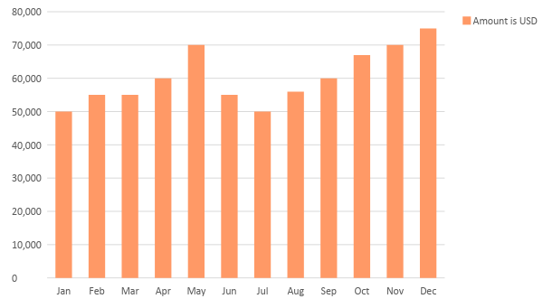

Monthly Revenue

The chart below shows the company’s projected monthly revenue for [2019].

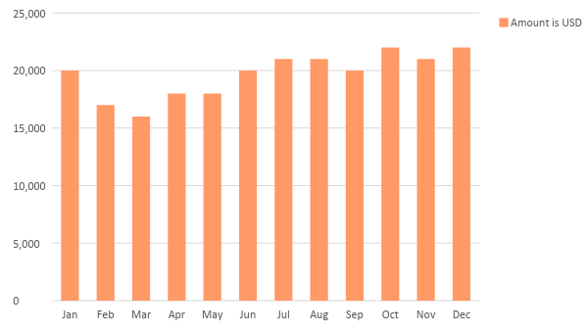
Business Financing

The business is funded solely by the proprietor to the amount of $[60,000]. Majority of the funds will be spent on business insurance, supplies, maintenance, payroll, rent, and marketing initiatives.

Statements

Profit and Loss Projection
 | FY2019 | FY2020 | FY2021
Sales | $750,000.00 | $800,000.00 | $820,000.00
Direct Cost of Sale | $190,000.00 | $210,000.00 | $250,000.00
Other Cost of Sale | $10,000.00 | $15,000.00 | $18,000.00
Total Cost of Goods Sold or COGS (Sales - Direct Cost of Sale - Other Cost of Sale) | $550,000.00 | $575,000.00 | $552,000.00
Gross Profit (Sales-Total Cost of Goods Sold) | $200,000.00 | $225,000.00 | $268,000.00
Gross Margin % (Gross Profit/Sales) | 26.67% | 28.13% | 32.68%
Operating Expenses
Rent | $30,000.00 | $30,000.00 | $40,000.00
Insurance | $12,000.00 | $12,000.00 | $12,000.00
Utilities | $15,000.00 | $20,000.00 | $25,000.00
Salary (Including Tax) | $100,000.00 | $100,000.00 | $110,000.00
Maintenance & Supplies | $11,000.00 | $13,000.00 | $15,000.00
Total Operating Expenses | $168,000.00 | $175,000.00 | $202,000.00
EBITDA (Total Cost of Sale-Total Operating Expenses) | $382,000.00 | $400,000.00 | $350,000.00
Depreciation | $9,000.00 | $9,000.00 | $9,000.00
Interest Expense | $0.00 | $0.00 | $0.00
Taxes Paid | $10,000.00 | $10,000.00 | $10,000.00
Net Profit (Gross Profit - Operating Expenses - Taxes - Interest) | $22,000.00 | $40,000.00 | $56,000.00

Balance Sheet Projection
 | FY2019 | FY2020 | FY2021
Cash | $160,000.00 | $180,000.00 | $200,000.00
Accounts Receivable | $50,000.00 | $60,000.00 | $70,000.00
Inventory | $25,000.00 | $35,000.00 | $45,000.00
Other Current Assets | $10,000.00 | $10,000.00 | $10,000.00
Total Current Assets | $245,000.00 | $285,000.00 | $325,000.00
Long-Term Assets | $20,000.00 | $20,000.00 | $20,000.00
Accumulated Depreciation | $9,000.00 | $9,000.00 | $9,000.00
Total Long-Term Assets (Long-Term Assets-Accumulated Depreciation) | $11,000.00 | $11,000.00 | $11,000.00
Total Assets (Total Current Assets + Total Long-Term Assets) | $256,000.00 | $296,000.00 | $336,000.00
Accounts Payable | $30,000.00 | $40,000.00 | $40,000.00
Notes Payable | $7,000.00 | $7,000.00 | $7,000.00
Other | $11,000.00 | $13,000.00 | $15,000.00
Total Liabilities | $48,000.00 | $60,000.00 | $62,000.00
Paid-in Capital | $60,000.00 | $20,000.00 | $20,000.00
Retained Earnings | $200,000.00 | $225,000.00 | $268,000.00
Total Owner's Equity (Total Assets - Total Liabilities) | $208,000.00 | $236,000.00 | $274,000.00
Total Liabilities & Equity (Total Liabilities/Total Owner's Equity) | 23.08% | 25.42% | 22.63%

Cash Flow Projection
 | FY2019 | FY2020 | FY2021
Operating Cash Beginning | $160,000.00 | $180,000.00 | $200,000.00
Sources of Cash | $25,000.00 | $25,000.00 | $30,000.00
Receivables | $11,000.00 | $13,000.00 | $15,000.00
Sales | $80,000.00 | $80,000.00 | $90,000.00
Others | $10,000.00 | $10,000.00 | $10,000.00
Total Cash | $286,000.00 | $308,000.00 | $345,000.00
Expenditures
Rent | $30,000.00 | $30,000.00 | $40,000.00
Insurance | $12,000.00 | $12,000.00 | $12,000.00
Utilities | $15,000.00 | $20,000.00 | $25,000.00
Salary (Including Tax) | $100,000.00 | $100,000.00 | $110,000.00
Maintenance & Supplies | $11,000.00 | $13,000.00 | $15,000.00
Total Expenditures | $168,000.00 | $175,000.00 | $202,000.00
Net Income/Loss (Total Cash - Total Expenditures) | $118,000.00 | $133,000.00 | $143,000.00

