Retail Store
Sales Plan
[Apatow Appliances]
Sales Plan [2018 – 2019]

Index

Executive Summary [PAGE NUMBER]
Company Overview [PAGE NUMBER]
Products and Services [PAGE NUMBER]
Marketing Analysis [PAGE NUMBER]
Strategy and Implementation [PAGE NUMBER]
Management and Personnel [PAGE NUMBER]

Sales Action Plan [PAGE NUMBER]

EXECUTIVE SUMMARY

[Apatow Appliances] is a consumer electronics store that offers convenient shopping at discount prices for its customers. The company remains committed to providing an efficient shopping experience for consumers who want to buy home appliances.

To increase their sales in the next year, [Apatow Appliances] will focus on delivering outstanding customer service, increased online marketing efforts, and seasonal promotional strategies.

COMPANY OVERVIEW

Mission Statement:

[Apatow Appliances] is a purpose-driven company that focuses on product quality and customer satisfaction.

Philosophy:

[Apatow Appliances] works to ensure efficient and enjoyable customer experience with fully stocked products, speedy checkout process, and overall desirable shopping experience.

Vision:

[Apatow Appliances] aims to create a legacy of responsible corporate citizenship and ethical business practice.

Outlook:

The consumer electronics industry has had steady growth, thanks to the growing middle-class economy and improved disposable income levels. The industry has been valued at [$174] billion in [2017] and is expected to continue growing at a compound annual growth rate of [2.6%] until [2023].

Type of Industry: Consumer Electronics

Business Structure: Sole Proprietorship

Ownership: Sole Proprietorship, Mark Apatow

Start-Up Summary:

The company has a budget of [$30,000] for marketing costs. This amount shall be used for different marketing strategies including sales training, promotional materials, and online marketing upkeep.

Start-Up Funding
Start-Up Expenses | $15,000
Start-Up Assets | $15,000
Total Funding Required | $30,000
Assets
Non-Cash Assets from Start-Up | $10,000
Cash Requirements from Start-up | $3,000
Additional Cash Raised | $1,000
Cash Balance on Starting Date | $1,000
Total Assets | $15,000
Capital
Planned Investment
Owner | $30,000
Other | $0
Additional Investment Requirement | $0
Total Planned Investment | $30,000
Loss at Start-Up (Start-Up Expenses) | -$15,000
Total Capital | $15,000
Total Capital and Liabilities | $15,000
Start-Up
Requirements
Start-Up Expenses
Advertising | $4,000
Legal Fees | $1,000
Staff Training | $8,000
Insurance | $1,000
Other | $1,000
Total Start-Up Expenses | $15,000
Start-Up Assets
Cash Required | $10,000
Start-Up Inventory | $1,000
Other Current Assets | $1,000
Long-Term Assets | $3,000
Total Assets | $15,000
Total Requirements (Total Start-Up Expenses + Total Assets) | $30,000

PRODUCTS AND SERVICES

Product/Service Description:

[Apatow Appliances] retails different brands of home appliances to fit the budget of different consumer types. Among the products offered include the following:

- Kitchen appliances such as range hoods, refrigerators, stoves, cookers, and ovens
- Home appliances such as vacuum cleaners and air conditioners
- Laundry appliances such as washing machines, dryers, and washer-dryers
- Door-to-door deliveries

Value Proposition:

[Apatow Appliances] retails a wide variety of brands in different price ranges and provides excellent customer service.

Pricing Strategy:

[Apatow Appliances] utilizes pricing for market penetration, offering products at a lower price compared to its competitors.

MARKETING ANALYSIS

The demand for appliances relies on consumer personal income, home sales, remodeling, and replacement of old appliances in the event of product failure. Retail companies generate their revenues based on effective advertising and sales strategies, with smaller businesses, such as [Apatow Appliances], prioritizing excellent consumer service, online marketing, and strategic promotional sales.

Market Segmentation

[Apatow Appliances] caters to homeowners and renters who want to purchase appliances for their homes. With the variety of brands and prices available, the company can cater to consumers from low- to high-income brackets.

The following chart shows the market segmentation based on sales from the previous year:

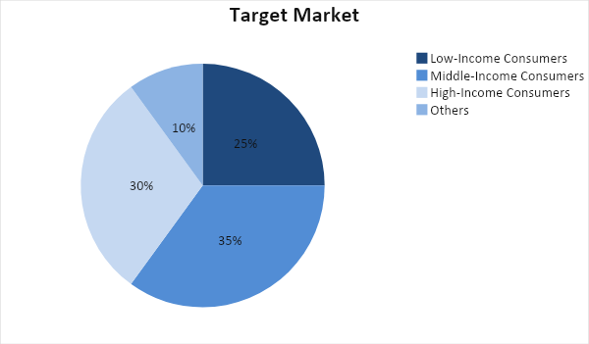

Target Market Segmentation Strategy

Low-Income Consumers

- The company will ensure that it has stocks of good quality that are affordable to college students and other low-income consumers. Seasonal promotional sales shall also be utilized to attract the attention of this target market.

Middle-Income Consumers

- The company will take advantage of online sales strategies such as optimizing its website and updating social media pages. Targeted ads will also be utilized to reach a wider audience.

High-Income Consumers

- The company will focus on customer service, as these consumers are likely to have little to no time to spend in appliance retailers. Customer service will include installation and delivery, when applicable.

STRATEGY AND IMPLEMENTATION

Target Market Strategy

[Apatow Appliances] aims to increase its sales in the following year by at least [15%]. This goal may be accomplished by improving its marketing strategies both online and offline.

Competitive Edge

The company offers a wide variety of products at different price ranges to cater to the needs of its customers. It will also emphasize the importance of customer service and support to build better relationships with its customers.

SWOT Analysis | Strengths | Weaknesses | Opportunities | Threats
Apatow Appliances | - Has a large customer base | - Its online store needs improvement | - Growing population expands the customer base | - Market penetration is difficult because of market saturation
Red Door Appliance Center | - A known retailer in the area | - Weak customer service | - Establish an online retail store | - An economic downturn can affect sales
Home and Office Center | - Great downtown location | - Caters to more expensive brands | - Opportunity for expansion in other locations | - More cost-effective retailers in the area

Sales Strategy and Forecast

By creating well maintained and optimized online platforms and delivering better customer service and more aggressive marketing and sales strategies, the company predicts the following monthly sales:

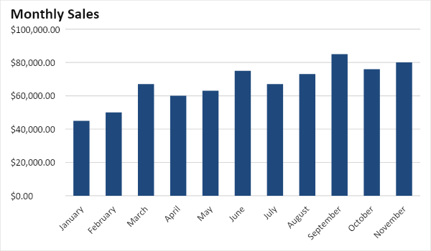

With a more aggressive marketing campaign, the company predicts positive sales growth in all sectors. The following chart shows these projections:

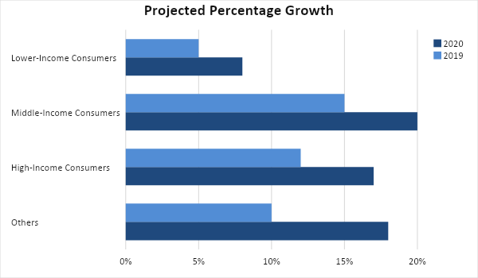

[Apatow Appliances] believes that excellent customer service plays a part in sales, on top of various marketing strategies. Therefore, the company will utilize the following strategies:

Sales Strategy | Activities | Timeline | Success Criteria
Online Marketing Campaigns | - The company will update and optimize its online content to include an efficient online ordering system. | - ASAP | - The company website has been optimized and updated to allow for online sales and payments.
 | - Create and curate content for social media pages and targeted ads | - ASAP | - Increased social media followers and audience engagement
Promotional Sales | - Seasonal promotional sales of up to 50% off to encourage customer purchase | - End of every quarter | - A 50% increase in customers during various sale periods

Marketing Strategy

The most efficient way to reach a wider audience remains to be through the use of online marketing strategies such as website optimization and social media marketing. However, the company believes that offline sales strategies play a large part in consumer buying behavior, including customer service and support, offline efforts, and psychological strategies such as promotional sales.

The company’s marketing team will put its efforts on the following strategies:

Milestones

Marketing Strategy | Activities | Timeline | Success Criteria
Online Marketing | - Hire a social media manager who will create and curate posts for online platforms, including written content, photos, and videos | - April 1, 2019 | - Online platforms have been updated and posts have been curated to fit the company’s goals
Promotional Sales | - Design and print promotional materials such as coupons, fliers, and posters | - ASAP | - Ensure that promotional materials are posted at least two weeks before the scheduled sales dates
Customer Service and Support | - Train the sales team and store staff for best customer support practices | - ASAP | - The sales team and staff have passed the training  - Customer reviews stay at 90% positive or higher

MANAGEMENT AND PERSONNEL

As a mid-sized single store operation, [Apatow Appliances] works with basic management organization, where the HR, Finance, Sales and Marketing, Staff, and Maintenance report directly to the owner.

Owner
Store Manager
Marketing Team
Finance
Sales Team
Delivery, Staff
Human Resources

SALES ACTION PLAN

The following table shows the company’s sales action plan, including its goals, corresponding activities, and other details to help measure success:

Sales Goals | Action Items | Start Date | End Date | KPIs | Owner
1. Increase sales by up to 12% in the next year | - Schedule daily meetings to update teams regarding sales goals | - January 1, 2018 | - No end date, regular practice | - Aligned marketing and sales goals  - Increasing sales | Sales Team  Marketing  Team
2. Improve customer service to create a better relationship with customers. | - Arrange regular training sessions for employees and sales personnel | - June 30, 2019 | - No end date, regular practice | - Successful training sessions | Store  Manager  Staff  Sales Team

