[XYZ Clothing & Apparel]

[For the Period 2017 – 2018]

RETAIL MARKETING PLAN
Index

Executive Summary [PAGE NUMBER]
Company Overview [PAGE NUMBER]

Products and Services [PAGE NUMBER]

Marketing Analysis [PAGE NUMBER]

Strategy and Implementation [PAGE NUMBER]
Management and Personnel [PAGE NUMBER]

Financial Plan [PAGE NUMBER]

EXECUTIVE SUMMARY

[XYZ Clothing & Apparel] will open wholesale and retail for its newly launched athletic and active wear product line. People nowadays are conscious about health and fitness especially with the increasing concerns about dangerous diseases. Thus, you can see different people go out for a jog at parks or participate in exercise programs at fitness clubs. With people paying attention to how they look when exercising, there is a high demand for affordable, durable, and fashionable athletic and sports attires following current trends in the market.

[XYZ Clothing & Apparel] will offer excellent quality and affordable athletic and active wear products and will open the wholesale and retail of the aforementioned products to different resellers around the world. Reseller opportunities will become a privilege for loyal customers of the business.

COMPANY OVERVIEW

Mission Statement

[XYZ Clothing & Apparel] provides its customers with opportunities to be fashionable and to feel good and confident about themselves by providing affordable yet high-quality ready-to-wear athletic and active wear worldwide.

Philosophy

[XYZ Clothing & Apparel] will continue to bring satisfaction to the clothing and fashion needs of its customers through the creation of creative, fashionable, and comfortable wear.

Vision

[XYZ Clothing & Apparel] aspires to become the leading retailer of different ready-to-wear athletic and active wear clothing around the world.

Outlook

People’s interest in being fashionable even when exercising or engaging in sports have increased with the promotion of fashion in a more subjective definition in various social media platforms. Being in style in everything has become the trend among people from young adults to middle-aged individuals. The need for a comfortable, durable, and fashionable yet affordable athletic and active wear implies an increased demand and a start of a new trend.

Type of Industry: Clothing/Apparel Industry
Business Structure: Sole Proprietorship

Ownership: Sole Proprietorship, [Blake Bracco]

Start-Up Summary

The start-up cost is [32K] USD to cover the various expenses, inventory, and supplies needed for [XYZ Clothing & Apparel] to start its operation. The funding is provided by the owner.

Start-Up Funding
Start-Up Expenses to Fund | $15,000
Start-Up Assets to Fund | $10,000
Total Funding Required | $25,000
Assets
Non-Cash Assets from Start-Up | $10,000
Cash Requirements from Start-up | $2,000
Additional Cash Raised | $3,000
Cash Balance on Starting Date | $2,000
Total Assets | $17,000
Capital
Planned Investment
Owner | $32,000
Other | $0
Additional Investment Requirement | $0
Total Planned Investment | $32,000
Loss at Start-Up (Start-Up Expenses) | $15,000
Total Capital | $17,000
Total Capital and Liabilities | $17,000
Total Funding | $25,000
Start-Up
Requirements
Start-Up Expenses
Rent - 5 Months | $7,000
Advertising | $1,500
Legal Fees | $1,500
Staff Training | $2,500
Insurance | $1,500
Miscellaneous | $1,000
Total Start-Up Expenses | $15,000
Start-Up Assets
Cash Balance Required | $2,000
Start-Up Inventory | $5,000
Other Current Assets | $1,500
Long-Term Assets | $1,500
Total Assets | $10,000
Total Requirements (Total Start-Up Expenses + Total Assets) | $25,000

PRODUCTS/SERVICES

Product/Service Description

[XYZ Clothing & Apparel] supplies a wide variety of athletic and active wear clothing around the world. Among the sportswear being sold are fitness apparel, gym wear, sports gears, water sports clothing, and other sweatshirts, shorts, and jackets.

Value Proposition

Be active, healthy, and fit in style. [XYZ Clothing & Apparel] opens the doors of various functional and fashionable athletic and active wear to its customers. The business is known for providing affordable but high-quality products in various locations in the world.

Pricing Strategy

[XYZ Clothing & Apparel] observes competitive psychological pricing. The affordability of the business’ products as compared to its competitors is what the customers prefer. The business will make a point to stay competitive and to fit its psychological pricing on every product through continuous observation of the competitors’ prices.

MARKETING ANALYSIS

The clothing/apparel industry will become more diverse in the next 10 years. There are clothing designs from previous generations returning as a new trend among younger generations adopted in a more modern and less flashy design. Both women and men are equally interested and attentive to fashion but for a different type or occasion. The media has also influenced the more personalized fashion sense of people in different parts of the globe.

Market Segmentation

[XYZ Clothing & Apparel] will focus its marketing and sales strategies on its customers from young adults to middle-aged groups. These two age groups tend to be more particular with what they wear. In this regard, the active wear product designs will be suited to the target customers’ preferences.

The table below presents the age groups that are more inclined to fitness and sports and those who are more attentive to how they look while doing such activities.

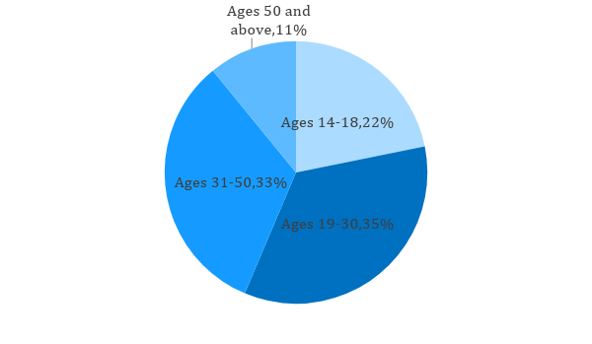
Target Market Segmentation Strategy

For customers between the ages [19-30] and [31-50]:

- [XYZ Clothing & Apparel] will provide functional and durable athletic and active wear product lines without jeopardizing the excellent quality and design of the clothing products.

- The business will open opportunities for small business enterprises for the wholesale and retail of the active wear products.

For Age Groups not inclined to fitness/sports:

- [XYZ Clothing & Apparel] will invest more in advertising its clothing and apparel associated with outdoor activities like swimming, sports, and many others.

- The business will provide education about the benefits of proper athletic and active wear in outdoor activities through videos and articles both online and on print media.

STRATEGY AND IMPLEMENTATION

Target Market Strategy

[XYZ Clothing & Apparel] targets an increase of [2]% in its sales for the first quarter of the fiscal year. The business aims to achieve such revenue increase through the aggressive advertisement of its product lines and the establishment of a secure and fast customer service. The business also seeks to satisfy the preferences of its customers with its product designs.

Competitive Edge

[XYZ Clothing & Apparel] makes its products’ prices competitive through psychological pricing and high-quality affordable offerings in the market.

SWOT Analysis | Strengths | Weaknesses | Opportunities | Threats
[XYZ Clothing & Apparel] | - Functional and durable product quality  - Affordable product prices  - High-quality products and designs | - A newcomer in the industry with less than 2 years in operation  - Flexible to adjustments and changes in the market, but weak in successful implementation  - Slow customer service/feedback | - High demand for active wear due to the increased awareness of people on health and fitness  - Opportunities for the business to follow the current trends in clothing styles and designs | - Established names of competitors in the clothing and apparel industry  - Involvement of competitor entities in various public sports or outdoor events
[Allure Clothing] | - A well-known brand of clothing and apparel, particularly, in active wear  - Excellent product quality and design | - Product prices are high compared to other stores | - Introduction of new products since the business has a secure market position | - Stores that offer similar excellent quality products at lower prices
[Flow Motion Clothing Company] | - offers wholesale and retail of its clothing and apparel  - Excellent quality products | - Not globally known, only domestic coverage  - Slow customer service/feedback | - Increased demand for wholesale and retail products worldwide | - Quick expansion of clothing businesses into wholesale and retail

Sales Strategy and Forecast

Through different online and video advertisements, the business aims to achieve the following quarterly sales:

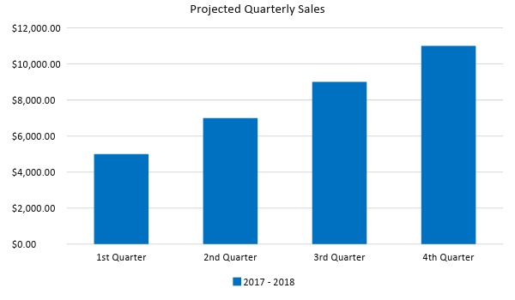

The table below presents the business’ projected growth of customers between the ages [19-30] after the implementation of advertisements and the psychological pricing of its athletic and active wear product lines.

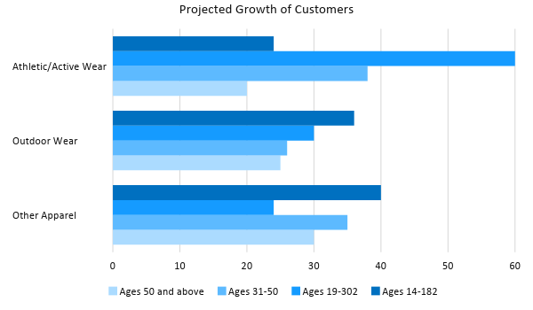

Marketing Strategy

People nowadays are invested in the use of the Internet and various social media platforms. [XYZ Clothing & Apparel] focuses more on establishing social media exposure for the business through online advertisements and content marketing. The business plans to open its website to reach a wider market for its wholesale and retail products

The business has an effective marketing team with a competent marketing manager to handle and manage the implementation of the marketing activities for its athletic and active wear products. Here are a few milestones in the implementation of its marketing strategies.

Milestones

Marketing Strategy | Activities | Timeline | Success Criteria
Creation of a website | - Collaboration with a trusted website creator  - Recruitment of an employee to handle website content | ASAP | A collaboration has been started with Cruxolutions and a website is set to be developed by the end of February 2017. The business is set to hire a person who would be in charge of website content by March 2017.
Online advertisements | - Produce online videos to be played on various social media platforms | March 9, 2017 | Outsource online advertising expertise by [March 19, 2017]
Publishing of fitness, health, and sports articles | - Article drafts are currently under evaluation | March 9, 2017 | Final drafts will be submitted on or before [March 20, 2017]

MANAGEMENT AND PERSONNEL

[XYZ Clothing & Apparel] is adopting a flat-type of organizational structure. The owner, [Mr. Blake Bracco], heads the business and handles the decision-making for the implementation of the business plans. All the department managers directly report to him.

The marketing manager focuses on the advertising and promotional activities of the business and will collaborate with the sales manager to boost the revenue of the business. With the creation of a business website, the marketing department will be divided into two sections, as defined below:

- The online marketing team who is tasked to handle and manage all digital and online advertisements as well as the regular content update of the website.

- The print and visual media marketing team is assigned to both print and visual promotions to be distributed or aired on various media platforms.

[XYZ Clothing & Apparel] has a total of [5] store branches with an assigned store manager for each. The store managers submit daily reports to the operations department who will segregate the information to the different areas of the business. All concerns of each store branch will be directly addressed to the HR and/or operations managers depending on the nature of the concern or issue.

Below is the organizational structure of the business:

Blake Bracco Owner
Finance & Accounting Team
Purchasing & Inventory Team
Store Managers
Marketing Team
Sales Team
Operations Team
Human Resource Team

FINANCIAL PLAN

[XYZ Clothing & Apparel] includes the projected break-even analysis, profit and loss, balance sheet, and cash flow in its financial plan as presented below.

Break-Even Analysis
Fixed Costs | Average Price | Variable Costs | Contribution Margin | Break-Even Units
$8,500.00 | $34.59 | $26.00 | $8.59 | 990
Fixed Costs | Amount |  | Variable Costs | Per Unit Amount
Rent | 7,000 |  | Advertising | 10
Insurance | 1,500 |  | Legal Fees | 10
 |  |  | Staff Training | 6
Total | 8,500 |  | Total | 26
Fixed Costs
Business Lease - Rent |  |  |  | $7,000
Insurance |  |  |  | $1,500
Total Fixed Costs |  |  |  | $8,500
Total Units Sold in 1 Month |  |  |  | 15,000
Variable Costs (Unit Sold/Cost per Unit)
Advertising |  |  | $1,500 | $10
Legal Fees |  |  | $1,500 | $10
Staff Training |  |  | $2,500 | $6
Total Variable Cost (Per Unit)
Break-Even
Selling Price Per Unit |  |  |  | $34.59
Break-Even Point Per Unit [Fixed Costs/(Sales Price Per Unit - Variable Cost Per Unit)] |  |  |  | 8,500
 |  |  |  | 8.59
Break-Even Point in Units |  |  |  | 990
Contribution Margin (Selling Price - Total Variable Cost) |  |  |  | $8.59

Profit and Loss Projection
 | FY2017 | FY2018 | FY2019
Sales | $518,850.00 | $560,358.00 | $605,186.64
Direct Cost of Sale | $390,000.00 | $409,500.00 | $429,975.00
Other Cost of Sale | $2,000.00 | $3,000.00 | $4,000.00
Total Cost of Goods Sold or COGS (Sales - Direct Cost of Sale - Other Cost of Sale) | $126,850.00 | $147,858.00 | $171,211.64
Gross Profit (Sales-Total Cost of Goods Sold) | $392,000.00 | $412,500.00 | $433,975.00
Gross Margin % (Gross Profit/Sales) | 75.55% | 73.61% | 71.71%
Operating Expenses
Rent | $20,000.00 | $20,000.00 | $20,000.00
Insurance | $18,000.00 | $18,500.00 | $19,000.00
Utilities | $15,000.00 | $17,000.00 | $19,000.00
Salary (Including Tax) | $70,000.00 | $80,000.00 | $90,000.00
Maintenance & Supplies | $2,500.00 | $3,000.00 | $3,500.00
Total Operating Expenses | $125,500.00 | $138,500.00 | $151,500.00
EBITDA (Total Cost of Sale-Total Operating Expenses) | $1,350.00 | $9,358.00 | $19,711.64
Depreciation (Asset Cost - Residual Value)/Useful Life of the Asset) | $6,000.00 | $6,000.00 | $6,000.00
Interest Expense | $0.00 | $0.00 | $0.00
Taxes Paid | $5,000.00 | $6,000.00 | $7,000.00
Net Profit (Gross Profit - Operating Expenses - Taxes - Interest) | $261,500.00 | $268,000.00 | $275,475.00

Balance Sheet Projection
 | FY2017 | FY2018 | FY2019
Cash | $100,000.00 | $110,000.00 | $120,000.00
Accounts Receivable | $20,000.00 | $23,000.00 | $26,000.00
Inventory | $5,000.00 | $7,500.00 | $11,250.00
Other Current Assets | $5,000.00 | $7,000.00 | $9,000.00
Total Current Assets | $130,000.00 | $147,500.00 | $166,250.00
Long-Term Assets | $10,000.00 | $12,000.00 | $14,000.00
Accumulated Depreciation | $3,000.00 | $3,000.00 | $3,000.00
Total Long-Term Assets | $7,000.00 | $9,000.00 | $11,000.00
Total Assets (Total Current Assets + Total Long-Term Assets) | $137,000.00 | $156,500.00 | $177,250.00
Accounts Payable | $15,000.00 | $16,000.00 | $17,000.00
Notes Payable | $5,000.00 | $6,500.00 | $8,000.00
Other | $2,000.00 | $2,500.00 | $3,000.00
Total Liabilities | $22,000.00 | $25,000.00 | $28,000.00
Paid-in Capital | $25,000.00 | $25,000.00 | $25,000.00
Retained Earnings | $90,000.00 | $106,500.00 | $124,250.00
Total Owner's Equity (Total Assets - Total Liabilities) | $115,000.00 | $131,500.00 | $149,250.00
Total Liabilities & Equity (Total Liabilities+Total Owner's Equity) | $137,000.00 | $156,500.00 | $177,250.00
Debt to Equity Ratio (Total Liabilities/Total Owner's Equity) | 19.13% | 19.01% | 18.76%

