[Janice Erikson]
[janicee@saulrietabeach.com]
[401-535-6146]
[www.saulrietabeach.com]
[1542 Myra Street]
[Providence, Rhode Island 02908 USA]
[INSERT COMPANY NAME]
BUSINESS PLAN FOR FISCAL YEAR [INSERT YEAR]
[INSERT DATE]

RESORT BUSINESS PLAN

INDEX

EXECUTIVE SUMMARY  COMPANY OVERVIEW  PRODUCTS AND SERVICES  EXECUTION  OPERATIONAL PLAN  FINANCIAL PLAN | [INSERT PAGE NO.]  [INSERT PAGE NO.]  [INSERT PAGE NO.]  [INSERT PAGE NO.]  [INSERT PAGE NO.]  [INSERT PAGE NO.]

EXECUTIVE SUMMARY

[Saulrieta Resort] is a small resort in Providence, [Rhode Island] that serves as a great alternative for people to relax and have fun away from the bustling city.

The hospitality industry is constantly growing and is seen to reach [$864 billion] in profits in the next year, with a projected annual growth of [4.3%]. With plenty of hotels and resorts competing in the market, it is important for [Saulrieta Resort] to invest in different marketing strategies such as partnerships with websites like [Agoda], [Klook], and Travel Advisor to maximize audience reach. If successful, the resort should see a positive income trajectory in the first year, and gain revenue within [18 months] of operation.

COMPANY OVERVIEW

Mission Statement: [Saulrieta Resort] is committed to providing memorable vacation experiences for its guests through excellence in service.

Philosophy: [Saulrieta Resort] celebrates the beauty of nature by consciously adapting best conservation practices without compromising the quality of services that customers will come to expect of the business.

Vision: [Saulrieta Resort] will provide a safe and enjoyable environment for customers and staff members.

Outlook: The surge of the US economy following the recession fueled the growth of the tourism industry. Majority of travelers in the [United States] are expected to be millennial by the year 2025. By focusing its strategies in satisfying this sector with easy check-ins and reasonable prices, the resort sees a steady rise in revenue in the coming [five years].

Type of Industry: Hospitality Industry

Business Structure: Sole Proprietorship

Ownership: Sole Proprietorship, [Janice Erikson]

Start-Up Summary: The owner will need a total amount of [$3 million] to start the resort business. This amount will be provided partly by [Janice Erikson], and partly from a personal loan, to be used for renovations of the beachfront property, furniture, supplies, and payroll.

Start-Up Funding
Start-Up Expenses | $1,000,000
Start-Up Assets | $2,000,000
Total Funding Required | $3,000,000
Assets
Non-Cash Assets from Start-Up | $1,200,000
Cash Requirements from Start-up | $450,000
Additional Cash Raised | $100,000
Cash Balance on Starting Date | $250,000
Total Assets | $2,000,000
Capital
Planned Investment
Owner | $500,000
Other | $2,500,000
Additional Investment Requirement | $0
Total Planned Investment | $3,000,000
Loss at Start-Up (Start-Up Expenses) | -$1,000,000
Total Capital | $2,000,000
Liabilities | $0
Total Capital and Liabilities | $2,000,000
Start-Up
Requirements
Start-Up Expenses
Construction and Renovations | $350,000
Advertising | $5,000
Legal Fees | $3,000
Staff Training | $450,000
Insurance | $12,000
Other | $180,000
Total Start-Up Expenses | $1,000,000
Start-Up Assets
Cash Required | $800,000
Start-Up Inventory | $200,000
Other Current Assets | $400,000
Long-Term Assets | $600,000
Total Assets | $2,000,000
Total Requirements (Total Start-Up Expenses + Total Assets) | $3,000,000

Management Team:

Management Team | Role/Function | Skills
Glenda Peterson | Resort Manager | Communication, Teamwork, Leadership
Alex de la Cruz | HR Manager | Onboarding, Performance Management

Short- and Long-Term Goals and Milestones:

Short-Term Goals | Milestones
Finish construction of entertainment facilities by April 30 | Construction is done  Interior decorating is ongoing
Hire resort staff by March 1 | Hiring 70% done
Long-Term Goals | Milestones
Expand business by offering new services after 1 year | Draft of the expansion plan is ongoing
Increase profits by 25% in the second year of operations | Preparation for an intensive marketing campaign has already started

PRODUCTS AND SERVICES

Product/Service Description: [Saulrieta Resort] offers customers several services such as massage and spa services and water sports.

Value Proposition: [Saulrieta Resort] is a small and quiet beachfront property located away from the populous areas of Providence, making it especially attractive to visitors who want to take time off from the city.

Pricing Strategy: As a new destination for tourists, the resort will start operations with lower rates to attract customers. After three months, the business will adhere to the average industry prices to remain competitive.

EXECUTION

Marketing Plan: [Saulrieta Resort] will utilize an aggressive social media campaign to reach its target audience. It will also create press releases for printing and features in local newspapers and travel and lifestyle magazines.

Market Research: The travelers in Providence include millennial who want to escape the bustle of the city and do activities such as water sports. There are also couples and elderly people who are looking to have romantic getaways and a time to rest and relax.

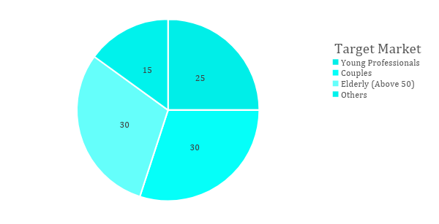

SWOT Analysis | Strengths | Weaknesses | Opportunities | Threats
Saulrieta Resort | Great ambiance | High seasonal dependency | Boom in hospitality industry could increase revenue | Natural disasters could impede operations
Marina Beachfront Resort | Has an effective customer loyalty program | Low-profit margins | Emerging markets could give an opportunity for expansion | Increasing competition threatens revenue
Seaside Chateau | Top-quality service | High prices show limited market share despite good branding | Changing market trends show travelers are willing to pay more for good service | Economic downturn could cut revenue

Marketing Strategy: [Saulrieta Resort] will take advantage of several marketing strategies to maximize audience reach and brand recall. Other than social media advertising and press releases, the resort will also use promotional pricing strategies year-round to attract more customers.

Marketing Strategy | Activities | Timeline | Success Criteria
Social Media Advertising | Create Facebook and Instagram accounts for advertising and boost posting | ASAP | At least 10,000 likes within the first three months of page launch
Press Releases and Magazine Features | Write press releases and contact travel magazines for resort feature articles | March 30 | - Press releases printed on local newspapers  - Resort featured in at least 5 travel magazines/websites
Resort Promos | Create monthly discounts and promo rates | First five months of operation | At least 25% increase in sales

Organizational Structure:

Chief Executive Officer
HR Manager
Grounds Manager
Marketing Manager
Recruitment
Employee Dev.
Service Crew
Maintenance
External Affairs

OPERATIONAL PLAN

Location and Facilities:
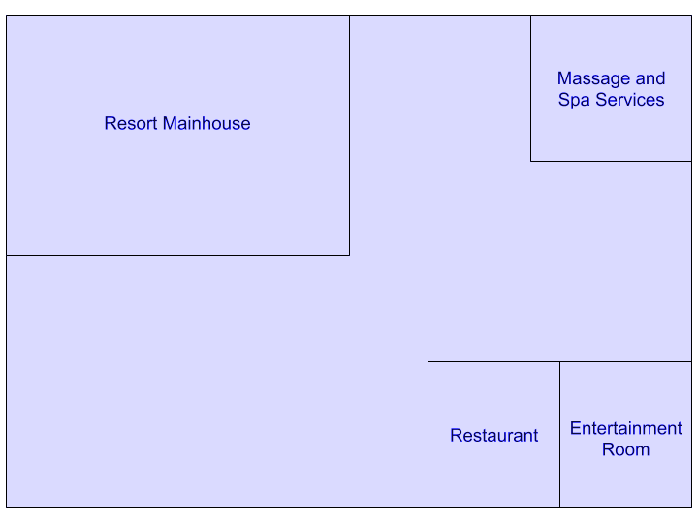

FINANCIAL PLAN

Assumptions

The financial forecast is based on the annual forecast in the hospitality industry. To compete in the market, the company will focus its efforts on aggressive social media advertising, as well as exceptional customer service to finance the resorts needs such as payroll, maintenance, supplies, and other related expenses.

Monthly Expense

The chart shows the projected monthly expenses for [2019]. Construction and purchasing of interior decorations and furniture caused very high expenses in the first three months of the year, which eventually leveled out as the resort was completed.

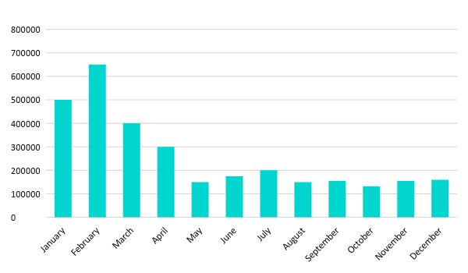

Monthly Revenue

The chart depicts the projected monthly revenues for 2019 beginning April when the resort officially opens for the public.

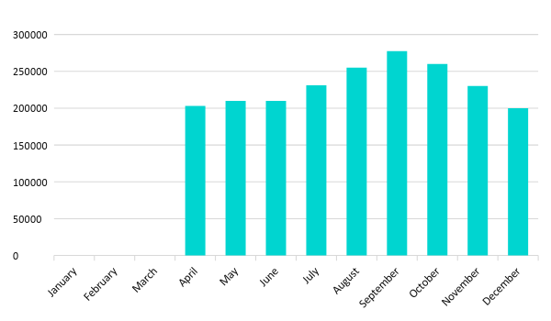

Business Financing

The owner shall put up [$3,000,000] of the amount needed to put up the business. The rest of the capital shall be obtained through a bank loan. Major expenses will include renovation of the beachside property, construction of additional facilities, salaries, furniture, and supplies.
Statements:

Profit and Loss Projection
 | FY2019 | FY2020 | FY2021
Sales | $2,765,000.00 | $3,500,000.00 | $4,700,000.00
Direct Cost of Sale | $1,800,000.00 | $2,750,000.00 | $3,500,000.00
Other Cost of Sale | $500,000.00 | $570,000.00 | $630,000.00
Total Cost of Goods Sold or COGS (Sales - Direct Cost of Sale - Other Cost of Sale) | $465,000.00 | $180,000.00 | $570,000.00
Gross Profit (Sales-Total Cost of Goods Sold) | $2,300,000.00 | $3,320,000.00 | $4,130,000.00
Gross Margin % (Gross Profit/Sales) | 83.18% | 94.86% | 87.87%
Operating Expenses
Construction and Renovation Costs | $350,000.00 | $100,000.00 | $75,000.00
Insurance | $12,000.00 | $12,000.00 | $12,000.00
Utilities and Maintenance | $50,000.00 | $55,000.00 | $63,000.00
Salary (Including Tax) | $700,000.00 | $725,000.00 | $800,000.00
Supplies | $60,000.00 | $63,000.00 | $66,000.00
Total Operating Expenses | $1,172,000.00 | $955,000.00 | $1,016,000.00
EBITDA (Total Cost of Sale-Total Operating Expenses) | -$707,000.00 | -$775,000.00 | -$446,000.00
Depreciation | $4,000.00 | $4,000.00 | $4,000.00
Interest Expense | $0.00 | $0.00 | $0.00
Taxes Paid | $4,000.00 | $5,000.00 | $6,000.00
Net Profit (Gross Profit - Operating Expenses - Taxes - Interest) | $1,124,000.00 | $2,360,000.00 | $3,108,000.00

Balance Sheet Projection
 | FY2019 | FY2020 | FY2021
Cash | $20,000.00 | $45,000.00 | $70,000.00
Accounts Receivable | $15,000.00 | $20,000.00 | $25,000.00
Inventory | $15,000.00 | $21,000.00 | $27,000.00
Other Current Assets | $8,000.00 | $10,000.00 | $12,000.00
Total Current Assets | $58,000.00 | $96,000.00 | $134,000.00
Long-Term Assets | $10,000.00 | $13,500.00 | $16,000.00
Accumulated Depreciation | $2,000.00 | $2,000.00 | $2,000.00
Total Long-Term Assets (Long-Term Assets-Accumulated Depreciation) | $8,000.00 | $11,500.00 | $14,000.00
Total Assets (Total Current Assets + Total Long-Term Assets) | $66,000.00 | $107,500.00 | $148,000.00
Accounts Payable | $10,000.00 | $15,000.00 | $23,000.00
Notes Payable | $3,000.00 | $5,000.00 | $2,700.00
Other | $2,000.00 | $1,500.00 | $3,000.00
Total Liabilities | $15,000.00 | $21,500.00 | $28,700.00
Paid-in Capital | $5,000.00 | $5,000.00 | $5,000.00
Retained Earnings | $24,000.00 | $56,000.00 | $53,000.00
Total Owner's Equity (Total Assets - Total Liabilities) | $51,000.00 | $86,000.00 | $71,300.00
Total Liabilities & Equity (Total Liabilities/Total Owner's Equity) | 29.41% | 25.00% | 40.25%

Cash Flow Projection
 | FY2019 | FY2020 | FY2021
Operating Cash Beginning | $250,000.00 | $300,000.00 | $375,000.00
Sources of Cash | $150,000.00 | $18,000.00 | $15,000.00
Receivables | $100,000.00 | $120,000.00 | $180,000.00
Sales | $2,765,000.00 | $3,500,000.00 | $4,700,000.00
Others | $50,000.00 | $70,000.00 | $80,000.00
Total Cash | $3,315,000.00 | $4,008,000.00 | $5,350,000.00
Expenditures
Construction and Renovation Costs | $350,000.00 | $100,000.00 | $75,000.00
Insurance | $12,000.00 | $12,000.00 | $12,000.00
Utilities and Maintenance | $50,000.00 | $55,000.00 | $63,000.00
Salary (Including Tax) | $700,000.00 | $725,000.00 | $800,000.00
Supplies | $60,000.00 | $63,000.00 | $66,000.00
Total Expenditures | $1,172,000.00 | $955,000.00 | $1,016,000.00
Net Income/Loss (Total Cash - Total Expenditures) | $2,143,000.00 | $3,053,000.00 | $4,334,000.00

