[Quality High]
Business Plan For Fiscal Year [2019]
[August 15, 2018]

QUALITY
ASSURANCE
BUSINESS PLAN

[Rose G. Moran]
[RoseGMoran@armyspy.com]
[678-707-6827]
[www.qh.com]
[2830 Kuhl Avenue
Norcross, GA 30092]

Index

Executive Summary | [PAGE NUMBER]
Company Overview | [PAGE NUMBER]
Products and Services | [PAGE NUMBER]
Execution | [PAGE NUMBER]
Operational Plan | [PAGE NUMBER]
Financial Plan | [PAGE NUMBER]

EXECUTIVE SUMMARY

[Quality High] aims to provide quality assurance services. The common problem of small companies is that they tend to ignore how important quality analysis is. [Quality High] provides quality assurance services to ensure that clients keep track of, maintain, or improve the quality of their products and services.

The company will be focusing its marketing services on new businesses through digital outreach which includes website and social media engagements. Other means like press releases will also be considered.

Quality High expects to raise its service sales by at least [30]% by the end of its first year of operations.

COMPANY OVERVIEW

Mission Statement

[Quality High] provides quality assurance services for every business need. By doing so, [Quality High] intends to improve the quality of their client’s products and services and the efficiency of their workforce.

Philosophy

[Quality High] inspires and innovates its employees and clients through service with full integrity, enjoyment, and responsibility.

Vision

[Quality High] aims to be the top quality assurance provider in the country by [2030].

Outlook

[Quality High] will be the trusted and leading quality assurance service provider in the country.

Type of Industry: Professional, Scientific, and Technical Services

Business Structure: Sole Proprietorship

Ownership: Sole Proprietorship, [Rose G. Moran]

Start-Up Summary

The start-up cost is [500,000] USD to be provided by the owner and to be allocated mainly for the monthly space rental, business insurance, materials, and salaries.

Start-Up Funding
Start-Up Expenses | $90,000
Start-Up Assets | $410,000
Total Funding Required | $500,000
Assets
Non-Cash Assets from Start-Up | $100,000
Cash Requirements from Start-up | $210,000
Additional Cash Raised | $50,000
Cash Balance on Starting Date | $50,000
Total Assets | $410,000
Capital
Planned Investment
Owner | $410,000
Other | $0
Additional Investment Requirement | $0
Total Planned Investment | $410,000
Loss at Start-Up (Start-Up Expenses) | $90,000
Total Capital | $500,000
Liabilities | $0
Total Capital and Liabilities | $500,000
Start-Up
Requirements
Start-Up Expenses
Rent - 5 Months | $50,000
Advertising | $10,000
Legal Fees | $5,000
Staff Training | $20,000
Insurance | $5,000
Other | $0
Total Start-Up Expenses | $90,000
Start-Up Assets
Cash Required | $210,000
Start-Up Inventory | $100,000
Other Current Assets | $50,000
Long-Term Assets | $50,000
Total Assets | $410,000
Total Requirements (Total Start-Up Expenses + Total Assets) | $500,000

Management Team

Management Team | Role/Function | Skills
[Cedric P. Poole]  [David A. Schwartz] | Operations Managers | Communication, Teamwork, and Resilience
[Francisco A. Perry] | Human Resource Manager | Onboarding and People Management

Short- and Long-Term Goals and Milestones

Short-Term Goals | Milestones
Hire operation and human resource managers | Done hiring last [April 31, 2018]
Hire programmers and agents | The human resource manager has started the interviews on [May 7, 2018].
Long-Term Goals | Milestones
Expand company to nationwide scale | The hiring of additional administrative personnel started on [January 4, 2019].
Partnership with a government agency | Business proposals for government agencies created on [January 13, 2019]

PRODUCTS AND SERVICES

Product/Service Description

[Quality High] offers industry standard testing, updated tools and equipment, and the service of professionals who are experts in the field. Below is a list of the company’s services:

- System Testing
- Usability Testing
- Integration Testing
- Accreditation

Quality
Assurance
Team
Client
Accreditation
Testing
Evaluation
Training

Value Proposition

[Quality High] main focus is to improve the efficiency of its client’s processes and employees. After conducting a study, quality assurance agents will evaluate the metrics and provide the necessary training, solutions, and improvements.

[Quality High] advanced testing tools set it apart from its competitors.

Pricing Strategy

[Quality High] will be using price skimming and penetration pricing. Penetration pricing will improve the company’s service deal image basically by lowering its price. It will slowly shift to price skimming in the later time to catch up with the projected price as the number of clients increase.

Formula:
Profit Margin = 1- (Expenses/Net Sales)

Quality High
Profit Margin = 1 - ($85,000/$215,625)
= 1-0.394
= 0.61 or 61%

EXECUTION

Marketing Plan

[Quality High] will be hiring web developers for the creation of the company’s website and social media accounts. Print advertising materials and press releases will be distributed.

The company will be hiring additional software developers to continuously improve its software tools.

Market Research

The industry is now adopting automated test tools, which guarantees end-user satisfaction because of its efficiency and accuracy. Artificial intelligence now plays a huge part in quality assurance, and many businesses are employing them in their tools and processes.

SWOT Analysis | Strengths | Weaknesses | Opportunities | Threats
[Quality High] | - Technically advanced testing tools and strategies  - Covers a wide scope of services  - Digital and manual tools | - New in the business  - No established connections yet | - The social media trend is an opportunity to market the service to a wider audience | - Most small businesses lack knowledge on the importance of quality assurance
[Testing Xperts] | - - Very low service prices | - Testing tools are outdated  - Only offers online testing | - The continued discovery of advanced tools and technology for quality assurance | - Companies that have better testing tools and experts
[QA Engineer] | - Established quality assurance provider | - Has yet to expand globally |  | - New quality assurance services are emerging in the market.

Marketing Strategy

Social media advertisements will be boosted to gain a higher number of audience. A website will also be made to provide more information about the company and its services.

Free seminars will be conducted to proprietors to further promote the industry as well as the services being offered. Other means of advertising such as newspapers, fliers, magazines, billboards, and television will also be used.

Management heads have already started the tasks and these are the updates:

Marketing Strategy | Activities | Timeline | Success Criteria
Creation of social media accounts and a company website | The programmers will work on the given tasks | July 3, 2018 | Social media accounts have been created.
Quality assurance seminars | Operation managers have distributed seminar invitations to various proprietors | July 5, 2018 | [80]% of the invited businessmen have accepted the invitations.
Media advertising | Paid for media advertisements | August 1, 2018 | The ads are expected to come out in the first week of September.

Organizational Structure

Chief Executive Officer (CEO) – Responsible for corporate decision-making and management of the overall operations

Operation Managers – Handle all company projects such as the creation of social media accounts and the company website, and software tools development

Services Operation Managers – Manage client services and ensure client satisfaction

Team Leaders – Work very closely with the operation managers, programmers, and QA agents

Programmers – Develop the software tools

QA Agents – Execute specific quality assurance activities

OPERATIONAL PLAN

Location and Facilities

Provide a sketch or blueprint of the facility.

Provide photos or images of the location/facility.

Tools and Equipment Checklist

Software | Quantity
Selenium | 5
Hardware | Quantity
Desktop Computers | 30

IT Infrastructure

The following table reflects [Quality High’s] IT infrastructure.

Infrastructure | Existing (Y/N) | Description
Social Media | Y | The company has Facebook, LinkedIn, and Twitter
Latency Proof | Y | Fast and stable network connections.
Zero Downtime | N | There has been no business disruption due to the network.
High-Performance Storage | Y | Has a big storage space for data collection and back up.

FINANCIAL PLAN

Assumptions

The financial plan is made based on market trends. The expenses will mostly cover the tools, salaries, insurance, marketing fees, and rent.

Monthly Expense

The chart shows the projected monthly expense for [2019].

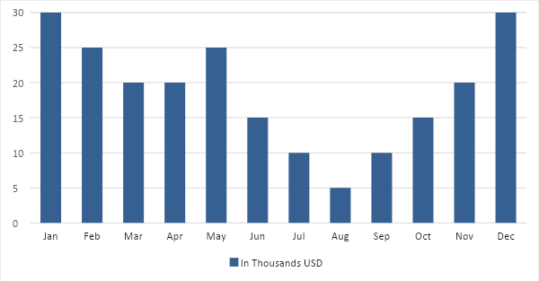

Monthly Revenue

The chart depicts the projected monthly revenue for [2019].

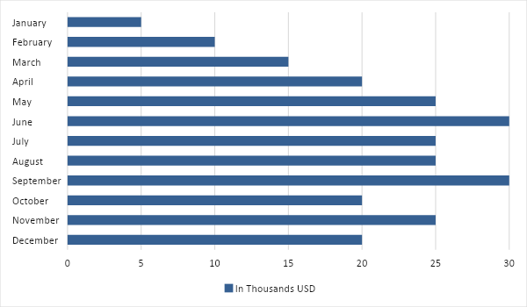

Business Financing

The business funding comes from a business investment worth [500,000] USD.

Statements

Profit and Loss Projection
 | FY2019 | FY2020 | FY2021
Sales | $575,000.00 | $650,000.00 | $725,000.00
Direct Cost of Sale | $143,750.00 | $162,500.00 | $181,250.00
Other Cost of Sale | $71,875.00 | $81,250.00 | $90,625.00
Total Cost of Goods Sold or COGS (Sales - Direct Cost of Sale - Other Cost of Sale) | $359,375.00 | $406,250.00 | $453,125.00
Gross Profit (Sales-Total Cost of Goods Sold) | $215,625.00 | $243,750.00 | $271,875.00
Gross Margin % (Gross Profit/Sales) | 37.50% | 37.50% | 37.50%
Operating Expenses
Rent | $50,000.00 | $50,000.00 | $50,000.00
Insurance | $5,000.00 | $6,000.00 | $7,000.00
Utilities | $5,000.00 | $6,000.00 | $6,000.00
Salary (Including Tax) | $20,000.00 | $25,000.00 | $30,000.00
Maintenance & Supplies | $5,000.00 | $6,000.00 | $7,000.00
Total Operating Expenses | $85,000.00 | $93,000.00 | $100,000.00
EBITDA (Total Cost of Sale-Total Operating Expenses) | $274,375.00 | $313,250.00 | $353,125.00
Depreciation | $5,000.00 | $5,000.00 | $5,000.00
Interest Expense | $0.00 | $0.00 | $0.00
Taxes Paid | $20,000.00 | $25,000.00 | $30,000.00
Net Profit (Gross Profit - Operating Expenses - Taxes - Interest) | $110,625.00 | $125,750.00 | $141,875.00

Balance Sheet Projection
 | FY2019 | FY2020 | FY2021
Cash | $100,000.00 | $200,000.00 | $300,000.00
Accounts Receivable | $50,000.00 | $55,000.00 | $60,000.00
Inventory | $25,000.00 | $30,000.00 | $35,000.00
Other Current Assets | $15,000.00 | $20,000.00 | $25,000.00
Total Current Assets | $190,000.00 | $305,000.00 | $420,000.00
Long-Term Assets | $50,000.00 | $55,000.00 | $60,000.00
Accumulated Depreciation | $25,000.00 | $25,000.00 | $25,000.00
Total Long-Term Assets (Long-Term Assets-Accumulated Depreciation) | $25,000.00 | $30,000.00 | $35,000.00
Total Assets (Total Current Assets + Total Long-Term Assets) | $215,000.00 | $335,000.00 | $455,000.00
Accounts Payable | $50,000.00 | $55,000.00 | $60,000.00
Notes Payable | $25,000.00 | $30,000.00 | $35,000.00
Other | $10,000.00 | $15,000.00 | $20,000.00
Total Liabilities | $85,000.00 | $100,000.00 | $115,000.00
Paid-in Capital | $50,000.00 | $55,000.00 | $60,000.00
Retained Earnings | $100,000.00 | $200,000.00 | $300,000.00
Total Owner's Equity (Total Assets - Total Liabilities) | $130,000.00 | $235,000.00 | $340,000.00
Total Liabilities & Equity (Total Liabilities/Total Owner's Equity) | 65.38% | 42.55% | 33.82%

Cash Flow Projection
 | FY2019 | FY2020 | FY2021
Operating Cash Beginning | $500,000.00 | $550,000.00 | $600,000.00
Sources of Cash | $100,000.00 | $150,000.00 | $200,000.00
Receivables | $25,000.00 | $30,000.00 | $35,000.00
Sales | $50,000.00 | $55,000.00 | $60,000.00
Others | $25,000.00 | $30,000.00 | $35,000.00
Total Cash | $700,000.00 | $815,000.00 | $930,000.00
Expenditures
Rent | $50,000.00 | $55,000.00 | $60,000.00
Insurance | $5,000.00 | $7,500.00 | $10,000.00
Utilities | $5,000.00 | $7,500.00 | $10,000.00
Salary (Including Tax) | $20,000.00 | $25,000.00 | $30,000.00
Maintenance & Supplies | $5,000.00 | $7,500.00 | $10,000.00
Total Expenditures | $85,000.00 | $102,500.00 | $120,000.00
Net Income/Loss (Total Cash - Total Expenditures) | $615,000.00 | $712,500.00 | $810,000.00

