Pharmaceutical Sales Plan

Index

Executive Summary [PAGE NUMBER]
Company Overview [PAGE NUMBER]
Products and Services [PAGE NUMBER]
Marketing Analysis [PAGE NUMBER]
Strategy and Implementation [PAGE NUMBER]
Management and Personnel [PAGE NUMBER]
Sales Action Plan [PAGE NUMBER]

EXECUTIVE SUMMARY

[MedServ Family Pharmacy], LLC's goal is to provide safe medicines of the highest quality but at an affordable price. In a time where medicine prices are soaring, [MedServ] wants to offer patients in Maryland a cheaper place to get their prescriptive and over-the-counter medicines. By maintaining operational efficiency and focusing on the core target markets, the drugstore will set competitive prices on both generic and branded medicines.

The [Maryland-based pharmacy] is a family-owned business maintaining the value of excellence, integrity, and honesty. The pharmacy works hard to employ knowledgeable and friendly associates to assist customers.

COMPANY OVERVIEW

Mission Statement:

[MedServ Family Pharmacy's] mission is to provide safe, high-quality, and affordable medicines. The community can expect customer care delivered in a way that is professional and respectful.

Philosophy:

[MedServ] believes in honesty, respect, and diversity to provide excellent customer care.

Vision:

[MedServ's] goal is to become [Maryland’s] best and most preferred drugstore of quality and affordable prescription and over-the-counter (OTC) medicines.

Outlook:

The aging population, health issue awareness, and advancement in medical treatment are the main driving force of the demand of the drugstore industry in the US. Although there are giant drugstore chains that dominate the national market, regional and small drugstores have the advantage in building a stronger relationship with customers with their personalized services. Another factor affecting the industry these days is the rise of ["e-patients."] These are customers that order their prescription and over-the-counter (OTC) drugs online. In response, drugstores are now developing web and mobile app stores.

Type of Industry: Drugstore Industry

Business Structure: Limited Liability Company

Ownership: Dr. Emily Pearson, Dr. Jackson Pearson, Angelo Pearson

Start-Up Summary:

The members of the company put up [400K] USD each as a startup fund, which is to be appropriated for the rent, insurance, supplies, and payroll.

Start-Up Funding
Start-Up Expenses | $109,000
Start-Up Assets | $500,000
Total Funding Required | $609,000
Assets
Non-Cash Assets from Start-Up | $300,000
Cash Requirements from Start-up | $100,000
Additional Cash Raised | $85,000
Cash Balance on Starting Date | $15,000
Total Assets | $500,000
Capital
Planned Investment
Owner | $1,200,000
Other | $0
Additional Investment Requirement | $0
Total Planned Investment | $1,200,000
Loss at Start-Up (Start-Up Expenses) | -$109,000
Total Capital | $1,091,000
Liabilities | $0
Total Capital and Liabilities | $1,091,000
Start-Up
Requirements
Start-Up Expenses
Rent - 5 Months | $88,000
Advertising | $15,000
Legal Fees | $35,000
Staff Training | $15,000
Insurance | $47,000
Inventory | $500,000
Total Start-Up Expenses | $700,000
Start-Up Assets
Cash Required | $0
Start-Up Inventory | $300,000
Other Current Assets | $100,000
Long-Term Assets | $100,000
Total Assets | $500,000
Total Requirements (Total Start-Up Expenses + Total Assets) | $1,200,000

PRODUCTS AND SERVICES

Product/Service Description:

[MedServ Family Pharmacy] offers a wide range of drugs to Maryland-based patients. Both generic and brand name drugs are available.

Value Proposition:

The drugstore also caters to mail orders anywhere in the country and offer [24/7] delivery services to patients in Maryland.

Pricing Strategy:

[MedServ] utilizes competitive pricing.

MARKETING ANALYSIS

The [pharmacy industry] continues to grow. However, the growth comes with new challenges, especially on the need for the industry to adjust to the new behavior of its target market. The rise of three different consumer groups—walk-ins, mail orders, and online—presents drugstores more opportunities to grow.

Market Segmentation

[MedServ Family Pharmacy’s] market is divided into three groups; the mail order customers, the locals or walk-in customers, and the online customers. The table below shows which of the three purchase options is preferred most by the customers.

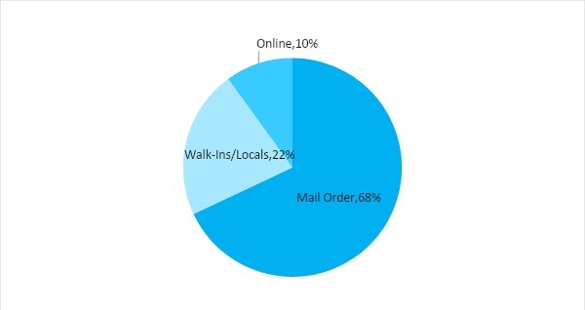

Target Market Segmentation Strategy

Mail Order Customers

- These are usually the older adults(50 years old and above), mostly under maintenance medication.
- The company will reach out to these customers through advertising campaigns in magazines and newsletters.

Walk-Ins or the Locals

- This group tends to purchase single prescription medicines.
- This group will be targeted through the local newspapers and posters highlighting the drugstore and its affordable medicines.

Online Customers

- [MedServ] will be launching a website and an app where customers can purchase online. Customers can either pick up the medicines at the physical store or have them delivered right at their doorstep for a minimal fee.

STRATEGY AND IMPLEMENTATION

Target Market Strategy

[MedServ Family Pharmacy] aims to increase its sales in the first year by at least [5%]. This will be accomplished by increasing its reach to the mail order and online consumers.

Competitive Edge

The Maryland-based drugstore offers OTC and prescription drugs at affordable prices. It also has a [24/7] delivery service to customers in Maryland.

SWOT Analysis | Strengths | Weaknesses | Opportunities | Threats
MedServ Family Pharmacy, LLC | - Nationwide mail order delivery  - Affordable prices | - Only has a small inventory of medicine | - Pharmaceutical companies looking for retailers for their growing customer base | - Competition with large drugstore chains that offer a much wider selection of medicines
Discount Pharmacy | - Very low prices | - Only offers generic medicines  - No online service | - Consumers who are looking for cheaper medicines | - Consumers who still trust and buy brand name medicines despite budget constraints
National Drugstore, Inc. | - Large national pharmacy chain | - Customer service is known to be bad | - The widening market presents chances to open up new stores | - Consumers who prefer purchasing medicines online and through mail orders

Sales Strategy and Forecast

[MedServ] sales strategy is to build stronger long-term relationships with its customers. To achieve this, the drugstore offers medicines of superior quality but at lower prices and increases its medicine stock to facilitate faster shipment and store pick up. The pharmacy is also investing more on its salespeople. They will be trained on how to provide better customer service.

At the same time, [MedServ] will also update its online store and launch an app to cater to online customers.

The pharmacy targets the following monthly sales:

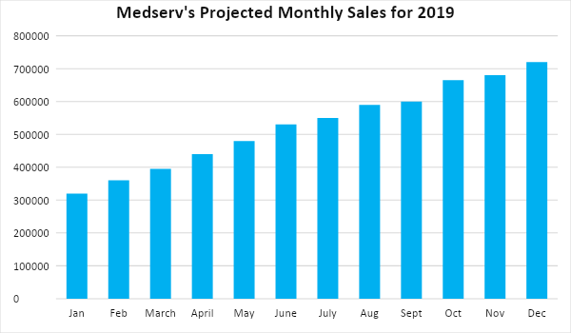

The company is putting emphasis on effective customer service, print advertising, and the launching of an online store and store app to meet the forecasted sales goals. Here are some updates:

Sales Strategy | Activities | Timeline | Success Criteria
Customer Service Excellence | All sales personnel will be trained on how to handle mail orders, walk-ins, and online customers. | Scheduled from November to December 2018 | Customer reviews should be generally positive
Online Store and App | The pharmacy will be updating its online store and app. | Updates are scheduled to be done starting January 5, 2019 | The online store increases traffic by 12% and meets the target of 1000 app downloads in the first month.

Marketing Strategy

[MedServ’s] marketing strategy is focused on targeted advertising. Through ads published in magazines and local papers, the drugstore anticipates an increase of brand recognition from both the mail order and in-store customers. Potential mail order customers, as well as the existing ones, will be sent a monthly magazine that features discounts on certain prescription and OTC drugs for the month.

The company will also do online advertising, especially now that it has an online store or an app for online purchasing.

Milestones

Marketing Strategy | Activities | Timeline | Success Criteria
Website upgrade | - Hired a specialist company to do the online store and app maintenance | January 5, 2019 | The online store and app are running before the end of January.
Advertising | - The marketing department will prepare print ads for magazines and local newspapers  - Monthly magazine distribution  - Online ads | ASAP | Ads are printed by the second week of January 2019.
Training for Salespeople | - HR will create a training manual for customer service | December 2018 | Salespeople are confident in dealing with clients; receive positive customer feedback regularly.
MANAGEMENT AND PERSONNEL

[MedServ Family Pharmacy], LLC is a family-owned business. Standing as [CEO] of the company is [Angelo Pearson], M.A. His parents, Dr. Emily and Dr. Jackson Pearson serve as the medical and financial consultants for the company. The general manager, who is also the chief pharmacist, oversees the daily store operations.

Below is the organizational structure of the company:

CEO
General Manager/Chief Pharmacist
Consultant
Marketing Team
Sales Team
Inventory
HR

SALES ACTION PLAN

The table below is the summary of [MedServ’s] sales goals and the corresponding programs. To measure the success of each activity, details such as target dates, resources, person-in-charge, and key performance indicators (KPIs) are included.

Sales Goals | Action Items | Start Date | End Date | KPIs | Owner
1. Coordination of goals between the sales and marketing teams. | - A weekly meeting is scheduled for updates and adjustment  - Distribution of resources to achieve goals. This includes budget and manpower. | - January 5, 2019  - January 5, 2018 | - This will be done consistently | - Alignment of goals  - Achievement of quarterly sales goals | - Sales Team Lead,  - Marketing Team Lead, and General Manager
2. Customer Service Excellence | - HR coordinates with the Marketing team to develop a training manual for new recruits  - Sales Team Lead will coordinate with HR to create a quarterly schedule of activities for sales personnel | - January 10, 2019  - January 20, 2019 | - February 30, 2019  - March 15, 2019 | - Creation of standard training manual  - Approved quarterly activities for the year | - HR Team Lead and Sales Team Lead
3. Increase sales by 8% | - The Sales Team will work with the Marketing team to develop promotional activities to boost sales | - December 20, 2018 | - End of 2019 | - Sales Increase by 8% by the end of 2019  - Show an increase in sales quarterly | - CEO, Sales Team Lead, General Manager, Marketing Team Lead

