PARALEGAL BUSINESS PLAN
[INSERT COMPANY NAME]
Business Plan for Fiscal Year [INSERT YEAR]
[INSERT DATE]

[JAMES HASTINGS]
[JAMESHASTINGS@GMAIL.COM ]
[808-942-4243]
[WWW.JAMESHASTINGS.COM]
[964 PRIDE AVENUE]
[NEW YORK CITY, NEW YORK 10019, USA]
INDEX

EXECUTIVE SUMMARY  COMPANY OVERVIEW  PRODUCTS AND SERVICES  EXECUTION  OPERATIONAL PLAN  FINANCIAL PLAN | [INSERT PAGE NO.]  [INSERT PAGE NO.]  [INSERT PAGE NO.]  [INSERT PAGE NO.]  [INSERT PAGE NO.]  [INSERT PAGE NO.]

EXECUTIVE SUMMARY

[Hastings Paralegal Services] will offer paralegal services in the city of [New York]. This startup firm focuses on providing services related to commercial law and the preparation of legal documents and cases filed within the jurisdiction of the small claims court.

[Hastings Paralegal Services] will employ online marketing strategies in order to reach a larger market at a lower cost. The firm aims to expand in the next two to five years.

COMPANY OVERVIEW

Mission Statement: The mission of [Hastings Paralegal Services] is to provide efficient, professional paralegal services, including legal document preparation, in a specific field of law.

Philosophy: [Hastings Paralegal Services] upholds itself to the highest standards of professionalism, confidentiality, trust, and accountability in the provision of services.

Vision: The vision of [Hastings Paralegal Services] is to provide clients with sound legal advice in a timely and efficient manner.

Outlook: There are different marketing and income-generating methods that the legal industry uses. These include social networking, legal process outsourcing, virtual law servicing, and other alternative legal service delivery models which have shown positive results to law firms. Hastings Paralegal Services aims to work around these methods to sustain its business for a longer period of time.

Type of Industry: Legal Industry

Business Structure: Partnership

Ownership: Partnership, [James Hastings] and [Darrell Jenkins]

Start-Up Summary: The start-up cost worth [100K USD] is to be provided by the owners and to be used mainly for the operational costs of the firm.

Start-Up Funding
Start-Up Expenses | $40,000
Start-Up Assets | $60,000
Total Funding Required | $100,000
Assets
Non-Cash Assets from Start-Up | $20,000
Cash Requirements from Start-up | $15,000
Additional Cash Raised | $5,000
Cash Balance on Starting Date | $20,000
Total Assets | $60,000
Capital
Planned Investment
Owner | $100,000
Other | $0
Additional Investment Requirement | $0
Total Planned Investment | $100,000
Loss at Start-Up (Start-Up Expenses) | -$40,000
Total Capital | $60,000
Liabilities | $0
Total Capital and Liabilities | $60,000
Start-Up
Requirements
Start-Up Expenses | $3,000
Rent - 1 year | $12,000
Advertising | $3,500
Legal Fees | $3,500
Staff Training | $8,000
Insurance | $5,000
Other | $5,000
Total Start-Up Expenses | $40,000
Start-Up Assets
Cash Required | $15,000
Start-Up Inventory | $20,000
Other Current Assets | $5,000
Long-Term Assets | $20,000
Total Assets | $60,000
Total Requirements (Total Start-Up Expenses + Total Assets) | $100,000

Management Team:

Management Team | Role/Function | Skills
James Hastings | Managing Partner | Leadership, effective management, communication, planning, and negotiation skills
Darrell Jenkins | Managing Partner

Short- and Long-Term Goals and Milestones:

Short-Term Goals | Milestones
Find an office space by February 28, 2019 | The managing partners already signed a lease contract on March 1, 2019.
Hire a secretary for the firm | The managing partners already hired a secretary on March 15, 2019.
Long-Term Goals | Milestones
Expand the firm and hire at least two paralegals by the end of 2020 | 50% of the firm’s profit will be restricted for the expansion
-- | --

PRODUCTS AND SERVICES

Product/Service Description: [Hastings Paralegal Services] will prepare and file legal documents for family, civil, and criminal law cases. It also prepares basic contracts and tends to matters to meet the jurisdictional limits of small claims court. [Hastings Paralegal Services] will work on the following legal matters:

- Civil complaints
- Small claims petitions
- Internal and external memoranda
- Prenuptial agreements
- Business agreements
- LLC formation and filing of legal requirements

Value Proposition: Outsource legal matters with [Hastings Paralegal Services]. Clients benefit from the expertise of paralegal professionals who high-quality work to relieve them from any legal matters.

Pricing Strategy: [Hastings Paralegal Services] bills clients by the number of hours it has spent in the preparation of the legal documents, and the fee per hour may vary according to the service that it provides. The firm also takes into consideration the expertise of the paralegals to determine its hourly fees.

EXECUTION

Marketing Plan: [Hastings Paralegal Services] aims to expand and hire more paralegals. It will use online marketing strategies to reach a larger market at a lesser expense.

Market Research: Different trends have emerged in the legal industry as lawyers, paralegals, and other legal professionals position themselves to survive the economy. These trends have shown positive results to law firms and have helped legal organizations become more efficient, productive, and competitive in the market.

SWOT Analysis | Strengths | Weaknesses | Opportunities | Threats
Hastings Paralegal Services | The firm has paralegals who have a vast experience in their specific fields of law | As a new firm, it expends billable hours to a large number of pro bono cases | Many companies avail of the firm’s service because of its focus on commercial law | The merger of a competitor law firm with an international law firm
Better Paralegal Services | The firm uses the latest technology to communicate with clients | The firm has employee management  issues that affect the productivity of each employee | Media attention that the firm gets can attract new clients | Presence of other legal services at affordable rates
Legalese Paralegals | The firm offers online paralegal services | The firm has faulty billing systems that may discourage clients to repeat business | Growing number of companies and individuals who would rather avail of the legal services online | Stricter laws and regulations on online legal servicing

Marketing Strategy: [Hastings Paralegal Services] plans to focus on online marketing strategies in order to reach a larger market at a lesser expense. Its online marketing strategies include the creation of the website, establishment of social media accounts, and the publication of reviews online.

The team has kicked-off various activities to move the marketing strategies forward. Here are some of the updates:

Marketing Strategy | Activities | Timeline | Success Criteria
Creation of website | The firm has contacted several IT companies | March 5, 2019 | The firm will enter into an agreement with an IT company for the creation and maintenance of the website by March 1, 2019
Establishment of social media accounts | The partners had a meeting and decided to establish Facebook, Instagram, Pinterest, and LinkedIn accounts | March 20, 2019 | All the social media accounts are fully operational by March 15, 2019
Publication of reviews | The partners made a list of its clients and ask them for a review | April 10, 2019 | The clients will have provided reviews on the firm by April 1, 2019

Organizational Structure:

[Hastings Paralegal Services], being a startup paralegal firm, has not yet hired any paralegals as both partners are paralegals and have a combined experience of 30 years. It has only hired a secretary to assist the partners in the administrative function of the firm.

Managing Partner
Senior Paralegal
Secretary

OPERATIONAL PLAN

Location and Facilities

[Hastings Paralegal Services] rents an office space located at [Blair Building, 964 Pride Avenue, New York City, New York]. The office space has 3 separate rooms, one restroom, and a front desk.

Tools and Equipment Checklist

Software | Quantity
Abacus Next | 1
Bill4Time | 1
Hardware | Quantity
Personal computer | 3
Laptop | 2

IT Infrastructure

The following table reflects [Hastings Paralegal Services] IT infrastructure.

Infrastructure | Existing (Y/N) | Description
Social Media | Y | The firm has Facebook, Instagram, Pinterest, and LinkedIn accounts.
Website | N | The firm has contacted several IT companies for the creation and maintenance of the website.

FINANCIAL PLAN

Assumptions

The financial forecast is based mainly on the current trends in the legal industry. The firm assumes that it will have [$100K] revenues for the first year, and will have a [20% and 25%] increase in revenue for the year [2020 and 2021], respectively. Most of its expenses will be on the payroll, maintenance and supplies, business insurance, and rent.

Monthly Expense

The chart shows the projected monthly expenses for [2019].

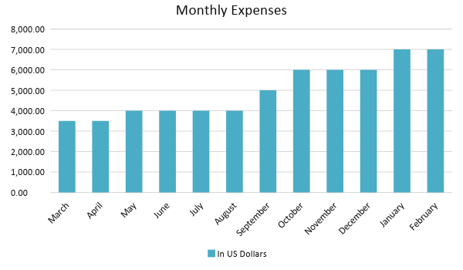

Monthly Revenue

The chart depicts the projected monthly revenues for [2019].
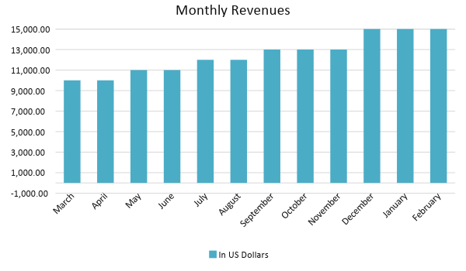
Business Financing

The funding for the business mainly comes from a business loan worth [$100,000.00]. The major expenses will go to business insurance, rent, salaries, supplies, and maintenance.

Statements

Profit and Loss Projection
 | FY 2019 | FY 2020 | FY 2021
Sales | $150,000.00 | $180,000.00 | $225,000.00
Direct Cost of Sale | $30,000.00 | $35,000.00 | $40,000.00
Other Cost of Sale | $3,000.00 | $5,000.00 | $7,500.00
Total Cost of Goods Sold or COGS (Sales - Direct Cost of Sale - Other Cost of Sale) | $33,000.00 | $40,000.00 | $47,500.00
Gross Profit (Sales-Total Cost of Goods Sold) | $117,000.00 | $140,000.00 | $177,500.00
Gross Margin % (Gross Profit/Sales) | 78.00% | 77.78% | 78.89%
Operating Expenses
Rent | $12,000.00 | $12,000.00 | $12,000.00
Insurance | $5,000.00 | $5,000.00 | $5,000.00
Utilities | $5,000.00 | $5,750.00 | $7,200.00
Salary (Including Tax) | $30,000.00 | $45,000.00 | $60,000.00
Maintenance & Supplies | $8,000.00 | $9,000.00 | $10,000.00
Total Operating Expenses | $60,000.00 | $76,750.00 | $94,200.00
EBITDA (Total Cost of Sale-Total Operating Expenses) | $57,000.00 | $63,250.00 | $83,300.00
Depreciation | $2,000.00 | $2,000.00 | $2,000.00
Interest Expense | $4,000.00 | $5,000.00 | $6,000.00
Taxes Paid | $5,700.00 | $6,325.00 | $8,330.00
Net Profit (Gross Profit - Operating Expenses - Taxes - Interest) | $47,300.00 | $51,925.00 | $68,970.00

Balance Sheet Projection
 | FY 2019 | FY 2020 | FY 2021
Cash | $261,000.00 | $294,750.00 | $351,800.00
Accounts Receivable | $60,000.00 | $69,000.00 | $82,800.00
Inventory | $1,000.00 | $2,000.00 | $3,000.00
Other Current Assets | $3,000.00 | $5,000.00 | $8,000.00
Total Current Assets | $325,000.00 | $370,750.00 | $445,600.00
Long-Term Assets | $20,000.00 | $20,000.00 | $20,000.00
Accumulated Depreciation | $5,000.00 | $10,000.00 | $15,000.00
Total Long-Term Assets (Long-Term Assets-Accumulated Depreciation) | $15,000.00 | $10,000.00 | $5,000.00
Total Assets (Total Current Assets + Total Long-Term Assets) | $340,000.00 | $380,750.00 | $450,600.00
Accounts Payable | $84,000.00 | $85,000.00 | $95,000.00
Notes Payable | $35,000.00 | $37,000.00 | $40,000.00
Other | $8,500.00 | $9,000.00 | $11,000.00
Total Liabilities | $127,500.00 | $131,000.00 | $146,000.00
Paid-in Capital | $100,000.00 | $114,750.00 | $135,850.00
Retained Earnings | $112,500.00 | $135,000.00 | $168,750.00
Total Owner's Equity (Total Assets - Total Liabilities) | $212,500.00 | $249,750.00 | $304,600.00
Total Liabilities & Equity (Total Liabilities/Total Owner's Equity) | 60.00% | 52.45% | 47.93%

Cash Flow Projection
 | FY 2019 | FY 2020 | FY 2021
Operating Cash Beginning | $20,000.00 | $25,000.00 | $30,000.00
Sources of Cash
Receivables | $60,000.00 | $69,000.00 | $82,800.00
Sales | $300,000.00 | $345,000.00 | $414,000.00
Others | $1,000.00 | $1,500.00 | $2,000.00
Total Cash | $381,000.00 | $440,500.00 | $528,800.00
Expenditures
Rent | $12,000.00 | $12,000.00 | $12,000.00
Insurance | $5,000.00 | $5,000.00 | $5,000.00
Utilities | $5,000.00 | $5,750.00 | $7,200.00
Salary (Including Tax) | $30,000.00 | $45,000.00 | $60,000.00
Maintenance & Supplies | $8,000.00 | $9,000.00 | $10,000.00
Total Expenditures | $60,000.00 | $76,750.00 | $94,200.00
Net Income/Loss (Total Cash - Total Expenditures) | $321,000.00 | $363,750.00 | $434,600.00

