Business Plan For Fiscal Year 2019

[January 5, 2019]

[Robert Young]
[robyoung@gmail.com]
[814-701-4127]
[www.investmentmate.com]
[6515 US-209 BUS
Hamilton, PA 15744, USA]

Mortgage
Broker Business Plan

Index

Executive Summary [PAGE NUMBER]
Company Overview [PAGE NUMBER]
Products and Services [PAGE NUMBER]
Execution [PAGE NUMBER]
Operational Plan [PAGE NUMBER]
Financial Plan [PAGE NUMBER]

EXECUTIVE SUMMARY

[Investment Mate] is a reliable partner and intermediary to clients when it comes to their residential, vacation home, and other property investment needs. The business will cost-effectively bring together lenders and clients and provide them with everything to successfully close a deal. With the expertise of its mortgage brokers, the business will become an efficient mediator and will assist its clients in availing favorable residential and commercial mortgage loans as well as renovation loans at inexpensive brokerage fees and percentages.

[Investment Mate] seeks to establish its market presence and position in [Hamilton, Pennsylvania]. In doing so, it plans to optimize data traffic online to spread awareness about the kind of business that the company brings to the market.

COMPANY OVERVIEW

Mission Statement

[Investment Mate] strives to strike a satisfying deal between its clients and lenders. The company is committed to finding reliable partners especially for their clients' first real property purchase.

Philosophy

[Investment Mate] engages in various mortgage transactions with its clients with the following competencies:

- The business provides quick, cost-efficient service and ensures clients that the brokerage fees they pay are not put to waste.

- The business guarantees its clients that the costs and interest payments they incur during the course of their mortgage remain constant from beginning to end.

- The business will be with its client every step of the way as its partner to achieving their dream residence, vacation home, or property investment.

Vision

[Investment Mate] aims to become the most reliable and trusted mortgage partner in [Hamilton, Pennsylvania].

Outlook

With the economy improving, and consumer confidence and purchasing power rising, an increase in residential mortgage loans in the last five years has been reported. During this period, the mortgage broker industry also has ventured into and established a strong presence online. In this regard, reaching target clients and showing the credibility of the business can be done through the company website, which will feature clients’ reviews on the services that the company provides.

Type of Industry: Mortgage Broker Industry

Business Structure: Sole Proprietorship

Ownership: Sole Proprietorship, [Robert Young]

Start-Up Summary

[Investment Mate] will need start-up capital amounting to USD [90K]. The owner will shoulder the payment of the start-up capital to be used for the rent, insurance, payroll, and other start-up assets for the business.

Start-Up Funding
Start-Up Expenses | $13,900
Start-Up Assets | $76,100
Total Funding Required | $90,000
Assets
Non-Cash Assets from Start-Up | $50,000
Cash Requirements from Start-up | $5,000
Additional Cash Raised | $16,100
Cash Balance on Starting Date | $5,000
Total Assets | $76,100
Capital
Planned Investment
Owner | $90,000
Other | $60,000
Additional Investment Requirement | $0
Total Planned Investment | $150,000
Loss at Start-Up (Start-Up Expenses) | -$13,900
Total Capital | $136,100
Liabilities | $0
Total Capital and Liabilities | $136,100
Start-Up
Requirements
Start-Up Expenses
Rent - 6 Months | $3,600
Advertising | $1,500
Legal Fees | $2,500
IT and Systems Maintenance | $3,000
Insurance | $1,800
Other | $1,500
Total Start-Up Expenses | $13,900
Start-Up Assets
Cash Required | $10,000
Start-Up Inventory | $5,000
Other Current Assets | $21,100
Long-Term Assets | $40,000
Total Assets | $76,100
Total Requirements (Total Start-Up Expenses + Total Assets) | $90,000

Management Team

Management Team | Role/Function | Skills
[Robert Young] | Managing Director | Leadership, Team Management, Decision-Making, Communication, Effective Delegation
[Kim Johnson] | Marketing and Communications | Market Awareness, Team Player, Time Management, Multitasking, Keen to Detail
[David Green] | Office Manager | Database Management, Report Presentations, Office Budgeting, Delegation, Communication

Short- and Long-Term Goals and Milestones:

Short-Term Goals | Milestones
Recruit certified and expert mortgage brokers | The final screening process for the shortlisted mortgage broker applicants will be done by [January 12, 2018].
Provide reliable assistants to hired mortgage brokers | A list of applicants is currently being screened and reviewed. Interviews of qualified applicants will start by [January 20, 2018].
Long-Term Goals | Milestones
Establish a strong presence particularly on the internet | Work on the optimization of the website traffic to improve the online visibility of the business
Build a solid client base in [Hamilton PA] | Distribution of flyers and putting up of posters is underway.

PRODUCTS AND SERVICES

Product/Service Description

[Investment Mate] provides its clients with hassle-free and inexpensive services in acquiring their dream residence, vacation home, or other property investment. The business has partners that deliver three types of mortgage loans, namely: fixed rate, adjustable rate, and renovation loan programs. With the help of these reliable and trusted lenders, the company is confident that it can find the property suited to the client’s specifications and budget.

Value Proposition

[Investment Mate] serves to become a trusted investment partner. The business offers the best quality of services to its clients without changes in brokerage fees. Employing excellent and professional mortgage brokers, the company assists its clients every step of the way.

Pricing Strategy

[Investment Mate] plays in the market using competitive pricing. The business will keep track of the competitors’ prices and sticks to the rates and fees all throughout the time until the client chooses a mortgage loan.

EXECUTION

Marketing Plan

[Investment Mate] desires to achieve a secure position in the market as the top mortgage broker in [Hamilton, Pennsylvania]. To achieve this objective, the company aims to increase its visibility online and enhance the awareness of its target market regarding the existence of the business and the services it offers. It plans to put up posters and distribute flyers to spread information about the company.

Market Research

The mortgage broker industry is growing over the past five years. This development has contributed largely to the surging of consumer confidence to avail of the residential mortgage and auto loans. In this regard, Investment Mate has conducted a survey on which mortgage service that people from ages [25 to 35] have availed of. Results of the survey are presented below.
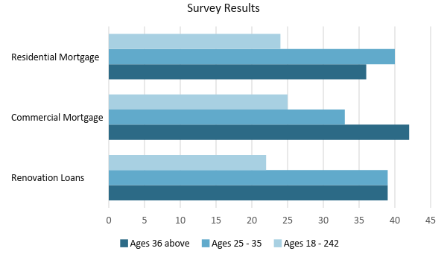

SWOT Analysis | Strengths | Weaknesses | Opportunities | Threats
Investment Mate | - Consistency in brokerage fees and percentages  - A wide range of partners and lenders to work with  - Cost-efficient services | - Considered as a new company in the local market  - Still vulnerable to changes | - There are only a few mortgage brokers in the local market which gives the company the opportunity to grow. | - The existence of reliable and trusted mortgage brokers
Accubroker | - The current top brokerage firm in Hamilton  - Provides professional quality of service | - Very expensive pricing of services  - Located outside of Hamilton | - The business has room for expansion | - The consumers’ interest in availing affordable mortgage brokers
Bright Broker | - Affordable pricing of services  - Always consider the budget and the needs of its clients | - Located outside of Hamilton  - Insufficient number of brokers who can accommodate multiple clients | - There are areas wherein the company can branch out which makes it nearer to its customers | - Existing mortgage brokers in locations where the company is planning to branch out

Marketing Strategy

[Investment Mate] wants to improve its market presence through the optimization of the website’s data traffic and public awareness of the business’ existence and services. The marketing and communications executive has started working on the website traffic optimization with the help of an SEO company. Other promotional activities accomplished for the business are presented in the table below.

Marketing Strategy | Activities | Timeline | Success Criteria
Optimization of website data traffic | - Provide sufficient website content regarding the company’s services  - Hire an SEO company to assist the business in increasing data traffic | January 31, 2018 | An SEO company has been contacted and a meeting is already scheduled to start the negotiation.
Posters and flyers | - Organize the layouts of each flyer or poster  - Contract a business partner to distribute or to post the finalized materials | January 28, 2018 | Final draft for the flyer and poster layouts will be completed by [January 20, 2018].
Word of mouth | - Assign people to talk about the business and its services | ASAP | Selected people are already talking to prospective clients in Hamilton.

Organizational Structure

[Investment Mate] follows a conventional type of organizational structure wherein the owner, [Mr. Robert Young], who is also the Managing Director, oversees and handles the overall business decisions. Since Investment Mate is a small office, the business employs experienced mortgage brokers who are given different assignments and tasks. Each of them has an assistant to aid them in document preparations. The business also employs an office manager and a marketing and communications executive.

The organizational structure for [Investment Mate] is provided below.

Managing Director/Owner
Marketing and Communications
Office Manager
Mortgage Broker
Managing Director/Owner
Mortgage Broker
Mortgage Broker
Executive Assistant
Broker’s Assistant
Broker’s Assistant
Broker’s Assistant

OPERATIONAL PLAN

Location and Facilities

[Investment Mate] is located in a [410 sq ft] office space in [6515 US-209 BUS Hamilton, PA 15744, USA]. The business has an open office setup with all the tables of the mortgage brokers located in one section of the office. A layout is provided below.

Entrance/Exit Door
Mortgage Broker’s Table
Mortgage Broker’s Table
Managing Director’s Table
Restrooms
Mortgage Broker’s Table
Office Manager’s Table
Marketing Executive’s Table
Assistants’ Table

Tools and Equipment Checklist

[Investment Mate] needs the following tools and equipment for its daily operations:

Software | Quantity
Client Database | 2
Loan Assistant | 1
Hardware | Quantity
Laptop Computers | 9
Printer | 3

IT Infrastructure

The following table reflects [Investment Mate] IT infrastructure.

Infrastructure | Existing (Y/N) | Description
Website | Y | The business owns a website with content about its services.
Social media | N | The business does not have social media accounts.
Latency | Y | There are no problems encountered in terms of the response time.
Downtime | N | The business experiences zero network interruptions.

FINANCIAL PLAN

Assumptions

The financial statement projections for [Investment Mate] are based on the following financial assumptions:

- Cost amounts are expected to be constant from the start of the operations.

- The business projects [2]% monthly increases in sales starting from the third quarter of [2018].
- Taxes on compensation equal to [8]% of the total gross compensation. The prevailing market interest rate is [6.5]%.

- Brokers get [10]% on the business’ gross profit following the deduction of the cost of sales.

- Payment of brokerage fees is usually done at the beginning, middle, and end of the transaction.

Monthly Expense

The following graph presents the project monthly expenses of [Investment Mate] for the year [2018].

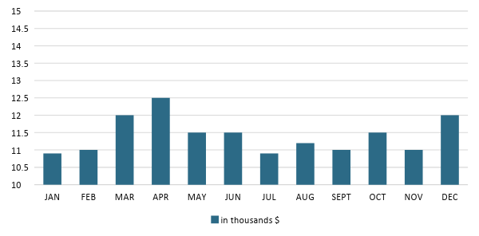
Monthly Revenue

The following graph presents the project monthly revenues of [Investment Mate] for the year [2018].

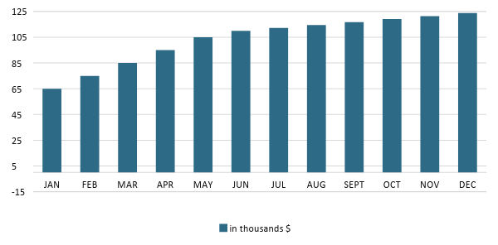
Business Financing

The owner of [Investment Mate], [Mr. Robert Young], invests [90K] USD to cover major expenses such as insurance, rent, compensation, and maintenance. In order for the business to thrive in its first year of operations, the owner acquired a business loan amounting to [60K] USD payable for two years plus interest.

Statements

Profit and Loss Projection
 | FY2018 | FY2019 | FY2020
Sales | $200,000.00 | $208,000.00 | $216,320.00
Direct Cost of Sale | $80,000.00 | $83,200.00 | $86,528.00
Other Cost of Sale | $1,000.00 | $1,020.00 | $1,040.40
Total Cost of Goods Sold or COGS (Sales - Direct Cost of Sale - Other Cost of Sale) | $119,000.00 | $123,780.00 | $128,751.60
Gross Profit (Sales-Total Cost of Goods Sold) | $81,000.00 | $84,220.00 | $87,568.40
Gross Margin % (Gross Profit/Sales) | 40.50% | 40.49% | 40.48%
Operating Expenses
Rent | $7,200.00 | $7,200.00 | $7,200.00
Insurance | $10,800.00 | $10,800.00 | $10,800.00
Utilities | $11,000.00 | $11,000.00 | $11,000.00
Salary (Including Tax) | $35,700.00 | $37,134.00 | $38,625.48
Maintenance & Supplies | $6,000.00 | $7,000.00 | $8,000.00
Total Operating Expenses | $70,700.00 | $73,134.00 | $75,625.48
EBITDA (Total Cost of Sale-Total Operating Expenses) | $48,300.00 | $50,646.00 | $53,126.12
Depreciation | $1,000.00 | $1,000.00 | $1,000.00
Interest Expense | $3,900.00 | $3,900.00 | $3,900.00
Taxes Paid | $2,856.00 | $2,970.72 | $3,090.04
Net Profit (Gross Profit - Operating Expenses - Taxes - Interest) | $3,544.00 | $4,215.28 | $4,952.88

Balance Sheet Projection
 | FY2018 | FY2019 | FY2020
Cash | $146,000.00 | $283,260.00 | $421,785.20
Accounts Receivable | $18,000.00 | $19,000.00 | $20,000.00
Inventory | $6,200.00 | $7,688.00 | $9,533.12
Other Current Assets | $26,164.00 | $26,164.00 | $26,164.00
Total Current Assets | $196,364.00 | $336,112.00 | $477,482.32
Long-Term Assets | $40,000.00 | $40,000.00 | $40,000.00
Accumulated Depreciation | $1,000.00 | $2,000.00 | $3,000.00
Total Long-Term Assets (Long-Term Assets-Accumulated Depreciation) | $39,000.00 | $38,000.00 | $37,000.00
Total Assets (Total Current Assets + Total Long-Term Assets) | $235,364.00 | $374,112.00 | $514,482.32
Accounts Payable | $57,510.00 | $51,120.00 | $44,730.00
Notes Payable | $2,000.00 | $2,400.00 | $2,880.00
Other | $1,000.00 | $1,500.00 | $2,000.00
Total Liabilities | $60,510.00 | $55,020.00 | $49,610.00
Paid-in Capital | $150,000.00 | $150,000.00 | $150,000.00
Retained Earnings | $3,544.00 | $7,759.28 | $12,712.16
Total Owner's Equity (Total Assets - Total Liabilities) | $174,854.00 | $319,092.00 | $464,872.32
Total Liabilities & Equity (Total Liabilities/Total Owner's Equity) | 34.61% | 17.24% | 10.67%

Cash Flow Projection
 | FY2018 | FY2019 | FY2020
Operating Cash Beginning | $10,000.00 | $146,000.00 | $283,260.00
Sources of Cash | $5,000.00 | $5,100.00 | $5,202.00
Receivables | $18,000.00 | $19,000.00 | $20,000.00
Sales | $105,000.00 | $105,000.00 | $105,000.00
Others | $8,000.00 | $8,160.00 | $8,323.20
Total Cash | $146,000.00 | $283,260.00 | $421,785.20
Expenditures
Rent | $7,200.00 | $7,200.00 | $7,200.00
Insurance | $10,800.00 | $10,800.00 | $10,800.00
Utilities | $11,000.00 | $11,000.00 | $11,000.00
Salary (Including Tax) | $35,700.00 | $37,134.00 | $38,625.48
Maintenance & Supplies | $6,000.00 | $7,000.00 | $8,000.00
Total Expenditures | $70,700.00 | $73,134.00 | $75,625.48
Net Income/Loss (Total Cash - Total Expenditures) | $75,300.00 | $210,126.00 | $346,159.72

