MONTHLY EXPENSE SHEET
Projected Monthly Expense |  | Daily Expenses |  |  |  | $59,000
 |  | Extra Expenses |  |  |  | $10,000
 |  | Total Monthly Expenses |  |  |  | $69,000
Actual Monthly Expense |  | Daily Expenses |  |  |  | $75,000
 |  | Extra Expenses |  |  |  | $28,550
 |  | Total Monthly Expenses |  |  |  | $103,550
Income | Projected |  | Actual |  |  | Difference
Wages and Tips | $800,000.00 |  | $870,000.00 |  |  | -$70,000.00
Interest Income
Total Income | $800,000.00 |  | $870,000.00 |  |  | -$70,000.00
Savings | Projected |  | Actual |  |  | Difference
Emergency Fund | $3,000.00 |  | $2,800.00 |  |  | $200.00
Transfer to Savings | $4,500.00 |  | $4,500.00 |  |  | $0.00
Others
Total Savings | $7,500.00 |  | $7,300.00 |  |  | $200.00

HOME BUDGET
Home Expenses | Projected | Actual | Difference
Electricity | $5,500.00 | $7,800.00 | -$2,300.00
Gas Bill | $4,500.00 | $4,500.00 | $0.00
Rent | $1,500.00 | $2,500.00 | -$1,000.00
Maintenance | $3,000.00 | $2,800.00 | $200.00
Others
Total Home Expenses | $14,500.00 | $17,600.00 | -$3,100.00
Daily Living | Projected | Actual | Difference
Groceries | $5,500 | $7,800 | -$2,300.00
Personal supplies | $4,500 | $4,500 | $0.00
Clothing | $1,500 | $2,500 | -$1,000.00
Total Daily Living Expenses | $11,500 | $14,800 | -$3,300.00
Children | Projected | Actual | Difference
School Fee | $5,500.00 | $5,500.00 | $0.00
Clothing | $4,500.00 | $4,500.00 | $0.00
School Supplies | $1,500.00 | $1,500.00 | $0.00
Music Lesson, Yoga classes etc., | $2,500.00 | $2,500.00 | $0.00
Total Children Expenses | $24,000.00 | $24,000.00 | $0.00

Transportation | Projected | Actual | Difference
Vehicle Payments | $4,500.00 | $4,500.00 | $0.00
Fuel | $4,500.00 | $4,500.00 | $0.00
Bus/Taxi/Van/Train Fare | $1,500.00 | $1,500.00 | $0.00
Repairs | $6,000.00 | $6,000.00 | $0.00
Others
Total Transportation Expenses | $16,500.00 | $16,500.00 | $0.00
Health | Projected | Actual | Difference
Doctor/Dentist | $5,500.00 | $5,500.00 | $0.00
Medicine/Drugs | $6,500.00 | $6,500.00 | $0.00
Emergency | $2,550.00 | $2,550.00 | $0.00
Others | $6,000.00 | $6,000.00 | $0.00
Total Health Expenses | $20,550.00 | $20,550.00 | $0.00
Entertainment | Projected | Actual | Difference
Movies/Theatres | $1,500.00 | $1,500.00 | $0.00
Concerts/Plays | $6,500.00 | $6,500.00 | $0.00
Books | $2,550.00 | $2,550.00 | $0.00
Magic Shows/Live Shows | $1,500.00 | $1,500.00 | $0.00
Outdoor Recreation | $550.00 | $550.00 | $0.00
Others
Total Entertainment Expenses | $12,600.00 | $12,600.00 | $0.00
Vacations | Projected | Actual | Difference
Travelling | $3,500.00 | $3,500.00 | $0.00
Lodging | $1,600.00 | $1,600.00 | $0.00
Food | $2,550.00 | $2,550.00 | $0.00
Rental Car | $1,500.00 | $1,500.00 | $0.00
Total Vacation Expenses | $9,150.00 | $9,150.00 | $0.00
Business Expenses | Projected | Actual | Difference
Deductible Expenses | $3,500.00 | $3,500.00 | $0.00
Non-Deductible Expenses | $2,600.00 | $2,600.00 | $0.00
Other | $6,550.00 | $6,550.00 | $0.00
Total Business Expenses | $12,650.00 | $12,650.00 | $0.00

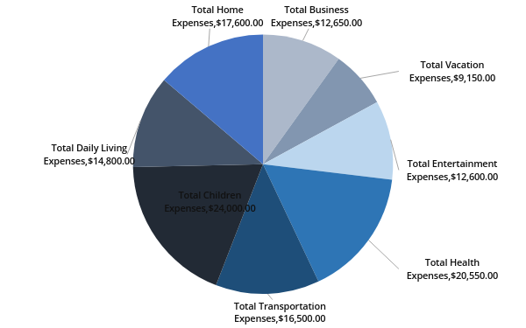
Expenses

