[Midas Jewelry Limited]
[2019 – 2020]

JEWELRY MARKETING PLAN

Index

Executive Summary | [PAGE NUMBER]
Company Overview | [PAGE NUMBER]
Products and Services | [PAGE NUMBER]
Marketing Analysis | [PAGE NUMBER]
Strategy and Implementation | [PAGE NUMBER]
Management and Personnel | [PAGE NUMBER]
Financial Plan | [PAGE NUMBER]

EXECUTIVE SUMMARY

[Midas Jewelry Limited] is recognized for its beautiful pieces. It specializes in unique luxury items with a diversified product range that includes customized products and other handcrafted items.

The increasing competition in jewelers has negatively impacted its sales in the industry in the last year. To remedy the situation, Midas Jewelry Limited is looking to utilize aggressive marketing campaigns for its upper-class target market, focusing on positive brand awareness through newspapers, magazines, mobile apps, parties, and events.

COMPANY OVERVIEW

Mission Statement

[Midas Jewelry Limited] adds luxury to everyday life with beautiful, quality products that exceed customer desires and expectations.

Philosophy

[Midas Jewelry Limited] assumes accountability for its actions as a responsible corporation that makes decisions that will create a positive impact on the world.

Vision: [Midas Jewelry Limited] wants to become the premier brand for beautiful personalized jewelry.

Outlook

The demand for jewelry in the US and European markets see widespread gains from lower-carat, mass-market jewelry to high-end pieces. However, the pace of growth slightly decelerated in the fourth quarter of [2018] due to the government shutdown. However, the current settlement of such political move will likely create a better market for [2019].

Type of Industry: Jewelry

Business Structure: Limited Company

Ownership: Limited Company, [Arnold Midas]

Marketing Summary

[Midas Jewelry Limited] will provide a budget of $[700,000] for its marketing expenses.

Marketing Funding
Expenses | $350,000
Assets | $350,000
Total Funding Required | $700,000
Assets
Non-Cash Assets | $200,000
Cash Requirements | $50,000
Additional Cash Raised | $70,000
Cash Balance on Starting Date | $30,000
Total Assets | $350,000
Capital
Planned Investment
Owner | $700,000
Other | $0
Additional Investment Requirement | $0
Total Planned Investment | $700,000
Loss | -$350,000
Total Capital | $350,000
Total Capital and Liabilities | $350,000
Marketing Expenses
Requirements
Expenses
Production Costs | $90,000
Advertising | $35,000
Legal Fees | $5,000
Event Staff | $20,000
Insurance | $200,000
Other | $0
Total Start-Up Expenses | $350,000
Company Assets
Cash Required | $50,000
Inventory | $70,000
Other Current Assets | $30,000
Long-Term Assets | $200,000
Total Assets | $350,000
Total Requirements (Total Start-Up Expenses + Total Assets) | $700,000

PRODUCTS AND SERVICES

Product/Service Description

[Midas Jewelry Limited] is known for its sterling jewelry and other luxury products. It offers a diversified and unique product range that includes the following

- Men’s Jewelry
- Pearls
- Wedding Bands
- Earrings
- Bracelets
- Rings
- Pendants and Necklace

Value Proposition: [Midas Jewelry Limited] is putting its focus on producing beautiful, understated pieces with exquisite quality.

Pricing Strategy: [Midas Jewelry Limited] utilizes a premier pricing strategy based on the weight, carat, size, design, and quality of its pieces.

MARKETING ANALYSIS

A company that offers luxury items, [Midas Jewelry Limited] wants to use marketing strategies that selectively expand its distribution channels without compromising its long-term value. Thus, it needs to address consumer wants and desires by utilizing product innovations and creating new jewelry lines that are based on the current industry trends.

Market Segmentation

[Midas Jewelry Limited] is popular with white-collar citizens who have flexible income. However, as seen below, millennials, who are the driving group in today’s economy, show little interest in purchasing jewelry. The company wants to change this behavior by connecting with a new generation of spenders to widen its market reach.

The chart below shows the target market for [Midas Jewelry Limited].

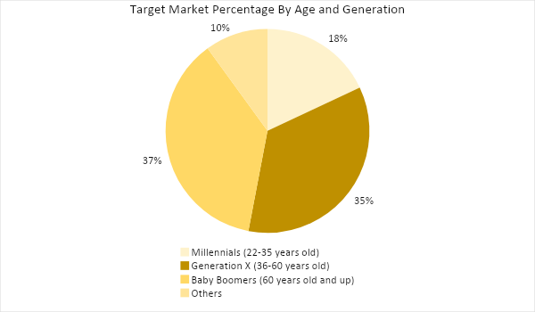

Target Market Segmentation Strategy

Millennials

- Hire an app developer to upgrade the company’s mobile app, to be more accessible for millennials.
- Promote the company’s new line of jewelry specifically designed for the millennial generation based on current jewelry trends through social media, magazines, and a big launching event

Generation X and Baby Boomers

- Throw a gala party to promote and market classic pieces that would appeal to the older crowd

STRATEGY AND IMPLEMENTATION

Target Market Strategy

[Midas Jewelry Limited] is looking to increase sales by at least [5]% in the next year. This will be accomplished by improving its reach to a younger market, specifically millennials who have the financial capability to invest in luxury items. This will be done by developing a company mobile app and advertising on social media.

Competitive Edge

The company’s ability to shift its designs based on the current trends while maintaining its timeless look make it attractive to millennials and older generations alike.

SWOT Analysis | Strengths | Weaknesses | Opportunities | Threats
Midas Jewelry Limited | Innovative company known for exquisite designs | Communication strategy needs improvement | Increasing disposable income allows for expansion opportunities | Competition with more known brands
Gatsby | Popular brand name with a strong global presence | Strong focus only on jewelry, while other brands are offering other luxury items | Extending to new market categories could help expand the company
Atlantis Jewels | Associated with its rich and famous customers | Inability to capture the interest of the younger market | Changing target market preferences in jewelry design allows for more brand opportunities | Online retailers are getting the bigger bulk of the industry’s market share

Sales Strategy and Forecast

[Midas Jewelry Limited] expects an increase in monthly sales in the year [2019] as shown below:

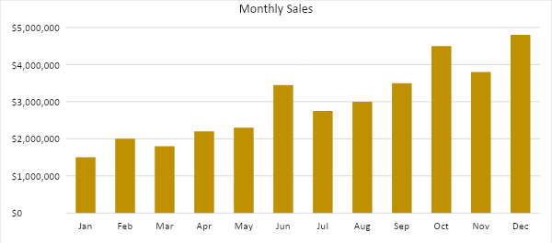

With a new jewelry line targeted for the younger market, increased media presence, and better marketing campaigns and events, the chart below depicts the projected percentage sales growth in the next [two] years:

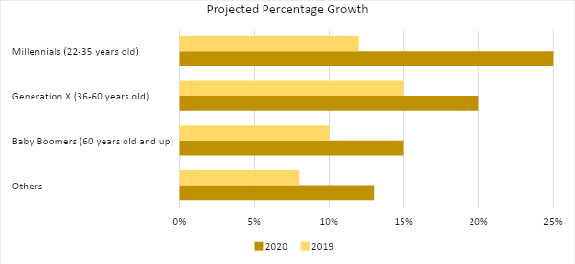

Marketing Strategy

[Midas Jewelry Limited] will take advantage of more aggressive marketing campaigns for its upper-class clients. To do so, the company will focus on positive brand awareness, such as emphasizing environmentally-friendly processes and fair practices.

It will also take advantage of technology by updating its online app to make it easier for the younger market to order and pay for jewelry items and have them delivered directly on their doorsteps.

Finally, launching parties and social events are very effective in getting the upper-class crowd to buy jewelry. These strategies are outlined below:

Milestones

Marketing Strategy | Activities | Timeline | Success Criteria
App upgrade | Hire a new developer to update the app for better navigation and include online ordering and payment | April 15, 2019 | The new developer has been hired and is working on the upgrades.  Improved online sales by [15]% on the first three months
Print advertisements | Produce new advertisements for upscale magazines such as InStyle, Vogue, and Town & Country | March 15 (for publishing in April volumes) | Post the ads on at least three major magazines
Launching of the new line for millennials | Jewelry fashion show and launch party | April 13, 2019 | Have at least [300] millennials sign up and attend the launching  At least $[200,000] in sales during the event

Management and Personnel

The organizational structure of [Midas Jewelry Limited] is shown below:

CEO
General Manager
HR Manager
Marketing Director
Sales Director
Store Manager
Content Creator
Customer Acquisition
Revenue Generation
Staff

FINANCIAL PLAN

The following tables show the financial plan of the company in the next three years. These tables include the projected break-even analysis, profit and loss, balance sheet, and cash flow.

Break-Even Analysis

Fixed Costs | Average Price |  | Variable Costs |  | Contribution Margin | Break-Even Units
$290,000.00 | $1,500.00 |  | $100.29 |  | 1,400 | 207
Fixed Costs |  | Amount |  | Variable Costs |  | Per Unit Amount
Marketing Costs |  | 90,000 |  | Advertising |  | 10.29
Insurance |  | 200,000 |  | Legal Fees |  | 72
 |  |  |  | Staff Training |  | 18
Total |  | 290,000 |  | Total |  | 100.29

Fixed Costs |  | Variable Costs
Marketing Costs |  | $90,000
Insurance |  | $200,000
Total Fixed Costs |  | $290,000
Total Units Sold in 1 Month |  | 360,000
Variable Costs (Unit Sold/Cost per Unit) | Average Price | Variable Costs
Advertising | $35,000 | $10.29
Legal Fees | $5,000 | $72.00
Event Staff | $20,000 | $18.00
Total Variable Cost (Per Unit) |  | $100.29
Break-Even
Selling Price Per Unit |  | $1,500.00
Break-Even Point Per Unit [Fixed Costs/(Sales Price Per Unit - Variable Cost Per Unit)] |  | 290,000
 |  | 1,400
Break-Even Point in Units |  | 207
Contribution Margin (Selling Price - Total Variable Cost) |  | 1,400

Profit and Loss Projection
 | FY2019 | FY2020 | FY2021
Sales | $35,600,000.00 | $40,000,000.00 | $50,000,000.00
Direct Cost of Sale | $32,000,000.00 | $37,000,000.00 | $47,000,000.00
Other Cost of Sale | $1,000,000.00 | $1,300,000.00 | $1,550,000.00
Total Cost of Goods Sold or COGS (Sales - Direct Cost of Sale - Other Cost of Sale) | $2,600,000.00 | $1,700,000.00 | $1,450,000.00
Gross Profit (Sales-Total Cost of Goods Sold) | $33,000,000.00 | $38,300,000.00 | $48,550,000.00
Gross Margin % (Gross Profit/Sales) | 92.70% | 95.75% | 97.10%
Operating Expenses
Marketing Costs | $130,000.00 | $150,000.00 | $180,000.00
Advertising Fees | $35,000.00 | $40,000.00 | $50,000.00
Legal Fees | $5,000.00 | $5,000.00 | $5,000.00
Event Staff Salary | $30,000.00 | $35,000.00 | $40,000.00
Other | $3,500,000.00 | $3,500,000.00 | $3,700,000.00
Total Operating Expenses | $3,700,000.00 | $3,730,000.00 | $3,975,000.00
EBITDA (Total Cost of Sale-Total Operating Expenses) | -$1,100,000.00 | -$2,030,000.00 | -$2,525,000.00
Depreciation | $4,000.00 | $4,000.00 | $4,000.00
Interest Expense | $0.00 | $0.00 | $0.00
Taxes Paid | $4,000.00 | $5,000.00 | $6,000.00
Net Profit (Gross Profit - Operating Expenses - Taxes - Interest) | $29,296,000.00 | $34,565,000.00 | $44,569,000.00

Balance Sheet Projection
 | FY2019 | FY2020 | FY2021
Cash | $100,000.00 | $150,000.00 | $180,000.00
Accounts Receivable | $500,000.00 | $1,500,000.00 | $1,700,000.00
Inventory | $300,000.00 | $500,000.00 | $600,000.00
Other Current Assets | $500,000.00 | $550,000.00 | $630,000.00
Total Current Assets | $1,400,000.00 | $2,700,000.00 | $3,110,000.00
Long-Term Assets | $1,200,000.00 | $700,000.00 | $600,000.00
Accumulated Depreciation | $12,000.00 | $8,000.00 | $5,000.00
Total Long-Term Assets (Long-Term Assets-Accumulated Depreciation) | $1,188,000.00 | $692,000.00 | $595,000.00
Total Assets (Total Current Assets + Total Long-Term Assets) | $2,588,000.00 | $3,392,000.00 | $3,705,000.00
Accounts Payable | $1,000,000.00 | $1,200,000.00 | $1,500,000.00
Notes Payable | $500,000.00 | $600,000.00 | $800,000.00
Other | $350,000.00 | $700,000.00 | $500,000.00
Total Liabilities | $1,850,000.00 | $2,500,000.00 | $2,800,000.00
Paid-in Capital | $5,000.00 | $5,000.00 | $5,000.00
Retained Earnings | $256,500.00 | $303,250.00 | $399,000.00
Total Owner's Equity (Total Assets - Total Liabilities) | $738,000.00 | $892,000.00 | $905,000.00
Total Liabilities & Equity (Total Liabilities/Total Owner's Equity) | 250.68% | 280.27% | 309.39%

Cash Flow Projection
 | FY2019 | FY2020 | FY2021
Operating Cash Beginning | $200,000.00 | $32,117,000.00 | $68,406,000.00
Sources of Cash | $5,000.00 | $7,000.00 | $10,000.00
Receivables | $7,000.00 | $5,000.00 | $7,500.00
Sales | $35,600,000.00 | $40,000,000.00 | $50,000,000.00
Others | $5,000.00 | $7,000.00 | $8,000.00
Total Cash | $35,817,000.00 | $72,136,000.00 | $118,431,500.00
Expenditures
Marketing Costs | $130,000.00 | $150,000.00 | $180,000.00
Advertising Fees | $35,000.00 | $40,000.00 | $50,000.00
Legal Fees | $5,000.00 | $5,000.00 | $5,000.00
Event Staff Salary | $30,000.00 | $35,000.00 | $40,000.00
Other | $3,500,000.00 | $3,500,000.00 | $3,700,000.00
Total Expenditures | $3,700,000.00 | $3,730,000.00 | $3,975,000.00
Net Income/Loss (Total Cash - Total Expenditures) | $32,117,000.00 | $68,406,000.00 | $114,456,500.00

