INFORMATION REPORT

[INSERT NAME OF BUSINESS]
[INSERT COMPLETE BUSINESS ADDRESS]
[INSERT BUSINESS CONTACT DETAILS]

As Compliance to [INSERT SUBJECT MATTER]

PREPARED FOR:

[INSERT NAME OF CLIENT]
[INSERT COMPLETE ADDRESS OF CLIENT]
[INSERT CLIENT CONTACT DETAILS]

PREPARED BY:

[INSERT NAME OF PREPARER]
[INSERT POSITION/TITLE OF PREPARER]
[INSERT PREPARER CONTACT DETAILS]

[INSERT MONTH DAY YEAR]

Table of Contents

Overview of Registered Information  History of the Business  Vision and Mission Statement  Products and Services  Employee Information  Background of Operations  Scope of the Business  Licenses and Certificates  Industry Overview  Market Background  Consumer Information  Target Market and Market Share  Business Achievements | [INSERT PAGE NUMBER]  [INSERT PAGE NUMBER].  [INSERT PAGE NUMBER]  [INSERT PAGE NUMBER]  [INSERT PAGE NUMBER]  [INSERT PAGE NUMBER]  [INSERT PAGE NUMBER]  [INSERT PAGE NUMBER]  [INSERT PAGE NUMBER]  [INSERT PAGE NUMBER]  [INSERT PAGE NUMBER]  [INSERT PAGE NUMBER]  [INSERT PAGE NUMBER]

Overview of Registered Information

[INSERT NAME OF BUSINESS] is legally and duly registered with the following credentials, presented on the table as follows:

Business Information | Registered Information Details
Date of Registration | [INSERT MONTH DAY YEAR]
Established Date | [INSERT MONTH DAY YEAR]
Business Code | BBB000 - 0000 - 0000 - 000
Registered Name | [INSERT REGISTERED BUSINESS NAME]
Registered Address | [INSERT REGISTERED BUSINESS ADDRESS]
Type of Business Entity | Sole Proprietorship
Type of Business Industry | Computer Software and Hardware, Consumer Electronics
Name of Legal Representative | [INSERT REGISTERED REPRESENTATIVE NAME]
Brief Business Scope | [INSERT DETAILS]
Registered Location | [INSERT REGISTERED LOCATION]
Registering Authority | [INSERT NAME OF REGISTERING AUTHORITY]

History of the Business

[INSERT NAME OF BUSINESS] has over [INSERT NUMBER OF YEARS] years of business expertise and experience in computer software and hardware as well as in consumer electronics. The business started out as a computer software and hardware store on [INSERT MONTH DAY YEAR]. The owner of the business, Mr. /Mrs. /Ms. [INSERT COMPLETE OWNER NAME], is a software and hardware engineer known for producing computer-related products.

Due to the recession in [INSERT YEAR], the business financial performance was greatly affected, which led the company to venture into consumer electronics. Its first product introduction in consumer electronics was [INSERT PRODUCT NAME] on [INSERT MONTH DAY YEAR], which paved the way for the business in the consumer electronics business industry.

Since then, the company has invested in both software and hardware electronics. [INSERT NAME OF BUSINESS] has been continuously number one in the sale of [INSERT PRODUCT DETAILS]. Its most recent product introduction, [INSERT DETAILS], accumulated sales amounting to US$ [INSERT AMOUNT], which increased the estimated value of the business as a publicly traded corporation to US$ [INSERT AMOUNT] as of [INSERT MONTH DAY YEAR].

Vision and Mission Statement

[INSERT NAME OF BUSINESS] is a leading player in the computer hardware, software, and consumer electronics industry. The business has the following mission and vision statements:

Vision Statement

To be the most influential and leading brand when it comes to computer hardware and software and consumer electronics within the business market.

Mission Statement

In order for the business to achieve its desired business direction, [INSERT NAME OF BUSINESS] must:

Provide exceptional services to consumers by catering to their concerns promptly with relevance to the computer hardware and software, as well as the consumer electronic products availed

[INSERT OTHER DETAILS]

Products and Services

[INSERT NAME OF BUSINESS] takes pride in its wide array of products and relevant service. These products and services are categorized and presented in complete detail on the table below:

CONSUMER ELECTRONICS
Product Name | Product and Service Details
Consumer Electronic Product A | [INSERT DETAILS]
Consumer Electronic Product B | [INSERT DETAILS]
Consumer Electronic Product C | [INSERT DETAILS]
Consumer Electronic Product D | [INSERT DETAILS]
Consumer Electronic Product E | [INSERT DETAILS]
COMPUTER HARDWARE AND SOFTWARE
Product Name | Product and Service Details
Hardware and Software Product F | [INSERT DETAILS]
Hardware and Software Product G | [INSERT DETAILS]
Hardware and Software Product H | [INSERT DETAILS]
Hardware and Software Product I | [INSERT DETAILS]
Hardware and Software Product J | [INSERT DETAILS]

Employee Information

[INSERT NAME OF BUSINESS] is known for being a diverse company, not only in the products and services they offer to its market, but also on the employees and staff they hire to provide and deliver such products and services. The business has 00.00 branches within and outside [INSERT BUSINESS LOCATION NAME]. And is currently employing 00.00 people.

Branches | Top Management | Managers | Supervisors | Staff | Maintenance
Branch 1 | 00.00 | 00.00 | 00.00 | 00.00 | 00.00
Branch 2 | 00.00 | 00.00 | 00.00 | 00.00 | 00.00
Branch 3 | 00.00 | 00.00 | 00.00 | 00.00 | 00.00
Branch 4 | 00.00 | 00.00 | 00.00 | 00.00 | 00.00
Branch 5 | 00.00 | 00.00 | 00.00 | 00.00 | 00.00
Total | 00.00 | 00.00 | 00.00 | 00.00 | 00.00

Background of Operations

Scope of the Business

[INSERT NAME OF BUSINESS] is listed and recognized as a software, hardware, and consumer electronics company.

Licenses and Certificates

With [INSERT NUMBER] years of experience, [INSERT NAME OF BUSINESS] achieved and garnered the following licenses and certificates in order to smoothly produce and sell quality products and services to consumers:

Licenses and Certificates | Authorized and Issued | Effectivity Date
License/Certificate 1 | [INSERT NAME DETAILS] | [INSERT MONTH DAY YEAR]
License/Certificate 2 | [INSERT NAME DETAILS] | [INSERT MONTH DAY YEAR]
License/Certificate 3 | [INSERT NAME DETAILS] | [INSERT MONTH DAY YEAR]
License/Certificate 4 | [INSERT NAME DETAILS] | [INSERT MONTH DAY YEAR]
License/Certificate 5 | [INSERT NAME DETAILS] | [INSERT MONTH DAY YEAR]
License/Certificate 6 | [INSERT NAME DETAILS] | [INSERT MONTH DAY YEAR]
License/Certificate 7 | [INSERT NAME DETAILS] | [INSERT MONTH DAY YEAR]

Industry Overview

[INSERT NAME OF BUSINESS] is a computer hardware and software, as well as a consumer electronics company. The graph below shows the percentage allocation for every division.

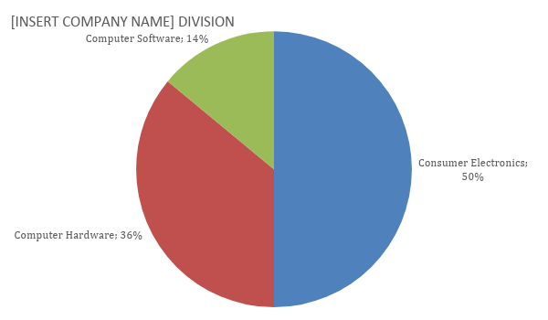
Computer hardware and software, as well as consumer electronics will continue to grow, but so will competitors. The company needs to focus on consumer satisfaction and product innovations.

Market Background

Consumer Information

[INSERT NAME OF BUSINESS] caters to a variety of consumers. The following table presents a profile of the company’s consumers.

Consumer Electronics | Computer Hardware and Software
First Top/Main Customer | First Top/Main Customer
Second Top/Main Customer | Second Top/Main Customer
Third Top/Main Customer | Third Top/Main Customer
Fourth Top/Main Customer | Fourth Top/Main Customer
Fifth Top/Main Customer | Fifth Top/Main Customer

Target Market and Market Share

The company’s target consumers consist of [INSERT DETAILS], which covers about 00% of the target market. The graph below highlights the company’s top target markets for its products.

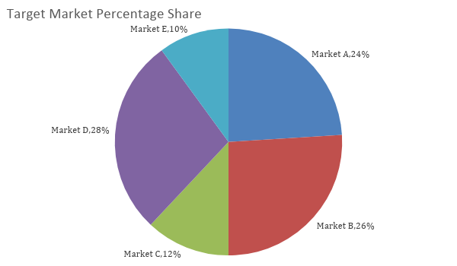

Business Achievements

[INSERT NAME OF BUSINESS] has obtained the following business achievements within [INSERT NUMBER] years of business summarized on the table below.

Date Received | Achievements | Awarding Authority
00 - 00 - 0000 | Achievement/Award Name 1 | [INSERT DETAILS]
00 - 00 - 0000 | Achievement/Award Name 2 | [INSERT DETAILS]
00 - 00 - 0000 | Achievement/Award Name 3 | [INSERT DETAILS]
00 - 00 - 0000 | Achievement/Award Name 4 | [INSERT DETAILS]
00 - 00 - 0000 | Achievement/Award Name 5 | [INSERT DETAILS]
00 - 00 - 0000 | Achievement/Award Name 6 | [INSERT DETAILS]
[INSERT NAME OF BUSINESS] continuously strives to achieve its goals and objectives, and live up to it’s the vision and mission.

