HEALTH
SPA BUSINESS PLAN

Business Plan For Fiscal Year 2019

[January 30, 2019]

[Dianne Lussier]
[dlussier@gmail.com]
[212-236-0823]
[www.stillwaterhealth.com]
[1789 Bell Street]
[New York, NY 10007, USA]

Index

Executive Summary [PAGE NUMBER]

Company Overview [PAGE NUMBER]

Products and Services [PAGE NUMBER]

Execution [PAGE NUMBER]

Operational Plan [PAGE NUMBER]

Financial Plan [PAGE NUMBER]

EXECUTIVE SUMMARY

Customers with relaxing and rejuvenating services in a setting where they can experience healing of the body and mind.

The health spa is devoted to providing massage services, acupuncture, and energy work. With its combination of services and customer-centric focus, [Stillwater Health Spa] provides quality and dependable services that ensure a high rate of return customers, providing a serene setting for a variety of mind and body relaxation and rejuvenating services.

COMPANY OVERVIEW

Mission Statement

[Stillwater Health Spa] provides a comforting atmosphere for customers to be able to relax in both mind and body through a wide range of holistic healing methods including different types of massage, body works, and acupuncture treatments.

Philosophy

[Stillwater Health Spa] focuses on its customers and aims to give them an escape from the stress of daily life and rejuvenate their energies.

Vision

[Stillwater Health Spa] envisions itself to become the health spa of choice offering a preventive lifestyle that adds value to its customers and staff.

Outlook

The [United States] is the largest spa market in the world with $[18 billion] in revenue in the last year. The demand for health spas is growing around the world with a forecast of a compound annual growth rate of [6.55]% from [2018 to 2023]. The demand for health spa services is connected not only to personal income but also to tourism and other demographic trends.

Type of Industry: Holistic Health and Wellness

Business Structure: Sole Proprietorship

Ownership: Sole Proprietorship, [Dianne Lussier]

Start-Up Summary

The start-up cost is [2M] USD to be provided by the owner and to be used mainly for the rent, insurance, supplies, and payroll.

Start-Up Funding
Start-Up Expenses to Fund | $1,000,000
Start-Up Assets to Fund | $1,000,000
Total Funding Required | $2,000,000
Assets
Non-Cash Assets from Start-Up | $20,000
Cash Requirements from Start-up | $950,000
Additional Cash Raised | $25,000
Cash Balance on Starting Date | $5,000
Total Assets | $1,000,000
Capital
Planned Investment
Owners | $2,000,000
Other | $0
Additional Investment Requirement | $0
Total Planned Investment | $2,000,000
Loss at Start-Up (Start-Up Expenses) | -$1,000,000
Total Capital (Total Planned Investment - Loss at Start-Up) | $1,000,000
Total Capital and Liabilities | $1,000,000
Total Funding | $1,000,000
Start-Up
Requirements
Start-Up Expenses
Buses | $950,000
Rent - 6 Months | $12,000
Advertising | $2,000
Legal Fees | $1,000
Staff Training | $3,000
Insurance | $2,000
Other | $30,000
Total Start-Up Expenses | $1,000,000
Start-Up Assets
Cash Required | $980,000
Start-Up Inventory | $4,000
Other Current Assets | $10,000
Long-Term Assets | $6,000
Total Assets | $1,000,000
Total Requirements | $2,000,000

Management Team:

Management Team | Role/Function | Skills
[Franca Medina] | Spa Manager | Communication, People Management, Teamwork, and Resilience
[Nina Jonsson] | HR Manager | Communication, Onboarding, People Skills, and Performance Management

Short- and Long-Term Goals and Milestones:

Short-Term Goals | Milestones
Develop an advertising budget within the next [three] months | The budget has been reviewed and will be executed in the [first] month
Hire additional massage therapists | Three of five massage therapists hired at the end of the last year.
Long-Term Goals | Milestones
Achieve [95]% positive customer feedback in [2019] | The spa has a [92]% positive customer feedback in [November and December 2018]
Increase website and social media traffic by [50]% in the following year

PRODUCTS AND SERVICES

Product/Service Description

[Stillwater Health Spa] will provide customers with relaxing and rejuvenating services and complementary products for their holistic health. The spa offers the following services:

- Swedish Massage
- Hot Stone Massage
- Deep Tissue Massage
- Shiatsu Massage
- Aroma Therapy Massages
- Energy Revitalization
- Therapeutic Touch
- Acupuncture
- Reiki

Value Proposition

[Stillwater Health Spa] offers relaxing and rejuvenating services, focusing on alternative modalities such as massages and spiritual cleansing as the customers see fit. The spa also offers consultation depending on the customers’ needs.

Pricing Strategy

[Stillwater Health Spa] offers packages that give discounts to customers who avail of more than one service at a time. These packages are offered on a per consultation basis.

EXECUTION

Marketing Plan

The company sees a lot of competitors in the [New York] area. The target market has money to spend on luxury and lead stressful, professional lives on a regular basis. [Stillwater Health Spa] is looking to implement the following marketing strategies for continued success in the following year:

- Emphasize the name and services of the business through traditional advertising as well as social media campaigns that focus on holistic healing
- Build a community relationship by consistently showing a friendly and caring atmosphere to encourage return clientele
- Build relationships in holistic healing clinics to encourage referrals

Market Research

The current trends in [holistic health spas] in [New York] show that proximity to the target market influences the choice of a health spa. Reputation for quality and good pricing are also greatly important. This, with the combined services offered by [Stillwater Health Spa] as well as its professional and able staff, it expects to compete in the industry.

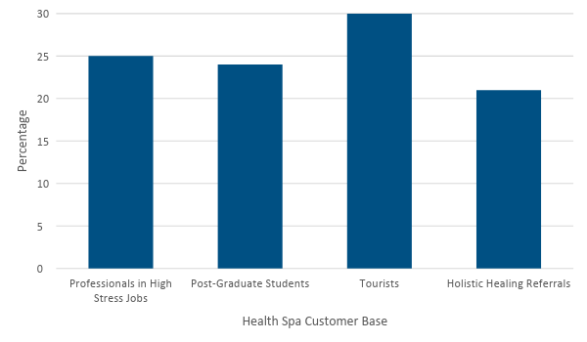

SWOT Analysis | Strengths | Weaknesses | Opportunities | Threats
[Stillwater Health Spa] | - Highly trained massage therapists | - Low budget for marketing | - New technologies to modernize services | - Too many established competitors in the area
[Head to Toe Spa] | - Offers a wider array of services | - Quality is average or below average | - Opportunities for training and hiring | - Current customer preferences affect the booking of services
[Lakeview Spa and Resort] | - Best-known health spa in the area  - Offers high-quality services | - Lacks parking for the size of the spa facility | - Customer buying behavior shows potential for expansion | - The spa is not ready to accommodate a large number of customers

Marketing Strategy

[Stillwater Health Spa] will utilize traditional and modern advertising strategies in the form of local newspapers and magazines, as well as mail-outs to all residential units and local business within a [five-mile] radius. It will also revamp its website and social media pages to update clients. Finally, it will also distribute brochures to medical clinics that are open to partnering with the health spa.

Marketing Strategy | Activities | Timeline | Success Criteria
Print Advertising | Ads for newspaper and magazines finalized | January 30 | Increase in customer response from print ads
Mail-Out Advertisement | Finalize the layout and mail out the advertising materials | February 15 | All materials mailed by the set date
Brochure Distribution | Layout for the brochure to be finalized | February 15 | All brochures distributed to the clinics
Website and Social Media Updates | Front-end developer and social media manager hired | February 28 | Website fully revamped and updated  Social media engagement has increased

Organizational Structure

[Stillwater Health Spa] is a small business headed by the CEO and supported by various managers and staff members.

Operations Manager
HR Manager
Financial Officer
In-House Staff
Development Staff
CEO
Administrative Staff
Maintenance Staff
Marketing Staff
Marketing Manager Officer
Merchandise and Inventory

OPERATIONAL PLAN

Location and Facilities
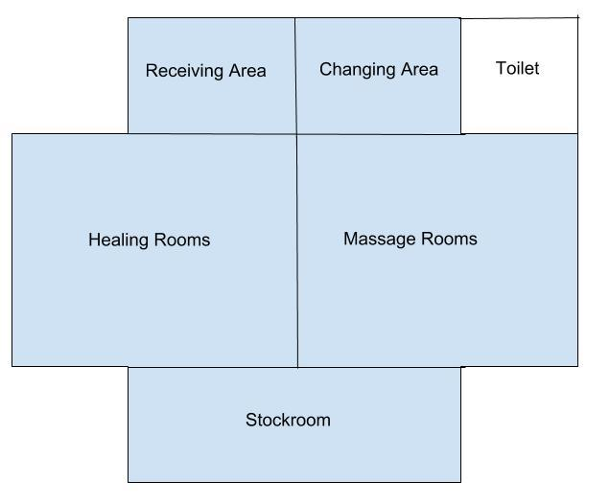

FINANCIAL PLAN

Assumptions

The [United States] is expected to see a compound annual growth rate of [6]% for health spas in the years [2018 to 2023]. With one of the highest demands for spa services in the world, the company will focus its efforts on its marketing strategies to keep up with the overall demands of its customers. The amount put up by the sole proprietor of [Stillwater Health Spa] will be used for the payroll, maintenance and supplies, utilities, insurance, and rent of the premises.

Monthly Expense

The following shows the projected monthly expense for the coming year:

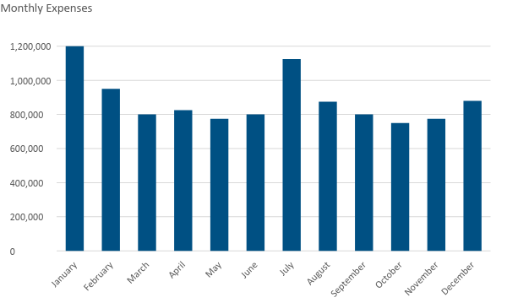
Monthly Revenue

The following chart shows a depiction of the probable revenue for the coming year.

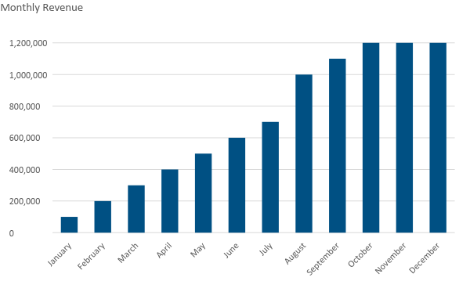

Business Financing

The business is funded by the sole proprietor from her personal funds, with the major expenses allocated for insurance, rent, salaries, supplies, and utilities.

Statements

Profit and Loss Projection
 | FY2018 | FY2019 | FY2020
Sales | $1,584,000.00 | $1,900,800.00 | $2,332,800.00
Direct Cost of Sale | $540,000.00 | $570,000.00 | $600,500.00
Other Cost of Sale | $139,000.00 | $141,000.00 | $146,000.00
Total Cost of Goods Sold or COGS (Sales - Direct Cost of Sale - Other Cost of Sale) | $905,000.00 | $1,189,800.00 | $1,586,300.00
Gross Profit (Sales-Total Cost of Goods Sold) | $679,000.00 | $711,000.00 | $746,500.00
Gross Margin % (Gross Profit/Sales) | 42.87% | 37.41% | 32.00%
Operating Expenses
Rent | $60,000.00 | $60,000.00 | $60,000.00
Insurance | $12,000.00 | $12,000.00 | $12,000.00
Utilities | $20,000.00 | $25,000.00 | $26,000.00
Salary (Including Tax) | $100,000.00 | $120,000.00 | $150,000.00
Maintenance & Supplies | $5,000.00 | $7,000.00 | $9,500.00
Monthly Coach Bus Payment | $39,000.00 | $0.00 | $0.00
Total Operating Expenses | $236,000.00 | $224,000.00 | $257,500.00
EBITDA (Total Cost of Sale-Total Operating Expenses) | $669,000.00 | $965,800.00 | $1,329,300
Depreciation (Asset Cost - Residual Value)/Useful Life of the Asset) | $10,000.00 | $10,000.00 | $10,000.00
Interest Expense | $0.00 | $0.00 | $0.00
Taxes Paid | $15,000.00 | $18,000.00 | $20,000.00
Net Profit (Gross Profit - Operating Expenses - Taxes - Interest) | $428,000.00 | $469,000.00 | $469,000.00

Balance Sheet Projection
 | FY2019 | FY2020 | FY2021
Cash | $1,000,000.00 | $1,250,000.00 | $1,450,000.00
Accounts Receivable | $100,000.00 | $150,000.00 | $110,000.00
Inventory | $7,000.00 | $8,000.00 | $10,000.00
Other Current Assets | $20,000.00 | $25,000.00 | $35,000.00
Total Current Assets | $1,127,000.00 | $1,433,000.00 | $1,605,000.00
Long-Term Assets | $45,000.00 | $43,000.00 | $47,000.00
Accumulated Depreciation | $3,000.00 | $2,500.00 | $2,000.00
Total Long-Term Assets (Long-Term Assets-Accumulated Depreciation) | $42,000.00 | $40,500.00 | $45,000.00
Total Assets (Total Current Assets + Total Long-Term Assets) | $1,169,000.00 | $1,473,500.00 | $1,650,000.00
Accounts Payable | $150,000.00 | $170,000.00 | $155,000.00
Notes Payable | $7,000.00 | $7,500.00 | $5,000.00
Other | $3,500.00 | $7,000.00 | $5,000.00
Total Liabilities | $160,500.00 | $184,500.00 | $165,000.00
Paid-in Capital | $10,000.00 | $5,000.00 | $5,000.00
Retained Earnings | $90,000.00 | $120,000.00 | $130,000.00
Total Owner's Equity (Total Assets - Total Liabilities) | $1,008,500.00 | $1,289,000.00 | $1,485,000.00
Total Liabilities & Equity (Total Liabilities/Total Owner's Equity) | 15.91% | 14.31% | 11.11%

Cash Flow Projection
 | FY2019 | FY2020 | FY2021
Operating Cash Beginning | $1,000,000.00 | $1,500,000.00 | $1,600,000.00
Sources of Cash | $15,000.00 | $18,000.00 | $15,000.00
Receivables | $10,000.00 | $12,000.00 | $30,000.00
Sales | $32,000.00 | $25,000.00 | $35,000.00
Others | $5,000.00 | $7,000.00 | $8,000.00
Total Cash | $1,062,000.00 | $1,562,000.00 | $1,688,000.00
Expenditures
Rent | $24,000.00 | $24,000.00 | $24,000.00
Insurance | $12,000.00 | $12,000.00 | $12,000.00
Utilities | $15,000.00 | $15,000.00 | $17,000.00
Salary (Including Tax) | $75,000.00 | $80,000.00 | $87,000.00
Maintenance & Supplies | $4,500.00 | $5,000.00 | $6,000.00
Total Expenditures | $130,500.00 | $136,000.00 | $146,000.00
Net Income/Loss (Total Cash - Total Expenditures) | $931,500.00 | $1,426,000.00 | $1,542,000.00

