Hair
Removal Business Plan

Business Plan For Fiscal Year 2019

[March 1, 2019]

[Clarice E. Wormley]
[ClariceEWormley@jourrapide.com]
[618-575-1010]
[www.clarice-e-wormley.com]
[433 Shinn Street
New York City, NY 10007]

Index

Executive Summary [PAGE NUMBER]

Company Overview [PAGE NUMBER]

Products and Services [PAGE NUMBER]

Execution [PAGE NUMBER]

Operational Plan [PAGE NUMBER]

Financial Plan [PAGE NUMBER]

EXECUTIVE SUMMARY

[OffGrid Hair Removal] will offer hair removals, including laser removal, in [Midtown West, New York City]. This is the third branch to serve [New York] and, like the other branches, it will become successful. As the hair removal procedure market continues to gain popularity, more and more individuals are availing of the service. Over the past five years, hair removal, most especially the laser hair removal, has quickly grown to become one of the most popular non-invasive aesthetic procedures for both men and women.

COMPANY OVERVIEW

Mission Statement

[OffGrid Hair Removal] banners a high-quality hair removal procedure that is both safe and comfortable.

Philosophy

[OffGrid Hair Removal] focuses on the safety and comfort of the clients. The company seeks to establish a relationship with clients based on trust and confidence.

Vision

[OffGrid Hair Removal] envisions itself to become the place of choice for hair removal procedure in [New York City].

Outlook

The hair removal market has been growing continuously. Not only is the market growing, but it has also garnered a growing number of male clients as the taboo around hair removal being female-inclusive has disappeared. What was once considered a discreet grooming ritual has now become a normal hygiene routine for many individuals. As the industry grows, the company will continue to evolve as it plans to improve its hair removal techniques and provide better customer experience.

Type of Industry: Service Industry

Business Structure: Sole Proprietorship

Ownership: Sole Proprietorship, [Clarice E. Wormley]

Start-Up Summary

The start-up cost is $[133,400] to be provided by the owner and to be used mainly for the purchase of equipment, supplies, insurance, payroll, and maintenance.

Start-Up Funding
Start-Up Expenses to Fund | $59,900
Start-Up Assets to Fund | $73,500
Total Funding Required | $133,400
Assets
Non-Cash Assets from Start-Up | $50,000
Cash Requirements from Start-up | $10,000
Additional Cash Raised | $8,000
Cash Balance on Starting Date | $5,500
Total Assets | $73,500
Capital
Planned Investment
Owner | $133,400
Other | $0
Additional Investment Requirement | $0
Total Planned Investment | $133,400
Loss at Start-Up (Start-Up Expenses) | -$59,900
Total Capital | $73,500
Total Capital and Liabilities | $73,500
Total Funding | $73,500
Start-Up
Requirements
Rent - 1 year | $24,000
Advertising | $500
Legal Fees | $7,200
Insurance | $1,200
Construction and Design | $10,000
Furniture and Fixture | $5,000
Others | $12,000
Total Start-Up Expenses | $59,900
Start-Up Assets
Cash Required | $10,000
Start-Up Inventory | $50,000
Other Current Assets | $8,000
Long-Term Assets | $5,500
Total Assets | $73,500
Total Requirements (Total Start-Up Expenses + Total Assets) | $133,400

Management Team:

Management Team | Role/Function | Skills
[Jennifer Hancock] | Administrative Manager | Technology, communication, organization, time management, and problem-solving
[Raymond Davis] | Accounting Manager | Strong interpersonal skill, excellent communication, and negotiation skills
[Bobbi Laubach] | Human Resource Manager | Employee relations, performance management, scheduling, customer and service management skills

Short- and Long-Term Goals and Milestones:

Short-Term Goals | Milestones
Hire necessary personnel | The main office has already hired all necessary personnel last [January 10, 2019].
Start the business operations by [March 1, 2019] | The rental agreement was signed last [January 10, 2019], and construction is already in place.
Long-Term Goals | Milestones
Achieve a 1-year payback period during the first year of operations | Marketing plans have already been made by the marketing manager.
Increase website traffic by at least [30]% | The company has already purchased web traffic analysis software.

PRODUCT AND SERVICES

Product/Service Description

[OffGrid Hair Removal] offers hair removals in [Midtown West, New York City NY].

The company offers both waxing and laser removals. Waxing is a semi-permanent hair removal treatment where the esthetician extracts hair by pulling its roots with warm wax. Hair regrowth occurs only after two to eight weeks. [OffGrid Hair Removal] offers waxing removal for any areas of the body. On the other hand, laser hair removal uses the standard Diode System which emits laser light that penetrates and destroys hair follicles while protecting the skin with a contact-cooling handpiece.

Body Part | Waxing Hair Removal | Laser Hair Removal
Eyebrow | $5.50 | none
Upper Lip | $5.50 | $44.00
Underarms | $6.00 | $76.00
Whole arms | $20.00 | none
Upper Legs | none | $240.00
Lower Legs | $10.00 | $280.00
Whole Legs | $20.00 | none
Back | $5.50 | $200.00
Bikini | $8.00 | $80.00

Value Proposition

Flawless skin can boost confidence. [OffGrid Hair Removal] serves customers every day of the year with high-quality waxing and laser removal treatment. The company is known in [New York] City for having the best and most disciplined staff who prioritize the health, safety, and comfort of its clients.

Pricing Strategy: [OffGrid Hair Removal] utilizes price bundling and competitive pricing.

EXECUTION

Marketing Plan

[OffGrid Hair Removal] aims to expand its market to the whole [New York] City. It plans to build more branches to establish a larger market share.

Market Research

The current trend in the industry implies that more men are into waxing. The share of clients between men and women also depends on the body parts waxed or lasered.

The graph below shows data in relation to the services availed mostly by men or women.
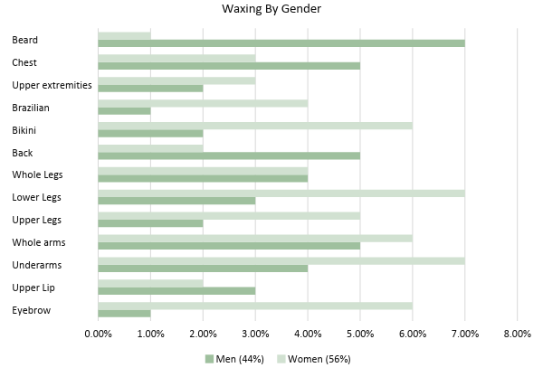

SWOT Analysis | Strengths | Weaknesses | Opportunities | Threats
[OffGrid Hair Removal] | The owner is a highly experienced business operator | Open to changes, but slow in execution | Ability to develop additional branches | Changes in regulations may affect the business
 | The business has a limited startup risk | Limited flexibility in pricing | Affiliated relations with other vendors | Increase in price inputs can cause upward pricing
[Bared Monkey Laser Spa] | Offers its services even outside [New York] | Quality of the services is not reliable | Expansion for the online sale of waxing products | Products are already sold by major competitors
 | Wide service offerings | Still new to the business | Development of proprietary products
[Erase Spa] | Very low prices | Has yet to expand to different states | Acquisition of additional rounds of capital | There is a continued increase in insurance costs
 | Offers more than two kinds of laser hair removal |  | Development of wholesale distribution relationships

Marketing Strategy

[OffGrid Hair Removal] plans to utilize the following marketing strategies:

- Website update

The company currently has a website and has already made updates about the new branch and the tentative opening date. The website is also updated with the kind of services it offers as well as the price. All promotions have also been posted on the website.

- Seasonal and special events promotions

This branch, like all other branches, will have seasonal and special events promotions. Previous financial statements prove that there is an increase in service revenues during summer and spring, and the company will take advantage of that by making service bundle offers.

- Word of mouth

The word of mouth is perhaps the most effective marketing strategy there is as this mirrors exactly as to how the company conducts its business operations. Being able to provide quality service will attract repeat customers, and these same customers will recommend the company to other people via either word of mouth or through their social media accounts.

The team has kicked off various activities to move the marketing strategy forward. Here are some of the updates:

Marketing Strategy | Activities | Timeline | Success Criteria
Website update | Provide updates on the upcoming branch | February 5, 2019 | Information on the branch has been posted on the company website
Seasonal and special events promotions | The company has posted the promotions on the website  The company has printed out fliers for seasonal and special events promotions | January 31, 2019  January 31, 2019 | Clients are inquiring on how to avail on the promotions  Fliers have been distributed by the end of February 2019
Word of mouth | Referral program | January 31, 2019 | The program is already encoded as part of the company website

Organizational Structure

The owner, along with the administrative, accounting, human resource, and marketing staff will be working in the main office of the company. On the other hand, the medical director, branch manager, receptionist, laser technician, and esthetician will be working on the store branch.
Operational Plan:

OWNER
Administrative Manager
Accounting Manager
Human Resource Manager
Marketing Manager
Medical Director
Branch Manager
Esthetician
Laser Technician
Receptionist

Location and Facilities

The new branch will be located at 44th West 45th Street, 2nd Floor, [New York City, NY 10036]. This branch will include a front desk, three waxing rooms, and one laser room.

The branch layout is as follows:

Chair
Chair
Front Desk
Waiting Room
Waxing Room 1
Waxing Room 2
Waxing Room 3
Laser Room
Door
Door
Door
Tools and Equipment Checklist

Equipment | Quantity
Laser Equipment | 1
Computer | 1
Tools | Quantity
Wax | 3 per room
Cloth | 5 per room
Tissue | 5 per room

IT Infrastructure

The IT Infrastructure of the company involves the company website, which is managed by an outsourced IT company. On the other hand, the company uses Xero for its accounting software for the recording of sales and expenses.

FINANCIAL PLAN

Assumptions

The financial forecast of the company is based mainly on the current trends in the hair removal market. The company’s finances are mainly for the construction of the building, purchase of necessary furniture, equipment, tools, and supplies as well as for rentals and salaries.

Monthly Expense

The chart shows the projected monthly expenses for [2019].

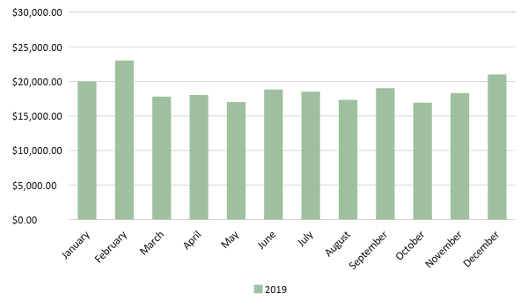
Monthly Revenue

The chart depicts the projected monthly revenues for [2019].

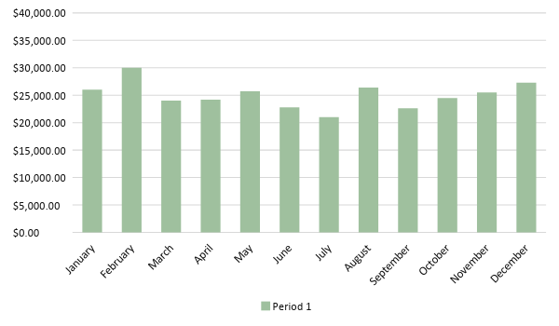
Business Financing

The funding for the business mainly comes from the owner’s investment worth $[133,400.00].

Statements

PROJECTED STATEMENT OF FINANCIAL PERFORMANCE
 | FY 2019 | FY 2020 | FY 2021
Service Revenues | $300,000.00 | $315,000.00 | $330,750.00
Direct Cost of Sale | $150,000.00 | $154,500.00 | $160,680.00
Other Cost of Sale | $3,000.00 | $3,090.00 | $3,180.00
Total Cost of Goods Sold | $153,000.00 | $157,590.00 | $163,860.00
Gross Profit (Sales-Total Cost of Goods Sold) | $147,000.00 | $157,410.00 | $166,890.00
Gross Margin % (Gross Profit/Sales) | 49.00% | 49.97% | 50.46%
Operating Expenses
Rent - 1 year | $24,000.00 | $24,000.00 | $24,000.00
Advertising | $500.00 | $500.00 | $500.00
Legal Fees | $7,200.00 | $7,200.00 | $7,200.00
Insurance | $1,200.00 | $1,200.00 | $1,200.00
Construction and Design | $10,000.00 | $7,500.00 | $5,000.00
Furniture and Fixture | $5,000.00 | $4,000.00 | $3,000.00
Training Expense | $1,200.00 | $1,200.00 | $1,200.00
Salaries Expense | $10,000.00 | $10,000.00 | $10,000.00
Supplies Expense | $13,500.00 | $13,500.00 | $13,500.00
Total Operating Expenses | $72,600.00 | $69,100.00 | $65,600.00
EBITDA (Gross Profit-Total Operating Expenses) | $74,400.00 | $88,310.00 | $101,290.00
Depreciation | $500.00 | $500.00 | $500.00
Interest Expense | $0.00 | $0.00 | $0.00
Taxes Paid | $11,160.00 | $13,246.50 | $15,193.50
Net Profit (Gross Profit - Operating Expenses - Taxes - Interest) | $63,240.00 | $75,063.50 | $86,096.50

PROJECTED STATEMENT OF FINANCIAL POSITION
 | FY 2019 | FY 2020 | FY 2021
Cash | $147,900.00 | $161,810.00 | $174,790.00
Accounts Receivable | $10,000.00 | $7,500.00 | $5,000.00
Inventory | $5,000.00 | $4,000.00 | $3,000.00
Other Current Assets | $0.00 | $0.00 | $0.00
Total Current Assets | $162,900.00 | $173,310.00 | $182,790.00
Long-Term Assets | $60,000.00 | $60,000.00 | $60,000.00
Accumulated Depreciation | $6,000.00 | $12,000.00 | $18,000.00
Total Long-Term Assets (Long-Term Assets-Accumulated Depreciation) | $54,000.00 | $48,000.00 | $42,000.00
Total Assets (Total Current Assets + Total Long-Term Assets) | $216,900.00 | $221,310.00 | $224,790.00
Accounts Payable | $70,000.00 | $90,000.00 | $110,000.00
Notes Payable | $31,260.00 | $46,606.50 | $69,990.00
Other | $0.00 | $0.00 | $0.00
Total Liabilities | $101,260.00 | $136,606.50 | $179,990.00
Paid-in Capital | $133,400.00 | $121,640.00 | $96,703.50
Retained Earnings | $63,240.00 | $75,063.50 | $86,096.50
Total Owner's Equity (Total Assets - Total Liabilities) | $115,640.00 | $84,703.50 | $44,800.00
Total Liabilities & Equity (Total Liabilities/Total Owner's Equity) | 87.56% | 161.28% | 401.76%

PROJECTED STATEMENT OF CASH FLOW
 | FY 2019 | FY 2020 | FY 2021
Operating Cash Beginning | $73,500.00 | $73,500.00 | $73,500.00
Sources of Cash
Service Revenues | $300,000.00 | $315,000.00 | $330,750.00
Total Cash | $373,500.00 | $388,500.00 | $404,250.00
Expenditures
Cost of Sales | $153,000.00 | $157,590.00 | $163,860.00
Rent - 1 year | $24,000.00 | $24,000.00 | $24,000.00
Advertising | $500.00 | $500.00 | $500.00
Legal Fees | $7,200.00 | $7,200.00 | $7,200.00
Insurance | $1,200.00 | $1,200.00 | $1,200.00
Construction and Design | $10,000.00 | $7,500.00 | $5,000.00
Furniture and Fixture | $5,000.00 | $4,000.00 | $3,000.00
Training Expense | $1,200.00 | $1,200.00 | $1,200.00
Salaries Expense | $10,000.00 | $10,000.00 | $10,000.00
Supplies Expense | $13,500.00 | $13,500.00 | $13,500.00
Total Expenditures | $225,600.00 | $226,690.00 | $229,460.00
Net Income/Loss (Total Cash - Total Expenditures) | $147,900.00 | $161,810.00 | $174,790.00

