MP

FITNESS
STUDIO MARKETING PLAN

[Parker Fitness Studio]
[2018 – 2019]

Index

Executive Summary | [PAGE NUMBER]
Company Overview | [PAGE NUMBER]
Products and Services | [PAGE NUMBER]
Marketing Analysis | [PAGE NUMBER]
Strategy and Implementation | [PAGE NUMBER]
Management and Personnel | [PAGE NUMBER]
Financial Plan | [PAGE NUMBER]

EXECUTIVE SUMMARY

[Parker Fitness Studio] is a health and fitness center based in [Charlotte, North Carolina]. The company offers affordable fitness and lifestyle programs for interested working professionals ages [20-39]. The company aims to break the fears and doubts that may keep these working professionals from getting healthy and fit. It will encourage them by posting, among other things, relevant content and videos on social media.

The company anticipates growth in the number of customers in the next two years.

COMPANY OVERVIEW

Mission Statement

[Parker Fitness Studio] assists customers to achieve a body that’s both healthy and fit through its proven fitness and lifestyle programs.

Philosophy

[Parker Fitness Studio] pursues excellence and efficiency when achieving the desired physical health and fitness of customers during the implementation of their chosen fitness and lifestyle programs.

Vision: [Parker Fitness Studio] is one of the most trusted and reliable fitness centers in [North Carolina].

Outlook

With the current campaign for health and fitness pushed by the government, more individuals go to health and fitness centers as part of their daily routine. The company anticipates that the number of fitness studio regulars will continue to grow as people become more concerned about getting fit and healthy.

Type of Industry: Health and Fitness Industry

Business Structure: Sole Proprietorship

Ownership: Sole Proprietorship, [Rafael Parker]

Start-Up Summary

[Parker Fitness Studio] initially operated with a total startup cost of [100K] USD provided by the sole proprietor. The fund covered payments for rent, insurance, advertising costs, legal fees, and payroll.
Start-Up Funding
Start-Up Expenses | $45,250
Start-Up Assets | $54,750
Total Funding Required | $100,000
Assets
Non-Cash Assets from Start-Up | $34,750
Cash Requirements from Start-up | $4,500
Additional Cash Raised | $15,000
Cash Balance on Starting Date | $500
Total Assets | $54,750
Capital
Planned Investment
Owner | $100,000
Other | $0
Additional Investment Requirement | $0
Total Planned Investment | $100,000
Loss at Start-Up (Start-Up Expenses) | -$45,250
Total Capital | $54,750
Total Capital and Liabilities | $54,750
Start-Up
Requirements
Start-Up Expenses
Rent - 5 Months | $3,750
Advertising | $1,800
Legal Fees | $1,200
Staff Training | $2,500
Insurance | $1,000
Other | $35,000
Total Start-Up Expenses | $45,250
Start-Up Assets
Cash Required | $5,000
Start-Up Inventory | $9,750
Other Current Assets | $15,000
Long-Term Assets | $25,000
Total Assets | $54,750
Total Requirements (Total Start-Up Expenses + Total Assets) | $100,000

PRODUCTS AND SERVICES

Product/Service Description

[Parker Fitness Studio] provides fitness programs for muscle gain or toning, and cardiovascular fitness programs for customers.

Value Proposition

[Parker Fitness Studio] always promotes and recommends a healthy lifestyle in every fitness program rendered to maintain the physical health of the customer.

Pricing Strategy

[Parker Fitness Studio] follows the price bundling approach while making its prices competitive in the market. The customer pays a monthly membership fee for the fitness trainer and use of the fitness equipment.

MARKETING ANALYSIS

The health and fitness industry is currently booming with the continuous campaign of the government for a healthy and fit life. More individuals are paying for fitness studio memberships with the goal to stay healthy, reduce weight, optimize strength/endurance, and look physically appealing. This resulted in an increasing number of health and fitness centers in the US.

Market Segmentation

[Parker Fitness Studio] will focus on promoting its fitness and lifestyle programs to working professionals ages [20-39]. The company will break the fears and doubts of this age group to get into its fitness and lifestyle programs.

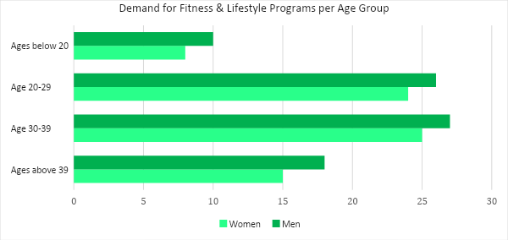

Target Market Segmentation Strategy

Customers ages [20-39] who exercise regularly

- The company will post relevant contents in relation to the fitness and lifestyle programs it offers on various social media platforms.

Interested individuals who have fears and doubts

- The company will post videos about the importance and the benefits associated with the fitness and lifestyle programs offered.

STRATEGY AND IMPLEMENTATION

Target Market Strategy

[Parker Fitness Studio] aims to attract new customers and increase its sales by [25]%. The company will achieve that sales growth with the help of social media.

Competitive Edge

SWOT Analysis | Strengths | Weaknesses | Opportunities | Threats
[Parker  Fitness Studio] | Affordable fitness and lifestyle programs for both beginners and regulars | Weak social media presence | The growing interest of individuals on fitness and lifestyle programs | Social media influence of already established fitness centers
[FlexFit Fitness Gym] | Flexible business hours | Poor quality of fitness equipment | The onset of advanced technology enabling the company to innovate | Availability of high-quality facilities from fitness centers with flexible business hours
[Healthy Fitness Center] | Top class fitness center facilities | Highly expensive membership fees | The unchanging purchase behavior of fitness and gym enthusiasts | Emerging fitness studios providing fitness programs at less costly rates

Sales Strategy and Forecast

[Parker Fitness Studio] targets the following monthly revenues for the fiscal year [2018].

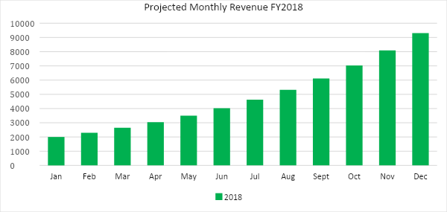

The company anticipates the following increments in the number of customers after posting contents on various social media platforms.

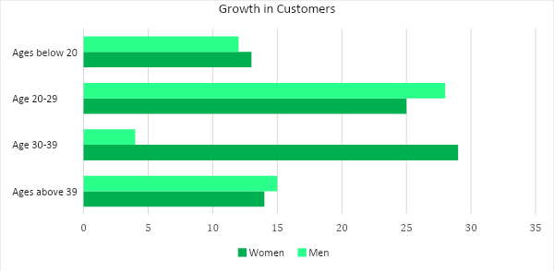

Marketing Strategy

[Parker Fitness Studio] plans to use the influence of social media to promote its services. The company will post contents and videos about its services and the importance of being healthy and fit.

Milestones

Marketing Strategy | Activities | Timeline | Success Criteria
Social Media | Post videos and contents about the company’s fitness programs | April 1, 2018 | The company earns customers after the videos and contents are posted on social media.
Video and Content Posts | Prepare articles/videos about health and fitness | ASAP | The articles and videos are created and posted on social media, which sparked interest to a significant number of people.
-- | -- | -- | --

MANAGEMENT AND PERSONNEL

[Parker Fitness Studio] is a sole proprietorship business personally managed by [Rafael Parker]. The company employs a total of [8] trainers who administer the fitness programs appropriate for each customer.

FINANCIAL PLAN

This financial plan prepared for [Parker Fitness Studio] includes a break-even analysis, estimated profit and loss, balance sheet, and cash flow statements.

Break-Even Analysis

Fixed Costs | Average Price |  | Variable Costs |  | Contribution Margin | Break-Even Units
$4,750.00 | $30.00 |  | $1.79 |  | $28.21 | 168
Fixed Costs |  | Amount |  | Variable Costs |  | Per Unit Amount
Rent |  | 3,750 |  | Advertising |  | 0.56
Insurance |  | 1,000 |  | Legal Fees |  | 0.83
 |  |  |  | Staff Training |  | 0.40
Total |  | 4,750 |  | Total |  | 1.79

Fixed Costs |  | Variable Costs
Business Lease - Rent |  | $3,750
Insurance |  | $1,000
Total Fixed Costs |  | $4,750
Total Units Sold in 1 Month |  | 1,000
Variable Costs (Unit Sold/Cost per Unit) | Average Price | Variable Costs
Advertising | $1,800 | $0.56
Legal Fees | $1,200 | $0.83
Staff Training | $2,500 | $0.40
Total Variable Cost (Per Unit) |  | $1.79
Break-Even
Selling Price Per Unit |  | $30.00
Break-Even Point Per Unit [Fixed Costs/(Sales Price Per Unit - Variable Cost Per Unit)] |  | 4,750
 |  | 28.21
Break-Even Point in Units |  | 168
Contribution Margin (Selling Price - Total Variable Cost) |  | $28.21

Profit and Loss Projection
 | FY2018 | FY2019 | FY2020
Sales | $200,000.00 | $270,000.00 | $364,500.00
Direct Cost of Sale | $80,000.00 | $108,000.00 | $145,800.00
Other Cost of Sale | $3,000.00 | $3,750.00 | $4,687.50
Total Cost of Goods Sold or COGS (Sales - Direct Cost of Sale - Other Cost of Sale) | $117,000.00 | $158,250.00 | $214,012.50
Gross Profit (Sales-Total Cost of Goods Sold) | $83,000.00 | $111,750.00 | $150,487.50
Gross Margin % (Gross Profit/Sales) | 41.50% | 41.39% | 41.29%
Operating Expenses
Rent | $7,500.00 | $7,500.00 | $7,500.00
Insurance | $12,000.00 | $12,000.00 | $12,000.00
Utilities | $5,000.00 | $5,000.00 | $5,000.00
Salary (Including Tax) | $23,000.00 | $23,000.00 | $23,000.00
Maintenance & Supplies | $7,000.00 | $7,000.00 | $7,000.00
Total Operating Expenses | $54,500.00 | $54,500.00 | $54,500.00
EBITDA (Total Cost of Sale-Total Operating Expenses) | $62,500.00 | $103,750.00 | $159,512.50
Depreciation | $250.00 | $250.00 | $250.00
Interest Expense | $0.00 | $0.00 | $0.00
Taxes Paid | $2,070.00 | $2,070.00 | $2,070.00
Net Profit (Gross Profit - Operating Expenses - Taxes - Interest) | $26,430.00 | $55,180.00 | $93,917.50

Balance Sheet Projection
 | FY2018 | FY2019 | FY2020
Cash | $30,000.00 | $76,475.00 | $150,748.75
Accounts Receivable | $25,000.00 | $32,500.00 | $42,250.00
Inventory | $15,000.00 | $18,750.00 | $23,437.50
Other Current Assets | $20,000.00 | $20,000.00 | $20,000.00
Total Current Assets | $90,000.00 | $147,725.00 | $236,436.25
Long-Term Assets | $65,000.00 | $68,250.00 | $71,662.50
Accumulated Depreciation | $250.00 | $500.00 | $750.00
Total Long-Term Assets (Long-Term Assets-Accumulated Depreciation) | $64,750.00 | $67,750.00 | $70,912.50
Total Assets (Total Current Assets + Total Long-Term Assets) | $154,750.00 | $215,475.00 | $307,348.75
Accounts Payable | $20,000.00 | $19,000.00 | $18,050.00
Notes Payable | $5,000.00 | $5,175.00 | $5,356.13
Other | $2,000.00 | $2,500.00 | $2,500.00
Total Liabilities | $27,000.00 | $26,675.00 | $25,906.13
Paid-in Capital | $100,000.00 | $115,000.00 | $132,250.00
Retained Earnings | $26,430.00 | $81,610.00 | $175,527.50
Total Owner's Equity (Total Assets - Total Liabilities) | $127,750.00 | $188,800.00 | $281,442.63
Total Liabilities & Equity (Total Liabilities/Total Owner's Equity) | 21.14% | 14.13% | 9.20%

Cash Flow Projection
 | FY2018 | FY2019 | FY2020
Operating Cash Beginning | $5,000.00 | $30,000.00 | $76,475.00
Sources of Cash | $6,500.00 | $6,825.00 | $7,166.25
Receivables | $25,000.00 | $32,500.00 | $42,250.00
Sales | $45,000.00 | $58,500.00 | $76,050.00
Others | $3,000.00 | $3,150.00 | $3,307.50
Total Cash | $84,500.00 | $130,975.00 | $205,248.75
Expenditures
Rent | $7,500.00 | $7,500.00 | $7,500.00
Insurance | $12,000.00 | $12,000.00 | $12,000.00
Utilities | $5,000.00 | $5,000.00 | $5,000.00
Salary (Including Tax) | $23,000.00 | $23,000.00 | $23,000.00
Maintenance & Supplies | $7,000.00 | $7,000.00 | $7,000.00
Total Expenditures | $54,500.00 | $54,500.00 | $54,500.00
Net Income/Loss (Total Cash - Total Expenditures) | $30,000.00 | $76,475.00 | $150,748.75

