Business Plan For Fiscal Year 2019
[February 1, 2019]

[Heather Thomas]
[hthomas@gmail.com]
[626-666-2842]
[eevents.com]
[934 Nickel Road]
[Pasadena, CA 91101]

Event
Planning Business Plan

Index

Executive Summary

Company Overview
Products and Services

Execution

Operational Plan

Financial Plan

EXECUTIVE SUMMARY

Market for event planning is steady and extremely profitable, thanks to the desire of many individuals to showcase their celebrations on social media.

[Effortless Events] boasts a combination of old-fashioned values with cutting-edge event planning software and technology to ensure that parties and events will truly be effortless on the clients’ end, making hosting more fun and simple for everyone.

COMPANY OVERVIEW

Mission Statement

[Effortless Events] strives to become the number one choice for clients by helping them plan the biggest milestones in their lives without the problems and headaches that come with it, ensuring worry- and hassle-free events at reasonable prices.

Philosophy

[Effortless Events] is a small business with big goals that believes in its commitment to quality. All employees push themselves to a higher level of professionalism.

Vision

[Effortless Events] aims to be one of the top event planning specialists in the country by producing the same quality results every single time.

Outlook

Companies that specialized in social events showed a negligible growth of [0.7] percent in [2007] to [2012]. However, by including business and corporate events, [Effortless Events] can expand its market significantly to ensure a more stable employment rate.

Type of Industry: Event Management

Business Structure: Sole Proprietorship

Ownership: Sole Proprietorship, [Heather Thomas]

Start-Up Summary: The start-up costs for Effortless Events is $[30,000.00].

Start-Up Funding
Start-Up Expenses | $10,000
Start-Up Assets | $20,000
Total Funding Required | $30,000
Assets
Non-Cash Assets from Start-Up | $15,000
Cash Requirements from Start-up | $1,000
Additional Cash Raised | $3,000
Cash Balance on Starting Date | $1,000
Total Assets | $20,000
Capital
Planned Investment
Owner | $30,000
Other | $0
Additional Investment Requirement | $0
Total Planned Investment | $30,000
Loss at Start-Up (Start-Up Expenses) | -$10,000
Total Capital | $20,000
Liabilities | $0
Total Capital and Liabilities | $20,000
Start-Up
Requirements
Start-Up Expenses
Rent - 5 Months | $1,000
Advertising | $1,000
Legal Fees and Insurance | $2,000
Staff Training | $2,000
Inventory Expenses | $4,000
Other | $0
Total Start-Up Expenses | $10,000
Start-Up Assets
Cash Required | $5,000
Start-Up Inventory | $2,000
Other Current Assets | $12,000
Long-Term Assets | $1,000
Total Assets | $20,000
Total Requirements (Total Start-Up Expenses + Total Assets) | $30,000

Management Team:

Management Team | Role/Function | Skills
[Jenna Harvey] | Financial Manager | Communication, People Management, Accounting, and Finance
[Laura Hoffman] | General Manager | Communication, People Skills, and Resilience
[Rosa Chavez] | Human Resources | Onboarding, People Skills, and Performance Management

Short- and Long-Term Goals and Milestones:

Short-Term Goals | Milestones
Hire General Manager | Hired last [November 30, 2018]
Hire Financial Manager | Hired Last [November 25, 2018]
Long-Term Goals | Milestones
Create effective teams to work together for different events | Team training ongoing
Create and maintain social media networks for the company | Outsource a part-time social media specialist; Shortlist of candidates drafted

PRODUCTS AND SERVICES

Product/Service Description

[Effortless Events] offers event planning services in [Pasadena, CA]. It produces different events such as weddings, birthdays, corporate events, marketing campaigns, and other milestone events such as christenings, bachelor and bachelorette parties, and even the now-popular divorce parties. No matter what kind of event the clients have in mind, [Effortless Events] will ensure that the entire event will be a success.

Value Proposition

[Effortless Events] serves customers in [Pasadena] by producing the perfect parties and events so that hosts will no longer have to feel the stress that comes with planning. By ensuring reliable and professional events every time, the company can compete with other event planning companies in the area.

Pricing Strategy

[Effortless Events] charges customers based on their preferences for each aspect of the event, including decorations, catering, hosting, audio-visual technology, among others.

EXECUTION

Marketing Plan

[Effortless Events] shall focus on the younger generation of party planners by focusing on strategies via networks such as Facebook and Instagram and by crafting aesthetically pleasing social media accounts to convince clients that the events are “Instagrammable” and worthy of social media posting. These accounts shall be updated on a daily basis and will include the different aspects of the event planning service, including decorations, designs, and menu, if applicable.

Market Research

When it comes to social and corporate events, aesthetics plays a large role, thanks to a generation rooted in social media. The current trend implies that events that look good in photos and posts are likely to gain a better trajectory among the clients.

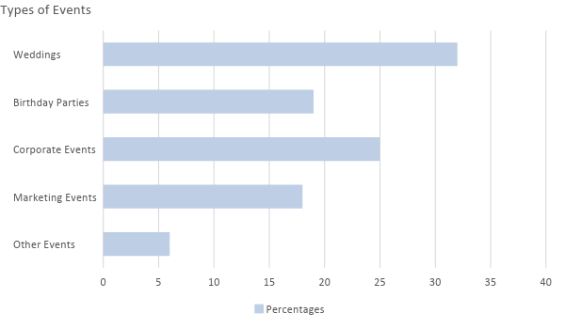
SWOT Analysis

The following analysis captures the strengths and weaknesses within the company, as well as the opportunities and threats that it faces from other outside factors.

SWOT Analysis | Strengths | Weaknesses | Opportunities | Threats
[Effortless Events] | - Specialized service offerings | - New to the business and will need better execution.  - Difficulty in generating awareness. | - Industry trends and company flexibility can contribute to its strengths over time. | - Large number of competitors in the market.
[Weddings and More] | - Strong relationships with service providers. | - Concentration of niche limits the company’s potential market size. | - Target market prefers to cater to company services, ensuring room for company growth. | - Slump in the economy may have a ripple effect on the need of the company’s services.
[Party Planners, Inc.] | - Most affordable party planning service in the local area. | - Tends to show inability to meet large and unexpected increase in demand. | - Growing market of companies outsource party planning. | - Inability of the company to find quality employees.

Marketing Strategy

[Effortless Events] will take advantage of social media since it is important to create an overall aesthetic that will attract different kinds of people to the events produced and created by the company. Thus, it is important for the company not only to create a clean and effective website but also to create viral events to maximize its client reach.

The company will hire a part-time marketing manager who will be present for big parties and events and will create posts that will attract the target clients whether they are couples looking for someone to manage their weddings, parents who want to throw their children milestone parties that they will love, or companies that are looking to reach out to their clients by impressing them with their corporate events and activities.

Below are some of the updates that the company has made to kick off the different marketing strategies:

Marketing Strategy | Activities | Timeline | Success Criteria
Website upgrade | Create and launch a company website | December 31, 2018 | The website should be functional on [January 1, 2019].
Social media reach | Outsource a social media manager to execute the different social media activities | ASAP | 100,000 followers each on Facebook, Twitter, Instagram by [January 15, 2019].
Viral videos | Create a viral video as a form of guerrilla marketing for the company | January 10, 2019 | The video shall have over 20,000 shares each on Facebook and Instagram within 48 hours of posting.

Organizational Structure:

Accounting
Financial Manager
General Manager
Human Resource
Bookkeeping
Payroll
Chief Executive Manager
Event Manager (Social)
Event Manager (Corporate)
Creative Design
Hiring
Onboarding
Purchasing Officer
Corporate Team Staff
Social Team Staff

OPERATIONAL PLAN

Location and Facilities

Financial Plan
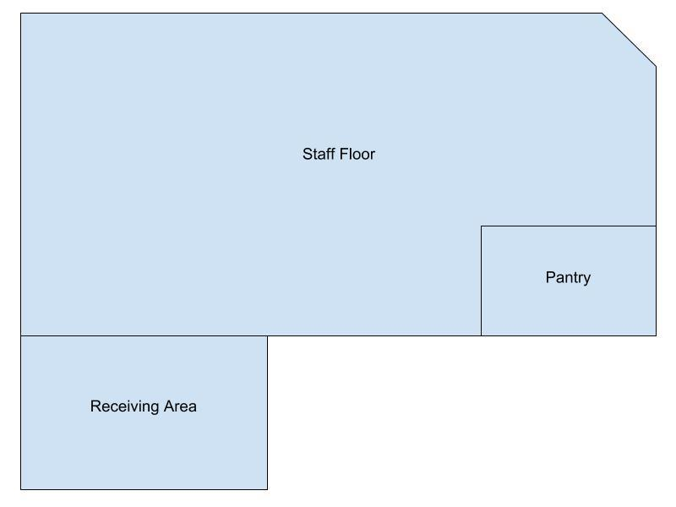

Assumptions

The company will focus its marketing efforts on maintaining a certain aesthetic to attract clients. Most of the expenses will be for utilities, rent, and payroll as the company will outsource all other necessities by partnering with other local businesses.

Monthly Expense

The company’s monthly expenses are indicated in the chart below:

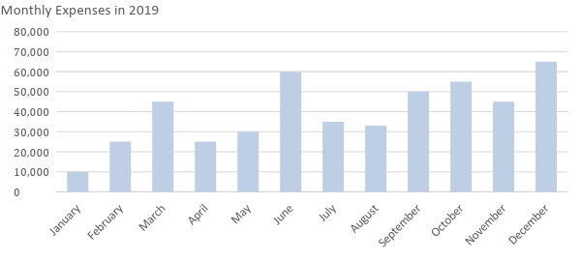

Monthly Revenue

The company’s projected monthly revenue for the following year is shown below:

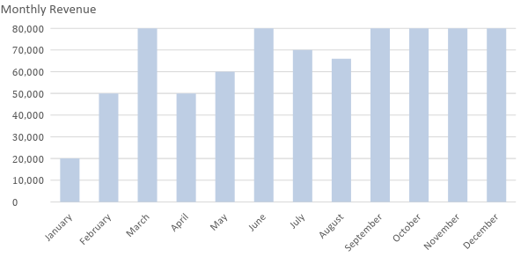

Business Financing

The funding for the business mainly comes from the personal accounts of the owner, with most of the expenses going to the rent, insurance, and salaries.

Statements

Profit and Loss Projection
 | FY2019 | FY2020 | FY2021
Sales | $450,000.00 | $500,000.00 | $550,000.00
Direct Cost of Sale | $150,000.00 | $150,000.00 | $175,000.00
Other Cost of Sale | $10,000.00 | $10,000.00 | $10,000.00
Total Cost of Goods Sold or COGS (Sales - Direct Cost of Sale - Other Cost of Sale) | $290,000.00 | $340,000.00 | $365,000.00
Gross Profit (Sales-Total Cost of Goods Sold) | $160,000.00 | $160,000.00 | $185,000.00
Gross Margin % (Gross Profit/Sales) | 35.56% | 32.00% | 33.64%
Operating Expenses
Rent | $18,000.00 | $18,000.00 | $18,000.00
Insurance | $9,000.00 | $9,000.00 | $9,000.00
Utilities | $1,500.00 | $1,500.00 | $1,500.00
Salary (Including Tax) | $75,000.00 | $80,000.00 | $85,000.00
Maintenance & Supplies | $2,500.00 | $2,500.00 | $3,000.00
Total Operating Expenses | $106,000.00 | $111,000.00 | $116,500.00
EBITDA (Total Cost of Sale-Total Operating Expenses) | $184,000.00 | $229,000.00 | $248,500.00
Depreciation | $4,000.00 | $4,000.00 | $4,000.00
Interest Expense | $0.00 | $0.00 | $0.00
Taxes Paid | $5,000.00 | $5,000.00 | $5,000.00
Net Profit (Gross Profit - Operating Expenses - Taxes - Interest) | $49,000.00 | $44,000.00 | $63,500.00

Balance Sheet Projection
 | FY2019 | FY2020 | FY2021
Cash | $125,000.00 | $150,000.00 | $190,000.00
Accounts Receivable | $15,000.00 | $17,000.00 | $13,000.00
Inventory | $7,000.00 | $8,000.00 | $10,000.00
Other Current Assets | $20,000.00 | $25,000.00 | $35,000.00
Total Current Assets | $167,000.00 | $200,000.00 | $248,000.00
Long-Term Assets | $25,000.00 | $33,000.00 | $42,000.00
Accumulated Depreciation | $3,000.00 | $2,500.00 | $2,000.00
Total Long-Term Assets (Long-Term Assets-Accumulated Depreciation) | $22,000.00 | $30,500.00 | $40,000.00
Total Assets (Total Current Assets + Total Long-Term Assets) | $189,000.00 | $230,500.00 | $288,000.00
Accounts Payable | $18,000.00 | $20,000.00 | $22,000.00
Notes Payable | $7,000.00 | $7,500.00 | $5,000.00
Other | $3,500.00 | $7,000.00 | $5,000.00
Total Liabilities | $28,500.00 | $34,500.00 | $32,000.00
Paid-in Capital | $10,000.00 | $5,000.00 | $5,000.00
Retained Earnings | $90,000.00 | $120,000.00 | $130,000.00
Total Owner's Equity (Total Assets - Total Liabilities) | $160,500.00 | $196,000.00 | $256,000.00
Total Liabilities & Equity (Total Liabilities/Total Owner's Equity) | 17.76% | 17.60% | 12.50%

Cash Flow Projection
 | FY2019 | FY2020 | FY2021
Operating Cash Beginning | $170,000.00 | $220,000.00 | $240,000.00
Sources of Cash | $20,000.00 | $18,000.00 | $22,000.00
Receivables | $15,000.00 | $17,000.00 | $19,000.00
Sales | $30,000.00 | $32,000.00 | $27,000.00
Others | $5,000.00 | $7,000.00 | $90,000.00
Total Cash | $240,000.00 | $294,000.00 | $398,000.00
Expenditures
Rent | $24,000.00 | $24,000.00 | $24,000.00
Insurance | $12,000.00 | $12,000.00 | $12,000.00
Utilities | $1,500.00 | $1,500.00 | $1,700.00
Salary (Including Tax) | $75,000.00 | $80,000.00 | $85,000.00
Maintenance & Supplies | $2,500.00 | $2,500.00 | $3,000.00
Total Expenditures | $115,000.00 | $120,000.00 | $125,700.00
Net Income/Loss (Total Cash - Total Expenditures) | $125,000.00 | $174,000.00 | $272,300.00

