ENQUINE BUSINESS PLAN

[INSERT NAME OF THE BUSINESS/COMPANY]
[INSERT THE COMPLETE BUSINESS/COMPANY ADDRESS]
[INSERT THE BUSINESS/COMPANY CONTACT NUMBERS]
[INSERT THE BUSINESS/COMPANY EMAIL ADDRESS]
[INSERT THE BUSINESS/COMPANY WEBSITE ADDRESS]

PREPARED BY:

[INSERT FULL NAME/S OF THE
PEOPLE WHO PREPARED THIS PLAN]

[INSERT DATE]

Index

Executive Summary [PAGE NUMBER]
Company Overview [PAGE NUMBER]
Products and Services [PAGE NUMBER]
Execution [PAGE NUMBER]
Operational Plan [PAGE NUMBER]
Financial Plan [PAGE NUMBER]

Executive Summary:

[Rhodes Riding School] is a standard horse riding school in [Omaha, Nebraska]. It will offer riding lessons for children, as well as training and coaching for older audiences who want to participate in equestrian shows and competitions.

To do so, the school will take advantage of online and social media marketing. It will also partner with private schools in the country and work with students that may show interest in equestrian training.

Bringing an estimated [$2 billion] in the [United States], [Rhodes Riding School] wants to take advantage of the growing industry by expanding its reach to neighboring towns to maintain positive revenue growth in the [first year].

Company Overview:

Mission Statement: [Rhodes Riding School] intends to build a business that promotes [horsemanship] for individuals of all ages in the [Omaha district area].

Philosophy: [Rhodes Riding School] strives to meet the needs of equestrians by providing a wide range of programs and developing a safe and responsible infrastructure for the equine community.

Vision: It is the vision of [Rhodes Riding School] to be known to the equine community as a top riding school in Omaha and other nearby towns.

Outlook: Studies show that the horse riding industry brings around [$2 billion] in revenue through a combination of activities that include horse racing. The industry, which faced a decline in the 2008 recession, is beginning to recover with more and more people owning and managing horses between [2013] and [2018].

Type of Industry: [Equine Industry], Recreation

Business Structure: Sole Proprietorship

Ownership: Sole Proprietorship, [Marissa Rhodes]

Start-Up Summary: It will cost [$750,000] to start an equestrian school in [Omaha]. This amount will be used for horse and stable [maintenance, insurance, facilities and equipment, and payroll].

Start-Up Funding
Start-Up Expenses | $450,000.00
Start-Up Assets | $300,000.00
Total Funding Required | $750,000.00
Assets
Non-Cash Assets from Start-Up | $150,000.00
Cash Requirements from Start-up | $65,000.00
Additional Cash Raised | $55,000.00
Cash Balance on Starting Date | $30,000.00
Total Assets | $300,000.00
Capital
Planned Investment
Owner | $750,000.00
Other | $0.00
Additional Investment Requirement | $0.00
Total Planned Investment | $750,000.00
Loss at Start-Up (Start-Up Expenses) | -$450,000.00
Total Capital | $300,000.00
Liabilities | $0.00
Total Capital and Liabilities | $300,000.00
Start-Up
Requirements
Start-Up Expenses
Stable Maintenance | $60,000.00
Advertising | $5,000.00
Legal Fees | $2,000.00
Staff Training | $270,000.00
Insurance | $33,000.00
Other | $80,000.00
Total Start-Up Expenses | $450,000.00
Start-Up Assets
Cash Required | $150,000.00
Start-Up Inventory | $50,000.00
Other Current Assets | $50,000.00
Long-Term Assets | $50,000.00
Total Assets | $300,000.00
Total Requirements (Total Start-Up Expenses + Total Assets) | $750,000.00

Management Team:

Management Team | Role/Function | Skills
Summer Cohen | Barn Manager | Communication, Stable Management Skills, Husbandry
Taylor Atwood | Senior Riding Instructor | Communication, Riding Skills

Short- and Long-Term Goals and Milestones:

Short-Term Goals | Milestones
Finish all horse riding track improvements | The track is currently 75% done.
Hire part-time instructors | Hired 3 part-time instructors
Long-Term Goals | Milestones
Become the go-to school for interested riders
Participate in equestrian sporting events

Products and Services

Product/Service Description: [Rhodes Riding School] offers the following services to its clients:

- Horse riding lessons
- Training and coaching
- Therapeutic horseback riding
- Horse boarding
- Stable rental and maintenance
- Consultancy services

Value Proposition: [Rhodes Riding School] is one of the very few equine schools in the area that offers [therapeutic horseback riding].

Pricing Strategy: [Rhodes Riding School] offers individual pricing strategies for different services depending on the skills, breed, and other factors.

Execution

Marketing Plan: [Rhodes Riding School] wants to introduce horseback riding to potential equestrians as young as [8 years old]. To do so, it wants to take advantage of social media marketing to the younger audience and their parents or guardians. It shall also make use of direct sales strategies to effectively discuss partnerships with schools and establishments.

Market Research: [Rhodes Riding School] intends to draft different strategies to gain a significant market share. Studies show that the equine market in [Omaha] caters to children, young adults, the elderly, individuals with special needs, and others who love horses.

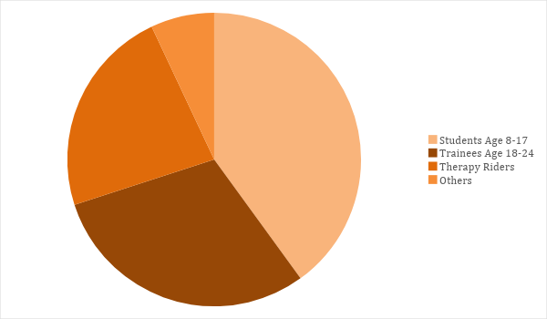

SWOT Analysis | Strengths | Weaknesses | Opportunities | Threats
Rhodes Riding School | Experienced trainers for therapeutic riding | New in the industry and needs to gain a positive reputation |  | More established competitors will make it difficult to penetrate the market
Stenton Stables | Established equine school | Needs to update its facilities and operation |  | Economic downturn
Omaha Riding Club | Has a strong client base | A tight budget limits its marketing strategies |  | Illnesses affecting horses

Marketing Strategy: Upon securing the necessary finances for building the training ground, [Rhodes Riding School] will target its client base with the help of different marketing strategies. Online marketing such as maintaining a website and updating its social media accounts will take priority.

Directly speaking with decision-makers from [schools, hospitals, or other establishments] will also be effective as this will help spread the word about the school. Finally, print media will still play a significant role, especially the local lifestyle magazines since many of those in the upper socioeconomic segments subscribe to them.

Marketing Strategy | Activities | Timeline | Success Criteria
Website upgrade and social media updates | Create and maintain a website and social network accounts | February 25, 2018 | 4,500 website views, 3,000 social media likes/follows in 3 months
Direct sales and partnerships | Meet and speak with decision-makers to discuss possible referrals to the school | ASAP | Positive responses, with at least 15 referrals within 3 months
Print advertising | Create print ads for local newspapers and magazines | February 25, 2018

Organizational Structure:

Owner-Operator
Marketing
Maintenance
Barn Manager
Lead Riding Instructor
Finance
Riding Instructors
Therapy Riders
Trainers and Coaches
Purchasing
Security

Operational Plan:

Location and Facilities

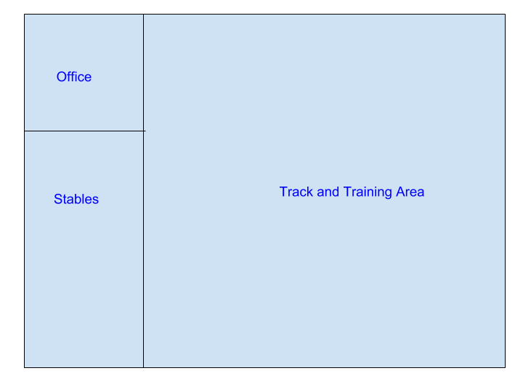

Financial Plan

Assumptions

The [horseback riding industry] in [Omaha] will continue to grow, with new horse owners investing in the industry. The following assumptions are based on the continuing upward economic trajectory.

Monthly Expense

The chart shows the projected monthly expense for [2019]. The high expense cost for January is due to track upgrades, stable maintenance, and others to ensure that the school is safe and ready for its launching.

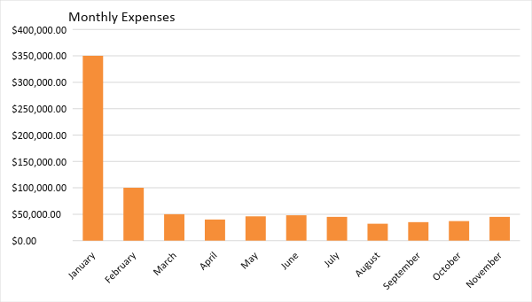

Monthly Revenue

The chart depicts the projected monthly revenue for [2019]. The school will officially open in March and will be closed for most of December for the holiday break.

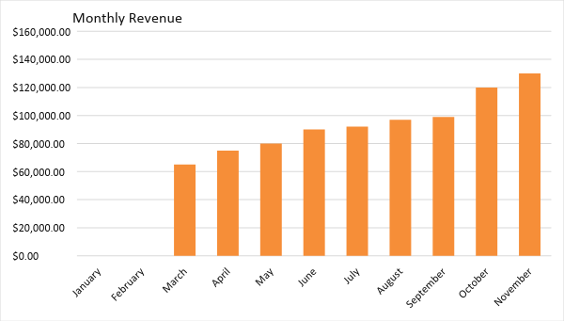

Business Financing

The business, which will cost [$750,000], shall be funded in full by the owner.

Statements

Profit and Loss Projection
 | FY2019 | FY2020 | FY2021
Sales | $918,000.00 | $1,300,000.00 | $1,500,000.00
Direct Cost of Sale | $400,000.00 | $700,000.00 | $900,000.00
Other Cost of Sale | $25,000.00 | $27,000.00 | $35,000.00
Total Cost of Goods Sold or COGS (Sales - Direct Cost of Sale - Other Cost of Sale) | $493,000.00 | $573,000.00 | $565,000.00
Gross Profit (Sales-Total Cost of Goods Sold) | $425,000.00 | $727,000.00 | $935,000.00
Gross Margin % (Gross Profit/Sales) | 46.30% | 55.92% | 62.33%
Operating Expenses
Rent | $60,000 | $60,000 | $65,000
Insurance | $33,000 | $33,000 | $33,000
Utilities | $45,000 | $50,000 | $57,000
Salary (Including Tax) | $200,000 | $225,000 | $275,000
Maintenance & Supplies | $50,000 | $52,000 | $50,000
Total Operating Expenses | $388,000.00 | $420,000.00 | $480,000.00
EBITDA (Total Cost of Sale-Total Operating Expenses) | $105,000.00 | $153,000.00 | $85,000.00
Depreciation | $3,000.00 | $3,000.00 | $3,000.00
Interest Expense | $0.00 | $0.00 | $0.00
Taxes Paid | $4,000.00 | $4,000.00 | $4,000.00
Net Profit (Gross Profit - Operating Expenses - Taxes - Interest) | $33,000.00 | $303,000.00 | $451,000.00

Balance Sheet Projection
 | FY2019 | FY2020 | FY2021
Cash | $150,000.00 | $500,000.00 | $700,000.00
Accounts Receivable | $818,000.00 | $1,200,000.00 | $1,400,000.00
Inventory | $100,000.00 | $120,000.00 | $115,000.00
Other Current Assets | $55,000.00 | $6,000.00 | $8,000.00
Total Current Assets | $1,123,000.00 | $1,826,000.00 | $2,223,000.00
Long-Term Assets | $50,000.00 | $70,000.00 | $60,000.00
Accumulated Depreciation | $3,000.00 | $2,500.00 | $2,000.00
Total Long-Term Assets (Long-Term Assets-Accumulated Depreciation) | $47,000.00 | $67,500.00 | $58,000.00
Total Assets (Total Current Assets + Total Long-Term Assets) | $1,170,000.00 | $1,893,500.00 | $2,281,000.00
Accounts Payable | $15,000.00 | $17,000.00 | $20,000.00
Notes Payable | $5,000.00 | $6,000.00 | $8,000.00
Other | $3,500.00 | $7,000.00 | $5,000.00
Total Liabilities | $23,500.00 | $30,000.00 | $33,000.00
Paid-in Capital | $5,000.00 | $5,000.00 | $5,000.00
Retained Earnings | $46,000.00 | $324,000.00 | $524,000.00
Total Owner's Equity (Total Assets - Total Liabilities) | $1,146,500.00 | $1,863,500.00 | $2,248,000.00
Total Liabilities & Equity (Total Liabilities/Total Owner's Equity) | 2.05% | 1.61% | 1.47%

Cash Flow Projection
 | FY2019 | FY2020 | FY2021
Operating Cash Beginning | $150,000.00 | $730,000.00 | $1,671,000.00
Sources of Cash | $10,000.00 | $130,000.00 | $150,000.00
Receivables | $35,000.00 | $40,000.00 | $55,000.00
Sales | $918,000.00 | $1,300,000.00 | $1,500,000.00
Others | $5,000.00 | $7,000.00 | $8,000.00
Total Cash | $1,118,000.00 | $2,207,000.00 | $3,384,000.00
Expenditures
Stable Maintenance | $60,000 | $60,000 | $65,000
Insurance | $33,000 | $33,000 | $33,000
Utilities | $45,000 | $50,000 | $57,000
Salary (Including Tax) | $200,000 | $225,000 | $275,000
Maintenance & Supplies | $50,000 | $52,000 | $50,000
Total Expenditures | $388,000.00 | $420,000.00 | $480,000.00
Net Income/Loss (Total Cash - Total Expenditures) | $730,000.00 | $1,787,000.00 | $2,904,000.00

