[Wagging Tails Training]
[2019 – 2020]

DOG
TRAINING MARKETING PLAN

Index

Executive Summary | [PAGE NUMBER]
Company Overview | [PAGE NUMBER]
Products and Services | [PAGE NUMBER]
Marketing Analysis | [PAGE NUMBER]
Strategy and Implementation | [PAGE NUMBER]
Management and Personnel | [PAGE NUMBER]
Financial Plan | [PAGE NUMBER]

EXECUTIVE SUMMARY

[Wagging Tails Training] is a dog training school in Skokie, Illinois that introduces a new approach to the dog obedience and training program. [Wagging Tails Training] works not only with dogs but with their owners as well in order for the owners to establish clear lines of communication with their pets.

To reach pet owners in Skokie, [Wagging Tails Training] plans on utilizing strong marketing campaigns that include online marketing, networking, reciprocal advertising with pet stores and veterinary clinics, and hosting dog-related events such as dog shows for the public.

[Wagging Tails Training] is expected to break-even within eight months of operation. Revenues are then expected to rise steadily at a rate of [12]% per year.

COMPANY OVERVIEW

Mission Statement

It is the mission of [Wagging Tails Training] to become a leading dog training center in Skokie, Illinois.

Philosophy

[Wagging Tails Training] operates the center in accordance with its core values of competence, character, and community.

Vision

[Wagging Tails Training] will become one of the most competent and effective dog training centers in Skokie that focuses on dog communication and training.

Outlook

According to the US Department of Labor, the employment of animal care and service workers are projected to grow until [2026] as more and more people consider pets to be part of their family and are willing to pay for pet care and training. Dog training and pet care expenditures have grown significantly with a record of $[72 billion] spent on pets in the US in [2018].

Type of Industry: Animal Care and Management Industry

Business Structure: Sole Proprietorship

Ownership: Sole Proprietorship, [Spencer Pierce]

Start-Up Summary

Wagging Tails Training will spend a total of $[80,000] for its start-up expenses. This will be used for utilities and maintenance, supplies, salaries, and marketing efforts.

Start-Up Funding
Start-Up Expenses | $40,000
Start-Up Assets | $40,000
Total Funding Required | $80,000
Assets
Non-Cash Assets from Start-Up | $25,000
Cash Requirements from Start-up | $3,000
Additional Cash Raised | $7,000
Cash Balance on Starting Date | $5,000
Total Assets | $40,000
Capital
Planned Investment
Owner | $80,000
Other | $0
Additional Investment Requirement | $0
Total Planned Investment | $80,000
Loss at Start-Up (Start-Up Expenses) | -$40,000
Total Capital | $40,000
Total Capital and Liabilities | $40,000
Start-Up
Requirements
Start-Up Expenses
Rent - 6 Months | $6,000
Advertising | $1,000
Legal Fees | $1,000
Staff Training | $12,000
Insurance | $1,000
Other | $19,000
Total Start-Up Expenses | $40,000
Start-Up Assets
Cash Required | $15,000
Start-Up Inventory | $8,000
Other Current Assets | $5,000
Long-Term Assets | $12,000
Total Assets | $40,000
Total Requirements (Total Start-Up Expenses + Total Assets) | $80,000

PRODUCTS AND SERVICES

Product/Service Description

[Wagging Tails Training] offers training services for dogs and communication classes for pet owners to better bond with their canine friends. The training center also offers the following services:

- Dog show handling
- Pet taxi services
- Consulting and advisory services

Value Proposition

[Wagging Tails Training] offers a new training approach that not only focuses on dog training but on the pets’ relationship with their owners as well. With this new approach, effective communication between pets and owners are established to help create a stronger bond.

Pricing Strategy

[Wagging Tails Training] will use a fixed rate pricing strategy for each of its services. Promos and packages shall also be made available for those who want to utilize two or more services.

MARKETING ANALYSIS

Animal care and management is a growing market as pet owners are becoming more and more aware of the importance of communication techniques between humans and pets. Training centers such as [Wagging Tails Training] help owners understand their pets’ behaviors. With as many as [65]% of households owning at least one pet, dog training services are estimated to grow at a rate of [10]% per year in the next few years as more and more individuals make use of these establishments.

Market Segmentation

[Wagging Tails Training] will focus its marketing strategies on families and individuals in Skokie. The chart below shows a breakdown of the training school’s target market:

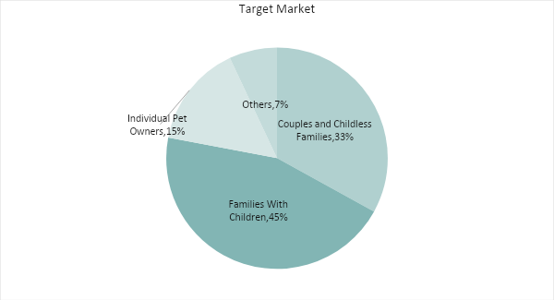

Target Market Segmentation Strategy

Individuals living alone or with roommates

- The school will take advantage of social media, curating posts that specifically show well-groomed, well-trained, and “Instagrammable” pets.

Couples and childless families

- Dog-related events such as dog pageants and dog training exercises are targeted to childless families who dedicate most of their time on their pets.

Families with children

- The school will produce brochures to be placed in pet shops, showing the center’s contact details and services, and will include information on the benefits of having pets to children.

STRATEGY AND IMPLEMENTATION

Target Market Strategy

[Wagging Tails Training] aims to increase its sales by at least [12]% by the third year of operation. This can be achieved by improving customer reach. A combination of print, social media, and events campaigns shall be utilized to meet the projected sales.

Competitive Edge
The company’s new training approach will be more attractive to customers who want to train and bond with their pets.

SWOT Analysis | Strengths | Weaknesses | Opportunities | Threats
[Wagging Tails Training] | New training methods not adopted by other schools in the area | Lack of market exposure | An increasing number of pets in the area with families placing great value on their pets shows promising market | Difficulty in finding qualified pet trainers may impact business negatively
[Paws Training School] | A large and loyal client base | A limited amount of time dedicated per pet | Improving economy shows potential for franchising or expansion | Competition from new pet training schools
[Doggie Day School] | Has experience with different dog breeds | Limited funds | Tie-ups with veterinary clinics | Slow recovering economy

Sales Strategy and Forecast

With an aggressive marketing campaign that targets different types of pet owners, the company targets monthly increase in revenue:

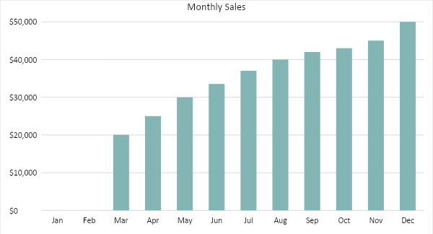

With numerous marketing efforts and effective pricing strategies, [Wagging Tails Training] hopes to see an increase in clientele. The chart below depicts the projected percentage growth in revenue in the next two years:

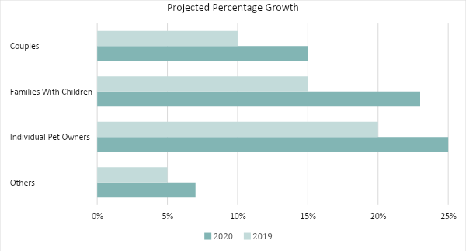

MARKETING STRATEGY

Customer satisfaction remains to be the best marketing tool for newly opened training centers for pets. However, as a new school, [Wagging Tails Training] will utilize a combination of marketing strategies to widen its market reach. This will include distribution of print literature, social media, and related marketing campaigns. These marketing strategies are discussed in the following section.

Milestones

Marketing Strategy | Activities | Timeline | Success Criteria
Social Media Campaign | Hire a social media manager for Facebook and Instagram | ASAP | - At least 1,000 likes on each of the pages within one month  - At least 200 online inquiries in the first three months
Print Advertising and Literature | Write, layout, and print brochures for distribution in pet stores and veterinary clinics | March 15, 2019 | - At least 100 inquiries from brochure information  - At least 30 enrolled dogs in the first month with information from brochures
Pet Events | Host a pet show | April 30, 2019 | - Attendance of more than 150 pet owners or more

MANAGEMENT AND PERSONNEL

As a newly opened small business, the school’s owner will serve as the head dog trainer, with two other trainers employed. There will also be a person to oversee the front desk, as well as a security and maintenance employee. Accounting and marketing shall be outsourced.

Below is the organizational structure of the company:

Owner and Manager
Dog Trainers
Security
Janitorial and Maintenance

FINANCIAL PLAN

The following financial plan shows the projected break-even analysis, profit and loss, balance sheet, and cash flow for [Wagging Tails Training]:

Break-Even Analysis

Fixed Costs | Average Price | Variable Costs | Contribution Margin | Break-Even Units
$30,000.00 | $45.00 | $15.00 | $30.00 | 1,000.00

Fixed Costs | Amount | Variable Costs | Per Unit Amount
Rent | 6,000 | Training | 10
Insurance | 1,000 | Supplies | 5
Legal Fees | 1,000
Staff Training | 22,000
Total | 30,000 | Total | 15

Fixed Costs |  | Variable Costs
Business Lease - Rent (6 Months) |  | $6,000
Insurance |  | $1,000
Legal Fees |  | $1,000
Staff Training |  | $22,000
Total Fixed Costs |  | $30,000
Total Units Sold in 1 Month |  | 450
Variable Costs (Unit Sold/Cost per Unit) | Average Price | Variable Costs
Training Fee | $45 | $10.00
Supplies | $90 | $5.00
Total Variable Cost (Per Unit) |  | $15.00
Break-Even
Selling Price Per Unit |  | $45.00
Break-Even Point Per Unit [Fixed Costs/(Sales Price Per Unit - Variable Cost Per Unit)] |  | 30,000
 |  | 30.00
Break-Even Point in Units |  | 1,000
Contribution Margin (Selling Price - Total Variable Cost) |  | $30.00

Profit and Loss Projection
 | FY2019 | FY2020 | FY2021
Sales | $350,000.00 | $375,000.00 | $400,000.00
Direct Cost of Sale | $310,000.00 | $350,000.00 | $375,000.00
Other Cost of Sale | $10,000.00 | $13,000.00 | $15,500.00
Total Cost of Goods Sold or COGS (Sales - Direct Cost of Sale - Other Cost of Sale) | $30,000.00 | $12,000.00 | $9,500.00
Gross Profit (Sales-Total Cost of Goods Sold) | $320,000.00 | $363,000.00 | $390,500.00
Gross Margin % (Gross Profit/Sales) | 91.43% | 96.80% | 97.63%
Operating Expenses
Rent | $12,000.00 | $12,000.00 | $12,000.00
Insurance | $1,000.00 | $1,000.00 | $1,000.00
Utilities | $8,000.00 | $8,000.00 | $8,000.00
Salary (Including Tax) | $36,000.00 | $36,000.00 | $36,000.00
Maintenance & Supplies | $3,000.00 | $4,000.00 | $4,500.00
Total Operating Expenses | $60,000.00 | $61,000.00 | $61,500.00
EBITDA (Total Cost of Sale-Total Operating Expenses) | -$30,000.00 | -$49,000.00 | -$52,000.00
Depreciation | $4,000.00 | $4,000.00 | $4,000.00
Interest Expense | $0.00 | $0.00 | $0.00
Taxes Paid | $4,000.00 | $5,000.00 | $6,000.00
Net Profit (Gross Profit - Operating Expenses - Taxes - Interest) | $256,000.00 | $297,000.00 | $323,000.00

Balance Sheet Projection
 | FY2019 | FY2020 | FY2021
Cash | $5,000.00 | $165,000.00 | $170,000.00
Accounts Receivable | $200,000.00 | $250,000.00 | $270,000.00
Inventory | $3,000.00 | $5,000.00 | $6,000.00
Other Current Assets | $50,000.00 | $60,000.00 | $80,000.00
Total Current Assets | $258,000.00 | $480,000.00 | $526,000.00
Long-Term Assets | $12,000.00 | $7,000.00 | $6,000.00
Accumulated Depreciation | $1,200.00 | $2,500.00 | $2,000.00
Total Long-Term Assets (Long-Term Assets-Accumulated Depreciation) | $10,800.00 | $4,500.00 | $4,000.00
Total Assets (Total Current Assets + Total Long-Term Assets) | $268,800.00 | $484,500.00 | $530,000.00
Accounts Payable | $10,000.00 | $30,000.00 | $15,000.00
Notes Payable | $5,000.00 | $6,000.00 | $8,000.00
Other | $3,500.00 | $7,000.00 | $5,000.00
Total Liabilities | $18,500.00 | $43,000.00 | $28,000.00
Paid-in Capital | $5,000.00 | $5,000.00 | $5,000.00
Retained Earnings | $126,000.00 | $142,000.00 | $148,000.00
Total Owner's Equity (Total Assets - Total Liabilities) | $250,300.00 | $441,500.00 | $502,000.00
Total Liabilities & Equity (Total Liabilities/Total Owner's Equity) | 7.39% | 9.74% | 5.58%

Cash Flow Projection
 | FY2019 | FY2020 | FY2021
Operating Cash Beginning | $30,000.00 | $337,000.00 | $670,000.00
Sources of Cash | $5,000.00 | $7,000.00 | $10,000.00
Receivables | $7,000.00 | $5,000.00 | $7,500.00
Sales | $350,000.00 | $375,000.00 | $400,000.00
Others | $5,000.00 | $7,000.00 | $8,000.00
Total Cash | $397,000.00 | $731,000.00 | $1,095,500.00
Expenditures
Rent | $12,000.00 | $12,000.00 | $12,000.00
Insurance | $1,000.00 | $1,000.00 | $1,000.00
Utilities | $8,000.00 | $8,000.00 | $8,000.00
Salary (Including Tax) | $36,000.00 | $36,000.00 | $36,000.00
Maintenance & Supplies | $3,000.00 | $4,000.00 | $4,500.00
Total Expenditures | $60,000.00 | $61,000.00 | $61,500.00
Net Income/Loss (Total Cash - Total Expenditures) | $337,000.00 | $670,000.00 | $1,034,000.00

