[Parker and Stanley Debt Collection Agency]
[February 1, 2019]

[Angela C. Stanley]
[wwwangelastanley.com]
[3419 John Calvin Drive
Chicago, Illinois 60607, USA]

Business Plan For Fiscal Year [2019]

DEBT
COLLECTION
BUSINESS PLAN

[angelastanley@gmail.com]

[708-854-7231]

Index

Executive Summary | [PAGE NUMBER]
Company Overview | [PAGE NUMBER]
Services | [PAGE NUMBER]
Execution | [PAGE NUMBER]
Operational Plan | [PAGE NUMBER]
Financial Plan | [PAGE NUMBER]

EXECUTIVE SUMMARY

[Parker and Stanley Debt Collection Agency] will offer debt collection services to healthcare providers in [Chicago, Illinois]. The debt collection industry is expected to grow at [26]% over the next [3] years. The company aims to increase the total debt collection percentage to [90]% in order to also attract companies from the utility and telecommunications industries.

COMPANY OVERVIEW

Mission Statement

The mission of [Parker and Stanley Debt Collection Agency] is to provide exceptional service to creditors and become an essential part of their growing business.

Philosophy

[Parker and Stanley Debt Collection Agency] will always treat all clients with respect, honesty, and integrity. It will open a clear line of communication to maintain a healthy relationship with clients throughout the entire collection process.

Vision

[Parker and Stanley Debt Collection Agency] envisions itself as the top performing debt collection agency in [Chicago] through continuous improvement, making sure that it builds beneficial and lasting relationships with the clients.

Outlook

Debt collection services are continuously in demand because businesses opt to focus on their operations rather than spending their time and efforts in collecting debts. In the US alone, there are 4,100 debt collection agencies, employing nearly [450,000] people, and the industry expects to grow by as much as [26]% percent over the next three years.

Type of Industry: Debt Collection Industry

Business Structure: General Partnership

Ownership: General Partnership, Pamela Parker and Angela Stanley

Start-Up Summary

The start-up cost is [175K] USD, which is to be provided by the partners and to be used mainly for the working capital, rent, supplies, and payroll.

Start-Up Funding
Start-Up Expenses | $75,000
Start-Up Assets | $100,000
Total Funding Required | $175,000
Assets
Non-Cash Assets from Start-Up | $50,000
Cash Requirements from Start-up | $30,000
Additional Cash Raised | $0
Cash Balance on Starting Date | $20,000
Total Assets | $100,000
Capital
Planned Investment
Owner | $175,000
Other | $0
Additional Investment Requirement | $0
Total Planned Investment | $175,000
Loss at Start-Up (Start-Up Expenses) | -$75,000
Total Capital | $100,000
Liabilities | $0
Total Capital and Liabilities | $100,000
Start-Up
Requirements
Start-Up Expenses | $5,000
Rent - 1 year | $12,000
Advertising | $1,200
Legal Fees | $1,000
Staff Training | $5,000
Insurance | $2,400
Other | $48,400
Total Start-Up Expenses | $75,000
Start-Up Assets
Cash Required | $30,000
Start-Up Inventory | $50,000
Other Current Assets | $0
Long-Term Assets | $20,000
Total Assets | $100,000
Total Requirements (Total Start-Up Expenses + Total Assets) | $175,000

Management Team:

Management Team | Role/Function | Skills
[Pamela Parker] | Administrative Manager | Communication, problem-solving, and time management
[Angela Stanley] | Operations Manager | Organizational, decision-making, and leadership

Short- and Long-Term Goals and Milestones:

Short-Term Goals | Milestones
Hire 2 customer service representatives and 3 field collectors | The operations manager has already hired employees for the positions last [February 1, 2019].
Conduct training and seminars to employees on government regulations regarding debt collection | The administrative manager has set the schedule for the meeting with the trainer on [February 10, 2019].
Long-Term Goals | Milestones
Establish a company website | The partners have contacted several IT companies on their respective rates for the development and maintenance of the website.
Increase the total debt collection percentage to [90]% | The partners have purchased Accurint, a skip tracing tool, to easily locate debtors.

SERVICES

Service Description

[Parker and Stanley Debt Collection Agency] offers debt collection services for healthcare providers. Its services include the following:

- NSF check collection
- Regular account placement
- Charge off recoveries
- Receivables
- Skip tracing

Value Proposition

[Parker and Stanley Debt Collection Agency] understands the importance of a company’s cash flow. Uncollectible accounts limit the company’s resources and its ability to provide services. [Parker and Stanley Debt Collection Agency] acts as an extension of the client’s accounts receivable department and provides value to the company by offering a manageable process in debt collection and by using advanced technology to expedite the process.

Pricing Strategy:

[Parker and Stanley Debt Collection Agency] is charging a [20]% collection costs from the total collected debt. As such, when the company fails to collect the debt, the client will not have any liability to pay.

EXECUTION

Marketing Plan

[Parker and Stanley Debt Collection Agency] aims to expand its target market to include companies from the utilities and telecommunications industries. It wants to leverage on the use of skip tracing tools and increasing its debt collection percentage to effectively attract utility and telecommunications companies.

Market Research

The current trend in the debt collection industry shows that the industry expects to grow by as much as [26]% percent over the next three years. Most of the debts collected by the agencies originated from healthcare providers, utility, and telecommunications companies.

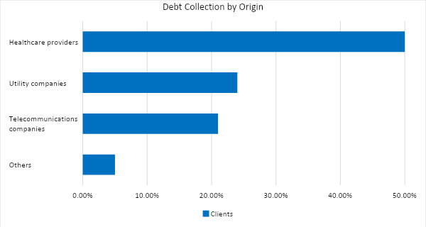

SWOT Analysis | Strengths | Weaknesses | Opportunities | Threats
Parker and Stanley Debt Collection Agency | The employees are well-trained and have a vast experience and knowledge in the job | Limited flexibility in pricing | Can establish relationships with different companies | Changing government regulations
Debt.ly | Collection costs are lower than its competitors | The employees are not well-trained in handling clients | Use of technology to easily trace debtors | The company has negative reviews on various social media accounts
Rocket Receivables, Inc. | The company has a high brand presence in the city | Prices are higher than its competitors | Expansion of business to other states | Increased number of competitors

Marketing Strategy

[Parker and Stanley Debt Collection Agency] plans to provide training and seminars to its employees and use skip tracing tools in order to increase its debt collection percentage, which will then attract more clients.

The company also plans to establish its own website to effectively increase its online presence.

The company has kicked-off various activities to move the marketing strategy forward. Here are some of the updates:

Marketing Strategy | Activities | Timeline | Success Criteria
Employee training and seminar | The administrative manager has set the schedule for the meeting with the trainer. | February 10, 2019 | The training and seminar will be conducted on [March 1, 2019].
Use of skip tracing tools | The partners have purchased Accurint. | February 15, 2019 | Increase the total debt collection percentage to [90]% by the end of [2019].
Website development | The partners have contacted several IT companies on their respective rates for the development and maintenance of the website. | February 28, 2019 | The website will be fully operational by the end of the 2nd quarter of [2019].

Organizational Structure

Operations Manager
Administrative Manager
Customer Service Representative
Field Collectors
Accounting
Sales and Marketing

OPERATIONAL PLAN

Location and Facilities

[Parker and Stanley Debt Collection Agency] is located in a commercial space building at [3419 John Calvin Drive, Chicago, Illinois].

Tools and Equipment Checklist

Software | Quantity
Quickbooks | 1
Accurint | 1
Hardware | Quantity
Personal Computer | 5

IT Infrastructure

The following table reflects [Parker and Stanley Debt Collection Agency’S] IT infrastructure.

Infrastructure | Existing (Y/N) | Description
Social Media | N | The company has no social media accounts.
Website | N | The company has not yet established its website.

FINANCIAL PLAN

Assumptions

The underlying assumptions used in the financial plan are the following:

- The revenue of Parker and Stanley Debt Collection Agency for the first year is $[600K].
- The revenue will increase by [10]% for the year [2020] and [15]% for the year [2021]

The financial forecast is based mainly on the current trends in the debt collection industry.

Monthly Expense

The chart shows the projected monthly expenses for [2019].

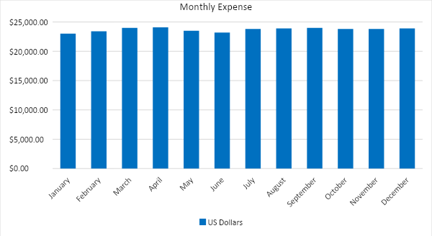

Monthly Revenue

The chart depicts the projected monthly revenues for [2019].

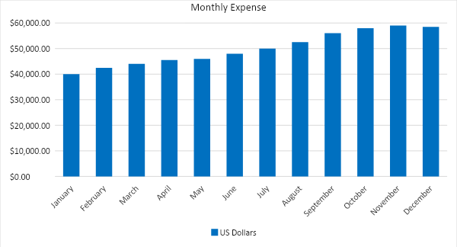

Business Financing

The funding for the business mainly comes from the investment of the partners worth $[175,000]. The major expenses will go to the working capital, rent, supplies, and payroll.

Statements

Profit and Loss Projection
 | FY 2019 | FY 2020 | FY 2021
Sales | $600,000.00 | $660,000.00 | $759,000.00
Direct Cost of Sale | $20,000.00 | $30,000.00 | $40,000.00
Other Cost of Sale | $5,000.00 | $10,000.00 | $15,000.00
Total Cost of Goods Sold or COGS (Sales - Direct Cost of Sale - Other Cost of Sale) | $25,000.00 | $40,000.00 | $55,000.00
Gross Profit (Sales-Total Cost of Goods Sold) | $575,000.00 | $620,000.00 | $704,000.00
Gross Margin % (Gross Profit/Sales) | 95.83% | 93.94% | 92.75%
Operating Expenses
Rent | $12,000.00 | $12,000.00 | $12,000.00
Insurance | $2,400.00 | $2,400.00 | $2,400.00
Utilities | $10,000.00 | $10,000.00 | $10,000.00
Salary (Including Tax) | $250,000.00 | $300,000.00 | $375,000.00
Maintenance & Supplies | $10,000.00 | $15,000.00 | $17,500.00
Total Operating Expenses | $284,400.00 | $339,400.00 | $416,900.00
EBITDA (Total Cost of Sale-Total Operating Expenses) | $290,600.00 | $280,600.00 | $287,100.00
Depreciation | $4,000.00 | $4,000.00 | $4,000.00
Interest Expense | $10,000.00 | $15,000.00 | $20,000.00
Taxes Paid | $29,060.00 | $28,060.00 | $28,710.00
Net Profit (Gross Profit - Operating Expenses - Taxes - Interest) | $251,540.00 | $237,540.00 | $238,390.00

Balance Sheet Projection
 | FY 2019 | FY 2020 | FY 2021
Cash | $543,600.00 | $581,600.00 | $626,100.00
Accounts Receivable | $50,000.00 | $80,000.00 | $100,000.00
Inventory | $1,000.00 | $2,000.00 | $3,000.00
Other Current Assets | $3,000.00 | $5,000.00 | $8,000.00
Total Current Assets | $597,600.00 | $668,600.00 | $737,100.00
Long-Term Assets | $30,000.00 | $45,000.00 | $60,000.00
Accumulated Depreciation | $5,000.00 | $10,000.00 | $15,000.00
Total Long-Term Assets (Long-Term Assets-Accumulated Depreciation) | $25,000.00 | $35,000.00 | $45,000.00
Total Assets (Total Current Assets + Total Long-Term Assets) | $622,600.00 | $703,600.00 | $782,100.00
Accounts Payable | $80,000.00 | $125,000.00 | $128,000.00
Notes Payable | $20,000.00 | $9,000.00 | $9,850.00
Other | $3,600.00 | $7,000.00 | $7,000.00
Total Liabilities | $103,600.00 | $141,000.00 | $144,850.00
Paid-in Capital | $69,000.00 | $67,600.00 | $68,000.00
Retained Earnings | $450,000.00 | $495,000.00 | $569,250.00
Total Owner's Equity (Total Assets - Total Liabilities) | $519,000.00 | $562,600.00 | $637,250.00
Total Liabilities & Equity (Total Liabilities/Total Owner's Equity) | 19.96% | 25.06% | 22.73%

Cash Flow Projection
 | FY 2019 | FY 2020 | FY 2021
Operating Cash Beginning | $175,000.00 | $175,000.00 | $175,000.00
Sources of Cash
Receivables | $50,000.00 | $80,000.00 | $100,000.00
Sales | $600,000.00 | $660,000.00 | $759,000.00
Others | $3,000.00 | $6,000.00 | $9,000.00
Total Cash | $828,000.00 | $921,000.00 | $1,043,000.00
Expenditures
Rent | $12,000.00 | $12,000.00 | $12,000.00
Insurance | $2,400.00 | $2,400.00 | $2,400.00
Utilities | $10,000.00 | $10,000.00 | $10,000.00
Salary (Including Tax) | $250,000.00 | $300,000.00 | $375,000.00
Maintenance & Supplies | $10,000.00 | $15,000.00 | $17,500.00
Total Expenditures | $284,400.00 | $339,400.00 | $416,900.00
Net Income/Loss (Total Cash - Total Expenditures) | $543,600.00 | $581,600.00 | $626,100.00

