Corporate Balance Sheet

Corporate Company
856 Kent St., Columbus, GA 31904
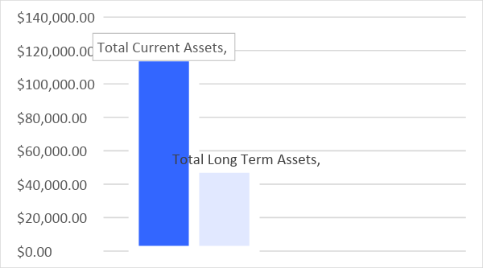
 |  | Total Assets
 |  | $166,383.00
ASSETS
Current Assets |  | Amount
Cash and Cash Equivalents |  | $32,387.00
Marketable Securities |  | $74,526.00
Accounts Receivable |  | $6,999.00
Inventories |  | $500.00
Income Tax
Tax Return |  | $500.00
Deferred Tax |  | $1,000.00
Prepared Accounts |  | $600.00
Total Current Assets |  | $116,512.00
Long Term Assets |  | Amount
Investments |  | $39,229.00
Property, Plant and Equipment |  | $8,992.00
Other |  | $1,650.00
Total Long Term Assets |  | $49,871.00
Total Assets |  | $166,383.00
 | 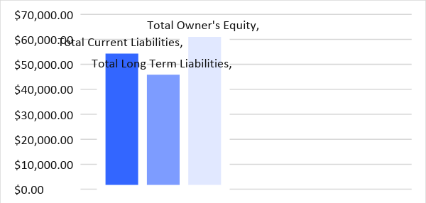
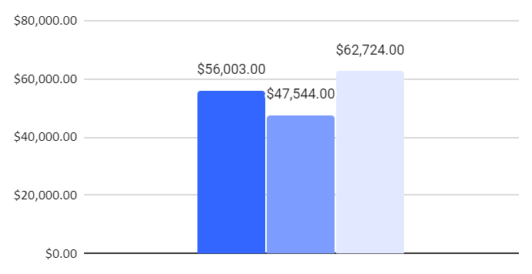
 |  | Total Liabilities and Equity
 |  | $166,271.00
LIABILITIES
Current Liabilities |  | Amount
Accounts Payable |  | $38,682.00
Unearned Income |  | $3,768.00
Accrued Compensation |  | $1,000.00
Accrued Expenses |  | $4,233.00
Deferred Income Tax |  | $2,720.00
Current Portion of Long Term Debt |  | $5,600.00
Others
Total Current Liabilities |  | $56,003.00
Long Term Liabilities |  | Amount
Notes Payable |  | $39,000.00
Capital Lease Obligations |  | $956.00
Deferred Long Term Liabilities |  | $9,500.00
Others
Total Long Term Liabilities |  | $47,544.00
Owner's Equity(Net Worth) |  | Amount
Preferred Stock |  | $15,000.00
Common Stock |  | $45,724.00
Retained Earnings |  | $0.00
Treasury Stock
Additional Paid-In Stock |  | $2,000.00
Other
Total Owner's Equity |  | $62,724.00
Total Liability and Equity |  | $166,271.00
