CATERING MARKETING PLAN

[Kitchen Share]
[2019 – 2020]

MP

Index

Executive Summary | [PAGE NUMBER]
Company Overview | [PAGE NUMBER]
Products and Services | [PAGE NUMBER]
Marketing Analysis | [PAGE NUMBER]
Strategy and Implementation | [PAGE NUMBER]
Management and Personnel | [PAGE NUMBER]
Financial Plan | [PAGE NUMBER]

EXECUTIVE SUMMARY

[Kitchen Share] is a catering company which offers food services and a wide variety of menu in the state of [Nevada].

The company will leverage videos and upload them on various social media platforms. The videos will include cooking tutorials and information on dietary requirements.

[Kitchen Share] will hire chefs, servers, and tech-savvy food enthusiasts. The last group will be responsible for online customer engagements. By participating in the two marketing strategies, the company expects to raise its revenue by [15]%.

COMPANY OVERVIEW

Mission Statement

[Kitchen Share] looks forward to serving clients the food products and services they need as part of their successful gatherings or events.

Philosophy

[Kitchen Share] values the delivery of its food products and services to the clients’ events in a creative, professional, and sanitary manner.

Vision

[Kitchen Share] will be among the top trusted businesses in the industry and will continue to provide excellent products and services to its clients.

Outlook: By adopting new marketing trends in the industry, Kitchen Share projects stable finances.

Type of Industry: Hospitality

Business Structure: Sole Proprietorship

Ownership: Sole Proprietorship, [Hilda F. Myers]

Start-Up Summary

The start-up cost is [20,000] USD to be provided by the owner and to be utilized for the rental, company insurance, equipment, and salaries.

Start-Up Funding
Start-Up Expenses | $10,000
Start-Up Assets | $10,000
Total Funding Required | $20,000
Assets
Non-Cash Assets from Start-Up | $5,000
Cash Requirements from Start-up | $3,000
Additional Cash Raised | $1,000
Cash Balance on Starting Date | $1,000
Total Assets | $10,000
Capital
Planned Investment
Owner | $20,000
Other | $0
Additional Investment Requirement | $0
Total Planned Investment | $20,000
Loss at Start-Up (Start-Up Expenses) | -$10,000
Total Capital | $10,000
Total Capital and Liabilities | $10,000
Start-Up
Requirements
Start-Up Expenses
Rent - 5 Months | $5,000
Advertising | $1,000
Legal Fees | $1,000
Staff Training | $2,000
Insurance | $1,000
Other | $0
Total Start-Up Expenses | $10,000
Start-Up Assets
Cash Required | $5,000
Start-Up Inventory | $3,000
Other Current Assets | $1,000
Long-Term Assets | $1,000
Total Assets | $10,000
Total Requirements (Total Start-Up Expenses + Total Assets) | $20,000

PRODUCTS AND SERVICES

Product/Service Description

[Kitchen Share] offers food services to clients who organize events or gatherings.

Value Proposition

Apart from the usual catering services, [Kitchen Share] also offers free cooking video tutorials.

Pricing Strategy

[Kitchen Share] uses price bundling as the pricing strategy. It best suits catering services which revolve in combined food products and services.

MARKETING ANALYSIS

One of the common trends in the catering industry is the use of digital platforms such as social media. Nowadays, businesses use bloggers, online influencers, or just mere food enthusiasts for their social sharing activities

Market Segmentation

[Kitchen Share] will be focusing its marketing strategies on corporate events and putting personal events like weddings, birthdays, and family events as the secondary target market.

The table below shows the distribution of catering services per target market.

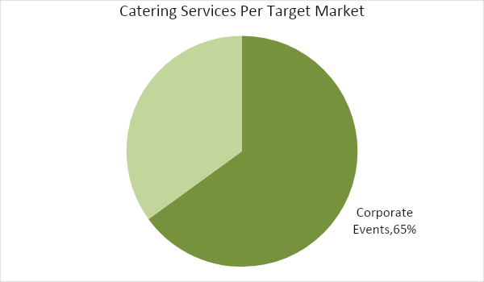

Target Market Segmentation Strategy

Corporate Events

- Kitchen Share will hire a website and social media developer.
- This target market will be the top priority in terms of scheduling and resources.

Personal Events

- Kitchen Share will offer the same products and services offered for corporate events.

STRATEGY AND IMPLEMENTATION

Target Market Strategy

[Kitchen Share] looks to raise its profit by [15]% within its first year of operation. The goal will be achieved through social media marketing.

Competitive Edge

[Kitchen Share] competitive edge is on its digital marketing.

SWOT Analysis | Strengths | Weaknesses | Opportunities | Threats
[Kitchen Share] | - Unique special service feature  - Offers local dishes in the menu | - Still new in the business | - Social media trends  - People’s specifications on their food intake | - Established catering companies
[Cocina Calzada Catering Services] | - Established business  - Many skilled workers | - Limited food  - choices | - Similar businesses emerging in the state | - Caterers offering a variety of food products
[Gracelle’s Catering Services] | - Offers a variety of menu  - No problem with food transportation | - Expensive | - Increased demand for catering services across the country | - Caterers with cheaper prices

Sales Strategy and Forecast

With the effective advertising of its services, [Kitchen Share] aims to reach the following monthly profit:

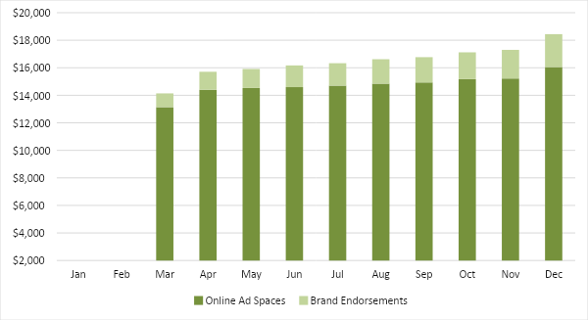

Through digital marketing, the table below illustrates the expected percentage growth of the company’s catering services.

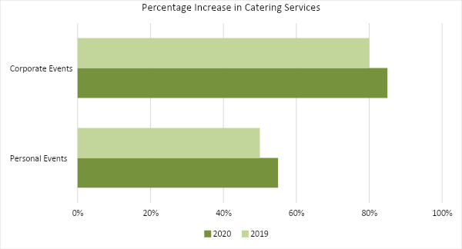

Marketing Strategy

[Kitchen Share] will be developing a website and opening social media accounts intended for the advertising of its services. The company will also use analog platforms: brochures, newspapers, television, radio, and billboards. Coordination between chefs and social media specialists will ensure good quality tutorial videos.

To properly assess what the customers need from the catering services, the marketing department will be given the task to perform a market analysis. Promotions of the products and services will be decided on the first month.

The team has started the activities for some of the marketing strategies.

Milestones

Marketing Strategy | Activities | Timeline | Success Criteria
Website and social media development | Web developer and social media specialists create a website and social media accounts | February 25, 2019 | Social media accounts have been created, while the web developer has started working on the website.
Cooking video tutorials | Set a meeting between social media specialists and chefs | February 27, 2019 | The storyboards have been created and approved for the first video shoot.
Marketing surveys | Formulate the questionnaires | March 6, 2019 | Questionnaires finalized last March 8, 2019

MANAGEMENT AND PERSONNEL

The chief executive officer will be responsible for the major decision-making in the company.

The marketing director’s duty is mainly on the advertising of the company’s products and services. He or she will also be responsible for the operations.

Below is the organizational structure of the company:

CEO
Marketing
Director
Digital Media
Team Leaders
Researchers
Press Relations
Sales
Web Developer
Social Media
Specialists
Staff (cooks and servers)

FINANCIAL PLAN

The financial plan includes the assumptions for the break-even analysis, profit and loss, balance sheet, and cash flow.
Break-Even Analysis

Fixed Costs | Average Price | Variable Costs |  | Contribution Margin | Break-Even Units
$6,000.00 | $50.00 | $25.00 |  | $25.00 | 240
Fixed Costs | Amount |  |  | Variable Costs | Per Unit Amount
Rent | 5,000 |  |  | Advertising | 10
Insurance | 1,000 |  |  | Legal Fees | 10
 |  |  |  | Staff Training | 5
Total | 6,000 |  |  | Total | 25
Fixed Costs |  |  |  |  | Variable Costs
Business Lease - Rent |  |  |  |  | $5,000
Insurance |  |  |  |  | $1,000
Total Fixed Costs |  |  |  |  | $6,000
Total Units Sold in 1 Month |  |  |  |  | 10,000
Variable Costs (Unit Sold/Cost per Unit) |  |  | Average Price |  | Variable Costs
Advertising |  |  | $1,000 |  | $10.00
Legal Fees |  |  | $1,000 |  | $10.00
Staff Training |  |  | $2,000 |  | $5.00
Total Variable Cost (Per Unit) |  |  |  |  | $25.00
Break-Even |  |  |  |  | Variable Costs
Selling Price Per Unit |  |  |  |  | $50.00
Break-Even Point Per Unit [Fixed Costs/(Sales Price Per Unit - Variable Cost Per Unit)] |  |  |  |  | 6,000
 |  |  |  |  | 25.00
Break-Even Point in Units |  |  |  |  | 240
Contribution Margin (Selling Price - Total Variable Cost) |  |  |  |  | $25.00

Profit and Loss Projection
 | FY2019 | FY2020 | FY2021
Sales | $23,000.00 | $26,000.00 | $29,000.00
Direct Cost of Sale | $10,000.00 | $15,000.00 | $20,000.00
Other Cost of Sale | $10,000.00 | $11,000.00 | $12,000.00
Total Cost of Goods Sold or COGS (Sales - Direct Cost of Sale - Other Cost of Sale) | $3,000.00 | $0.00 | -$3,000.00
Gross Profit (Sales-Total Cost of Goods Sold) | $20,000.00 | $26,000.00 | $32,000.00
Gross Margin % (Gross Profit/Sales) | 86.96% | 100.00% | 110.34%
Operating Expenses
Rent | $5,000.00 | $6,000.00 | $7,000.00
Insurance | $1,000.00 | $1,500.00 | $2,000.00
Utilities | $1,000.00 | $1,500.00 | $2,000.00
Salary (Including Tax) | $2,000.00 | $2,500.00 | $3,000.00
Maintenance & Supplies | $1,000.00 | $1,000.00 | $1,000.00
Total Operating Expenses | $10,000.00 | $12,500.00 | $15,000.00
EBITDA (Total Cost of Sale-Total Operating Expenses) | -$7,000.00 | -$12,500.00 | -$18,000.00
Depreciation | $1,000.00 | $1,500.00 | $2,000.00
Interest Expense | $0.00 | $0.00 | $0.00
Taxes Paid | $1,000.00 | $1,500.00 | $2,000.00
Net Profit (Gross Profit - Operating Expenses - Taxes - Interest) | $9,000.00 | $12,000.00 | $15,000.00

Balance Sheet Projection
 | FY2019 | FY2020 | FY2021
Cash | $10,000.00 | $15,000.00 | $20,000.00
Accounts Receivable | $5,000.00 | $7,500.00 | $10,000.00
Inventory | $3,000.00 | $4,000.00 | $6,000.00
Other Current Assets | $2,000.00 | $3,500.00 | $4,000.00
Total Current Assets | $20,000.00 | $30,000.00 | $40,000.00
Long-Term Assets | $4,000.00 | $6,000.00 | $8,000.00
Accumulated Depreciation | $1,500.00 | $2,000.00 | $2,500.00
Total Long-Term Assets (Long-Term Assets-Accumulated Depreciation) | $2,500.00 | $4,000.00 | $5,500.00
Total Assets (Total Current Assets + Total Long-Term Assets) | $22,500.00 | $34,000.00 | $45,500.00
Accounts Payable | $5,000.00 | $7,500.00 | $10,000.00
Notes Payable | $2,500.00 | $5,000.00 | $7,500.00
Other | $1,250.00 | $2,500.00 | $3,750.00
Total Liabilities | $8,750.00 | $15,000.00 | $21,250.00
Paid-in Capital | $5,000.00 | $6,000.00 | $7,000.00
Retained Earnings | $20,000.00 | $40,000.00 | $60,000.00
Total Owner's Equity (Total Assets - Total Liabilities) | $13,750.00 | $19,000.00 | $24,250.00
Total Liabilities & Equity (Total Liabilities/Total Owner's Equity) | 63.64% | 78.95% | 87.63%

Cash Flow Projection
 | FY2019 | FY2020 | FY2021
Operating Cash Beginning | $10,000.00 | $15,000.00 | $20,000.00
Sources of Cash | $5,000.00 | $7,500.00 | $10,000.00
Receivables | $1,500.00 | $2,000.00 | $3,000.00
Sales | $2,500.00 | $3,500.00 | $4,000.00
Others | $1,000.00 | $2,000.00 | $3,000.00
Total Cash | $20,000.00 | $30,000.00 | $40,000.00
Expenditures
Rent | $5,000.00 | $5,500.00 | $6,000.00
Insurance | $1,000.00 | $1,500.00 | $2,000.00
Utilities | $1,000.00 | $1,500.00 | $2,000.00
Salary (Including Tax) | $2,000.00 | $2,500.00 | $3,000.00
Maintenance & Supplies | $1,000.00 | $1,500.00 | $2,000.00
Total Expenditures | $10,000.00 | $12,500.00 | $15,000.00
Net Income/Loss (Total Cash - Total Expenditures) | $10,000.00 | $17,500.00 | $25,000.00

