ART
GALLERY BUSINESS PLAN

Business Plan For Fiscal Year 2019

[January 20, 2019]

[Helen Kershner]
[helenkershner@gmail.com]
[972-656-8319]
[youngarts.com]
[4828 Harley Vincent Drive]
[North Bloomfield, 4450 Ohio]

Index

Executive Summary

Company Overview
Products and Services

Execution
Operational Plan

Financial Plan

EXECUTIVE SUMMARY

[Young Arts Gallery] is a registered art gallery located in [North Bloomfield], [Ohio] that promotes local artists. The gallery has leased a facility that is big enough for the different kinds of art that it wants to curate and display.

[Young Arts Gallery] also auctions and retails artwork through private functions and gallery exhibitions. Other merchandise by featured artists is sold in the gallery or online. The gallery customers and patrons are given first-class treatment and privacy and are offered free deliveries for larger pieces of art.

COMPANY OVERVIEW

Mission Statement

[Young Arts Gallery] wants to make available a wide range of artwork from local artists, including paintings, drawings, prints, sculptures, and other creative merchandise.

Philosophy

[Young Arts Gallery] wants to promote and to market local talents and show the importance of art and creativity on a larger scale.

Vision

Through its promotion of local art, [Young Arts Gallery] wants to show the community the importance of art and creativity as a form of self-expression.

Outlook

Despite economic uncertainty, the art market is seeing a stable year. Studies have shown a positive outlook across regional markets due mostly to the “wealth effect” that has bolstered art buying in the United States. Popular fine art and antique seller [Christie’s] reported an increase in new buyers in [2015] and suggested that it is finding success due to new collectors from other markets, which [Young Arts Gallery] can take advantage of in the years to come.

Type of Industry: Art Industry

Business Structure: Sole Proprietorship

Ownership: Sole Proprietorship, [Elizabeth Young]
Start-Up Summary

Young Arts Gallery will need an estimated $[300,000] to successfully open its art gallery in [North Bloomfield, Ohio].

Start-Up Funding
Start-Up Expenses | $100,000
Start-Up Assets | $200,000
Total Funding Required | $300,000
Assets
Non-Cash Assets from Start-Up | $150,000
Cash Requirements from Start-up | $10,000
Additional Cash Raised | $30,000
Cash Balance on Starting Date | $10,000
Total Assets | $200,000
Capital
Planned Investment
Owner | $300,000
Other | $0
Additional Investment Requirement | $0
Total Planned Investment | $300,000
Loss at Start-Up (Start-Up Expenses) | -$100,000
Total Capital | $200,000
Liabilities | $0
Total Capital and Liabilities | $200,000
Start-Up
Requirements
Start-Up Expenses
Rent - 5 Months | $10,000
Advertising | $10,000
Legal Fees and Insurance | $20,000
Staff Training | $20,000
Inventory Expenses | $40,000
Other | $0
Total Start-Up Expenses | $100,000
Start-Up Assets
Cash Required | $50,000
Start-Up Inventory | $20,000
Other Current Assets | $120,000
Long-Term Assets | $10,000
Total Assets | $200,000
Total Requirements (Total Start-Up Expenses + Total Assets) | $300,000

Management Team:

Management Team | Role/Function | Skills
[Annie Burton] | Gallery Manager | Communication, People Management
[Lian Chung] | HR Manager | Communication, Onboarding, People Skills, and Performance Management
[Kristin Ritter] | Acquisitions Manager | Creativity, Negotiation Skills, People Skills, Eye for Detail
[Zhu Shen] | Marketing Manager | Creativity, People Skills, Resilience, Communication

Short- and Long-Term Goals and Milestones:

Short-Term Goals | Milestones
Hire Gallery and Acquisitions Managers | Acquisitions Manager hired in [October 2018]  Gallery Manager for a final interview
Close deals with local artists | Acquisitions manager finalizing contracts with [5] artists.
Long-Term Goals | Milestones
Create an artist’s network to provide regular exhibitions at the gallery | The official gallery opening on [March 15, 2019] will serve as a networking mixer for artists.
Create a social media presence to reach out to a wider audience | Outsource a front-end developer for the gallery’s official website Hire a marketing manager to help update the website and social media pages and create events for the gallery.

PRODUCTS AND SERVICES

Product/Service Description

The gallery shall make profits by making available a wide range of artworks from different artists. Not only shall it sell paintings, prints, and sculptures, it will also offer related merchandise as desired by the artists.

Value Proposition

[Young Arts Gallery] is in the business of creating, accumulating, and selling art creations. The artworks are delivered through the gallery’s functional areas under the curatorial (acquisitions) and operation departments.

Pricing Strategy

[Young Arts Gallery] believes in ensuring that its artists are paid well, which is why it offers a mix of mass media artwork and high-priced pieces.

EXECUTION

Marketing Plan

[Young Arts Gallery] will plan special exhibitions as well as interactive and educational displays to attract visitors and patrons.

Market Research

With the growth of the online community, creating an online presence for the gallery is necessary. The gallery will also be leveraging on social media platforms to reach out to a wider audience. Below is a chart depicting the gallery’s collectors and patrons.

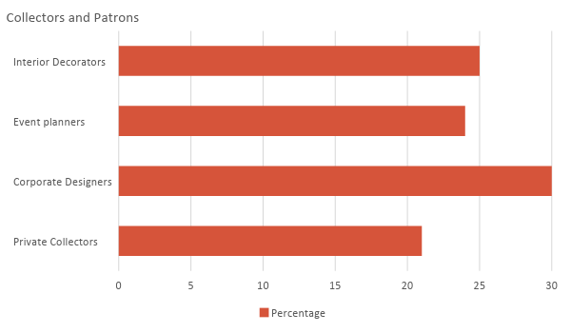

SWOT Analysis | Strengths | Weaknesses | Opportunities | Threats
[Young Arts Gallery] | - Good Location  - An online and Offline business model | - Lack of financial capacity compared to competitors | - Increased demand for art from wealthy consumers | - Economic downturn affecting purchasing power
[Culture Fix Art Gallery] | - A wide range of artworks | - Numerous complaints on delivery as per website reviews | - Improved operations and delivery can increase buying potential | - A rise in the number of smaller art galleries offering affordable art
[La Maison D’Art] | - Is an established name in the industry  - High-profile patrons | - Not in touch with current market trends | - Learning market trends can expand customer reach | - The opening of new art galleries catering to the same target market

Marketing Strategy

The gallery has a wide range of artworks from different artists at all times. To maximize its marketing potential, the company will improve its online and social media presence.

Marketing Strategy | Activities | Timeline | Success Criteria
Website upgrade | Hire a front-end developer to create and launch the official gallery website | January 10, 2019 | The front-end developer has been hired and the new website should be launched on the set date.
Social Media Management | The marketing manager and officers shall update the gallery’s social media pages. | ASAP | The marketing manager has been hired.  Interviews for marketing officers are ongoing.

Organizational Structure:

CEO
Gallery Manager
HR Manager
Acquisitions Manager
Marketing Manager
In-House Staff
Delivery Staff
Administrative Staff
Maintenance Staff
Development Staff
Purchasing Staff
Merchandise and Inventory
Sales Staff
Creative Staff
Media Marketing Staff

OPERATIONAL PLAN

Location and Facilities
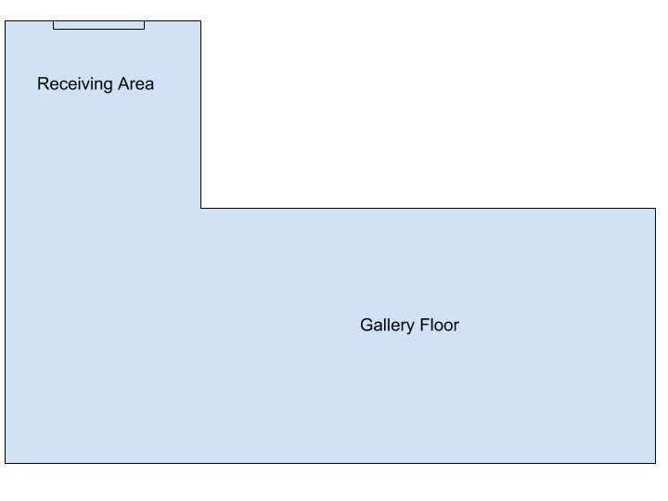

FINANCIAL PLAN

Assumptions

The financial forecast is made by considering the current trends in the art and creative industries. The gallery shall put more effort into improving its online presence while continuing to hold marketing events to reach out to high-income patrons and other customers.

Monthly Expense

The company’s expenses will cover payroll, maintenance, acquisitions, supplies, insurance, rent, and utilities. The following chart shows the projected monthly expense for [2019]. [January] will cost the most as the gallery finalizes its acquisitions and initial operational expenses.

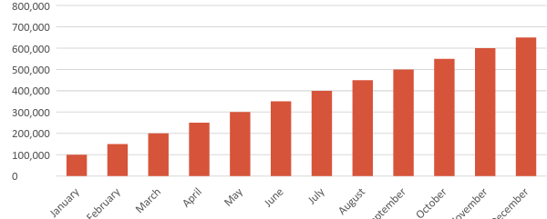

Monthly Revenue

The gallery will officially open in [March 2019] with a high projected revenue due to opening sales. The next high sales are predicted to be in June for a mid-year event. Numerous charity events and parties at the end of the year are projected to generate a steady increase in revenue. The following chart depicts the projected monthly revenue for [2019].
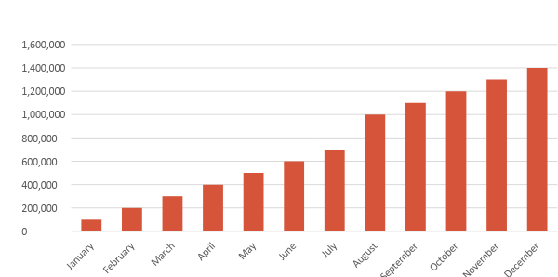

Business Financing

The funding for the business comes from the gallery’s owner and proprietor. Majority of the expenses will go to the business’ insurance, rent, salaries, supplies, and maintenance.

Statements

Profit and Loss Projection
 | FY2019 | FY2020 | FY2021
Sales | $450,000.00 | $500,000.00 | $550,000.00
Direct Cost of Sale | $190,500.00 | $200,000.00 | $220,000.00
Other Cost of Sale | $9,000.00 | $10,000.00 | $10,000.00
Total Cost of Goods Sold or COGS (Sales - Direct Cost of Sale - Other Cost of Sale) | $250,500.00 | $290,000.00 | $320,000.00
Gross Profit (Sales-Total Cost of Goods Sold) | $199,500.00 | $210,000.00 | $230,000.00
Gross Margin % (Gross Profit/Sales) | 44.33% | 42.00% | 41.82%
Operating Expenses
Rent | $24,000.00 | $24,000.00 | $24,000.00
Insurance | $12,000.00 | $12,000.00 | $12,000.00
Utilities | $15,000.00 | $15,000.00 | $17,000.00
Salary (Including Tax) | $75,000.00 | $80,000.00 | $87,000.00
Maintenance & Supplies | $4,500.00 | $5,000.00 | $6,000.00
Total Operating Expenses | $130,500.00 | $136,000.00 | $146,000.00
EBITDA (Total Cost of Sale-Total Operating Expenses) | $120,000.00 | $154,000.00 | $174,000.00
Depreciation | $4,000.00 | $4,000.00 | $4,000.00
Interest Expense | $0.00 | $0.00 | $0.00
Taxes Paid | $5,000.00 | $5,000.00 | $5,000.00
Net Profit (Gross Profit - Operating Expenses - Taxes - Interest) | $64,000.00 | $69,000.00 | $79,000.00

Balance Sheet Projection
 | FY2019 | FY2020 | FY2021
Cash | $100,000.00 | $125,000.00 | $145,000.00
Accounts Receivable | $10,000.00 | $15,000.00 | $11,000.00
Inventory | $7,000.00 | $8,000.00 | $10,000.00
Other Current Assets | $20,000.00 | $25,000.00 | $35,000.00
Total Current Assets | $137,000.00 | $173,000.00 | $201,000.00
Long-Term Assets | $45,000.00 | $43,000.00 | $47,000.00
Accumulated Depreciation | $3,000.00 | $2,500.00 | $2,000.00
Total Long-Term Assets (Long-Term Assets-Accumulated Depreciation) | $42,000.00 | $40,500.00 | $45,000.00
Total Assets (Total Current Assets + Total Long-Term Assets) | $179,000.00 | $213,500.00 | $246,000.00
Accounts Payable | $15,000.00 | $17,000.00 | $15,500.00
Notes Payable | $7,000.00 | $7,500.00 | $5,000.00
Other | $3,500.00 | $7,000.00 | $5,000.00
Total Liabilities | $25,500.00 | $31,500.00 | $25,500.00
Paid-in Capital | $10,000.00 | $5,000.00 | $5,000.00
Retained Earnings | $90,000.00 | $120,000.00 | $130,000.00
Total Owner's Equity (Total Assets - Total Liabilities) | $153,500.00 | $182,000.00 | $220,500.00
Total Liabilities & Equity (Total Liabilities/Total Owner's Equity) | 16.61% | 17.31% | 11.56%

Cash Flow Projection
 | FY2019 | FY2020 | FY2021
Operating Cash Beginning | $100,000.00 | $150,000.00 | $160,000.00
Sources of Cash | $15,000.00 | $18,000.00 | $15,000.00
Receivables | $10,000.00 | $12,000.00 | $30,000.00
Sales | $32,000.00 | $25,000.00 | $35,000.00
Others | $5,000.00 | $7,000.00 | $8,000.00
Total Cash | $162,000.00 | $212,000.00 | $248,000.00
Expenditures
Rent | $24,000.00 | $24,000.00 | $24,000.00
Insurance | $12,000.00 | $12,000.00 | $12,000.00
Utilities | $15,000.00 | $15,000.00 | $17,000.00
Salary (Including Tax) | $75,000.00 | $80,000.00 | $87,000.00
Maintenance & Supplies | $4,500.00 | $5,000.00 | $6,000.00
Total Expenditures | $130,500.00 | $136,000.00 | $146,000.00
Net Income/Loss (Total Cash - Total Expenditures) | $31,500.00 | $76,000.00 | $102,000.00

