ARCHITECT BUSINESS PLAN

[INSERT NAME OF THE BUSINESS/COMPANY]
[INSERT THE COMPLETE BUSINESS/COMPANY ADDRESS]
[INSERT THE BUSINESS/COMPANY CONTACT NUMBERS]
[INSERT THE BUSINESS/COMPANY EMAIL ADDRESS]
[INSERT THE BUSINESS/COMPANY WEBSITE ADDRESS]

PREPARED BY:

[INSERT FULL NAME/S OF THE
PEOPLE WHO PREPARED THIS PLAN]

[INSERT DATE]

Index

Executive Summary [PAGE NUMBER]

Company Overview [PAGE NUMBER]

Products and Services [PAGE NUMBER]

Execution [PAGE NUMBER]

Operational Plan [PAGE NUMBER]

Financial Plan [PAGE NUMBER]

Executive Summary

[Latonia B. Stone] is an independent architect based in [San Antonio], Texas. Her services include all basic planning, design, and consultancy services. Stone plans to position herself as a reliable architect for millennial homeowners and retail store developers. In order to attract her target markets, she will utilize social media and other forms of digital marketing to communicate directly to her customers.

Company Overview

Mission Statement: Stone is committed to providing cost-efficient design, planning, and other architectural services for private project owners in San Antonio, Texas.

Philosophy: Professionalism, creativity, and close coordination with the customer are central to [Latonia Stone's] conduct of business.

Vision: Stone aims to build good and profitable relationships with homeowners and commercial builders in San Antonio. She aspires to be one of the trusted contractors of architectural services in the city.

Outlook: Both residential and non-residential constructions are booming in [San Antonio, TX]. The value of residential construction is seen to increase as the demand for construction of single and multi-family residential units increases. Recent developments in the busier districts of the city foresee more commercial property development projects in the future. Independent architects, engineers, and other key industry personnel will be more in demand as contractors and project owners bid for reasonably priced yet quality service providers.

Type of Industry: Architecture Industry / Construction Industry

Business Structure: Sole Proprietorship

Ownership: Latonia B. Stone, Owner/Operator

Start-Up Summary: The total start-up cost is [$50,700.00], covering basic expenses such as rent, utilities, equipment and tools, and operational costs.

Start-Up Funding
Start-Up Expenses | $23,200.00
Start-Up Assets | $27,500.00
Total Funding Required | $50,700.00
Assets
Non-Cash Assets from Start-Up | $5,000.00
Cash Requirements from Start-up | $18,200.00
Additional Cash Raised | $2,300.00
Cash Balance on Starting Date | $2,000.00
Total Assets | $27,500.00
Capital
Planned Investment
Owners | $10,000.00
Additional Investment Requirement | $17,500.00
Total Planned Investment | $27,500.00
Loss at Start-Up (Start-Up Expenses) | -$23,200.00
Total Capital | $4,300.00
Total Capital and Liabilities | $4,300.00
Start-Up
Requirements
Start-Up Expenses
Rent | $6,000.00
Utilities | $4,200.00
Equipment & Tools | $5,000.00
Operations | $6,000.00
Marketing & Promotion | $2,000.00
Total Start-Up Expenses | $23,200.00
Start-Up Assets
Cash Required | $22,500.00
Other Current Assets | $2,500.00
Long-Term Assets | $2,500.00
Total Assets | $27,500.00
Total Requirements (Total Start-Up Expenses + Total Assets) | $50,700.00

Management Team:

Management Team | Role/Function | Skills
Latonia B. Stone | Overall Management | Design and planning, organization, negotiation

Short- and Long-Term Goals and Milestones:

Short-Term Goals | Milestones
Register with the Texas Board of Architectural Examiners | - Completed all pre-examination requirements on September 29, 2018  - Passed the examination on October 27, 2018
Acquire funds for start-up expenses | - Loan $5,000.00 from parents on December 1, 2018
Long-Term Goals | Milestones
Build client list | - Acquire a mailing list of potential customers in November 2018  - Send service proposal to select recipients in December 2018
Break-even on Q3 of FY 2020 | - Created sales and marketing plan on December 2, 2018  - Created budget outline for 1-year operations on December 7, 2018

Products and Services

Product/Service Description: Architect Stone offers standard architectural services such as design certification, exterior and interior design, measurement survey and drawing, and basic consultancy. She specializes in designing and planning residential and retail properties.

Value Proposition: Simplicity is key in designing exteriors and interiors that are both ergonomic and eye pleasing. Latonia Stone takes pride in her ability to combine what’s necessary and pretty in order to come up with a design that will benefit her clients in the long run.

Pricing Strategy: Pricing strategies will be project-based. Cost-plus pricing will be applied to projects that require additional materials and paraphernalia. Architect Stone will charge a fixed hourly fee for consultancy and certification services.

Execution

Marketing Plan: Architect Stone aims to secure contractual work for residential and retail properties. The strategies for reaching her target market include networking through social media and conventions related to construction and design.

Market Research: As of 2018, the construction industry in Texas has the highest growth rate at 10% in the US. In San Antonio alone, experts anticipate a 13% growth rate and 9% employment growth rate, which means that there are sufficient job opportunities in the city for large firms and independent contractors alike. Major industry drivers include non-residential design projects for mid- to large-scale firms. Small firms and individual contractors will find a considerable number of potential clients in the residential construction market.

SWOT Analysis | Strengths | Weaknesses | Opportunities | Threats
Latonia B. Stone, RA | - Strong creative agency | - No second opinion on business decisions | - New homeowners looking for contractors who can adjust their prices accordingly | - Other competing independent architects
ArchiTex Design Studio | - Sufficient working team | - Weak internal management systems | - More tech startups opening in San Antonio in need of like-minded building design consultants | - High market volatility
Build N Improve Home Renovation Services | - Large customer base | - Poor digital marketing strategies | - Positive customer referrals/recommendations | - Customers' need for online accessibility

Marketing Strategy: Architect Stone will utilize social media and other digital capacities to attract her target market of new homeowners and retail store developers.

Marketing Strategy | Activities | Timeline | Success Criteria
Online marketing | - Create Facebook, Instagram and Twitter pages  - Sign up with LinkedIn and Houzz  - Develop a blog | - 2nd to 3rd week of December 2018 | Increase of inquiries directly messaged to any of the pages/accounts
Word-of-mouth advertising | - Attend design conventions, real estate development events, and other related conferences  - Ask friends and relatives to spread the word | - October 2018 to present | Obtain contacts from other firms, developers, and other pertinent industry players

Organizational Structure: All roles and functions in the business will be the responsibility of Architect Stone.

Operational Plan

Location and Facilities: Stone will operate the business at her residential unit in Todds Lane.

Tools and Equipment Checklist:

Software | Quantity
AutoCAD LT | 1
Microsoft Office 2016 Professional | 1
Hardware | Quantity
Plotter | 1
Multi-functional printer | 1

IT Infrastructure

Infrastructure | Existing (Y/N) | Description
Data Storage | Y | - Basic storage capacities only  - To be upgraded once clients come in
Network Security | N | - To be checked by IT service provider
Social Media | Y | - LinkedIn, Facebook, Instagram, Twitter, Houzz

Financial Plan

Assumptions: The financial plan for this business is based on the following assumptions:

1. Monthly expenses after Q1 of 2019 will not exceed $2,000.00.

2. Revenue from contractual work will come in by Q2 of 2019.

Monthly Expense

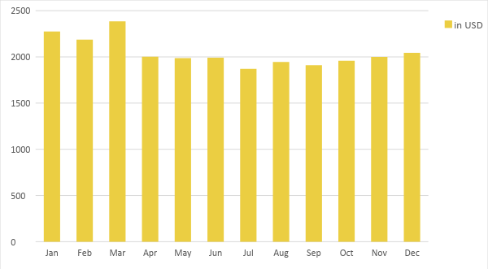

Monthly Revenue

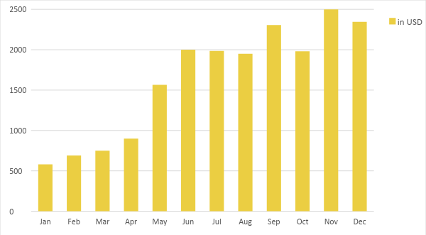

Business Financing: Architect Stone will finance the business through personal funds and a loan from her parents. Beginning in FY 2020, operational costs will be covered by business revenue.

Statements

Profit and Loss Projection
 | FY2019 | FY2020 | FY2021
Sales | $19,551.00 | $38,769.99 | $51,284.46
Direct Cost of Sale | $1,000.00 | $2,500.00 | $3,000.00
Other Cost of Sale | $0.00 | $0.00 | $0.00
Total Cost of Goods Sold or COGS (Sales - Direct Cost of Sale - Other Cost of Sale) | $1,000.00 | $2,500.00 | $3,000.00
Gross Profit (Sales-Total Cost of Goods Sold) | $18,551.00 | $36,269.99 | $48,284.46
Gross Margin % (Gross Profit/Sales) | 94.89% | 93.55% | 94.15%
Operating Expenses
Rent | $6,000.00 | $6,000.00 | $6,500.00
Utilities | $4,200.00 | $4,800.00 | $5,200.00
Equipment & Tools | $5,000.00 | $3,000.00 | $1,500.00
Operations | $6,000.00 | $6,000.00 | $6,000.00
Marketing & Promotion | $2,000.00 | $2,300.00 | $3,500.00
Total Operating Expenses | $23,200.00 | $22,100.00 | $22,700.00
EBITDA (Total Cost of Sale-Total Operating Expenses) | -$22,200.00 | -$19,600.00 | -$19,700.00
Depreciation | $0.00 | $500.00 | $500.00
Interest Expense | $0.00 | $0.00 | $0.00
Taxes Paid | $0.00 | $100.00 | $100.00
Net Profit (Gross Profit - Operating Expenses - Taxes - Interest) | -$4,649.00 | $14,069.99 | $25,484.46

Balance Sheet Projection
 | FY2019 | FY2020 | FY2021
Cash | $22,500.00 | $25,000.00 | $27,500.00
Accounts Receivable | $0.00 | $0.00 | $500.00
Inventory | $0.00 | $500.00 | $1,500.00
Other Current Assets | $2,500.00 | $3,500.00 | $4,000.00
Total Current Assets | $25,000.00 | $29,000.00 | $33,500.00
Long-Term Assets | $2,500.00 | $3,000.00 | $4,000.00
Accumulated Depreciation | $0.00 | $500.00 | $500.00
Total Long-Term Assets (Long-Term Assets-Accumulated Depreciation) | $2,500.00 | $2,500.00 | $3,500.00
Total Assets (Total Current Assets + Total Long-Term Assets) | $27,500.00 | $31,500.00 | $37,000.00
Accounts Payable | $3,000.00 | $3,500.00 | $3,500.00
Notes Payable | $1,000.00 | $1,540.00 | $2,000.00
Other | $1,500.00 | $2,000.00 | $1,750.00
Total Liabilities | $5,500.00 | $7,040.00 | $7,250.00
Paid-in Capital | $10,000.00 | $15,000.00 | $20,000.00
Retained Earnings | $3,745.00 | $7,438.00 | $11,454.00
Total Owner's Equity (Total Assets - Total Liabilities) | $22,000.00 | $24,460.00 | $29,750.00
Total Liabilities & Equity (Total Liabilities/Total Owner's Equity) | 25.00% | 28.78% | 24.37%

Cash Flow Projection
 | FY2019 | FY2020 | FY2022
Operating Cash Beginning | $22,500.00 | $25,000.00 | $27,500.00
Sources of Cash
Receivables | $0.00 | $0.00 | $500.00
Sales | $19,551.00 | $38,769.99 | $51,284.46
Others | $2,500.00 | $3,500.00 | $4,000.00
Total Cash | $44,551.00 | $67,269.99 | $83,284.46
Expenditures
Rent | $6,000.00 | $6,000.00 | $6,500.00
Utilities | $4,200.00 | $4,800.00 | $5,200.00
Equipment & Tools | $5,000.00 | $3,000.00 | $1,500.00
Operations | $6,000.00 | $6,000.00 | $6,000.00
Marketing & Promotion | $2,000.00 | $2,300.00 | $3,500.00
Total Expenditures | $23,200.00 | $22,100.00 | $22,700.00
Net Income/Loss (Total Cash - Total Expenditures) | $21,351.00 | $45,169.99 | $60,584.46

