Business Plan For Fiscal Year 2019
[December 1, 2019]

Animal
Daycare Business Plan

[Anita Davis]
[adavis@ppcare.com]
[503-773-3830]
[www.ppcare.com]
[4292 Heron Way]
[Portland, OR, 97204 USA]

Index

Executive Summary
Company Overview
Products and Services
Execution
Operational Plan
Financial Plan

EXECUTIVE SUMMARY

[Pongo & Perdita Care Center] is an animal daycare facility that caters to professionals with disposable income who feel the desire to provide quality care for their pets while they are at work or on a holiday. This business is a response to the increasing need of individuals and families in high-end, high-income markets.

Located in the heart of Portland, [Oregon], [Pongo & Perdita Care Center] will provide all-around pet care services for dogs, cats, and other household pets. These services include obedience training, guard dog training, animal boarding, and standard daycare. [Pongo & Perdita Care Center] ensures that all pets under its custody are well taken care of, taking into account the best interests of its clients.

COMPANY OVERVIEW

Mission Statement

It is our mission to position [Pongo & Perdita Care Center] to become the leading animal daycare center and top pet services brand in Portland.

Philosophy

[Pongo & Perdita Care Center] shall operate in accordance with its three core values:

- Competence: We strive to provide the highest quality animal daycare services available with a competent and compassionate staff that puts the needs of the clients first.
- Character: We shall treat people and animals the respect they deserve, focusing on honest and straightforward recommendations for our clients.
- Community: We believe that a successful animal daycare clinic is defined by its positive impact on the community. Thus, we aim to serve the local community and keep it as an essential component of our operations.

Vision

[Pongo & Perdita Care Center] shall build a highly competitive and effective animal daycare business that will make it the number one choice for families in Portland.

Outlook

The animal care and management industry is at its infancy stage and is projected to grow in the next five years. The animal care and management industry in the United States is estimated to be worth $[7 billion] with a projected growth rate of [6]% annually. Due to the growth of the population, as well as the increasing desire to adopt pets, the industry is seen to have a continuous growth, especially considering that today, millennials perceive their pets as their “firstborn” babies and will not hesitate to spend to ensure that they are comfortable every day.

Type of Industry: Animal Care and Management Industry

Business Structure: Sole Proprietorship

Ownership: [Sole Proprietorship], [Anita Davis]

Start-Up Summary

[Pongo & Perdita Care Center] will have a simple and cost-efficient start-up. The main expense shall be used on rent and utilities. Advertising expenses shall also use a large chunk of the initial budget. However, this will lessen as months go on and individuals become more aware of the service. Inventory will consist of food, shampoo, and grooming supplies. Kennel and play structures shall be considered assets, as will bathing facilities.

Start-Up Funding
Start-Up Expenses to Fund | $32,000
Start-Up Assets to Fund | $23,000
Total Funding Required | $55,000
Assets
Non-Cash Assets from Start-Up | $5,000
Cash Requirements from Start-Up | $8,000
Additional Cash Raised | $0
Cash Balance on Starting Date | $10,000
Total Assets | $23,000
Capital
Planned Investment
Owners | $55,000
Other | $0
Additional Investment Requirement | $0
Total Planned Investment | $55,000
Loss at Start-Up (Start-Up Expenses) | $32,000
Total Capital (Total Planned Investment - Loss at Start-Up) | $87,000
Total Capital and Liabilities | $87,000
Total Funding | $87,000
Start-Up
Requirements
Start-Up Expenses
Rent - 6 Months | $12,000
Advertising | $2,000
Legal Fees | $1,000
Staff Training | $3,000
Insurance | $2,000
Other | $12,000
Total Start-Up Expenses | $32,000
Start-Up Assets
Cash Required | $18,000
Start-Up Inventory | $4,000
Other Current Assets | $1,000
Long-Term Assets
Total Assets | $23,000
Total Requirements | $55,000

Management Team

Management Team | Role/Function | Skills
[Betty Wright] | Center Manager | Communication, People Management, and Veterinary Experience
[Martha Stanley] | Communications Director | Communications, Art and Design, and Teamwork

Short- and Long-Term Goals and Milestones

Short-Term Goals | Milestones
Expand the company’s presence in the market | The marketing team is in the process of creating marketing materials
Long-Term Goals | Milestones
Expand customer base | Increase sales by [23]% by the end of the year
Increase cooperation from suppliers and other partners | Establish partner relationship

PRODUCTS AND SERVICES

Product/Service Description

[Pongo & Perdita Care Center] offers pet owners a place to leave their pets while they are at work, away for weekend trips, or for long vacations. It offers not only an animal daycare facility, but a training, grooming, and low-level veterinary services as well.

- Daycare and boarding
- Shampoo and grooming
- Obedience training
- Guard dog training
- Pet travel

Value Proposition

Pet owners will no longer need to leave their dogs at home unattended, whether for a few hours or for longer periods. Recognizing that the company can only cater to those with high disposable income, the market remains sufficient considering the number of pet owners in the area.

Pricing Strategy

[Pongo & Perdita Care Center] utilizes fixed rates for each of its services. It shall also utilize promos and packages for those utilizing more than one service at a time.

EXECUTION

Marketing Plan

There are different ways to promote animal day care centers, such as utilizing traditional media, including fliers and brochures. New media, such as official websites and social networks will also help disseminate information about the center. Promotions by partnering with other websites such as Groupon may also be used in the future.

Market Research

As many as [65]% of households in the US own at least one pet and will be in need of this type of products and services. Pet care is a $[62 billion] industry as of [2016] and is expected to grow steadily in the next five years. Different studies have shown strong growth in the industry, with no signs of slowing down. Based on current US demographic trends, it is seen that the strength of the industry is based on baby boomers and millennials. Baby boomers are now at a stage where they are replacing their children with animals, while millennials are treating their pets as their “kids.” From an economic standpoint, these millennials will make loyal customers for years to come.

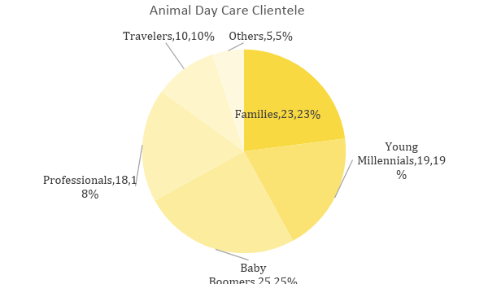

SWOT Analysis | Strengths | Weaknesses | Opportunities | Threats
[Pongo & Perdita Care Center] | Offers high-quality services | Lack of exposure in the market | Potential to grow business | Loyal client base in competitor centers
[Lassie’s Day Care] | Has a loyal client base | Not able to provide long-term boarding | Provide more services for clients | Increasing number of competitors
[Paws Pet Care] | Vast experience with different animals | Ongoing costs affect business dynamics | Niche market of customers | Increased cost of living

Marketing Strategy

Satisfied customers remain to be the best marketing tool. Customers who leave the business with a happy pet will attract loyal customers as long as services remain consistent. [Pongo & Perdita Care Center] will distribute advertising brochures to veterinary clinics and large businesses to help build its client base. In addition, the center will also utilize the use of online channels such as establishing its own website and social media accounts to get a wider scope.

Marketing Strategy | Activities | Timeline | Success Criteria
Online Communities | Create website and social media pages | March 15, 2019 | Get at least 1,000 views on the website and 2,500 “likes” and “follows” on social media
Flyers and Brochures | Design marketing materials | February 28, 2019 | Print and distribute at least 500 fliers and 200 brochures to local businesses
Local TV and Radio Ads | Contact local networks to feature the services | March 30, 2019 | Feature on at least one local TV show and one radio channel

Organizational Structure:

CEO
Operations Manager
HR Manager
Center Manager
Veterinary
Administrative Staff
Maintenance Staff
Pet Sitters
Pet Groomers

OPERATIONAL PLAN

Location and Facilities

The care center is a large leased space in downtown Oregon. The open plan facility is divided into several areas to accommodate the services offered by [Pongo & Perdita Care Center].
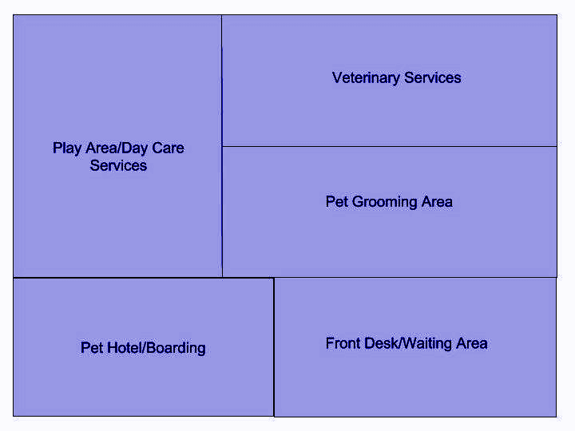

FINANCIAL PLAN

Assumptions

The pet care service industry has experienced steady growth even during the recession. The industry, which includes grooming, pet care, training, and boarding has a steady demand. There are low barriers of entry, which means that the industry is heavily saturated, however, this does not deter the owner of the center as it relies on service and customer satisfaction to gain more clients in the long run.

Monthly Expense

The chart shows the projected monthly expense of the animal day care center for the year [2019]:

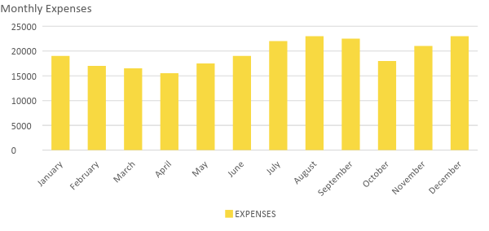
Monthly Revenue

The following chart shows the projected revenue of Pongo & Perdita Care Center in [2019]:

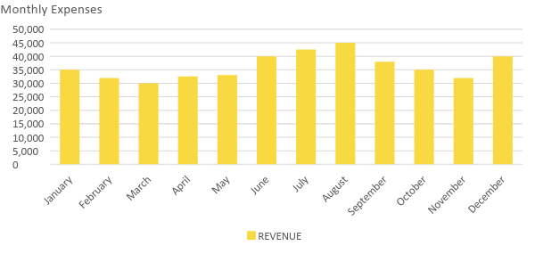

Business Financing

The business will be funded primarily by the owner through existing funds and credit accounts. Majority of the amount will be set aside for rent, business insurance, salaries, supplies, and maintenance.

Statements

Profit and Loss Projection
 | FY2018 | FY2019 | FY2020
Sales | $435,000.00 | $500,000.00 | $525,000.00
Direct Cost of Sale | $200,000.00 | $225,000.00 | $250,000.00
Other Cost of Sale | $35,000.00 | $40,000.00 | $45,000.00
Total Cost of Goods Sold or COGS (Sales - Direct Cost of Sale - Other Cost of Sale) | $200,000.00 | $235,000.00 | $230,000.00
Gross Profit (Sales-Total Cost of Goods Sold) | $235,000.00 | $265,000.00 | $295,000.00
Gross Margin % (Gross Profit/Sales) | 54.02% | 53.00% | 56.19%
Operating Expenses
Rent | $24,000.00 | $24,000.00 | $24,000.00
Insurance | $6,000.00 | $6,000.00 | $6,000.00
Utilities | $15,000.00 | $15,000.00 | $17,000.00
Salary (Including Tax) | $100,000.00 | $120,000.00 | $150,000.00
Maintenance & Supplies | $3,000.00 | $3,500.00 | $3,500.00
Total Operating Expenses | $148,000.00 | $168,500.00 | $200,500.00
EBITDA (Total Cost of Sale-Total Operating Expenses) | $52,000.00 | $66,500.00 | $29,500.00
Depreciation (Asset Cost - Residual Value)/Useful Life of the Asset) | $10,000.00 | $10,000.00 | $10,000.00
Interest Expense | $0.00 | $0.00 | $0.00
Taxes Paid | $15,000.00 | $18,000.00 | $20,000.00
Net Profit (Gross Profit - Operating Expenses - Taxes - Interest) | $72,000.00 | $78,500.00 | $74,500.00

Balance Sheet Projection
 | FY2019 | FY2020 | FY2021
Cash | $110,000.00 | $125,000.00 | $145,000.00
Accounts Receivable | $10,000.00 | $15,000.00 | $11,000.00
Inventory | $1,000.00 | $12,000.00 | $1,250.00
Other Current Assets | $2,000.00 | $2,500.00 | $3,500.00
Total Current Assets | $123,000.00 | $154,500.00 | $160,750.00
Long-Term Assets | $7,000.00 | $8,500.00 | $10,000.00
Accumulated Depreciation | $3,000.00 | $2,500.00 | $2,000.00
Total Long-Term Assets (Long-Term Assets-Accumulated Depreciation) | $4,000.00 | $6,000.00 | $8,000.00
Total Assets (Total Current Assets + Total Long-Term Assets) | $127,000.00 | $160,500.00 | $168,750.00
Accounts Payable | $15,000.00 | $17,000.00 | $15,500.00
Notes Payable | $700.00 | $750.00 | $500.00
Other | $3,500.00 | $4,000.00 | $4,500.00
Total Liabilities | $19,200.00 | $21,750.00 | $20,500.00
Paid-in Capital | $10,000.00 | $5,000.00 | $5,000.00
Retained Earnings | $25,000.00 | $27,000.00 | $35,000.00
Total Owner's Equity (Total Assets - Total Liabilities) | $107,800.00 | $138,750.00 | $148,250.00
Total Liabilities & Equity (Total Liabilities/Total Owner's Equity) | 17.81% | 15.68% | 13.83%

Cash Flow Projection
 | FY2019 | FY2020 | FY2021
Operating Cash Beginning | $450,000.00 | $470,000.00 | $480,000.00
Sources of Cash | $15,000.00 | $18,000.00 | $15,000.00
Receivables | $10,000.00 | $12,000.00 | $30,000.00
Sales | $32,000.00 | $25,000.00 | $35,000.00
Others | $5,000.00 | $7,000.00 | $8,000.00
Total Cash | $512,000.00 | $532,000.00 | $568,000.00
Expenditures
Rent | $24,000.00 | $24,000.00 | $24,000.00
Insurance | $6,000.00 | $6,000.00 | $6,000.00
Utilities | $20,000.00 | $25,000.00 | $26,000.00
Salary (Including Tax) | $100,000.00 | $120,000.00 | $150,000.00
Maintenance & Supplies | $3,000.00 | $3,500.00 | $3,500.00
Total Expenditures | $153,000.00 | $178,500.00 | $209,500.00
Net Income/Loss (Total Cash - Total Expenditures) | $359,000.00 | $353,500.00 | $358,500.00

