COME

ADVERTISING SALES PLAN

[IGNITE ADVERTISING SALES PLAN]

[2018 – 2019]

Index

Executive Summary [PAGE NUMBER]
Company Overview [PAGE NUMBER]
Products and Services [PAGE NUMBER]
Marketing Analysis [PAGE NUMBER]
Strategy and Implementation [PAGE NUMBER]
Management and Personnel [PAGE NUMBER]
Sales Action Plan [PAGE NUMBER]

EXECUTIVE SUMMARY

[Ignite Advertising] offers advertising and marketing services for companies in Boston and other nearby areas that are looking for different strategies to put their business names on the map. Ignite Advertising offers different advertising strategies including [print and broadcast advertising, social media management, data mining, event campaigns, and others].

The number of businesses opening in the United States every year shows a continued business opportunity as many new businesses prefer outsourcing to save money on project-based advertising activities. With different companies shifting their budgets for advertising, the industry is expected to grow remarkably at [30.5%] in expenditures in [2020]. At the current rate of growth, the company is looking forward to a profitable year, with a [15%] increase the year after.

COMPANY OVERVIEW

Mission Statement:

[Ignite Advertising] provides traditional and innovative advertising, marketing, and public relation solutions for businesses in Boston and other nearby areas.

Philosophy:

[Ignite Advertising] promises to deliver the best advertising solutions for clients who are willing to invest and grow their businesses.

Vision:

[Ignite Advertising] aims to help its clientele grow their business by delivering targeted and results-oriented advertising strategies and programs.

Outlook:

Emerging trends in digital marketing will show a positive increase in revenue for the advertising industry. With the help of online platforms such as targeted social media advertising, search engine optimization, data mining, and website upkeep, there are plenty of opportunities for start-up advertising firms such as Ignite Advertising to improve profits in the next year.

Type of Industry: Advertising Industry

Business Structure: Sole Proprietorship

Ownership: Sole Proprietorship, Melanie Anderson

Start-Up Summary:

[Ignite Advertising] will start its operations with [$50,000] as capital. The amount is provided by the owner and will be used for office space rental, equipment and software, and payroll.

Start-Up Funding
Expenses | $25,000
Assets | $25,000
Total Funding Required | $50,000
Assets
Non-Cash Assets | $10,000
Cash Requirements | $5,000
Additional Cash Raised | $7,000
Cash Balance on Starting Date | $3,000
Total Assets | $25,000
Capital
Planned Investment
Owner | $50,000
Other | $0
Additional Investment Requirement | $0
Total Planned Investment | $50,000
Loss | -$25,000
Total Capital | $25,000
Total Capital and Liabilities | $25,000
Start-Up
Requirements
Start-Up Expenses
Rent | $12,000
Advertising | $3,000
Legal Fees | $1,000
Hardware and Software | $6,000
Insurance | $1,000
Other | $2,000
Total Start-Up Expenses | $25,000
Start-Up Assets
Cash Required | $5,000
Inventory | $3,000
Other Current Assets | $5,000
Long-Term Assets | $12,000
Total Assets | $25,000
Total Requirements (Total Start-Up Expenses + Total Assets) | $50,000

PRODUCTS AND SERVICES

Product/Service Description:

[Ignite Advertising] handles interactive advertising services ranging from print, broadcast, and online advertising, public relations, event campaigns, and strategic planning services for businesses in the Boston area.

Value Proposition:

Specializing in start-up marketing and advertising, the company helps entrepreneurs promote their products and services by offering advertising services at a fair price.

Pricing Strategy:

[Ignite Advertising] utilizes a blended price rate with time estimates to ensure that all specialists and staff are covered at every level. Assessment is necessary before the company can give a fair-price quote for the services needed.

MARKETING ANALYSIS

The advertising industry continues to thrive in the [Boston] area. As more and more businesses open, the need for advertising services grows with them as entrepreneurs become more interested in growth and expansion. Research has shown that advertising will account for [30.5%] of the global expenditure in [2020], and will total [$187] billion in the same year.

Market Segmentation

[Ignite Advertising] predicts steady positive growth in revenue in the following years as the economy strengthens. Business ventures find the need to reach their target markets in a highly competitive business landscape; thus, the need for services offered by Ignite Advertising also increase.

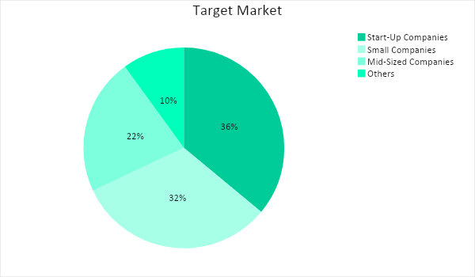

Target Market Segmentation Strategy

Start-up companies

- Focus on targeted social media advertising through Facebook Ads, Instagram Business, and Messenger Ads, to ensure maximum reach at a lower cost.
- Utilize connections with business expos related to the different business industries when necessary

Other small and mid-sized companies

- Focus on new product and service advertising through the newspaper, radio, or magazine features.
- Produce advertising events that put the spotlight on new products and services
- In-store advertising deliverables such as standees, tarpaulins, or posters, if desired

STRATEGY AND IMPLEMENTATION

Target Market Strategy

[Ignite Advertising] will focus on targeted [social media advertising], participation in business expos, as well as event marketing and campaign to reach its client’s target market. It will also provide produce in-store advertising deliverables such as standees, posters, and tarpaulins if so desired.

Competitive Edge

[Ignite Advertising] offers effective marketing and advertising strategies for different businesses, at a fair price.

SWOT Analysis | Strengths | Weaknesses | Opportunities | Threats
Ignite Advertising | Has an experienced advertising staff | Lack of clients | New businesses opening every year offers client potential | Economic changes can be problematic for revenue
Cortez- Reyes Advertising Firm | Has a steady and loyal roster of clients | Needs improvement in print and broadcast advertising |  | Increasing competition due to low barriers of entry
AZ Advertising and Marketing | Go-to firm for companies in local and other nearby areas | High employee turnover rates | Outsourcing arrangements allow more clients

Sales Strategy and Forecast

The company is aiming to reach the following monthly sales in its first year of operation:

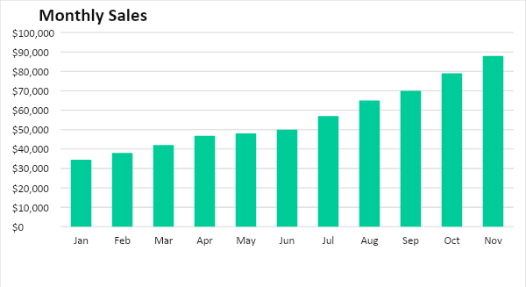

With the help of its own advertising efforts, Ignite Advertising projects the following company growth in terms of revenue in the next two years:

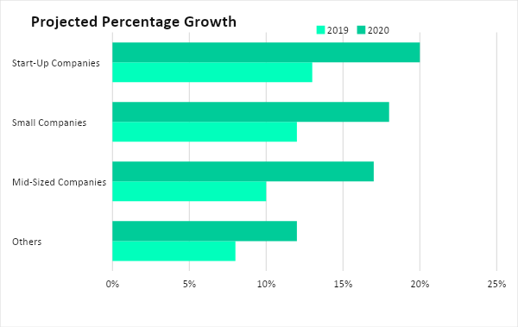

[Ignite Advertising] believes that marketing strategies can only go so far. Thus, it will put emphasis on customer satisfaction by fostering relationships with its clients.

Sales Strategy | Activities | Timeline | Success Criteria
Sales Promotions | - Conduct meetings with business owners in the area and speak with them about the company’s services | - March 10, 2019 | - Positive responses from companies, with at least 65% signing up as clients
 | - Use social media and the company website as an online portfolio to attract potential clients | - March 15, 2019 | - Increasing network hits and strong audience engagement
Customer Satisfaction | - Foster customer relationships by being open to suggestions and criticisms to ensure improving outputs | - Per-project | - Positive reviews and referrals from customers

Marketing Strategy

[Ignite Advertising] will focus on small and mid-sized businesses in order to serve a larger target market. To increase profits, the company will focus on customer acquisition strategies by speaking directly to business owners and decision makers.

Milestones

Marketing Strategy | Activities | Timeline | Success Criteria
Website Update and Social Media Management | - Update website for better customer navigation and access | - March 1, 2019 | - More online inquiries, increased blog hits, and strong visitor ratio (hits plus time spent per page)
 | - Maintain social media pages and create targeted ads | - March 10, 2019 | - Strong audience engagement
Customer Acquisition | - Meet with business owners and contacts to discuss advertising offers and possible strategies | - ASAP | - Have a positive response from companies, with at least 65% signing up as clients
Networking | - Contact business expo planners as well as government and private agencies | - May 10, 2019 | - Increased client referrals through effective execution

MANAGEMENT AND PERSONNEL

[Ignite Advertising] is a small advertising firm and has the following structure:

CEO
Financial Officer
HR Manager
Advertising
HR Assistant
Video
Graphics
Events Team

SALES ACTION PLAN

The following table shows the company’s sales goals as well as its corresponding activities with details on the target dates, resources, person-in-charge, and key performance indicators (KPIs).

Sales Goals | Action Items | Start Date | End Date | KPIs | Owner
Increase sales and profit | Weekly meetings with the marketing and advertising team to look into and apply strategies as necessary | March 1, 2019 | No end date, this is will be recurring | Increasing sales and profit | Advertising Team
A high rate of customer satisfaction | Create good customer relations through regular meetings and by encouraging criticism and suggestions. | Per project basis, pre-project | Per project basis, post-project | At least 90% client satisfaction rating;  Successful advertising strategies | Advertising Team

